QIR AUTOMATION PLATFORM
Application Architecture, Data Architecture and End-to-End Process Flows
Implementation-ready functional architecture derived from the UKI QIR Master Reval Work Instruction V4.1
Prepared for: Vikram Vishal
Document type: Solution Architecture and Functional Design
Version: 1.0
Date: 20 August 2026

1. Executive Architecture Summary
The proposed platform replaces a single large, formula-intensive Excel workbook with a modular validation application. Every QIR test is implemented as an independently executable function, while all functions share governed ingestion, normalization, evidence, scoring, exception and audit services.
- Inventory Service remains the authoritative base dataset.
- Raw uploads are preserved unchanged; processing occurs on staged and canonical copies.
- Every execution is identified by Account, Financial Quarter, QIR Cycle, Test, Run and Rule Version.
- A single discrepancy makes the applicable test NOK; an applicable NOK makes the overall QIR NOK.
- Monitoring selection is account-driven, requires at least two toolsets, and supports a custom monitoring tool.
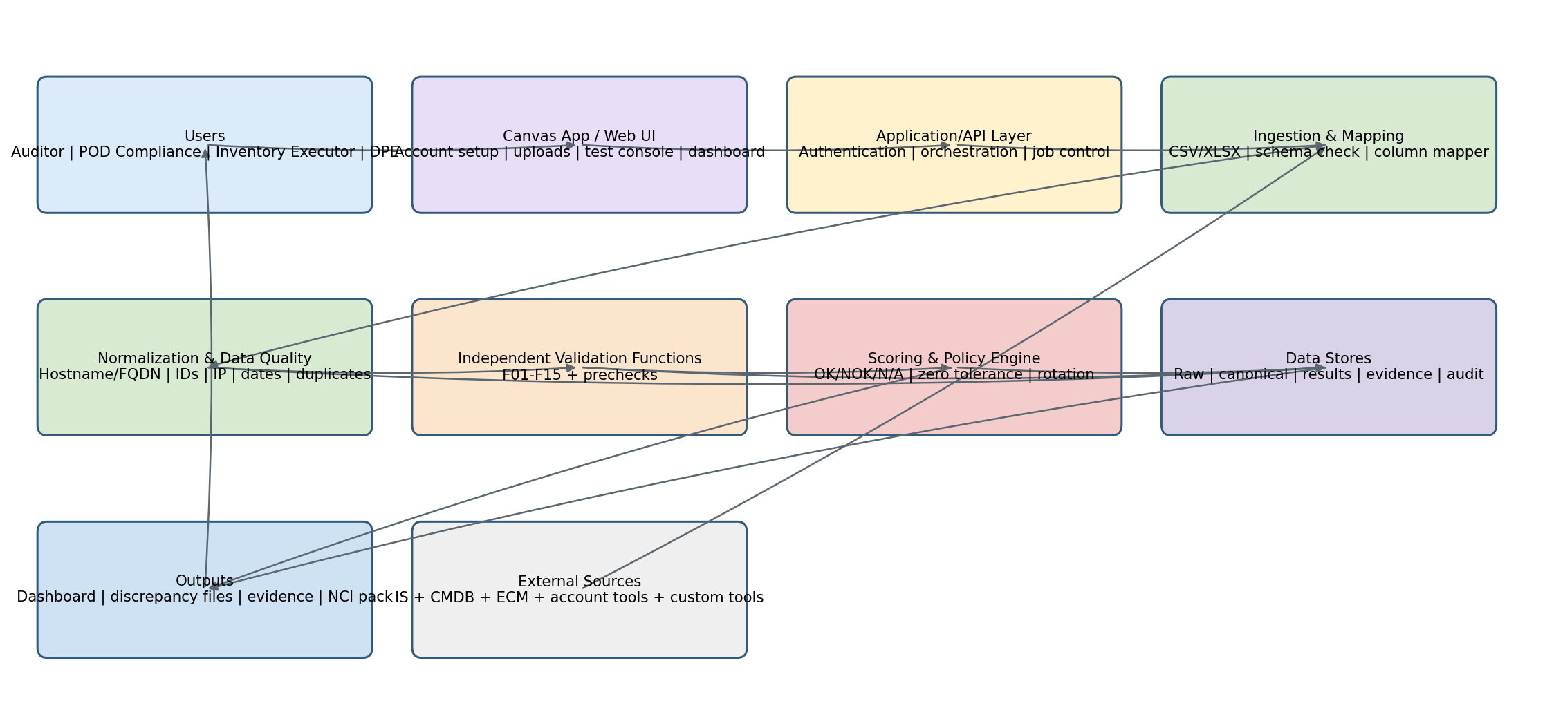
Figure 1. Logical enterprise architecture

2. End-to-End Process Architecture
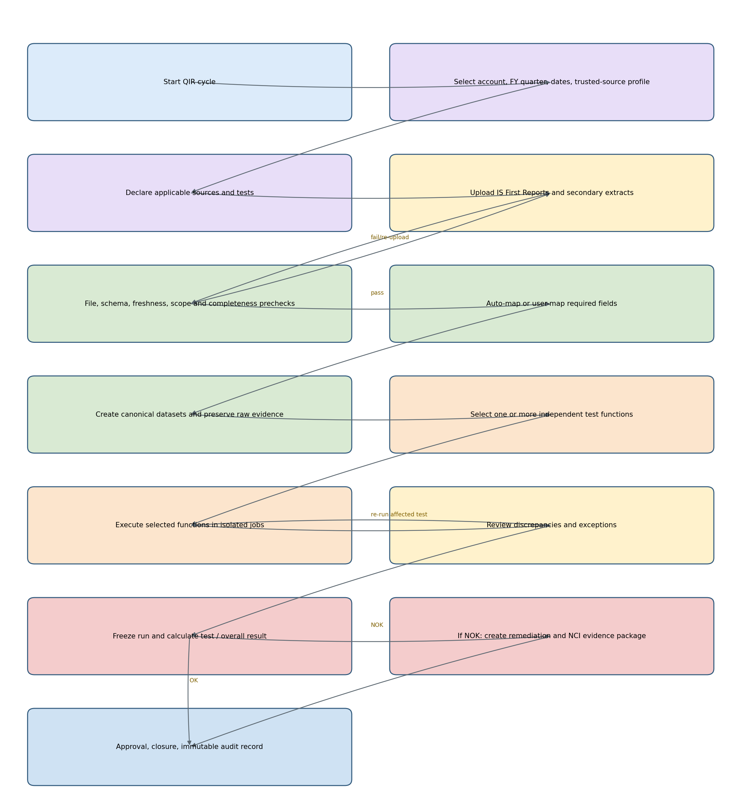
Figure 2. QIR cycle process and decision flow

2.1 Process states
State | Entry criteria | Permitted action | Exit condition
Draft | Cycle created | Configure account, dates, sources | Mandatory metadata complete
Input Pending | Applicable tests identified | Upload or replace files | Required inputs accepted
Ready | Prechecks and mappings pass | Select tests | At least one runnable test
Running | Execution submitted | View job progress; do not edit frozen inputs | All selected functions complete
Review | Results available | Review, classify exception, assign owner | Findings accepted or input corrected
Frozen | Completion date set | Score and publish | Result package generated
Remediation | Overall NOK | Track corrections and evidence | All actions closed
Closed | Approval complete | Read-only retrieval | Immutable record retained

3. Data Architecture and Flow
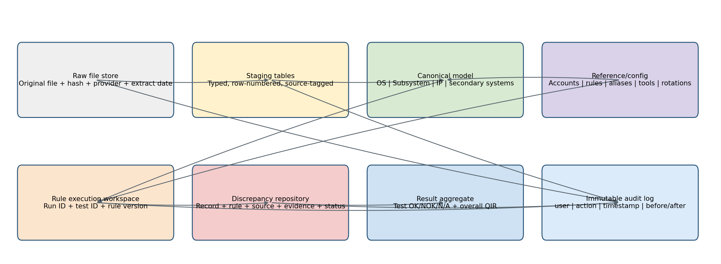
Figure 3. Data lineage from upload to final result

3.1 Core data entities
Entity | Purpose | Key identifiers
Account | Account-specific scope and tool profile | account_id
QIR Cycle | Quarterly assessment header | qir_cycle_id, account_id, FY quarter
Source Registration | Applicable source and trusted-source status | source_id, source_type, custom_name
File Submission | Raw evidence and metadata | file_id, hash, extract_date, provided_by
Column Mapping | Source-to-canonical field map | mapping_id, source_id, canonical_field
Canonical Record | Normalized row used by rules | record_id, dataset_type, normalized keys
Test Definition | Independent function metadata | test_id, applicability, required inputs
Rule Definition | Versioned atomic validation rule | rule_id, rule_version, severity
Test Run | Execution status and frozen input set | run_id, test_id, rule_version
Discrepancy | Row-level failed rule output | discrepancy_id, run_id, record_id
Exception | Approved justification and validity | exception_id, approval, start/end dates
Result | Test and overall outcome | result_id, OK/NOK/N/A
Audit Event | Traceability | event_id, actor, timestamp, action

3.2 Canonical processing rules
- Retain original hostname/FQDN and create normalized comparison keys.
- Trim whitespace, normalize case for matching, remove a trailing dot, and derive short hostname where configured.
- Do not overwrite raw values. Every transformation records rule, before value and after value.
- Detect blank keys, duplicate keys, invalid types, invalid dates and missing mandatory columns before business validation.
- Retain source-tool attribution after consolidation so each finding is traceable to its originating extract.

4. Application Components
Component | Responsibilities
Account and QIR Setup | Account profile, trusted-source decision, quarter, initiation/test/completion dates, applicable tests, source registration.
Upload Center | File upload, metadata, virus/security gateway integration point, hash, version, replace/reject controls.
Schema and Mapping Wizard | Header detection, required-field validation, saved mappings, manual override, preview and mapping confidence.
Normalization Service | Hostname/FQDN, identifier, Boolean, date, lifecycle and IP normalization; duplicate profiling.
Validation Orchestrator | Independent job creation, dependency checking, parallel execution, retries, cancellation and run isolation.
Rule Engine | Versioned deterministic rules, rule applicability, thresholds, reason codes and discrepancy messages.
Exception Manager | Exception type, evidence, owner, approval, effective dates and rule-specific suppression without deleting findings.
Scoring Engine | OK/NOK/N/A, zero-tolerance aggregation, frozen result and publication control.
Dashboard and Exports | Progress, counts, drill-down, discrepancy CSV/XLSX, execution summary and evidence index.
Audit and Governance | RBAC, immutable event history, data lineage, rule version, file provenance and retention policy hooks.

5. Independent Function Contract
Every test implements the same callable contract so it can run from a canvas tile, API or scheduled orchestration without depending on other test screens.
Contract element | Requirement
Inputs | qir_cycle_id, test_id, selected file versions, mappings, rule version, exception snapshot
Preconditions | Applicable test, required source files accepted, mapped mandatory fields, no blocking precheck error
Processing | Read canonical datasets only; never modify raw/staged data
Outputs | run status, metrics, candidate findings, accepted discrepancies, warnings, evidence references
Idempotency | Same inputs and rule version produce the same result
Isolation | Failure of one function does not corrupt or prevent unrelated functions
Re-run | Create new run version; preserve prior run and show superseded status
Observability | Start/end, duration, row counts, rejected rows, error code and processing log

6. Detailed Functional Architecture

F00 - Shared Data Quality Precheck
Aspect | Detailed requirement
Purpose | Shared Data Quality Precheck
Inputs | All uploaded files
Pre-run controls | Confirm applicability, accepted files, mappings, rule version and frozen source versions.
Processing flow | Required headers, parseability, row count, blank keys, duplicates, extraction metadata, Active/Unknown IS scope
Outputs | Blocking errors or warnings; accepted canonical datasets
Canvas controls | Run Test; View Inputs; View Mapping; View Findings; Export; Re-run; Compare Runs.
Audit evidence | File IDs and hashes, mapping version, counts in/out, rule IDs, runtime, actor and discrepancy records.
Failure handling | No partial publication. Mark run Failed with error code; keep diagnostic log; previous successful run remains intact.

F01 - Contractual/Billing Baseline or CMDB
Aspect | Detailed requirement
Purpose | Contractual/Billing Baseline or CMDB
Inputs | IS OS hostname; selected trusted baseline/CMDB hostname
Pre-run controls | Confirm applicability, accepted files, mappings, rule version and frozen source versions.
Processing flow | Bidirectional normalized hostname comparison; N/A when IS is sole trusted source; retain source rotation history
Outputs | IS-only and baseline-only discrepancies
Canvas controls | Run Test; View Inputs; View Mapping; View Findings; Export; Re-run; Compare Runs.
Audit evidence | File IDs and hashes, mapping version, counts in/out, rule IDs, runtime, actor and discrepancy records.
Failure handling | No partial publication. Mark run Failed with error code; keep diagnostic log; previous successful run remains intact.

F02 - Enterprise Compliance Management
Aspect | Detailed requirement
Purpose | Enterprise Compliance Management
Inputs | IS OS OS Opaque ID; ECM System ID
Pre-run controls | Confirm applicability, accepted files, mappings, rule version and frozen source versions.
Processing flow | One-to-one identifier comparison; blank or duplicate identifiers flagged; 100% IS representation expected
Outputs | IS ID absent in ECM; ECM ID absent in IS; identifier-quality findings
Canvas controls | Run Test; View Inputs; View Mapping; View Findings; Export; Re-run; Compare Runs.
Audit evidence | File IDs and hashes, mapping version, counts in/out, rule IDs, runtime, actor and discrepancy records.
Failure handling | No partial publication. Mark run Failed with error code; keep diagnostic log; previous successful run remains intact.

F03 - Monitoring Coverage
Aspect | Detailed requirement
Purpose | Monitoring Coverage
Inputs | IS OS hostname; at least two selected monitoring extracts
Pre-run controls | Confirm applicability, accepted files, mappings, rule version and frozen source versions.
Processing flow | Ask account toolset; standard or Custom Monitoring Tool; require minimum two; map each source hostname; compare each independently; preserve source; rotation history
Outputs | Per-tool missing-in-IS findings and consolidated coverage view
Canvas controls | Run Test; View Inputs; View Mapping; View Findings; Export; Re-run; Compare Runs.
Audit evidence | File IDs and hashes, mapping version, counts in/out, rule IDs, runtime, actor and discrepancy records.
Failure handling | No partial publication. Mark run Failed with error code; keep diagnostic log; previous successful run remains intact.
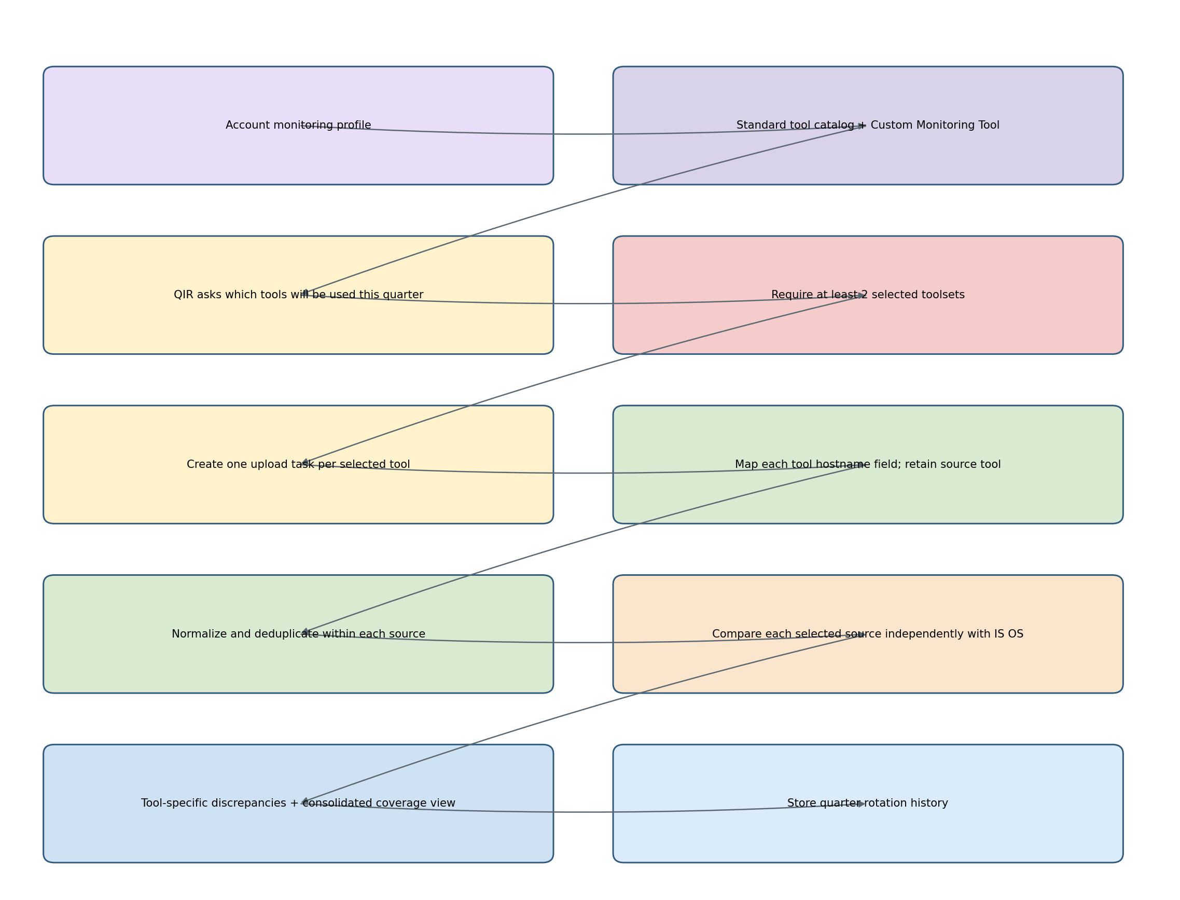
Figure 4. Account-driven monitoring flow with custom-tool support

F04 - Network
Aspect | Detailed requirement
Purpose | Network
Inputs | IS OS hostname, image_purpose; consolidated network list
Pre-run controls | Confirm applicability, accepted files, mappings, rule version and frozen source versions.
Processing flow | Bidirectional hostname match; matched network device requires image_purpose=Network
Outputs | Missing in network list; invalid image purpose; missing in IS
Canvas controls | Run Test; View Inputs; View Mapping; View Findings; Export; Re-run; Compare Runs.
Audit evidence | File IDs and hashes, mapping version, counts in/out, rule IDs, runtime, actor and discrepancy records.
Failure handling | No partial publication. Mark run Failed with error code; keep diagnostic log; previous successful run remains intact.

F05 - Storage
Aspect | Detailed requirement
Purpose | Storage
Inputs | IS OS hostname, image_purpose; storage list
Pre-run controls | Confirm applicability, accepted files, mappings, rule version and frozen source versions.
Processing flow | Bidirectional hostname match; matched storage device requires image_purpose=Storage
Outputs | Missing in storage list; invalid image purpose; missing in IS
Canvas controls | Run Test; View Inputs; View Mapping; View Findings; Export; Re-run; Compare Runs.
Audit evidence | File IDs and hashes, mapping version, counts in/out, rule IDs, runtime, actor and discrepancy records.
Failure handling | No partial publication. Mark run Failed with error code; keep diagnostic log; previous successful run remains intact.

F06 - VM, Host and Cloud
Aspect | Detailed requirement
Purpose | VM, Host and Cloud
Inputs | IS OS virtualization/cloud/parent/provider fields; consolidated VM/host/cloud sources
Pre-run controls | Confirm applicability, accepted files, mappings, rule version and frozen source versions.
Processing flow | Classify VM, host, ESXi and hyperscaler; validate hostname coverage, os_is_virtual, is_cloud, parent_type and required provider metadata
Outputs | Seven source/flag/parent/provider discrepancy classes
Canvas controls | Run Test; View Inputs; View Mapping; View Findings; Export; Re-run; Compare Runs.
Audit evidence | File IDs and hashes, mapping version, counts in/out, rule IDs, runtime, actor and discrepancy records.
Failure handling | No partial publication. Mark run Failed with error code; keep diagnostic log; previous successful run remains intact.

F07 - Security Health Check
Aspect | Detailed requirement
Purpose | Security Health Check
Inputs | IS OS and Subsystem SHC fields
Pre-run controls | Confirm applicability, accepted files, mappings, rule version and frozen source versions.
Processing flow | Validate security standard; YES/NO flags; if YES require interval/unit; if NO require exception reason; repeat for manual HC and subsystem equivalents
Outputs | Atomic OS and subsystem SHC findings
Canvas controls | Run Test; View Inputs; View Mapping; View Findings; Export; Re-run; Compare Runs.
Audit evidence | File IDs and hashes, mapping version, counts in/out, rule IDs, runtime, actor and discrepancy records.
Failure handling | No partial publication. Mark run Failed with error code; keep diagnostic log; previous successful run remains intact.

F08 - Backup and Recovery
Aspect | Detailed requirement
Purpose | Backup and Recovery
Inputs | IS contracted flag; B&R hostname list
Pre-run controls | Confirm applicability, accepted files, mappings, rule version and frozen source versions.
Processing flow | Bidirectional hostname comparison plus contracted-flag alignment
Outputs | Contracted but absent; source match with invalid flag; source-only
Canvas controls | Run Test; View Inputs; View Mapping; View Findings; Export; Re-run; Compare Runs.
Audit evidence | File IDs and hashes, mapping version, counts in/out, rule IDs, runtime, actor and discrepancy records.
Failure handling | No partial publication. Mark run Failed with error code; keep diagnostic log; previous successful run remains intact.

F09 - Disaster Recovery
Aspect | Detailed requirement
Purpose | Disaster Recovery
Inputs | IS DR contracted flag and plan ID; DR list
Pre-run controls | Confirm applicability, accepted files, mappings, rule version and frozen source versions.
Processing flow | Bidirectional match; contracted coverage; when contracted and matched require plan ID
Outputs | Coverage, flag and missing plan ID findings
Canvas controls | Run Test; View Inputs; View Mapping; View Findings; Export; Re-run; Compare Runs.
Audit evidence | File IDs and hashes, mapping version, counts in/out, rule IDs, runtime, actor and discrepancy records.
Failure handling | No partial publication. Mark run Failed with error code; keep diagnostic log; previous successful run remains intact.

F10 - Anti-Virus
Aspect | Detailed requirement
Purpose | Anti-Virus
Inputs | IS AV required flag; AV coverage list
Pre-run controls | Confirm applicability, accepted files, mappings, rule version and frozen source versions.
Processing flow | Bidirectional match and applicability flag alignment
Outputs | Required but absent; covered but flag invalid; source-only
Canvas controls | Run Test; View Inputs; View Mapping; View Findings; Export; Re-run; Compare Runs.
Audit evidence | File IDs and hashes, mapping version, counts in/out, rule IDs, runtime, actor and discrepancy records.
Failure handling | No partial publication. Mark run Failed with error code; keep diagnostic log; previous successful run remains intact.

F11 - AIC
Aspect | Detailed requirement
Purpose | AIC
Inputs | IS software collection required/tool; AIC list
Pre-run controls | Confirm applicability, accepted files, mappings, rule version and frozen source versions.
Processing flow | Bidirectional match; required flag and tool consistency; support consolidated ILMT/CIT inputs
Outputs | Coverage, flag, tool-present-without-source and source-only findings
Canvas controls | Run Test; View Inputs; View Mapping; View Findings; Export; Re-run; Compare Runs.
Audit evidence | File IDs and hashes, mapping version, counts in/out, rule IDs, runtime, actor and discrepancy records.
Failure handling | No partial publication. Mark run Failed with error code; keep diagnostic log; previous successful run remains intact.

F12 - CACF
Aspect | Detailed requirement
Purpose | CACF
Inputs | IS CACF required flag and AAP inventory hostname; CACF list
Pre-run controls | Confirm applicability, accepted files, mappings, rule version and frozen source versions.
Processing flow | Bidirectional match; applicability and AAP hostname validation; account-policy applicability and rotation recorded
Outputs | Coverage, flag, AAP hostname and source-only findings
Canvas controls | Run Test; View Inputs; View Mapping; View Findings; Export; Re-run; Compare Runs.
Audit evidence | File IDs and hashes, mapping version, counts in/out, rule IDs, runtime, actor and discrepancy records.
Failure handling | No partial publication. Mark run Failed with error code; keep diagnostic log; previous successful run remains intact.

F13 - IAM Primary and Shared ID
Aspect | Detailed requirement
Purpose | IAM Primary and Shared ID
Inputs | IS two IAM flags; DVC28 and SHID01/approved alternatives
Pre-run controls | Confirm applicability, accepted files, mappings, rule version and frozen source versions.
Processing flow | Expose two independently runnable subfunctions; bidirectional match and flag validation per stream
Outputs | Primary-control findings and Shared-ID findings kept separate
Canvas controls | Run Test; View Inputs; View Mapping; View Findings; Export; Re-run; Compare Runs.
Audit evidence | File IDs and hashes, mapping version, counts in/out, rule IDs, runtime, actor and discrepancy records.
Failure handling | No partial publication. Mark run Failed with error code; keep diagnostic log; previous successful run remains intact.

F14 - Primary IP Address
Aspect | Detailed requirement
Purpose | Primary IP Address
Inputs | IS OS ip_address; IS IP address/address DHCP/type fields
Pre-run controls | Confirm applicability, accepted files, mappings, rule version and frozen source versions.
Processing flow | Parse IPv4; reject loopback and invalid octets; require primary IP unless justified; validate DHCP/restriction evidence; duplicate IP requires CLUSTER NODE or STACK type
Outputs | IP format, missing IP, missing flags/evidence, primary designation and unjustified duplicate findings
Canvas controls | Run Test; View Inputs; View Mapping; View Findings; Export; Re-run; Compare Runs.
Audit evidence | File IDs and hashes, mapping version, counts in/out, rule IDs, runtime, actor and discrepancy records.
Failure handling | No partial publication. Mark run Failed with error code; keep diagnostic log; previous successful run remains intact.

F15 - Lifecycle Status Usage Matrix
Aspect | Detailed requirement
Purpose | Lifecycle Status Usage Matrix
Inputs | OS lifecycle/change/origin; Subsystem lifecycle and parent
Pre-run controls | Confirm applicability, accepted files, mappings, rule version and frozen source versions.
Processing flow | Validate allowed values; DISCOVERED/INSTALLED >30 days; PRE-PRODUCTION/TRANSITION/IDLE >90 days; active child with inactive parent
Outputs | OS lifecycle, threshold, subsystem lifecycle and orphan findings
Canvas controls | Run Test; View Inputs; View Mapping; View Findings; Export; Re-run; Compare Runs.
Audit evidence | File IDs and hashes, mapping version, counts in/out, rule IDs, runtime, actor and discrepancy records.
Failure handling | No partial publication. Mark run Failed with error code; keep diagnostic log; previous successful run remains intact.

7. Scoring and Policy Flow
- Test result = N/A only when applicability is explicitly decided and supported by account policy metadata.
- Test result = OK only when the applicable function completes successfully and has zero unresolved discrepancies.
- Test result = NOK when one or more unresolved discrepancies exist.
- Overall QIR = OK only when every applicable test is OK and no unresolved discrepancy exists.
- Overall QIR = NOK when any applicable test is NOK. The platform then exposes the NCI/remediation package workflow.
- Warnings from prechecks do not change the score unless a versioned policy rule classifies them as discrepancies.

8. Security, Governance and Non-Functional Requirements
Area | Requirement
RBAC | Separate permissions for setup, upload, execute, review exception, approve, publish and administer rules.
Data protection | Encrypt in transit and at rest; configurable retention; restrict cross-account access; avoid exposing source files in exports unless authorized.
Auditability | Immutable download/upload/run/exception/approval history and reproducible result from frozen inputs.
Performance | Stream or chunk large CSV/XLSX files; background worker pool; per-test progress and row counters; avoid loading entire workbook-style datasets into UI memory.
Reliability | Transactional metadata updates, retry-safe jobs, checksum verification, graceful cancellation and no corruption of prior runs.
Scalability | Horizontal workers; partition by account/cycle/test; object storage for raw files; relational store for metadata/results.
Maintainability | Versioned rules and mappings; unit tests for every atomic condition; regression packs based on approved masked examples.
Usability | Canvas tiles by function, clear preconditions, actionable errors, source attribution, saved mappings and accessible status indicators.
Interoperability | CSV and XLSX first; API/connectors later through the same canonical ingestion contract.
Observability | Centralized logs, job metrics, failure taxonomy, audit dashboard and exportable run manifest.

9. Recommended Deployment View
- Presentation tier: Power Apps canvas or responsive web client.
- Application tier: API, authentication/authorization, QIR orchestration and export services.
- Processing tier: Python-based workers using dataframe or SQL execution for scalable comparisons.
- Persistence tier: relational database for metadata/results, object storage for raw/evidence files, optional analytics model for dashboards.
- Integration tier: optional connectors to Inventory Service, ECM, ServiceNow/CMDB, GLPI and account tools, added without changing test contracts.

10. Acceptance Criteria
- Each F01-F15 function can be executed independently from its own canvas tile.
- A user cannot run a function until its declared mandatory inputs and mappings pass prechecks.
- A function failure cannot change another function result or delete a prior result.
- Every finding identifies account, quarter, test, rule, canonical row, original source file and source tool.
- Monitoring setup accepts standard and custom tools and blocks execution when fewer than two toolsets are selected.
- Re-running a test produces a new version and preserves comparison with the prior run.
- The platform reproduces the strict OK/NOK aggregation required by the work instruction.
- Exports remain usable for high-volume data without embedding all source data in one Excel workbook.

11. Architecture Review and Final Rating
Review outcome: 10/10 for solution-architecture completeness at requirements stage. The design covers process, data, modular functions, monitoring variability, independent execution, evidence, scoring, governance, non-functional controls and acceptance criteria. Field-by-field source mappings and approved exception value lists should be maintained as controlled configuration during detailed design rather than hardcoded in this architecture.

Source Basis
UKI QIR - Master Reval Workbook - Work Instruction - V4.1 (20 August 2026 file supplied by the user). This architecture distinguishes policy-derived requirements from proposed application design. The requirement for “minimum two monitoring toolsets” and custom monitoring tools reflects the user’s clarified business requirement in this design conversation.

