Unified Network and Server
Hardware Governance V6
Architecture, Matching Logic, Data Flow, Controls and Output Specification

Document purpose
This document is the technical and operational reference for the V6 Python/Tkinter application that reconciles Network and Server CMDB data against Inventory Services product catalogs and category reports. It explains the implemented matching rules, category coverage controls, lifecycle validation, drift analysis, load-file construction and audit outputs.

Document attribute | Value
Application | Unified Network and Server Hardware Governance V6
Document type | Architecture and logic design / operational technical reference
Primary owner | Vikram Vishal
Application interface | Single Tkinter GUI with Network, Server and combined run modes
Supported inputs | .csv, .xlsx, .xlsm, .xlsb
Output format | .xlsx
Design baseline | Field List and Mapping workbook, Network and Server catalog schemas, agreed reconciliation rules

Contents
- 1. Executive summary
- 2. Scope and objectives
- 3. System context and architecture
- 4. Input schemas and field mapping
- 5. Common processing framework
- 6. Network module logic
- 7. Server module logic
- 8. Category coverage and load generation
- 9. Category catalog drift analysis
- 10. Lifecycle date validation
- 11. Output workbooks
- 12. GUI and execution flow
- 13. Controls, exceptions and auditability
- 14. Performance and scalability
- 15. Testing and acceptance criteria
- 16. Operational runbook
- 17. Limitations and enhancement roadmap
- 18. Appendices

1. Executive summary
V6 consolidates Network and Server hardware catalog governance into one desktop application while preserving different business rules for each domain. The application reads product catalogs, CMDB reports and existing Inventory Services category reports; builds in-memory indexes; performs catalog matching; validates operational category coverage; identifies catalog drift; compares lifecycle dates; and generates load candidates and governance evidence.
Core governance principle
Manufacturer, hardware type, hardware model and subcategory values used for required updates or category loads are taken only from the applicable published product catalog. Unmatched records are routed to a catalog-enhancement recommendation report rather than being silently guessed.
- Network catalog matching is driven by CMDB Model number and supports exact model, exact type-plus-model composite and indexed partial matching.
- Server catalog matching is driven by CMDB Manufacturer plus Model ID. There is no Server CMDB Model number dependency.
- Category presence is evaluated only for Lifecycle Stage = Operational devices using normalized serial-number joins.
- Network lifecycle validation compares CMDB EOL and EOSL fields with catalog dates. Server lifecycle validation compares CMDB Due with catalog end_of_life_date.
- Category load files inherit the source category report headers and ordering at runtime, reducing dependency on separately maintained templates.

2. Scope and objectives

2.1 In scope
Capability | Network | Server
Catalog match | Model number to hardware_model, hardware_type, or composite | Manufacturer + Model ID to manufacturer + hardware_model
Category presence | Serial number to network_serial_number | Serial number to serial_number / server_serial_number
Operational filter | Life Cycle Stage = Operational | Life Cycle Stage = Operational
Lifecycle validation | EOL and EOSL | Due to EOL
Catalog drift | Manufacturer, type, model, subcategory | Manufacturer, type, model, subcategory
Category load | IS Network header structure | IS Server header structure
Catalog recommendation | Unmatched Network models | Unmatched Server manufacturer/model combinations

2.2 Out of scope
- Direct write-back to Inventory Services or ServiceNow.
- Automatic approval of catalog enhancement recommendations.
- Uncontrolled online vendor lookup during a production run.
- Automatic correction of ambiguous duplicate catalog or category records.
- Retired and End of Life devices as normal category-load candidates.

3. System context and architecture
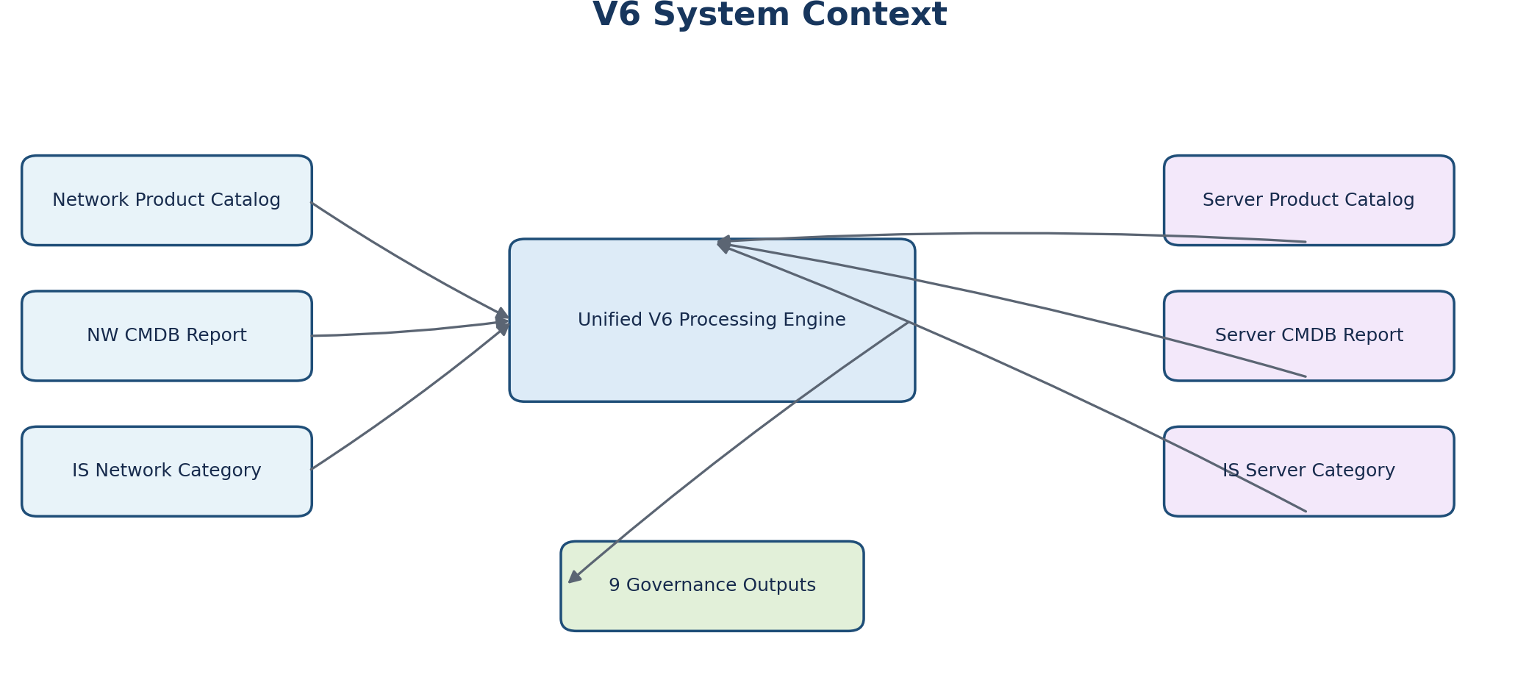
Figure 1. V6 system context and primary data relationships

3.1 Architectural layers
Layer | Responsibility
GUI | Collect six optional module-specific input paths, output folder and run mode; display progress and errors.
Reader and schema resolution | Read CSV, XLSX, XLSM and XLSB; detect header row; preserve category headers and metadata rows.
Normalization | Create stable header, model, manufacturer and serial comparison keys.
Catalog indexing | Build domain-specific in-memory lookup dictionaries once per run.
Reconciliation engines | Apply Network or Server matching, lifecycle, presence and drift rules.
Output services | Create formatted Excel outputs, category-load workbooks and governance summary.

3.2 Modular design
The script keeps Network and Server reconciliation functions separate within one executable. Shared services handle input reading, normalization, date parsing, serial indexing, workbook formatting and summary generation. This separation makes the matching policies explicit and reduces the risk of applying Network assumptions to Server data or vice versa.

4. Input schemas and field mapping
The application resolves columns through normalized aliases rather than relying only on exact case or separator spelling. The runtime category report itself defines the complete load-file header list and ordering.

4.1 Core Network fields
Source | Logical field | Expected header
NW CMDB | Hostname | Configuration Item; fallback CI.Name or Fully qualified domain name
NW CMDB | Serial | Serial number
NW CMDB | Catalog search value | Model number
NW CMDB | Lifecycle gate | Life Cycle Stage
NW CMDB | Lifecycle status | Life Cycle Stage Status
NW CMDB | Lifecycle dates | HW_End_Of_Life_Date; HW_End_Of_Support_Date
IS Network | Identity | network_opaque_id or id
IS Network | Serial join | network_serial_number
IS Network | Current catalog values | network_manufacturer, network_hardware_type, network_hardware_model, network_subcategory
Network Catalog | Required catalog values | manufacturer, hardware_type, hardware_model, subcategory
Network Catalog | Lifecycle dates | end_of_life_date, end_of_support_date

4.2 Core Server fields
Source | Logical field | Expected header
Server CMDB | Hostname | Name; fallback Fully qualified domain name
Server CMDB | Serial | Serial number
Server CMDB | Catalog manufacturer | Manufacturer
Server CMDB | Catalog model key | Model ID
Server CMDB | Lifecycle gate | Life Cycle Stage
Server CMDB | Lifecycle status | Life Cycle Stage Status
Server CMDB | CMDB EOL | Due
IS Server | Identity | server_opaque_id or id
IS Server | Serial join | serial_number or server_serial_number
IS Server | Current catalog values | server_manufacturer, server_hardware_type, server_hardware_model, server_subcategory
Server Catalog | Required values | manufacturer, hardware_type, hardware_model, subcategory
Server Catalog | Lifecycle dates | end_of_life_date, end_of_support_date

5. Common processing framework

5.1 File ingestion
- CSV encoding detection supports UTF-8 BOM, UTF-8, Windows-1252 and Latin-1.
- CSV delimiter detection supports comma, semicolon, tab and pipe.
- Excel readers scan candidate sheets and the first 25 rows to locate the strongest header match.
- XLSB is read through pyxlsb.
- A Mandatory/Optional/Required/Reference metadata row is detected and preserved in category load outputs.

5.2 Normalization
Normalization | Rule | Purpose
Header key | Lowercase and remove non-alphanumeric characters | Resolve spaces, underscores, hyphens and case differences.
Value key | Lowercase and remove non-alphanumeric characters | Compare catalog manufacturers, types and models.
Serial key | Lowercase and remove all non-alphanumeric characters | Treat SN-1, SN_1, SN/1 and sn1 as the same serial.
Model tokens | Retain compound alphanumeric parts plus letter/number fragments | Retrieve candidates such as ASA5508 and K9.

5.3 Date processing
Dates are parsed from common ISO, day-first, month-first, textual and Excel serial formats. Written output dates remain native Excel date values and use the short-date display format mm/dd/yyyy.
Value | Interpretation
2099-12-31 or 31-12-2099 | Catalog date not published
1999-12-31 or 31-12-1999 | Legacy placeholder requiring review
Blank or unparseable | Missing or invalid date
Other valid date | Published lifecycle date

6. Network module logic
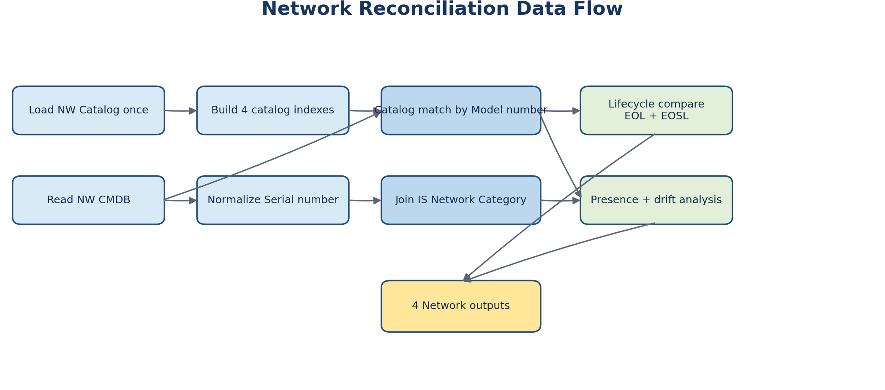
Figure 2. Network reconciliation processing sequence

6.1 Catalog indexes
Index | Key | Use
exact_model_index | Normalized hardware_model | Highest-priority direct model match.
hardware_type_index | Normalized hardware_type | Find catalog family/type candidates.
partial_token_index | Tokens from type and model | Retrieve candidates by model fragments.
composite_index | Normalized hardware_type + hardware_model | Resolve CMDB model formed from both catalog fields.

6.2 Match priority
Priority | Rule | Status/detail
1 | CMDB Model number equals catalog hardware_model after normalization | EXACT MATCH / EXACT HARDWARE_MODEL
2 | CMDB Model number equals hardware_type + hardware_model after normalization | EXACT MATCH / EXACT TYPE + MODEL COMPOSITE
3 | Use hardware_type and token indexes to obtain candidates | PARTIAL MATCH / INDEXED HARDWARE_TYPE/TOKEN MATCH
4 | If top candidates produce different governed outputs | NO MATCH / AMBIGUOUS ...
5 | No supported candidate | NO MATCH / NO INDEXED CANDIDATE

6.3 Composite match examples
CMDB Model number | Catalog hardware_type | Catalog hardware_model | Outcome
AIR-AP2802I-E-K9 | air-ap2802i | e-k9 | Exact composite
C9500-40X-A | c9500 | 40x-a | Exact composite
WS-C2960L-8TS-LL | ws-c2960 | l-8ts-ll | Exact composite
ASA5508-K9 | asa5508 | sec-bun-k9 | Indexed partial candidate with K9 tie-break evidence

7. Server module logic
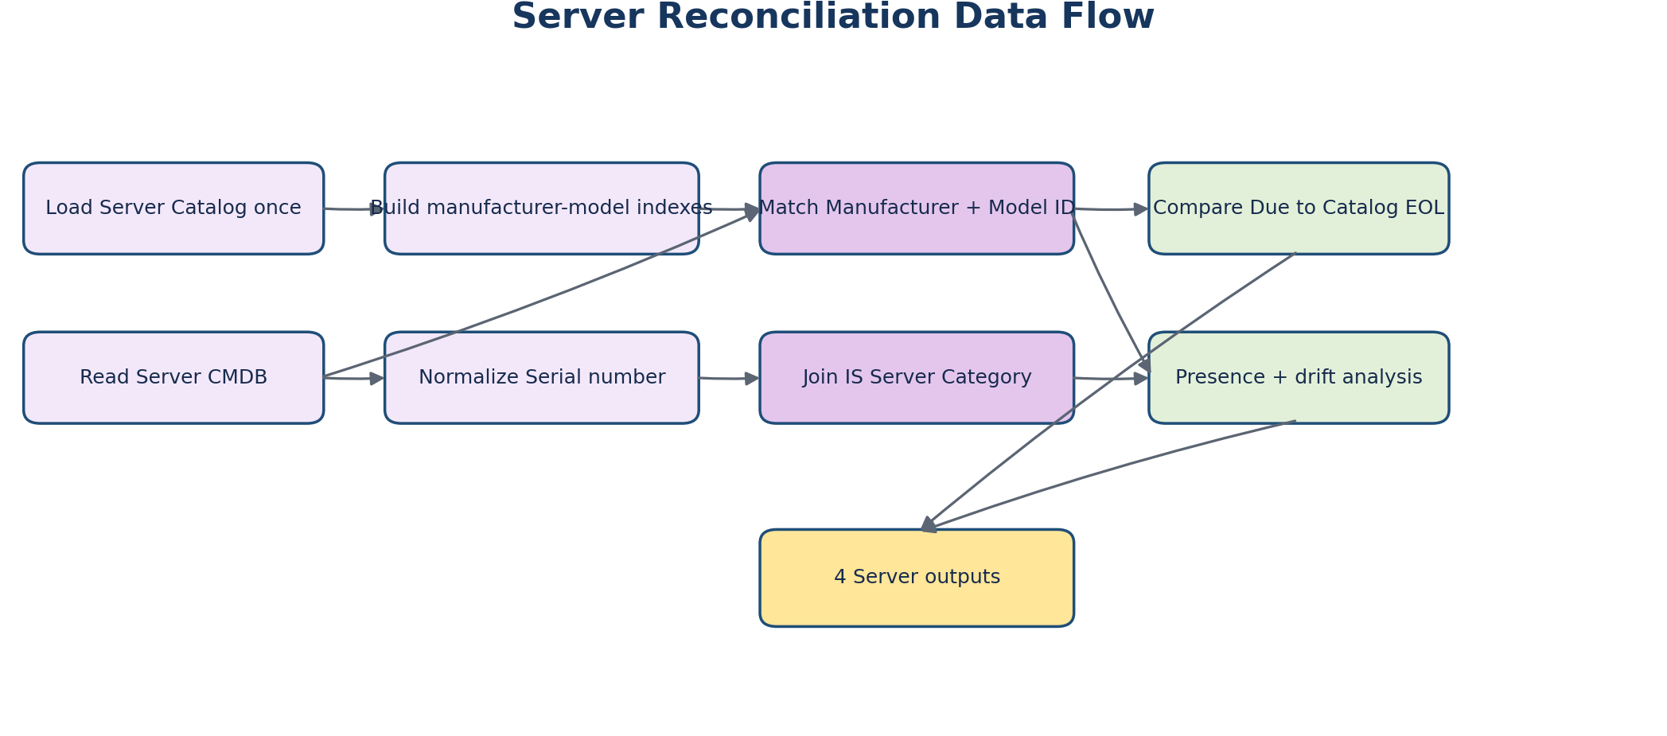
Figure 3. Server reconciliation processing sequence

7.1 Authoritative match relationship
Server-specific rule
Server CMDB provides Manufacturer and Model ID as the definitive catalog information. Model ID maps to catalog hardware_model and to IS server_hardware_model. The Server workflow does not require a CMDB Model number.

7.2 Catalog indexes and match priority
Priority / index | Key | Behavior
1. manufacturer_model_index | manufacturer + hardware_model | Exact Server match.
2. model_only_index | hardware_model | Fallback when the Model ID is unique.
Manufacturer review | Unique model but manufacturer differs | Partial match with explicit manufacturer review detail.
Ambiguous model | Same model resolves to different governed outputs | No match; create recommendation evidence.

7.3 Catalog-controlled server values
The required Server manufacturer, hardware type, hardware model and subcategory are always copied from the matched catalog row. CMDB virtualization indicators can support catalog recommendations, but they do not authorize a value that is absent from the supplied Server catalog.

8. Category coverage and load generation
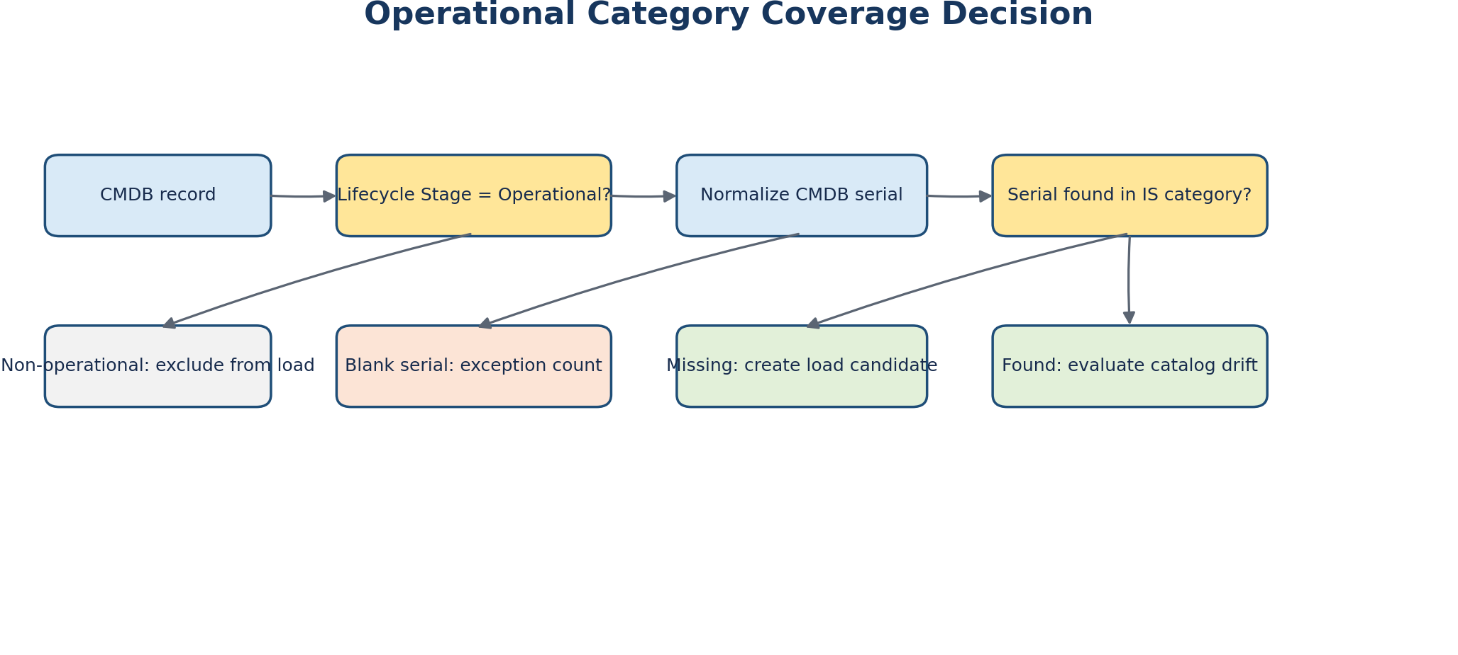
Figure 4. Operational category coverage decision path

8.1 Eligibility
Only records with Life Cycle Stage normalized to Operational enter category coverage load-candidate evaluation. Non-operational records remain visible in the catalog-match output but are excluded from the load candidate set.

8.2 Serial joins
Module | CMDB field | IS category field
Network | Serial number | network_serial_number
Server | Serial number | serial_number or server_serial_number

8.3 Load-file construction
The category report is the runtime template. V6 copies every category header in its original order and prepends CMDB reference columns. If a Mandatory/Optional metadata row is detected, V6 preserves that row and writes Reference under the prepended columns.
Network prefix columns | Server prefix columns
CMDB Hostname | CMDB Hostname
CMDB Serial Number | CMDB Serial Number
CMDB Model ID | CMDB Model ID
CMDB Model Number | Not applicable
CMDB Lifecycle Stage | CMDB Lifecycle Stage
CMDB Lifecycle Stage Status | CMDB Lifecycle Stage Status

Load safety rule
A missing operational device can appear in the load workbook even when no catalog match exists, but catalog-controlled target fields remain blank. The same record is also included in the catalog enhancement recommendations. This avoids inserting unsupported catalog values.

9. Category catalog drift analysis
For serials already present in the category report, V6 compares current IS values against required values from the catalog match. Drift is reported only when a valid catalog record exists.
Comparison | Network current field | Server current field | Required source
Manufacturer | network_manufacturer | server_manufacturer | Catalog manufacturer
Hardware type | network_hardware_type | server_hardware_type | Catalog hardware_type
Hardware model | network_hardware_model | server_hardware_model | Catalog hardware_model
Subcategory | network_subcategory | server_subcategory | Catalog subcategory

9.1 Retained existing identifiers
- Network drift output retains network_opaque_id and network_serial_number.
- Server drift output retains server_opaque_id and the existing server serial field.
- Both outputs show current values, required values, individual match indicators and a combined Required Action.

9.2 Required Action values
- UPDATE MANUFACTURER
- UPDATE HARDWARE TYPE
- UPDATE HARDWARE MODEL
- UPDATE SUBCATEGORY
- UPDATE MULTIPLE FIELDS: ...

10. Lifecycle date validation

10.1 Network
CMDB source | Catalog source | Validation
HW_End_Of_Life_Date | end_of_life_date | EOL status
HW_End_Of_Support_Date | end_of_support_date | EOSL status

10.2 Server
CMDB source | Catalog source | Validation
Due | end_of_life_date | Server hardware EOL status

10.3 Status semantics
- MATCH: both valid dates are equal.
- MISMATCH: both valid dates exist but differ.
- CMDB DATE MISSING: catalog has a valid date but CMDB is blank or unparseable.
- CATALOG DATE MISSING: CMDB has a valid date but catalog is blank or unparseable.
- CATALOG DATE NOT PUBLISHED: catalog contains the 2099-12-31 sentinel.
- CATALOG LEGACY PLACEHOLDER REVIEW: catalog contains the 1999-12-31 sentinel.
- BOTH BLANK: both values are blank or unparseable.

11. Output workbooks
Output | Purpose
NW_Catalog_Match.xlsx | Complete NW CMDB catalog outcome, dates, status, detail and category presence.
NW_Category_Load.xlsx | Operational NW devices missing from IS Network Category, using category headers.
NW_Category_Catalog_Drift.xlsx | Existing Network records whose catalog-controlled values need change.
NW_Catalog_Enhancement_Recommendations.xlsx | Network CMDB models that have no supported catalog match.
Server_Catalog_Match.xlsx | Complete Server CMDB catalog outcome and Due-to-EOL validation.
Server_Category_Load.xlsx | Operational Server devices missing from IS Server Category.
Server_Category_Catalog_Drift.xlsx | Existing Server records whose catalog-controlled values need change.
Server_Catalog_Enhancement_Recommendations.xlsx | Server manufacturer/Model ID combinations requiring catalog review.
Governance_Summary.xlsx | Run metrics and operational category coverage for executed modules.

12. GUI and execution flow
The V6 Tkinter window separates Network and Server inputs and supports independent or combined execution. An output-folder selector defines the destination for all generated workbooks.
Control | Behavior
Run Network | Requires only the three Network inputs.
Run Server | Requires only the three Server inputs.
Run Network + Server | Runs both modules sequentially into one output folder.
Open Output Folder | Opens the selected folder through the operating system.
Progress indicator | Shows that processing is active.
Status line | Shows run completion counts or failure state.

12.1 Supported input types and dependencies
Supported input types: CSV, XLSX, XLSM and XLSB. Python dependencies are openpyxl and pyxlsb. The generated outputs are XLSX workbooks.

13. Controls, exceptions and auditability
Control | Implemented behavior
No silent guessing | Ambiguous catalog outputs are returned as no match.
Catalog authority | Required governed values are copied from the matching catalog record.
Operational load gate | Only Lifecycle Stage = Operational enters load-candidate evaluation.
Blank serial protection | Operational blank-serial records are counted but cannot be joined or loaded normally.
Duplicate serial visibility | Duplicate normalized category serials receive an explicit presence status.
Unmatched evidence | CMDB identity and classification fields are written to recommendation reports.
Date sentinel awareness | 2099 and 1999 placeholders receive explicit statuses.
Schema resilience | Aliases and normalized headers reduce sensitivity to separators and case.

13.1 Failure behavior
The GUI validates that selected files exist and have supported extensions. Missing required columns raise a clear error naming the logical field and expected aliases. The traceback is displayed for technical diagnosis. Outputs are generated only after the corresponding module completes its in-memory analysis.

14. Performance and scalability
Catalogs and category serials are indexed once per module. Exact matches use dictionary lookup. Network fallback evaluates a candidate set assembled from type and token indexes rather than immediately applying full scoring to every catalog row. Category presence uses a normalized serial dictionary.
Data structure | Complexity intent
Exact catalog dictionaries | Near constant-time lookup per normalized key
Serial index | Near constant-time presence lookup
Partial token retrieval | Limits scoring to indexed candidates
Single catalog load | Avoids repeated file reads during CMDB iteration

The current XLSB reader materializes each candidate worksheet into memory while identifying headers. This is operationally simple but should be watched for exceptionally large binary workbooks.

15. Testing and acceptance criteria

15.1 Minimum functional tests
Test | Expected result
Network exact hardware_model | EXACT MATCH / EXACT HARDWARE_MODEL
Network composite examples | EXACT MATCH / EXACT TYPE + MODEL COMPOSITE
Network indexed partial ASA example | PARTIAL MATCH with supported catalog row
Server manufacturer + Model ID | EXACT MATCH
Server unique Model ID and manufacturer difference | PARTIAL MATCH / manufacturer review
Operational serial absent from category | Row appears in category load
Non-operational serial absent | Excluded from category load
Existing category values differ | Row appears in drift report
2099 catalog date | DATE NOT PUBLISHED status
Unmatched catalog input | Recommendation row generated
CSV/XLSX/XLSB equivalents | Same logical outputs

15.2 Data-quality edge cases
- Blank and placeholder serial numbers.
- Duplicate normalized serials.
- Catalog duplicates producing identical versus conflicting outcomes.
- Model values separated by hyphen, underscore, slash or spaces.
- Blank lifecycle dates and invalid date text.
- Category reports with and without a requiredness metadata row.
- Very wide category schemas, preserving original header order.

16. Operational runbook

16.1 Prerequisites
- Install Python with Tkinter support.
- Install dependencies: pip install openpyxl pyxlsb.
- Have the applicable catalog, CMDB and IS category reports available.
- Select a writable output folder.

16.2 Network run
- Select NW Product Catalog.
- Select NW CMDB Report.
- Select IS Network Category Report.
- Select output folder.
- Choose Run Network.
- Review catalog-match, load, drift, recommendation and summary workbooks.

16.3 Server run
- Select Server Product Catalog.
- Select Server CMDB Report.
- Select IS Server Category Report.
- Select output folder.
- Choose Run Server.
- Review catalog-match, load, drift, recommendation and summary workbooks.

16.4 Review sequence
Recommended review order: Governance Summary, Catalog Match, Catalog Enhancement Recommendations, Category Load, then Category Catalog Drift. Catalog recommendations should be resolved before unsupported rows are approved for a category load.

17. Limitations and enhancement roadmap
Area | Current V6 behavior | Recommended enhancement
Output versioning | Uses fixed filenames in selected folder | Add independent same-day V1/V2 counters per output type.
Run manifest | Summary contains metrics only | Add input filename, size, hash, rule version and timestamp.
Logging | GUI shows status and traceback | Add structured log workbook or JSON run log.
Large XLSB | Worksheet rows materialized in memory | Introduce streamed/optimized binary handling if needed.
Category load completeness | Populates core catalog and serial fields | Add controlled mapping configuration for additional mandatory attributes.
Automated publication | Not implemented | Keep gated behind approval and enterprise action tooling.
Configuration | Aliases reside in code and JSON reference | Make field_list_mapping_index.json the runtime policy source.

18. Appendices

Appendix A. Matching decision register
Decision | Approved V6 design
Network identity | CMDB Model number drives catalog matching.
Server identity | CMDB Manufacturer + Model ID drives catalog matching.
Server Model number | Not used; field is not required.
Category identity | Normalized serial number.
Load eligibility | Lifecycle Stage = Operational only.
Catalog values | No manufacturer/type/model/subcategory outside supplied catalog.
Network dates | CMDB EOL/EOSL compared with catalog EOL/EOSL.
Server date | CMDB Due compared with catalog EOL.
Load templates | Derived from category report headers and ordering.
Date display | Short date mm/dd/yyyy.

Appendix B. Source basis
- unified_hw_catalog_governance_v6.py, generated implementation baseline.
- field_list_mapping_index.json, consolidated logical schema and mapping index.
- Field List and Mapping.xlsx, field inventory and explicit mapping workbook.
- Network and Server product catalog extracts, CMDB reports and IS category reports reviewed during design.
- WPP_Enterprise_CMDB_Inventory_Services_V5_2_Architecture_and_Logic_Design.docx, prior architecture principles and decision baseline.

Appendix C. Installation and launch
Install: pip install openpyxl pyxlsb
Launch: python unified_hw_catalog_governance_v6.py

