**Software Installations required:**

1. Maven
2. Eclipse
3. MySql workbench
4. Node JS
5. Angular CLI
6. Chrome Driver
7. Java 1.8

**Setting up Maven:**

1. Extract the maven from resources folder to program files
2. Place the below system environment variable
3. Ensure Java home set correctly
4. Fire the below command to ensure maven installed properly or not. (**mvn -version**)
5. 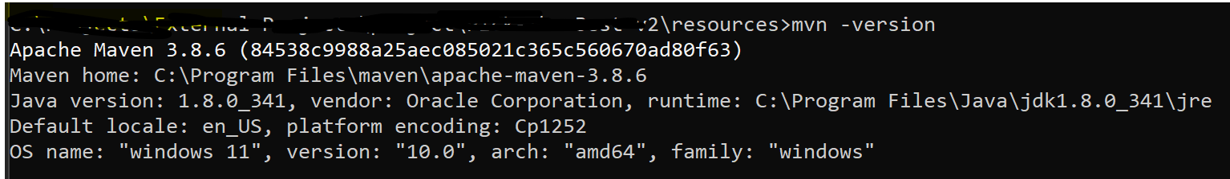

Setting up Node JS:

1. Extract the node js folder from resources folder to your resources folder
2. 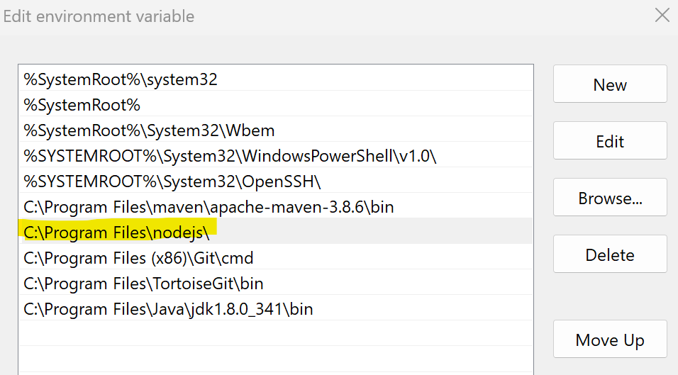Set the environment variable as below
3. Once you save the environment variable fire the below command in command prompt. The output should be similar (**node -v**)
4. 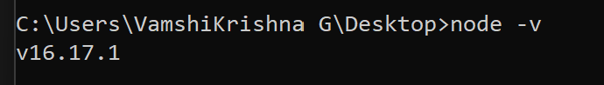

Setup Anular CLI

1. Open new command prompt
2. Fire the below command
3. **npm install -g @angular/cli**
4. With this if program finish properly means your angular set up is ready

MySql workbench:

1. Download mySql community server and complete the set up
2. <https://dev.mysql.com/downloads/mysql/>

Selinium Driver:

1. If your chrom browser version is 105 you can use the driver present in the resources folder (check in help -> about google chrome)
2. If not download from below url as per your browser version
3. <https://chromedriver.chromium.org/downloads>

Setting up the database:

1. Open mysql work bech and connect to server.
2. Navigate as server -> Data Import
3. 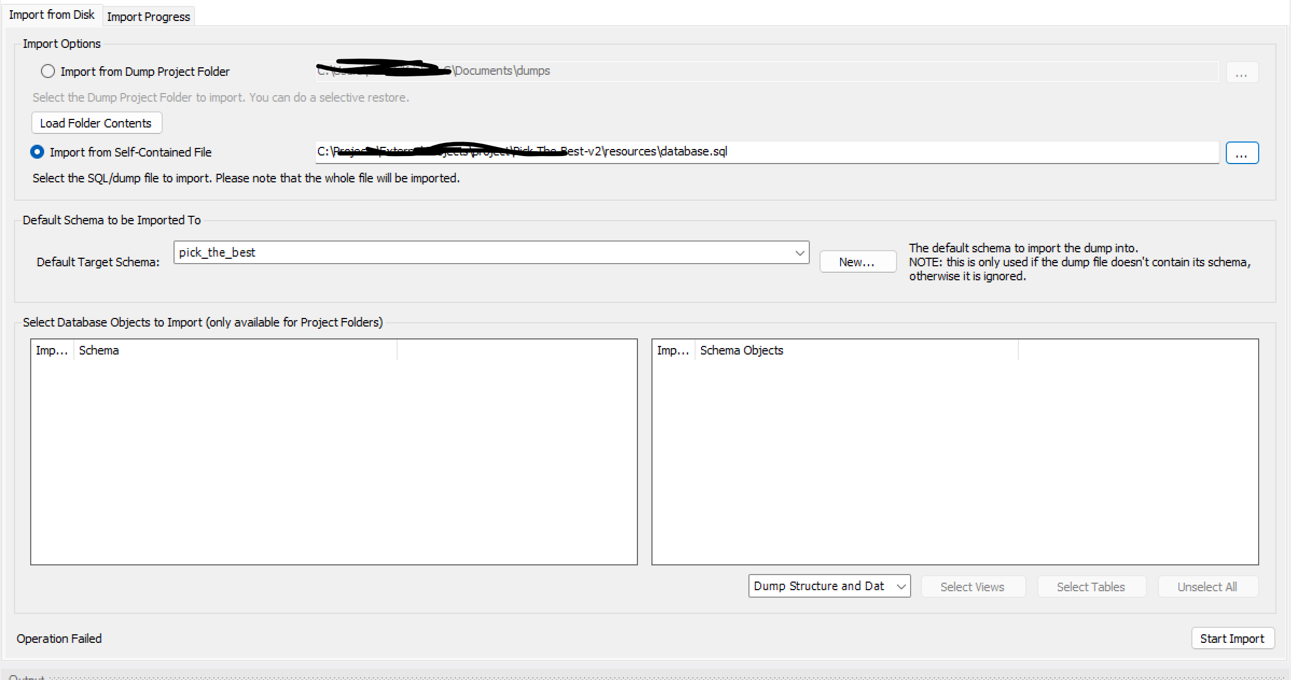
4. Choose import from self contained file and select data.sql file present in resources folder
5. Click on new and enter pick_the_best then click on data import.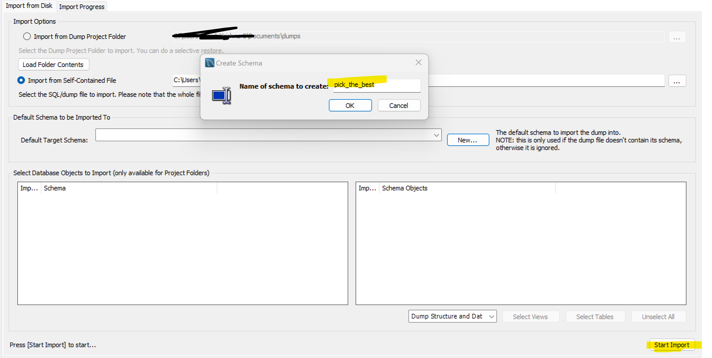
6. Everything went well you should see below message.
7. 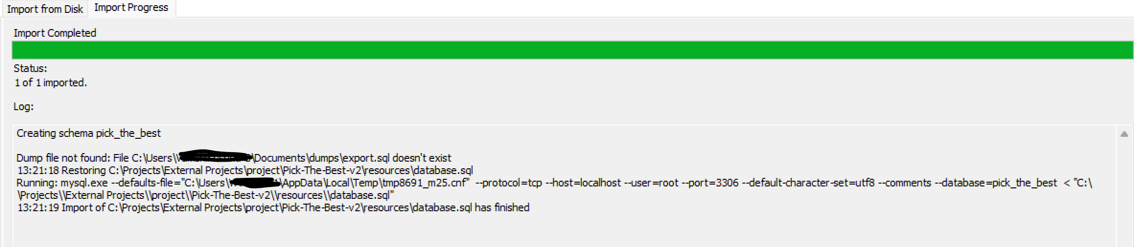

Clone the project:

1. Navigate to folder where you want to set up the app
2. Clone the project with command git clone <https://github.com/vikramthakkallapally/project.git>

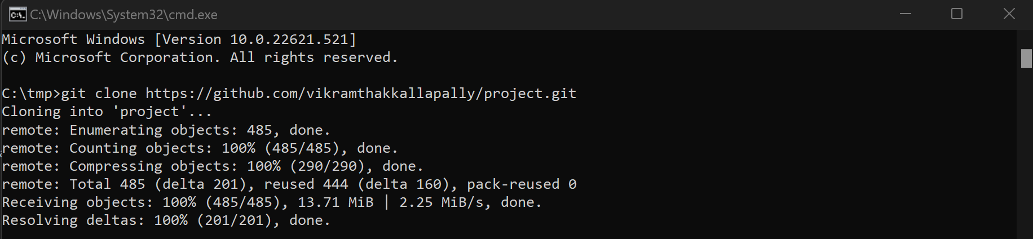

1. Navigate to front end and open a new command prompt. Run command npm install.

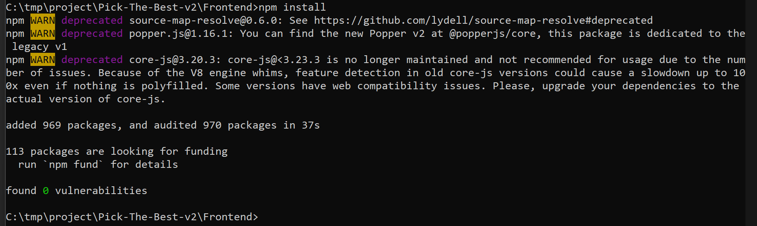

1. Navigate to backend till src Pick-The-Best-v2\Backend\ecom\src\main\resources folder
2. Open application. properties folder
3. Replace the database details remove curly braces too

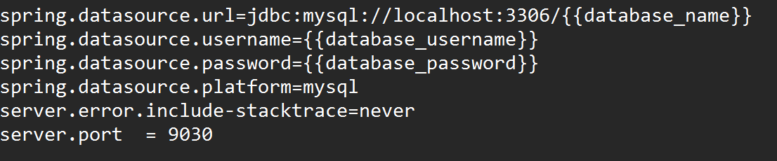

1. Replace the smtp details. Yopu can get them here [https://hotter.io/docs/email-accounts/app-password-gmail/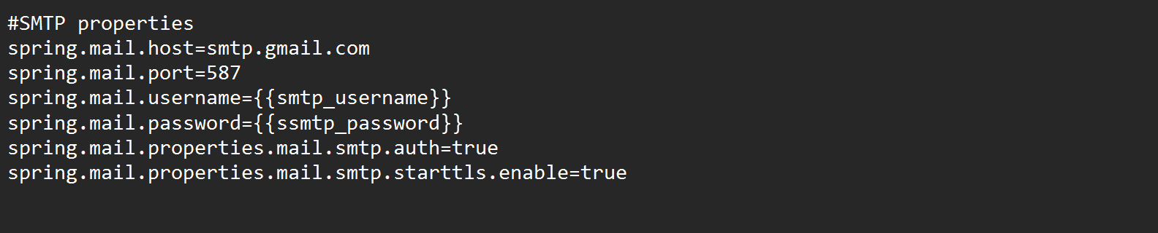](https://hotter.io/docs/email-accounts/app-password-gmail/#)
2. Navigate to the path shown in below cmd and fire command mvn clean install

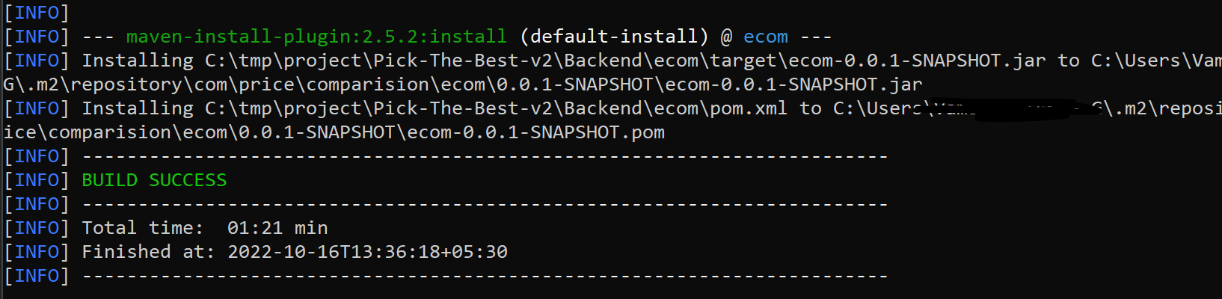

1. Once build complete Navigate to front end and fire ng serve command

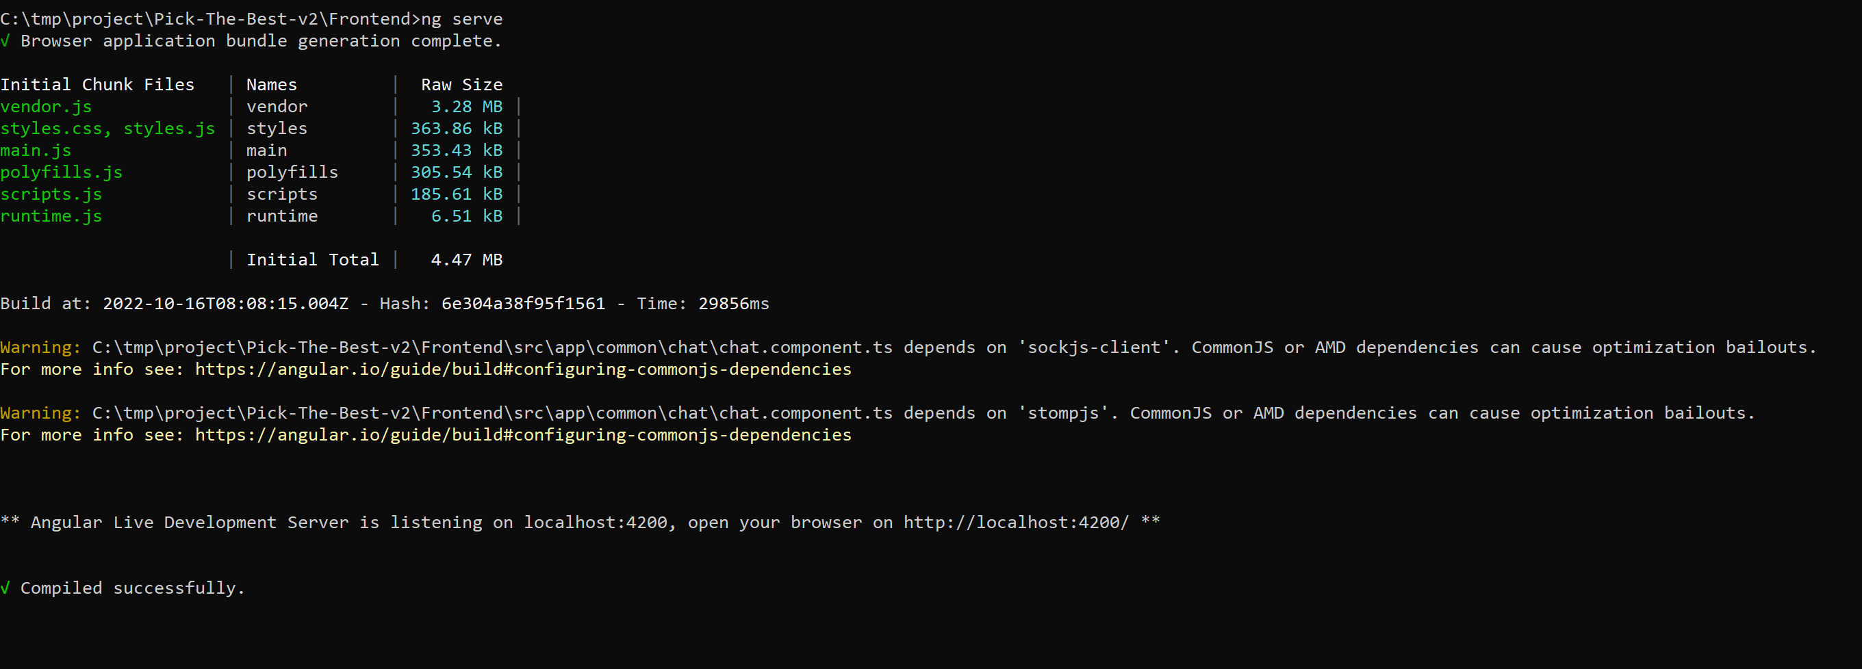

Your application running on <http://localhost:4200>. Open same on browser you should see the pick the best login page.

1. Now open the eclipse

File -> import -> Existing maven project -> browse the project and click on ecom folder ->finish

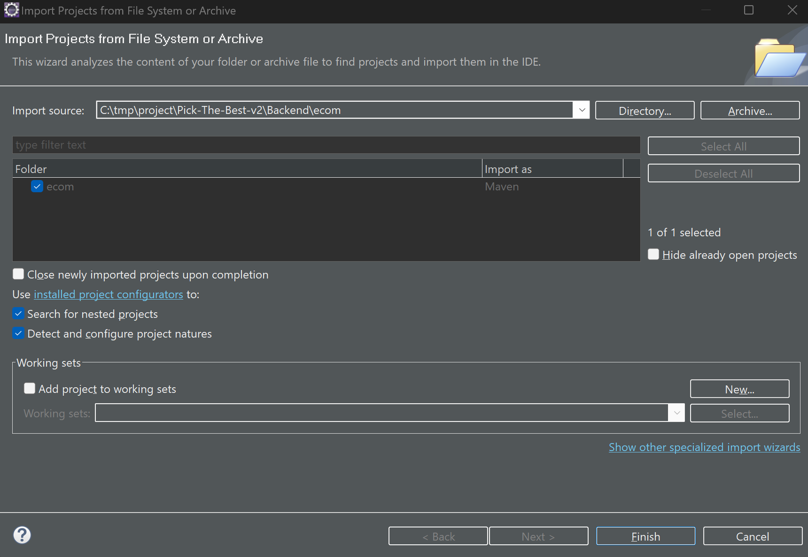

1. Open **SeliniumConfig.java** file and replace the highlighted path with the path where chrome driver present.

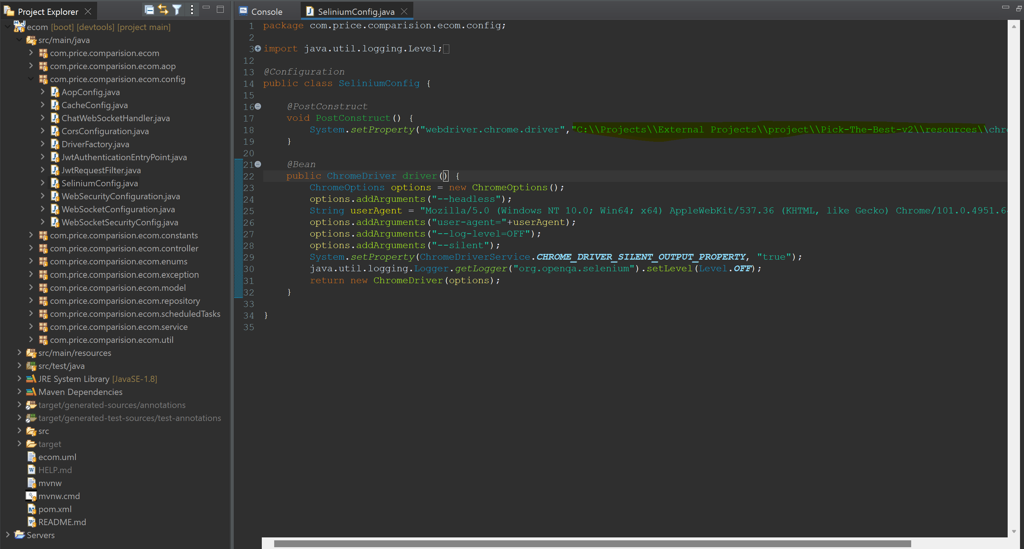

1. Open **DriverFactory.java** file and replace the path as above.

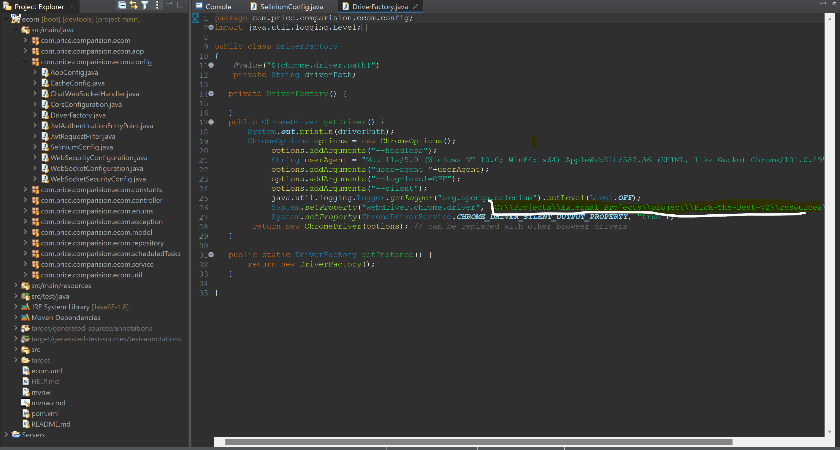

1. RightClick on EcomApplication.java -> Run As -> Java Application
2. 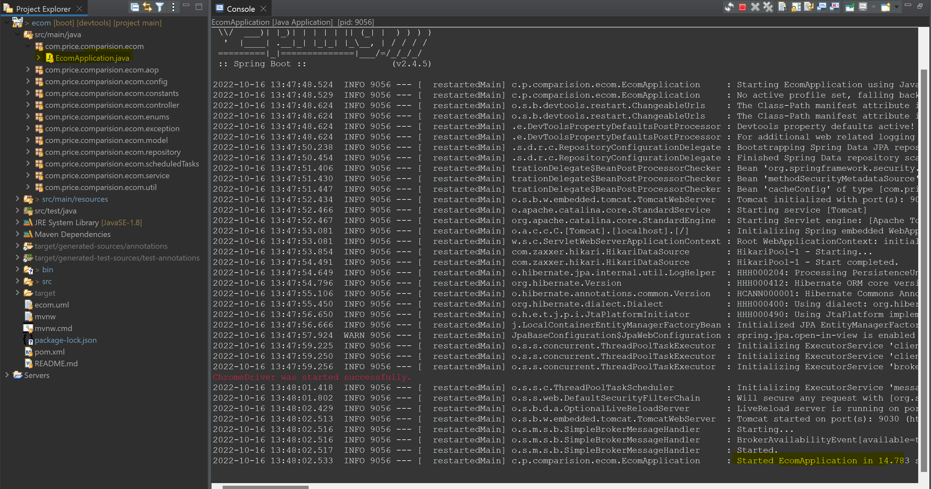

Now you can login with below credentials

user1, user2, admin1 and admin2. Password will be admin@123.