**PROTIMER**

Hardware Design Document

|  |  |  |
| --- | --- | --- |
| Date | Owner | Remarks |
| 14-Apr-2025 | Vikrant Sugandhi |  |
|  |  |  |

|  |  |  |  |  |  |
| --- | --- | --- | --- | --- | --- |
| Created  Date | Created  By | Review  Date | Reviewed  By | Ver | Remarks |
| 14-Apr-2025 | Vikrant Sugandhi |  | Kavya C S | 0.1 | Draft version |
|  |  |  |  |  |  |
|  |  |  |  |  |  |
|  |  |  |  |  |  |
|  |  |  |  |  |  |
|  |  |  |  |  |  |

Table of Contents

1. Scope/Purpose 3

2. Hardware System Block Diagram 3

3. Schematics Overview 4

4. Interface Pin Mapping Table 4

5. PCB Stack-up & Layer Info 4

6. PCB Design Guidelines & Constraints 5

7. Power Budget Table 5

8. Signal Integrity & Noise Margin Analysis 5

9. Mechanical Drawings 6

10. Compliance & Safety Notes-- 6

11. References 6

Figure 1: Block Diagram 4

# Scope/Purpose

This document defines the hardware design for PROTIMER including system-level block diagram, schematics, PCB design guidelines, mechanical constraints, interface mapping, and compliance considerations.

It gives detailed documentation specific to hardware: schematics, PCB layout notes, BoM, physical dimensions, interfacing constraints.

Contents:

* Detailed schematics
* PCB layout constraints and stack-up
* Power budgeting
* Thermal design considerations
* Mechanical enclosure constraints
* Firmware interface pin mappings
* Compliance/EMC notes
* Test points and debugging ports

Audience:

Hardware design engineer, firmware engineer (for pin maps), and mechanical team.

# Hardware System Block Diagram

*Clear, labeled block diagram of major functional blocks:*

* MCU / ESP32
* RTC
* Audio Playback Module
* Rotary Encoder
* Push Button
* Power/Battery management
* USB/Charging
* Speaker
* Connectivity (WiFi/BT)

(This helps firmware/app engineers understand hardware interconnections.)

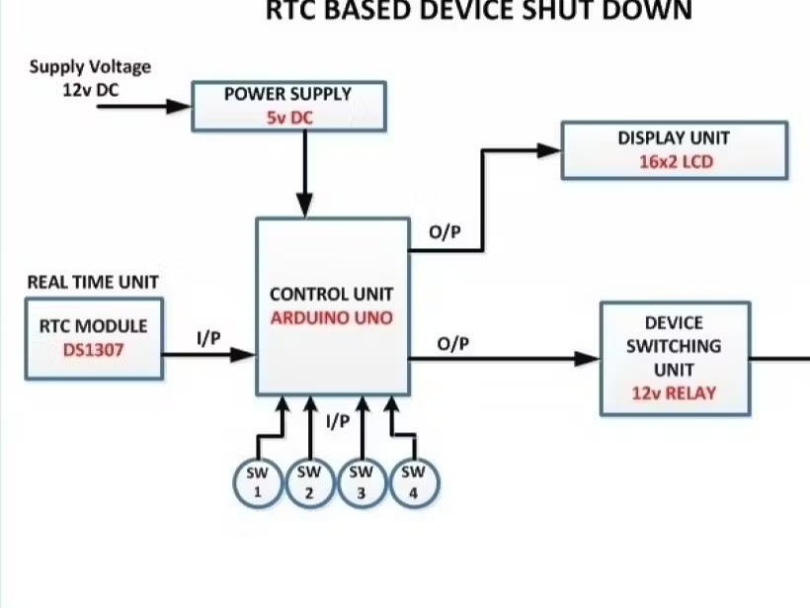

Figure 1: Block Diagram

# Schematics Overview

List of schematic pages / sections

Key highlights or design notes

e.g. “RTC battery backup enabled”, “ADC channel on GPIO36 for battery voltage”, etc.

# Interface Pin Mapping Table

|  |  |  |
| --- | --- | --- |
| Function | MCU Pin | Description |
| Speaker Out | GPIO25 | DAC output to amplifier |
| Rotary A | GPIO32 | Encoder signal A |
| Rotary B | GPIO33 | Encoder signal B |
| Button Top | GPIO27 | Active low push button input |
| RTC SDA/SCL | GPIO21/22 | I2C interface |
| DFPlayer RX/TX | GPIO16/17 | UART for audio module |
| USB VBUS Sense | GPIO36 | Detect external power connection |

# PCB Stack-up & Layer Info

* Number of layers
* Proposed stack-up (e.g. Top, Ground, Power, Signal, Bottom)
* Impedance control notes (if needed)

# PCB Design Guidelines & Constraints

To be shared with CAD engineer.

|  |  |
| --- | --- |
| Constraint Type | Value / Note |
| Min trace width | 6 mil (adjust per fab capability) |
| Min spacing | 6 mil |
| Ground pour strategy | Solid fill with stitched vias |
| Analog/Digital split | Separate return paths for analog audio |
| Via type | Through hole, micro via if needed (note limits) |
| Component placement | Audio DAC & amp near speaker driver |
| Power trace width | 20 mil min for >300mA |
| USB D+/D- routing | Differential, length matched within 0.25mm |
| RTC backup battery area | Keep isolated from high current traces |

# Power Budget Table

|  |  |  |
| --- | --- | --- |
| Block | Operating Current (mA) | Idle Current (mA) |
| ESP32 | 160 | 20 |
| RTC DS3231 | 0.2 | 0.002 |
| DFPlayer Mini | 30 | 0.5 |
| Rotary Encoder | Negligible | Negligible |
| Speaker (during playback) | 250 | 0 |
| Vibration Motor (optional) | 80 | 0 |

Note: Estimate total consumption and battery size accordingly.

# Signal Integrity & Noise Margin Analysis

This ensures logic levels from each source have clean noise margins against thresholds.

DC Analysis Example

|  |  |  |  |  |  |  |
| --- | --- | --- | --- | --- | --- | --- |
| Signal | VOH(min) | VIH(min) | VOL(max) | VIL(max) | Margin High (VOH-VIH) | Margin Low (VIL-VOL) |
| I2C SDA/SCL | 3.0V | 2.2V | 0.4V | 0.8V | 0.8V | 0.4V |
| GPIO button | 3.3V | 2.4V | 0V | 0.8V | 0.9V | 0.8V |
| UART TX/RX | 3.0V | 2.0V | 0.4V | 0.8V | 1.0V | 0.4V |

AC Analysis Example

For critical high-speed or sensitive lines (like audio or USB D+/D-):

|  |  |  |  |  |  |
| --- | --- | --- | --- | --- | --- |
| Signal | Max Ringing (mV) | Max Overshoot | Rise Time (ns) | Fall Time (ns) | Result |
| USB D+ | 100 | 3.5V (3.3V typ) | 3 ns | 3 ns | Pass |
| Audio DAC out | 50 | 3.4V | 10 ns | 10 ns | Pas |

Note: Use simulation tools like:

* LTspice / TINA-TI for simple circuits
* Allegro SI / HyperLynx for board-level

# Mechanical Drawings

* 2D dimensioned drawings
* 3D enclosure overview
* Critical cut-outs / mounting points / button positions

# Compliance & Safety Notes--

* Maximum current, temperature
* ESD precautions
* Audio output limits
* Li-ion charging safety compliance
* RoHS / CE mark plan

# References

1. PROTIMER-Product_Idea_And_Planning.docx
2. PROTIMER- PRD.docx
3. PROTIMER-PRD Matrix.docx
4. PROTIMER-Engineering_Collaboration_And_Handoff_Document.docx
5. PROTIMER-Product_Architecture Document.docx
6. Signal Integrity & Noise Margin Analysis.xlxs
7. PCB Design Guidelines & Constraints.xlxs
8. PROTIMER-Schematics.pdf