Can a methane detector see carbon monoxide?
Every result from the 2019 run, and how to read it
Vikrant Tomar · ARIES, Nainital
Companion document to the code in this repository. Written for a reader who is curious but not a specialist — no atmospheric chemistry or machine learning assumed.

The short version
Satellites can see plumes of gas from space. A group at SRON in the Netherlands built a machine-learning system that automatically finds plumes of methane in satellite images. We asked a simple question: if that system was only ever taught to recognise shapes, does it also work on a completely different gas — carbon monoxide?
The answer is not a simple yes or no — and what sits in between is the useful part.
What we found
The model works on a gas it was never trained on. It only ever learned from methane images, but when we showed it carbon monoxide it still picked out the large Indian steel plants — they stand out clearly against the air around them.
It also reacts to picture quality, not just to plumes. When a scene had many cloud gaps, the score dropped. That effect turned out to be about three times stronger than the effect of a steel plant actually being there.
European plants did not stand out at all — no better than our empty control sites. But other researchers did successfully measure those same plants, in the same year, by averaging a whole year of data instead of looking at single images. So the plants are not silent; a single image is simply not enough to see them.
Taken together, that is the real result — and it is more useful than a clean success would have been. It tells you exactly what a carbon monoxide detection system still needs, and why.

1. What a satellite actually sees
A satellite called Sentinel-5P circles the Earth roughly fourteen times a day. On board is an instrument, TROPOMI, built partly by SRON, which measures how much sunlight of each colour comes back off the planet. Different gases absorb different colours, so from that reflected light you can work out how much of a given gas sits in the column of air between the ground and space.
It does this for a patch of ground about 7 kilometres across. So you end up with something like a photograph, except each pixel holds a gas amount rather than a brightness.
When a factory releases gas, the wind smears it downwind into a shape — wider and fainter as it travels. From above it looks a bit like steam drifting off a kettle, seen from the ceiling. That characteristic smear is what a plume detector is looking for.

Why carbon monoxide is worth chasing
Carbon monoxide is produced whenever something burns incompletely. Steelmaking is unusually good at making it: blast furnaces deliberately use carbon monoxide to strip oxygen out of iron ore, and some always escapes. A steel plant emits roughly six times more carbon monoxide per unit of carbon dioxide than the industrial average.
That makes it a useful fingerprint. Carbon dioxide is hard to see from space because the background is enormous and a single plant barely moves it. Carbon monoxide has a much lower background, so a plant can stand out — and because the two are emitted together, seeing the carbon monoxide gives you a handle on the carbon dioxide you cannot see.

Why reuse a methane model
Teaching a computer to recognise plumes needs thousands of labelled examples, and someone has to look at every one of them. That work has already been done for methane. It has not been done for carbon monoxide.
But the methane model was never told it was looking at methane. It was shown small square images and asked whether the pattern looked plume-like. If those images are stripped of their units first, the model genuinely cannot know which gas it is reading. So it might just work on another one.

2. The trick that makes the swap possible
Methane and carbon monoxide sit at completely different amounts in the air, and vary differently from day to day. Feeding raw carbon monoxide numbers to a model trained on methane numbers would be like handing a thermometer reading to someone expecting a bank balance.
The fix is to throw away the units before the model ever sees the image. For each scene we find the middle value, subtract it, and divide by how spread out the rest of the values are. What comes out is not “parts per billion of anything” — it is simply how unusual each pixel is compared with its neighbours.
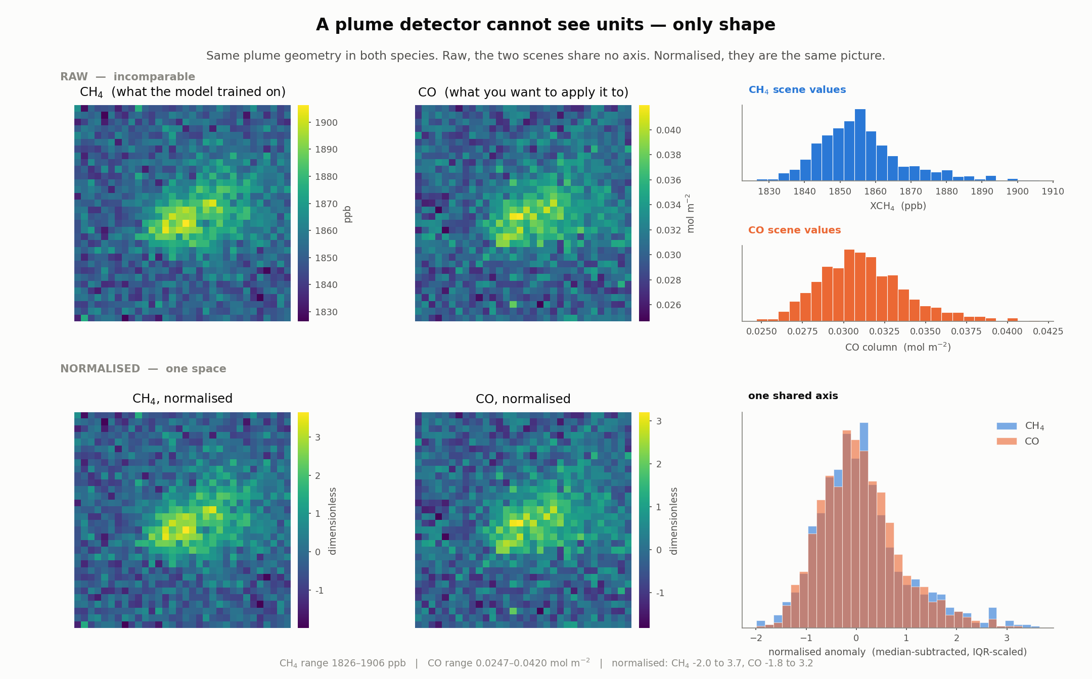
Top row: the same plume as methane and as carbon monoxide, raw — they cannot even share an axis. Bottom row: after normalising, they are statistically the same picture.
The numbers underneath are worth a moment. The same plume is a 2.8% bump above background in methane, and a 35.5% bump in carbon monoxide. After normalising, both peak at about 3.2 to 3.7.
The asymmetry, and why it does not mean CO is easier
A 35% bump sounds far easier to spot than a 3% one. It is not. Carbon monoxide's background moves around much more from day to day, and fires put plume-shaped carbon monoxide almost everywhere. The difficulty moves from finding the plume to deciding what it is.
There is a second catch. Dividing by the spread means a calm, clean day gets stretched and a busy, variable day gets squashed. It makes the comparison possible and distorts it at the same time.

3. What we trained, and what we collected
The model is small by modern standards: about 590,000 adjustable numbers, arranged as two pattern-finding layers followed by two decision layers. It reads a 32 by 32 pixel square — roughly 220 kilometres on a side — and returns a single number between 0 and 1: how plume-like does this look?
Before trying anything new, we checked the model on methane — the gas it was built for.
Out of every 100 real plumes, it found 97.
Out of every 100 things it flagged, 96 were genuine plumes.
These scores match the ones reported in the original paper. That was the point of the check: it told us our rebuilt copy of the model was working properly. So if something looked strange later with carbon monoxide, we would know it was about the gas — not about a model we had built wrong.
Then, without retraining a single thing, we pointed it at carbon monoxide over 26 places in four groups:
Group | Sites | Why
Indian steel plants | 13 | Large, poorly monitored, no public facility reporting
European steel plants | 7 | Emissions already published — the honest test
Indian cities | 3 | Big but diffuse: traffic, cooking, industry
Empty places | 3 | Sahara, open Pacific, a clean Himalayan site
That last group matters most. If a detector lights up over the middle of the Sahara, it is finding faults in the data, not gas in the air.

What we actually got
Quantity | Value
Tiles collected | 335, from 26 sites on 18 days across 2019
Site-days attempted | 468 — so 28% were dropped, mostly to cloud
Usable pixels per tile | 81% on average
CO range | 0.0222 to 0.0590 mol m⁻² (1st to 99th percentile)
Nitrogen dioxide available | 333 of 335 tiles
MODIS fire signal present | 128 of 335 tiles
Every site was sampled on the same 18 days, so no region got only its clear season. Hold on to the 28% figure — it comes back to matter.

4. What 335 tiles look like
Before any statistics, it is worth simply looking at the pictures the detector is being handed.
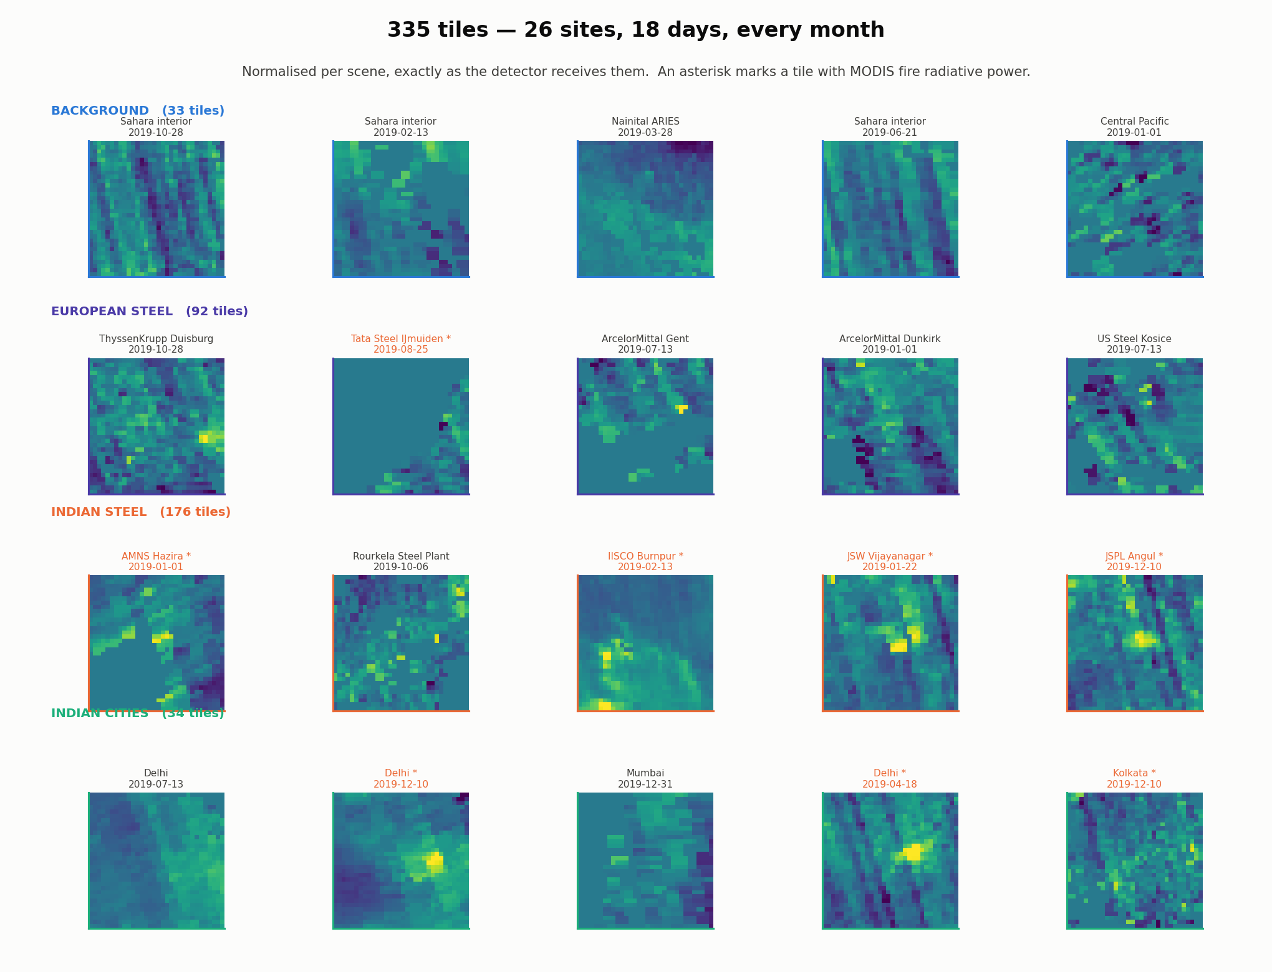
A sample of the 335 tiles, normalised, exactly as the detector receives them. Rows are the four groups; an asterisk marks a tile where MODIS saw a fire.
Two textures keep recurring, and both matter.
- Compact bright cores near the middle, sometimes with a tail. These are plumes. Bhilai and Rourkela show the clearest examples.
- Regular diagonal banding running corner to corner. This is not atmosphere — it is an instrument artefact. The satellite scans in strips, and small differences between detector columns leave stripes; the re-gridding turns them diagonal.
The striping is the awkward one. A stripe is straight, elongated and coherent — which is also a fair description of a plume. This is exactly the class of false alarm that the published method needs a whole second stage to reject, and it turned up in our own data on the first day.

5. A sanity check that passed
Before asking whether the detector works, ask whether the data is real. If the underlying carbon monoxide amounts do not line up with what we already know about the world, nothing built on top of them will mean anything.
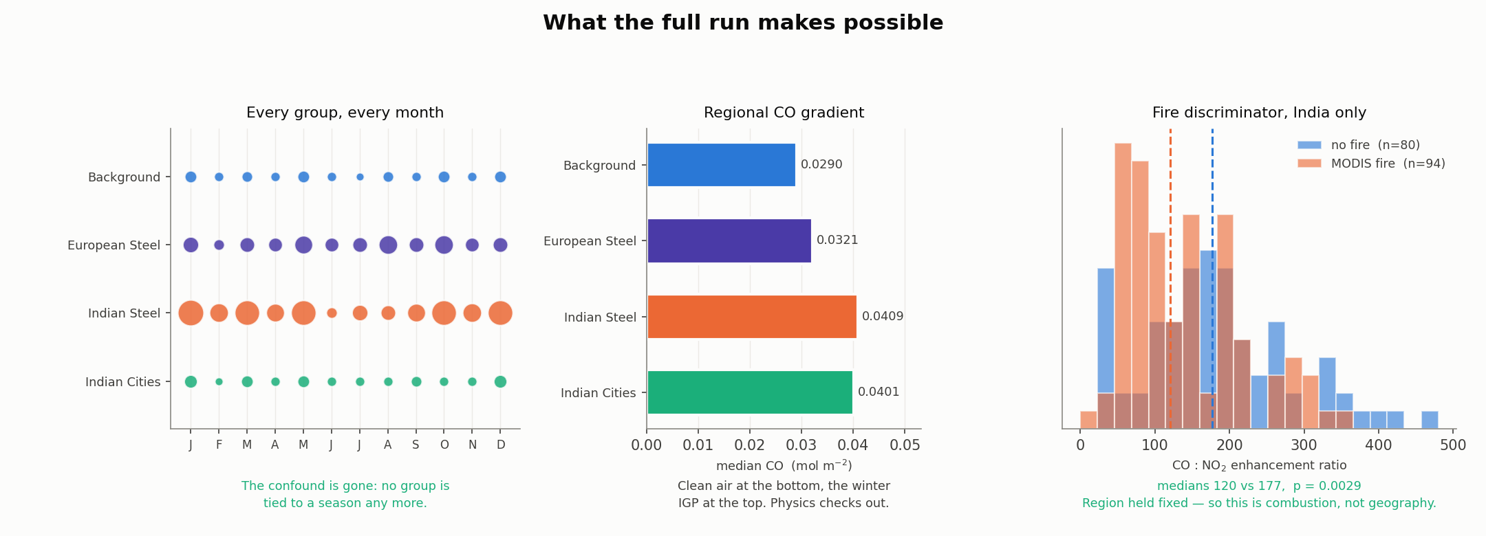
Left: every group appears in every month, so region is not confounded with season. Middle: the regional carbon monoxide gradient. Right: the fire discriminator over India.
The middle panel is the reassuring one. Median carbon monoxide by group:
Group | Median CO (mol m⁻²) | Reading
Empty controls | 0.0290 | Clean marine and desert air
European steel | 0.0321 | Moderately polluted continental air
Indian cities | 0.0401 | Indo-Gangetic Plain
Indian steel | 0.0409 | Same, plus local industry
Nothing here is surprising, and that is precisely the point — it tells you the pipeline is sound. Clean air at the bottom, the winter Indo-Gangetic Plain at the top.
The right-hand panel tests the fire filter. Scenes where MODIS saw an active fire have a median carbon monoxide to nitrogen dioxide ratio of 120; scenes without, 177 (p = 0.003, with region held fixed so it is not geography). That is the direction the physics predicts: actively flaming fires burn efficiently and make relatively more nitrogen dioxide.
Be precise about what the fire result means
This shows the ratio tracks how efficiently something is burning, as van der Velde's framework predicts. It does not by itself separate industry from fire, because furnaces also burn hot. That separation needs the ratio plus knowing a fire was actually there.

6. The ranking, site by site
Here is the raw output — every site, ranked by its average score across the year. This is the table that looks like a result, and it is the one to be most careful with.
# | Site | Mean score | Scenes | Usable data
1 | IISCO Burnpur | 0.840 | 15 | 94% Indian steel
2 | Bokaro Steel Plant | 0.779 | 17 | 91% Indian steel
3 | Bhilai Steel Plant | 0.735 | 14 | 90% Indian steel
4 | Durgapur Steel Plant | 0.718 | 15 | 94% Indian steel
5 | Rourkela Steel Plant | 0.695 | 16 | 91% Indian steel
6 | Tata Steel Jamshedpur | 0.659 | 15 | 92% Indian steel
7 | Tata Steel Kalinganagar | 0.561 | 14 | 92% Indian steel
8 | JSPL Angul | 0.514 | 15 | 93% Indian steel
9 | JSPL Raigarh | 0.461 | 15 | 91% Indian steel
10 | Kolkata | 0.369 | 15 | 88% Indian city
11 | Delhi | 0.357 | 13 | 83% Indian city
12 | Nainital ARIES | 0.300 | 15 | 84% Control
13 | Central Pacific | 0.296 | 3 | 79% Control
14 | ThyssenKrupp Duisburg | 0.276 | 12 | 76% European steel
15 | JSW Vijayanagar | 0.257 | 12 | 81% Indian steel
16 | US Steel Kosice | 0.246 | 17 | 74% European steel
17 | Vizag Steel RINL | 0.174 | 12 | 82% Indian steel
18 | ArcelorMittal Gent | 0.168 | 13 | 69% European steel
19 | AMNS Hazira | 0.144 | 8 | 63% Indian steel
20 | ArcelorMittal Gijon | 0.108 | 11 | 70% European steel
21 | ArcelorMittal Taranto | 0.061 | 13 | 67% European steel
22 | ArcelorMittal Dunkirk | 0.056 | 14 | 54% European steel
23 | Tata Steel IJmuiden | 0.055 | 12 | 61% European steel
24 | Sahara interior | 0.030 | 15 | 82% Control
25 | JSW Dolvi | 0.011 | 8 | 66% Indian steel
26 | Mumbai | 0.006 | 6 | 69% Indian city
All 26 sites ranked by mean plume score. The right-hand column is the share of each tile that contained real data.
The top of the list is encouraging: eight of the top nine are Indian steel plants, with the two big Indian cities just below them. Read no further and you would conclude the detector works beautifully.
But four entries should stop you.
- IISCO Burnpur is first, at 0.840. It makes about 2.5 million tonnes of steel a year — roughly a quarter of Tata Jamshedpur, which is sixth. It also sits in the middle of the Durgapur–Asansol industrial belt, 30 km from another steel plant on the list, surrounded by coal power stations.
- Nainital and the Central Pacific — two of our deliberately empty control sites — score 0.300 and 0.296, above ThyssenKrupp Duisburg at 0.276. Duisburg is the largest steelworks in Europe.
- JSW Dolvi is 25th out of 26, at 0.011. It produces about ten million tonnes of steel a year. Mumbai, a city of twenty million people, is last.
- The Sahara, which should be dead last, is 24th — above two working steel plants.
None of that is believable as a statement about emissions. So the question becomes: what else could these scores be tracking?

7. The scores are partly grading the weather
Look again at the last column of that table. The top of the list runs at 90–94% usable data. The bottom runs at 54–70%.
The mechanism
Satellites cannot see through cloud, and the carbon monoxide measurement needs sunlight reflected off a bright surface. Where it fails, the image has a hole in it.
Our code fills those holes with zeros before showing the image to the model.
A patch of zeros is perfectly flat, and a flat patch contains no plume shape at all.
So an image with many holes is pushed towards a low score no matter what is underneath it.
The size of this effect is much larger than expected. Across the 26 sites, average score and fraction of usable data move together with a correlation of 0.87 — close to a straight line. Within the Indian sites alone it is still 0.81. Across all 335 individual tiles it is 0.58.
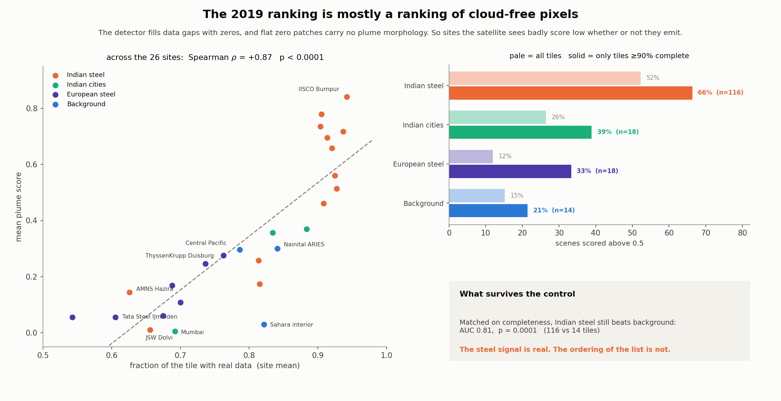
Left: each dot is one site. Almost all the spread in the ranking is explained by how much usable data the satellite got. Right: what happens when you compare only the clearest images.
The three sites at the bottom — JSW Dolvi, Mumbai, AMNS Hazira — are all coastal. The sea is dark at the wavelengths this measurement uses, so the retrieval mostly fails over water. Half of each of those images was missing. Their low scores say nothing at all about their emissions.
The honest fix is to stop comparing images of different quality. Keep only images at least 90% complete and the comparison becomes fair:
Group | All images | Clearest only
Indian steel | 52% | 66%
Indian cities | 26% | 39%
European steel | 12% | 33%
Empty control sites | 15% | 21%
Share of images the detector flagged as containing a plume.
The ordering survives and the gap between real sources and empty places widens. Matched this way, Indian steel separates from the control sites with an accuracy of 0.81 — less than one chance in ten thousand of arising by luck.

8. What the detector throws away
Anyone can show the cases where a method works. What it rejects tells you what it has actually learned — so here are the sixteen lowest-scoring scenes in the whole set.
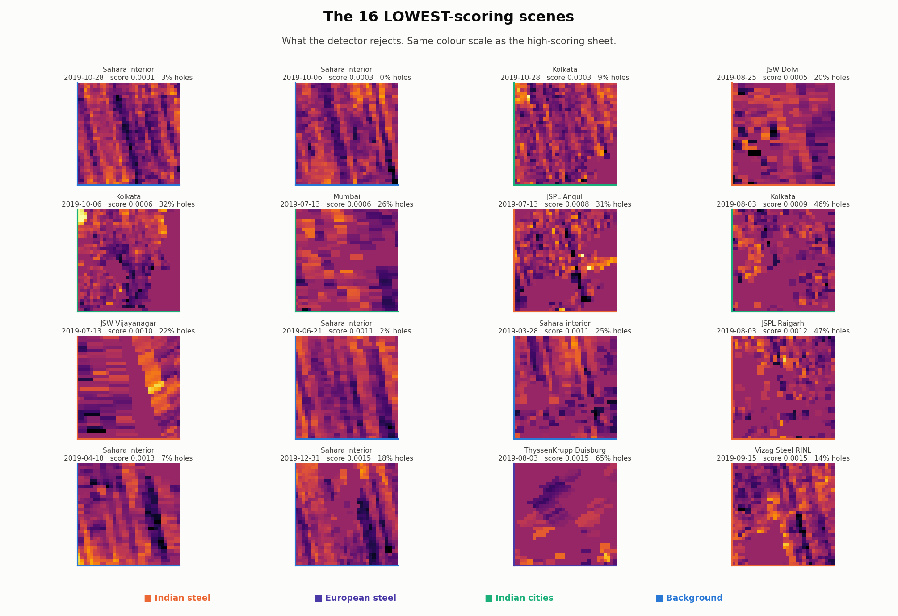
The 16 lowest-scoring scenes, on the same colour scale as the high scorers.
Almost every one is dominated by the diagonal banding described earlier — the Sahara appearing at scores of 0.0001, 0.0003, 0.0011. This is genuinely good news, and it corrected a prediction we had made in the other direction: the worry was that the detector would latch onto instrument stripes and report them as plumes. It does the opposite. Regular periodic banding evidently does not look like a plume to it.
The second pattern here is less welcome. Several of the low scorers have large missing-data fractions — 65%, 47%, 46%. That is the confound from the previous section, showing up in the pictures.

9. One day is never enough
You said early on that you could not see much signal at some steel sites. The numbers agreed with you. Measured on single overpasses, the enhancement was 1.10 for background sites, 1.29 for Europe and 1.35 for India — heavily overlapping distributions.
At 7 kilometre resolution, one overpass usually does not show a steel-plant plume at all.
So we do what astronomers do with faint stars: leave the shutter open. Every tile is centred on the same facility, so averaging a site's days is exactly the oversampling technique the literature uses. Random noise averages down; anything permanently there survives.
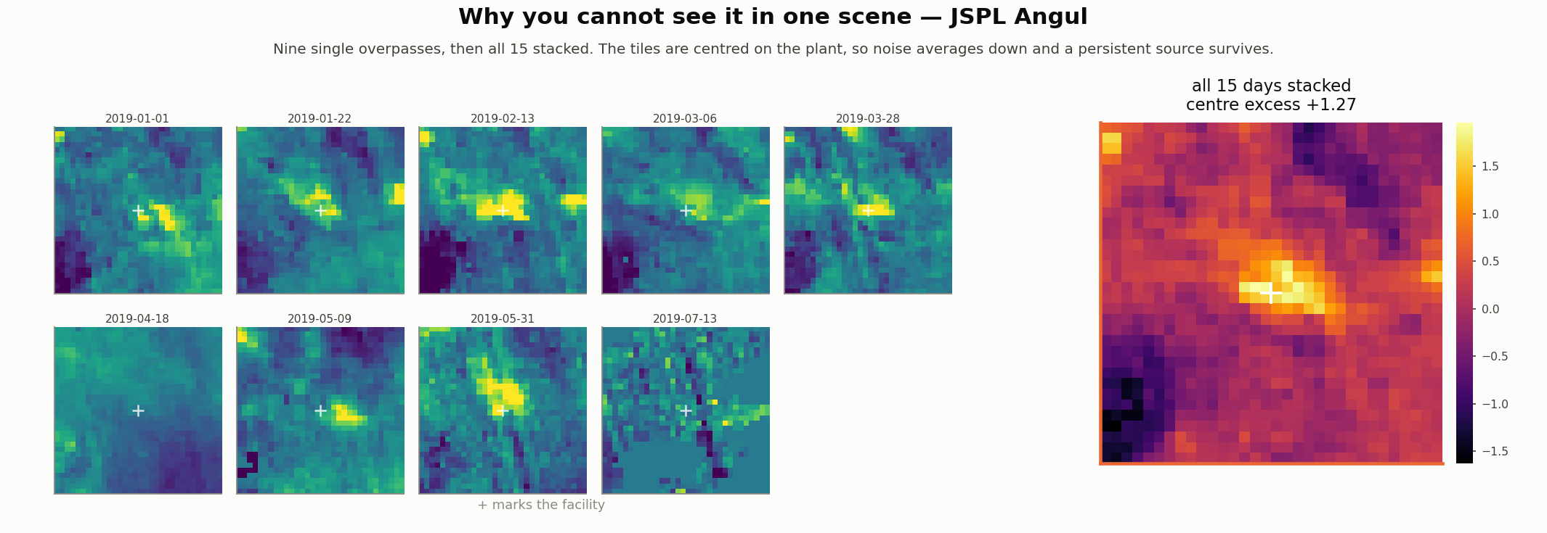
Nine ordinary days at JSPL Angul, then all fifteen averaged. The blob only appears in the average.

10. All 26 places, side by side
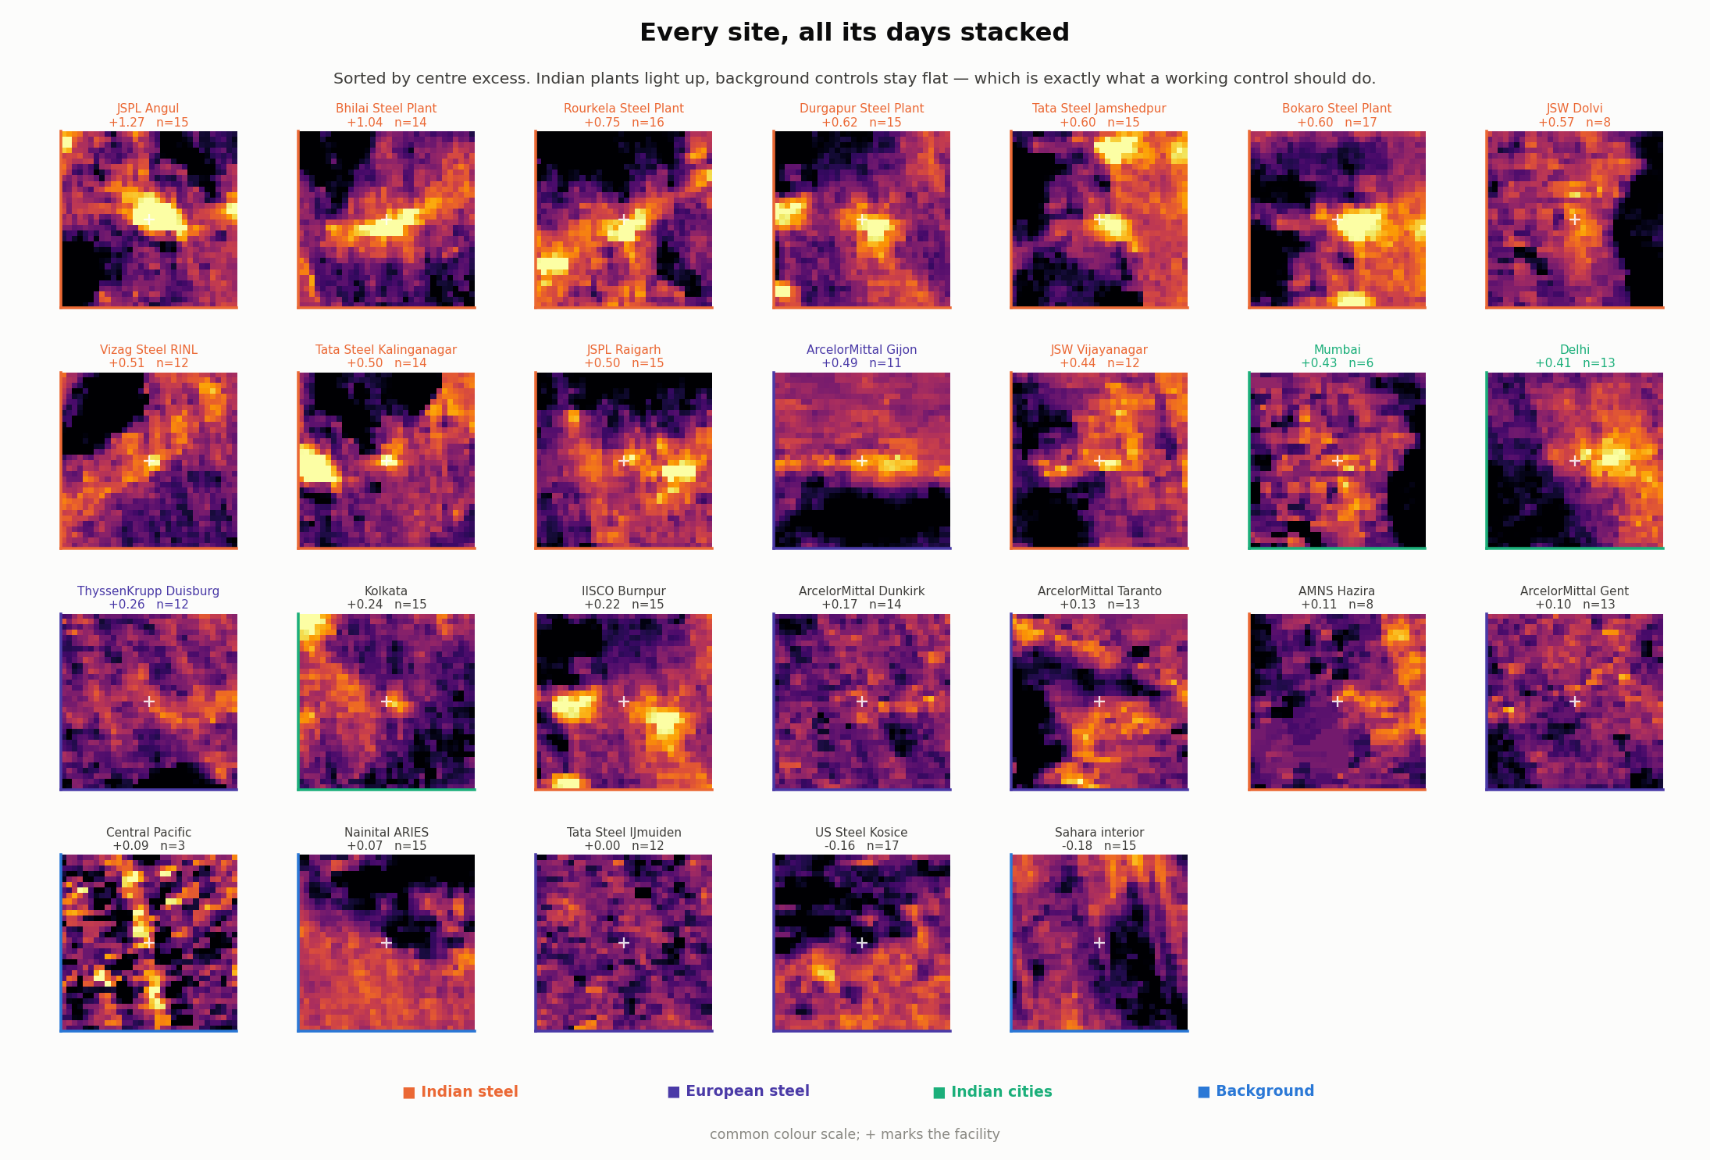
Every site, all its days stacked, sorted by how much the centre stands out. Orange borders are Indian steel; violet European steel; green Indian cities; blue the empty control sites.
Indian plants light up with compact bright cores. The background controls sit at −0.003 — flat, exactly as a working negative control must be.
Why this is arguably the best result in the project
It does not depend on the neural network at all. It is a straight average of the data, and it says something substantive: steel-plant carbon monoxide is not reliably a single-image detection problem. It emerges from stacking many days.
That is why Leguijt and colleagues use year-long inversions rather than per-image detection — and it is the sharpest statement of why porting a methane super-emitter detector to carbon monoxide is not straightforward.

11. Does the signal survive the confounds?
The obvious worry is that the detector has simply learned to recognise “India”. Three tests say otherwise.
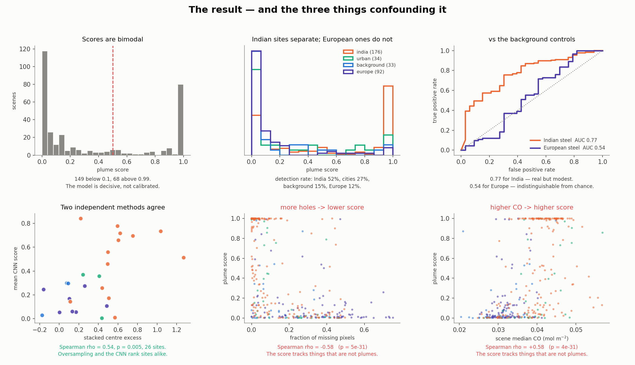
Top row: the scores are strongly bimodal; Indian sites separate from controls while European ones do not; the accuracy curves. Bottom row: the three things confounding the result.
A few readings from that figure. The model is decisive rather than calibrated — 149 tiles score below 0.1 and 68 above 0.99, so a score of 0.99 is not a 99% probability, and moving the threshold barely changes anything. Indian steel reaches an accuracy of 0.77 against the control sites using all tiles; European steel reaches 0.54, which is chance.
A caption we had to correct
The bottom-left panel was originally labelled “two independent methods agree”. Testing it showed the agreement holds across all 26 sites (correlation 0.54, p = 0.005) but collapses within either region on its own — correlation 0.33, p = 0.27 for Indian steel alone. So what agrees is the between-region contrast, not the ranking of source strength. The label was wrong and has been changed.

Test one — stay inside India
Steel plants beat non-steel Indian sites: 52% detection against 27%, median score 0.53 against 0.08, p below 0.0001. Same region, same sampling calendar, and steel still separates.

Test two — control for everything at once
A statistical model predicting detection, with all the effects put on the same scale so their sizes can be compared directly:
What is included | steel | regional CO | missing data | texture | in India
steel alone | +0.34 | — | — | — | —
+ regional CO | +0.31 | +1.08 | — | — | —
+ missing, texture | +0.34 | +0.72 | −1.02 | +0.04 | —
+ region | +0.36 | +0.58 | −0.99 | −0.03 | +0.34
Two readings, and the second is the finding:
- The steel effect does not move — between +0.31 and +0.36 whatever else is included. It is not an artefact of the confounds.
- But it is small. Missing data contributes −0.99 and regional carbon monoxide +0.58. The score is roughly three times more sensitive to how much data is in the image than to whether there is a steel plant in it.
- Texture drops to about zero once the others are included — it was never independent, just a stand-in for them. One of three apparent confounds dissolves under scrutiny.

Test three — the strongest control
Same coordinates, same plant, same detector. Only the weather changes.
Group | Dry season | Monsoon | p
Indian steel | 59% detected | 21% detected | < 0.00001
Indian cities | 36% | 0% | 0.02
Nainital (no local source) | 25% | 33% | 0.73
European steel (no monsoon) | 12% | 12% | 0.46
Sites with a local point source in the monsoon region swing hard. Sites without one, or outside the monsoon region, do not. If the model were simply detecting “polluted Indian atmosphere”, Nainital — same region, same monsoon — would swing too. It does not.
Physically this is exactly right: monsoon convection and rain-out disperse and wash away a low-level plume, so there really is less to see.

12. The answer
What carried over, and what came with it
The useful part carried over. A network trained on methane still recognises the shape of a plume in carbon monoxide, and picks steel plants out of the air around them. That result held under every check we ran, and it turns up again in the day-averaging, which does not use the network at all.
The unhelpful part came too. The model leans heavily on things that have nothing to do with plumes — mainly how complete the picture is, and how polluted the wider region is. Those barely varied in the clean methane images it learned from, so it never had to learn to ignore them.
That is a to-do list, not a failure. The published method has a second stage we did not build: a filter that looks at 41 measured properties of each scene — how good the retrieval was, how cloudy, how bright the ground, what the air pressure was. Those are exactly the things our model is being distracted by. Feed them to a filter and it can subtract them out, leaving the plume behind.
So this work arrives at the need for that second stage on its own, and puts numbers on how big it has to be. That is more useful than a good score would have been.

The European result is worth stating on its own
European plants were flagged in 12% of images, slightly below the 15% of our empty control sites, and their stacked signal was +0.14 against the controls' −0.003. By our method, they are invisible.
Yet Leguijt and colleagues measured those same plants successfully — same satellite, same year — by fitting a whole year of data at once instead of judging images one at a time.
So the plants are certainly emitting. The lesson is about the method: looking at single images fails exactly where year-long averaging works. That matters for how a system like COGNITO should be designed.

13. What holds up, and what does not
Holds up:
- A methane-trained network, with no retraining, detects carbon monoxide plumes over large Indian steel plants — accuracy 0.77 against clean controls on all tiles, 0.81 once matched on image quality.
- The steel effect is stable at +0.31 to +0.36 across every statistical specification.
- The seasonal test: the same plants score 59% in the dry season against 21% in the monsoon, while control sites show no swing at all.
- Stacking a site's days turns an invisible signal into a visible one. Indian steel reaches +0.59 centre excess; the empty controls sit at −0.003.
- The detector rejects instrument stripes rather than firing on them.
- The regional carbon monoxide gradient comes out exactly as physics predicts.
Does not hold up:
- The ranking of individual facilities. It mostly reflects cloud cover and coastline, not emissions, and should not be quoted.
- Any comparison between coastal and inland sites.
- Any claim that a particular plant is running below capacity.
- The idea that these scores are probabilities. They are not calibrated.

14. What we would do next
- Stop filling gaps with zeros. Mask them instead, so a hole is invisible to the model rather than read as flat ground. This is the single highest-value change.
- Add the second stage — a classifier over retrieval-quality quantities, which is what the published method uses and what the numbers here independently argue for.
- Bring in wind. A plume's brightness depends as much on how fast the air was moving as on how much gas came out. With wind speed from a weather model, a brightness can begin to become an emission rate.
- Extend the fire separation, calibrating the carbon monoxide to nitrogen dioxide ratio against independent fire detections rather than leaving the threshold unset.
- Move from the convenience product to the raw measurements, which carry the quality information this version had to do without.

15. Honest limits
Stated plainly, because the people most likely to read this built the instrument:
Limitation | Why it matters
28% of site-days were dropped | And not at random. The Central Pacific lost 15 of 18 days to dark-ocean retrieval failure; June and August lost half to monsoon cloud. What survives is the clear-sky subset — inland eastern plants in the dry season, which is also where carbon monoxide backgrounds are highest.
The seasonal test rides partly on that same effect | The monsoon sample is small (29 tiles) precisely because of the cloud dropout.
The architecture is a reconstruction | Layer widths, optimiser and dropout were never published. This reproduces the approach, not the model.
The normalisation scheme is our choice, not theirs | And it is the single most consequential decision in the project.
This is gridded data, not the raw measurements | No averaging kernel, no retrieval diagnostics, and the quality threshold was fixed before we saw the data.
Detection is not quantification | Nothing here estimates an emission rate. That needs cross-sectional flux or an inversion with transport modelling.
Nainital is a compromised control | Himalayan terrain plus Indo-Gangetic outflow give it genuine carbon monoxide structure. It detected 4 of 15. Lead with the Sahara.
Seven of twenty plant coordinates are unverified | Thirteen were checked against Global Energy Monitor; twelve were within half a pixel and JSPL Angul was 11.4 km out and has been corrected.
Tile centring has been corrected since this run | At high latitude the sampling grid was not perfectly centred on the facility. The code in this repository is fixed; the numbers above come from the earlier run.

Sources
Schuit, B. J., Maasakkers, J. D., Bijl, P., et al. (2023). Automated detection and monitoring of methane super-emitters using satellite data. Atmospheric Chemistry and Physics 23, 9071–9098.
Leguijt, G., Maasakkers, J. D., Denier van der Gon, H. A. C., Segers, A. J., Borsdorff, T., van der Velde, I. R., and Aben, I. (2025). Comparing space-based to reported carbon monoxide emission estimates for Europe's iron and steel plants. Atmospheric Chemistry and Physics 25, 555–574.
van der Velde, I. R., van der Werf, G. R., Houweling, S., Eskes, H. J., Veefkind, J. P., Borsdorff, T., and Aben, I. (2021). Biomass burning combustion efficiency observed from space using measurements of CO and NO₂ by TROPOMI. Atmospheric Chemistry and Physics 21, 597–616.
Borsdorff, T., et al. (2019). Improving the TROPOMI CO data product. Atmospheric Measurement Techniques 12, 5443–5455.
Sentinel-5P TROPOMI carbon monoxide and nitrogen dioxide, and MODIS fire radiative power, accessed through Google Earth Engine. Training images from Schuit et al., Zenodo record 13903869, CC-BY 4.0.

