TIME SERIES ANALYSIS AND FORECASTING
FOR STOCK MARKET

By Name : Vikrant Mahajan

CHAPTER 1: INTRODUCTION
1.1 Introduction
Bitcoin is one of the most widely used cryptocurrencies and is known for its highly volatile nature.
This project focuses on performing time series analysis of Bitcoin using Power BI.
The dataset includes Date, Open, High, Low, Close, and Volume.
The goal is to transform raw data into meaningful insights using dashboards and forecasting.
1.2 Objectives
• Analyze Bitcoin historical data
• Understand trends and patterns
• Build Power BI dashboards
• Create DAX measures
• Perform forecasting
1.3 Motivation
The motivation behind this project is the importance of data analytics in financial markets.
Bitcoin provides a strong use case due to its volatility and dynamic behavior.
1.4 Scope of Work
• Data collection and cleaning
• Dashboard creation
• DAX calculations
• Forecasting using Power BI
1.5 Feasibility Study
The project is feasible due to availability of datasets and Power BI tools with minimal hardware requirements.

CHAPTER 2: DESIGN AND IMPLEMENTATION
2.1 Introduction
This chapter explains the overall design and implementation of the project using Power BI. The system is designed to transform raw Bitcoin data into meaningful insights through data processing, analysis, and visualization. The implementation focuses on simplicity, efficiency, and clarity, ensuring that complex financial data can be easily understood through interactive dashboards.
The approach followed in this project is structured and modular, starting from data collection and cleaning, followed by feature creation using DAX, and finally visualization and forecasting using Power BI tools.
2.2 Requirements
The requirements of this project are divided into functional and non-functional components.
2.2.1 Functional Requirements
• Import Bitcoin dataset into Power BI
• Clean and preprocess data using Power Query
• Create calculated columns and measures using DAX
• Build interactive dashboards for analysis
• Perform forecasting using Power BI analytics tools
• Enable filtering and user interaction through slicers

2.2.2 Non-Functional Requirements
• Performance: Dashboard should load quickly and respond efficiently
• Usability: Visuals should be simple and easy to understand
• Accuracy: Calculations and insights should be correct
• Scalability: System should handle larger datasets if required
• Reliability: System should handle missing or inconsistent data
2.3 Proposed Design
The project follows a step-by-step analytical workflow:
Data Collection → Data Cleaning → DAX → Visualization → Forecast → Insights
Explanation of Workflow:
- Data Collection:
Bitcoin historical data is collected from reliable sources in CSV format.
- Data Cleaning (SQL + Power Query):
Initial data cleaning and validation are performed using SQL.
Missing values and inconsistencies are handled before loading into Power BI.
- Data Transformation:
Power Query is used to format data types, remove errors, and prepare the dataset for analysis.
- Feature Engineering (DAX):
DAX measures are created for:
  - Average Price
  - Maximum and Minimum Price
  - Price Change
  - Moving Averages (MA7, MA30)
- Visualization:
Interactive dashboards are built using:
  - Line charts
  - Column charts
  - KPI cards
  - Forecast visuals
- Forecasting:
Power BI’s built-in forecasting feature is used to predict future price trends along with uncertainty.

2.3.1 Visuals
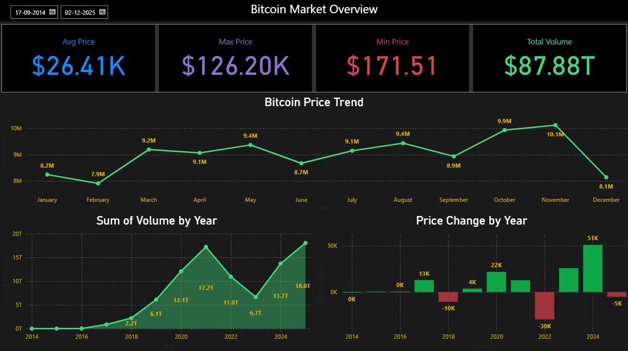
EXECUTIVE OVERVIEW (PAGE 1)
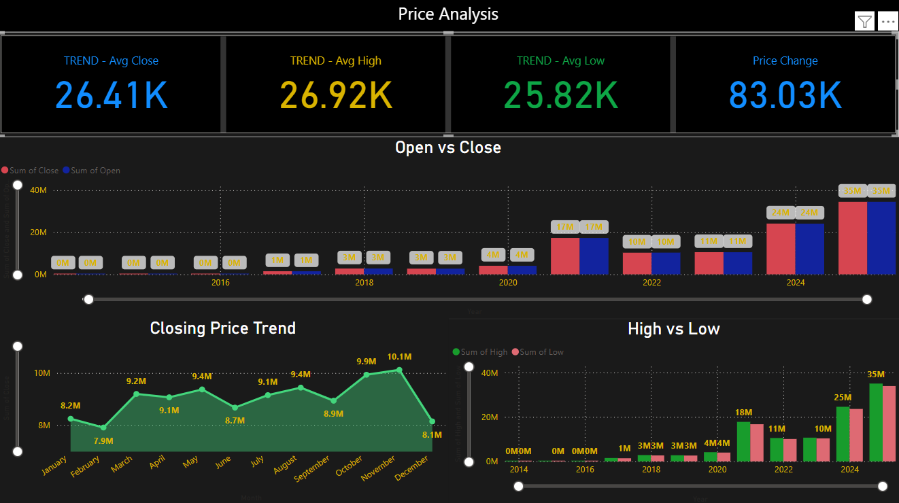 PRICE ANALYSIS (PAGE 2)
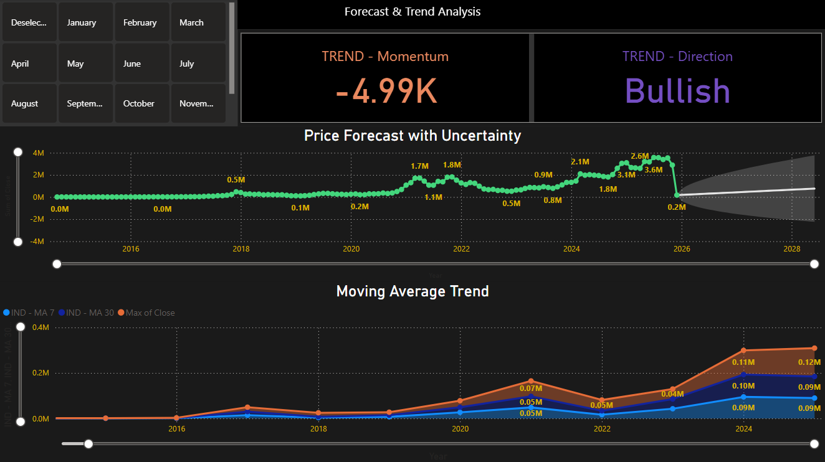
FORECAST (PAGE 3)

2.4 Hardware Requirements
Processor: i5 or above
RAM: 8GB
Storage: 5GB
2.5 Software Requirements
Power BI
SQL Server
Excel/CSV

CHAPTER 3: RESULTS AND DISCUSSION
3.1 Introduction
This chapter presents the results obtained from the analysis of Bitcoin data using Power BI dashboards. The objective is to interpret the visual outputs and understand key market behaviors such as price trends, volatility, and future predictions. The dashboards provide a clear and interactive way to analyze large amounts of data and extract meaningful insights.
3.2 Result Analysis
The analysis of the Bitcoin dataset through different dashboard pages led to the following key findings:
- Trend Analysis:
The price trend chart shows a consistent upward movement over the observed time period. Although there are fluctuations, the long-term trend indicates growth in Bitcoin value.
- Price Behavior (Open vs Close):
The comparison between open and close prices highlights daily market movement. In many instances, there is a noticeable difference between opening and closing prices, indicating active trading and price shifts within a single day.
- Volatility Analysis (High vs Low):
The high and low price charts demonstrate significant variation in daily price ranges. This confirms that Bitcoin is a highly volatile asset, where prices can change rapidly within short time intervals.
- Volume Impact:
The volume chart shows that trading activity directly influences price movements. Periods of high trading volume often correspond with sharp price changes, indicating strong market participation.
- Forecasting Results:
Using Power BI’s forecasting feature, future price trends were predicted. The forecast suggests a continuation of the upward trend, while the confidence interval (uncertainty band) indicates possible variation in predicted values.
- Moving Average Insights:
Moving averages (MA7 and MA30) help smooth out price fluctuations and reveal the underlying trend. When the short-term average (MA7) is above the long-term average (MA30), it indicates an upward trend, and vice versa.
3.3 Observations
Based on the analysis, the following observations were made:
- Bitcoin market exhibits high volatility, with frequent fluctuations in price.
- Despite short-term variations, the overall trend is upward over time.
- Trading volume plays a significant role in influencing price changes.
- Forecasting provides a useful estimate of future trends but includes uncertainty.
- Moving averages are effective in identifying trend direction and stability.
- Visual dashboards make it easier to interpret complex financial data quickly and efficiently.

CHAPTER 4: CONCLUSION
4.1 Conclusion
This project successfully demonstrates the application of time series analysis on Bitcoin data using Power BI. Through interactive dashboards, key insights related to price trends, volatility, and forecasting were identified. The use of DAX measures and visualization techniques helped transform raw data into meaningful information.
The analysis shows that Bitcoin is a highly volatile asset with an overall upward trend. Forecasting techniques provide a useful perspective on future price movements, although they are subject to uncertainty. Overall, this project highlights the effectiveness of business intelligence tools like Power BI in financial data analysis and decision-making.
4.2 Future Scope
The project can be further improved and extended in the following ways:
- Integration of Machine Learning Models:
Advanced models such as ARIMA, SARIMA, and LSTM can be used for more accurate forecasting.
- Real-Time Data Integration:
Connecting the dashboard to real-time APIs can allow live updates of Bitcoin prices.
- Automation of Analysis:
Automated pipelines can be developed to update dashboards without manual intervention.
- Advanced Financial Indicators:
Indicators like RSI, MACD, and Bollinger Bands can be added for deeper analysis.
- Web Dashboard Deployment:
The project can be deployed as a web application for easy access and user interaction.

