***MAVEN***

- sudo -i #### root user ki route avtadi######

- nano /etc/ssh/sshd_config

- service sshd restart

- adduser jenkin

- visudo ///jenkin ALL=(ALL:ALL) NOPASSWD:ALL

- su jenkin

CD ~ >>>>>>>> user home directory change

- sudo apt-get update

1. installing jdk8/oracle jdk (digital ocean.com)

sudo apt-get update

sudo apt-get install openjdk-8-jdk -y

sudo apt-get install default-jre -y

Environment path settings:

sudo update-alternatives --config java

sudo nano /etc/environment

JAVA_HOME="path of the jdk" ===>JAVA_HOME="/usr/lib/jvm/java-8-openjdk-amd64/"

source /etc/environment

echo $JAVA_HOME

2. installing maven on ubuntu16 (Google)

sudo apt-get install maven -y

mvn --version

echo $M2_HOME

sudo nano /etc/environment

M2_HOME="path of the maven" ===>M2_HOME="/usr/share/maven"

echo $M2_HOME

source /etc/environment

####################

3. install git

sudo apt-get install git -y

git --version

git clone "url of project"

cd folder name of the project----

4. maven commands

mvn compile

mvn test

mvn package

5. Jenkins:

installastion jekins

wget -q -O - https://pkg.jenkins.io/debian/jenkins-ci.org.key | sudo apt-key add -

sudo sh -c 'echo deb http://pkg.jenkins.io/debian-stable binary/ > /etc/apt/sources.list.d/jenkins.list'

sudo apt-get update

sudo apt-get install jenkins -y

sudo service jenkins status ////// sudo nano var/lib/jenkins/secrets/initialAdminPassword

sudo -i

getent passwd

now go to ec2 machine copy public-ip and enter into url section ==> http://(public-ip:8080) its opens jenkins site,

copy the path from our jenkins site,

sudo -i

cat "past the above path here" //(enter in terminal, it will gives the passwd of our jenkins).

in above we will get passwd, enter that passwd in the jenkins site)

the n now, install suggested plugns,

-create admin user/jenkins user,

-start using

--new item

-free style project,

############################

6. Addding node(Jenkins master Remotely accessing Node):

1. create an ec2 instance based on your requirement.

2. install java

3. add user

4. passwd based authentiction (sshd) (like ansible)

5. direct to the root to user (added user)

6. install maven

NODE******************

open jenkins master server in cmd and login with jenkins user.

- ssh-keygen (to generate the keygen key) enter

- no PRIVATE IP(1111111) then enter

- ssh NODE PRIVATE IP (122333) excute from Master jenkins

7. go to Jenkins dash board

-manage jenkins

-manage nodes

-new node

-enter the details what ever the required

(must importent Label, credentials, host key verifrication).

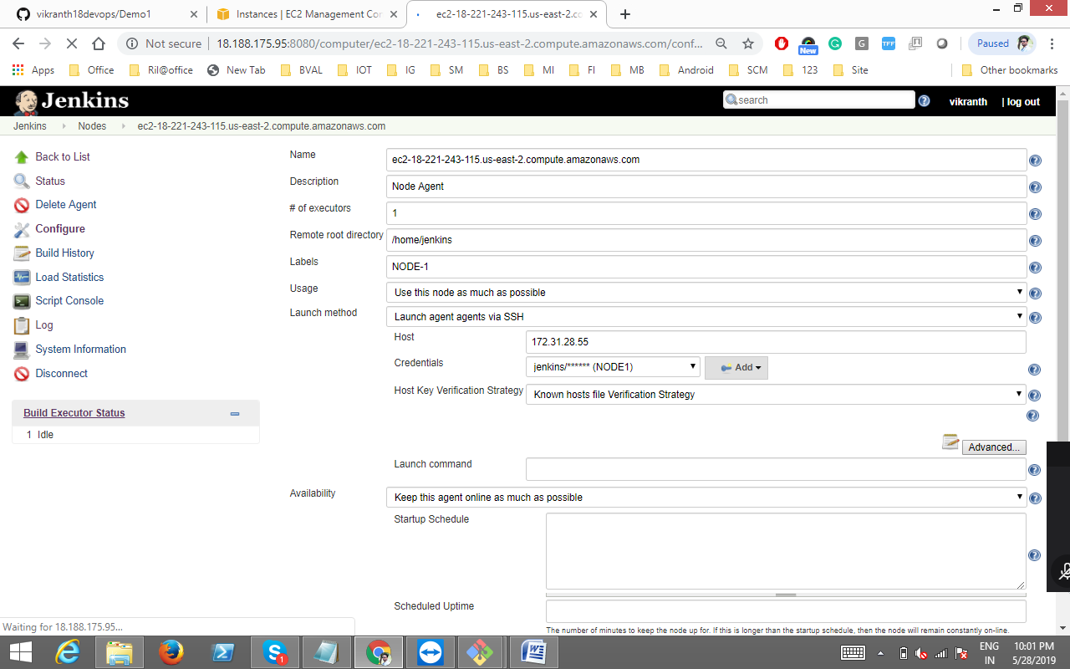

CLICK ON ADD

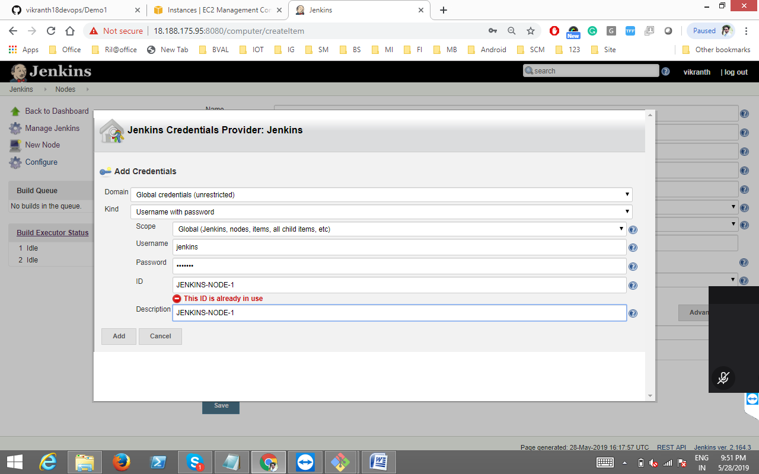

-save.

8. now go to jenkins dash board.

-new item

-free style project

-choose the options

- General and SCM, Build triggers, ..etc.

Maven Life Cycle:

* Validate, Clean, compile, test, package, install, deploy.

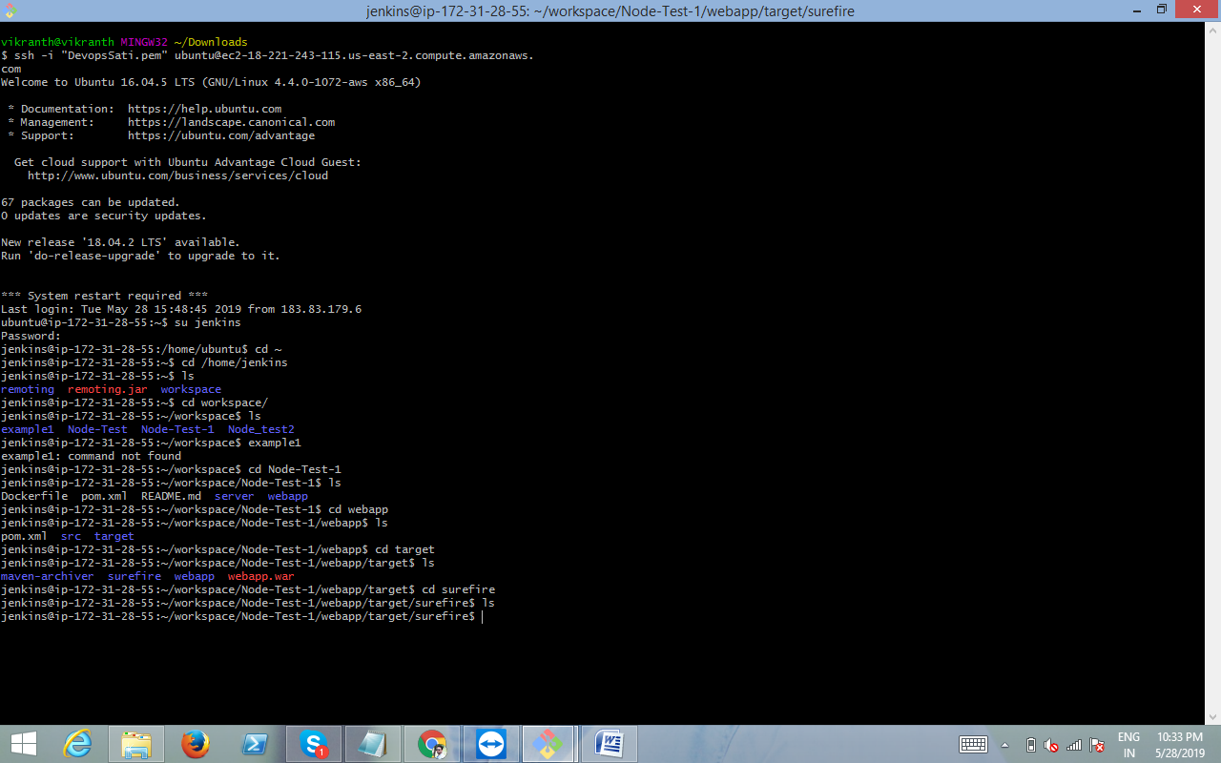

**DOCKER**

Basic

: docker version

: docker -v

: docker info

: docker --help

: docker login

————————————

Images

: docker images

: docker pull

: docker rmi

————————————

Containers

: docker ps

: docker run

: docker start

: docker stop

System

: docker stats

: docker system df

: docker system prune