(Role)
Act as a professional event coordinator.

(Goal)
Write a launch email announcing a Chess workshop.

(Context)
Audience: Undergraduate students
Date: Next Friday
Duration: 3 hours
Location: University activity hall

Workshop topics:
- Basics of chess

Suggest a better version of the previous prompt so that the email becomes more persuasive and exciting for students.

Improve the prompt by adding:
- benefits of learning chess
- competitive advantage for students
- strong call to action

(Role)
Act as a professional event coordinator.

(Goal)
Write a launch email announcing a Chess workshop.

(Context)
Audience: Undergraduate students
Date: Next Friday
Duration: 3 hours
Location: University activity hall

Workshop topics:
- Basics of chess
- Opening strategies
- Common beginner mistakes
- Quick tactics to improve gameplay

Tone: Exciting, friendly, and informative.

The email should include:
- Catchy subject line
- Brief introduction
- Workshop highlights
- Invitation to register
- Closing message

Dear Students,
Are you curious about chess or looking to sharpen your strategic thinking skills? We are excited to invite you to an engaging Chess Workshop designed especially for undergraduate students who want to learn, improve, and enjoy the game of chess.
Whether you’re a complete beginner or someone who has played casually with friends, this workshop will help you understand the fundamentals and develop smarter gameplay strategies.
Workshop Details
📅 Date: Next Friday
⏰ Duration: 3 Hours
📍 Location: University Activity Hall
What You’ll Learn:
♟️ Basics of Chess – Understand the rules, pieces, and board setup
♟️ Opening Strategies – Learn how strong players start their games
♟️ Common Beginner Mistakes – Avoid typical traps that cost games
♟️ Quick Tactics to Improve Gameplay – Simple techniques to win more matches
This interactive session will include live demonstrations, guided practice, and opportunities to play with fellow students.
🎯 Seats are limited!
Secure your spot by registering early and take the first step toward mastering the art of chess.
We look forward to seeing you at the workshop and helping you make your first move toward becoming a stronger chess player!
Best regards,
Event Coordination Team
University Activity Committee

Image Generation

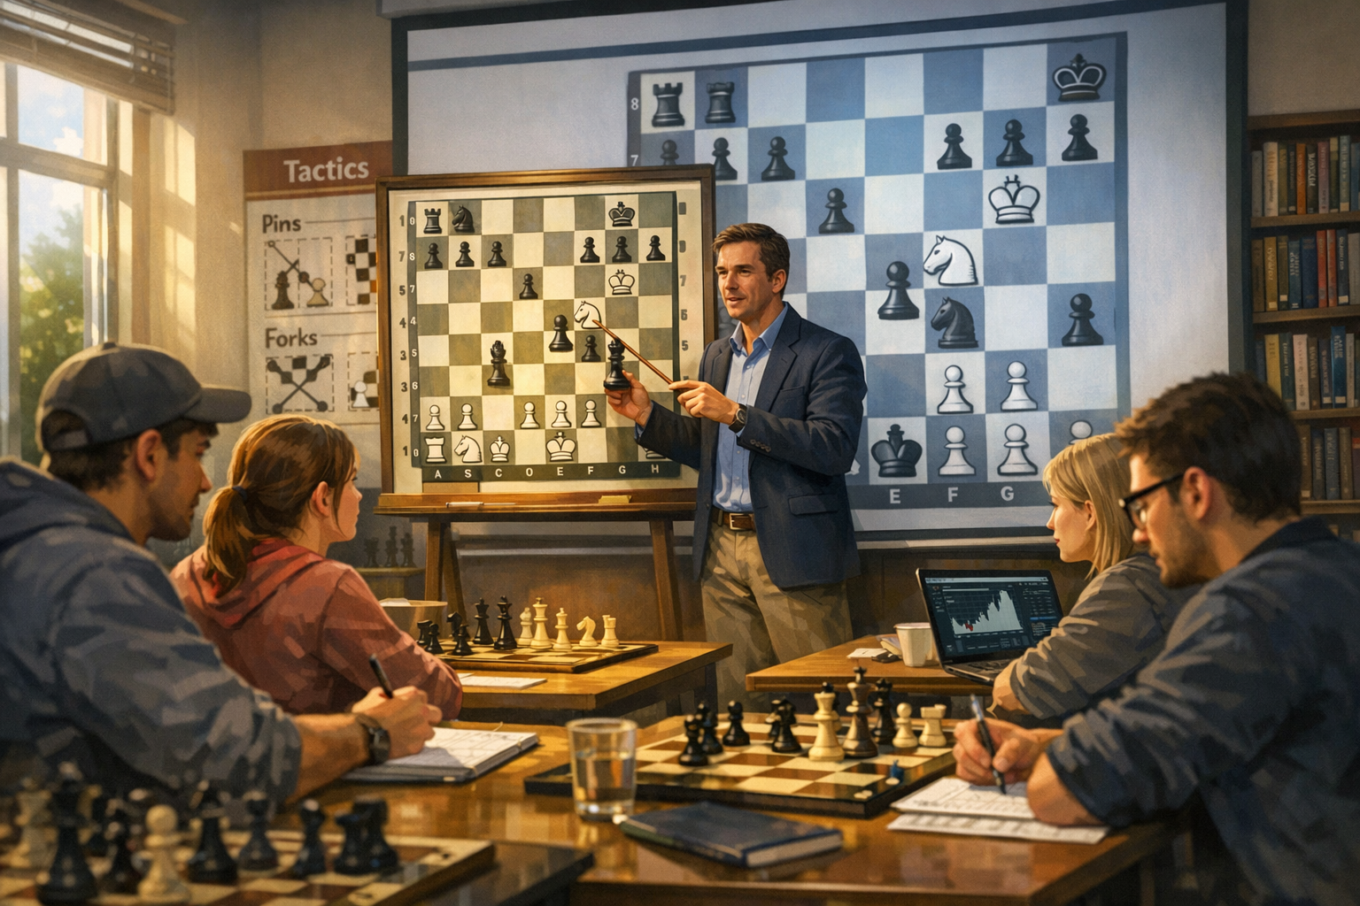

Video Generation:
https://drive.google.com/file/d/1e1UxQVx_rpHf9APIMf9TN3nVKp7k5AGR/view?usp=sharing

