You are an AI assistant that analyzes customer reviews.

A customer wrote the following review about a smartphone:

"The phone camera is excellent and the battery lasts all day. However, the phone heats up during gaming and the price feels a little high."

Task:
1. Identify the positive points.
2. Identify the negative points.
3. Decide whether the overall sentiment is Positive, Negative, or Neutral.

Let's think step-by-step before giving the final answer.

1. Positive Points 👍
- The camera is excellent.
- The battery lasts all day.
2. Negative Points 👎
- The phone heats up during gaming.
- The price feels a little high.
3. Overall Sentiment 🧠
- Neutral
Reason (short explanation):
The review contains both clear positive aspects (camera, battery) and negative aspects (heating issue, high price). Because the positives and negatives balance each other, the overall sentiment is Neutral.

Analyze the sentiment of the following customer reviews for an online store.

Reviews:
1. "The laptop is fast and lightweight. Perfect for work."
2. "The headphones look good but the sound quality is disappointing."
3. "The delivery was late but the product works fine."

Task:
For each review identify:
- Product
- Key Positive Point
- Key Negative Point
- Overall Sentiment (Positive/Negative/Neutral)

Provide the results in a markdown table with the following headers:

| Review Number | Product Type | Positive Point | Negative Point | Sentiment |
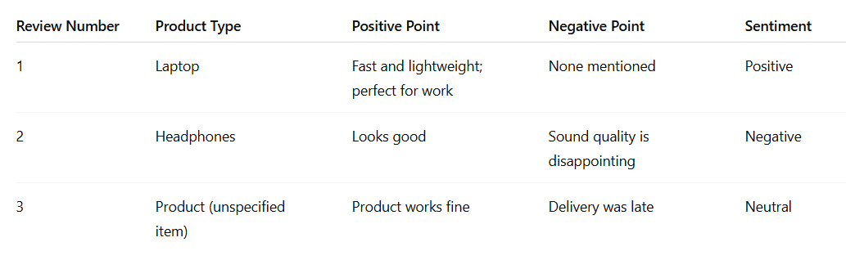

Complete the following product review analysis template based on the given review.

Review:
"The smartwatch tracks fitness accurately and the display is very clear. But the battery drains quickly."

Template:

Product Type: _______

Main Positive Feature: _______

Main Negative Feature: _______

Overall Sentiment: _______

Explanation: _______
Product Type: Smartwatch
Main Positive Feature: Accurate fitness tracking and a very clear display
Main Negative Feature: Battery drains quickly
Overall Sentiment: Neutral
Explanation: The review contains both positive aspects (accurate fitness tracking and clear display) and a negative aspect (fast battery drain). Because it includes both praise and criticism, the overall sentiment is neutral.

Role:
You are a professional data analyst specializing in customer feedback analysis for e-commerce companies.

Goal:
Your goal is to analyze product reviews and summarize the main insights from them.

Context:
An online electronics store wants to understand customer opinions about their products so they can improve product quality and customer satisfaction.

Task:
Analyze the following review and provide:
1. The product type
2. The key positive feedback
3. The key negative feedback
4. A short summary of the overall sentiment

Review:
"The tablet is very fast and the screen quality is amazing. However, the speakers are not loud enough for watching movies."

1. Product Type 📱
Tablet
2. Key Positive Feedback 👍
- The tablet is very fast (good performance).
- The screen quality is amazing (high display quality).
3. Key Negative Feedback 👎
- The speakers are not loud enough, which affects the experience when watching movies.
4. Overall Sentiment Summary 🧠
The overall sentiment is mostly positive but slightly mixed. The customer is satisfied with the tablet’s performance and display, but there is a minor complaint about the speaker volume that could affect multimedia usage.

Classify the sentiment of the following product review as Positive, Negative, or Neutral.

Review:
"The design of the backpack is great and it is comfortable to carry, but the zippers feel weak."

Provide:
1. Sentiment
2. One sentence explanation

1. Sentiment: Neutral
2. Explanation: The review mentions positive aspects (great design and comfortable to carry) but also a negative aspect (weak zippers), resulting in a balanced or mixed opinion. 🙂

Classify the sentiment of product reviews.

Example:
Review: "The keyboard is comfortable to type on but the keys are a bit noisy."
Sentiment: Neutral

Now analyze the following review:

Review: "The camera quality is amazing and the phone runs very smoothly."

Provide the sentiment only.
Sentiment: Positive

Classify product reviews into Positive, Negative, or Neutral sentiment.

Examples:

Review: "The laptop battery lasts long and performance is excellent."
Sentiment: Positive

Review: "The shoes look good but they became uncomfortable after one day."
Sentiment: Negative

Review: "The speaker works fine but nothing special."
Sentiment: Neutral

Review: "The phone screen is bright and the performance is very smooth."
Sentiment: Positive

Now classify the following review:

Review: "The smartwatch has many features but the battery life is disappointing."

Sentiment:
Sentiment: Negative

