**Ingress - Context Path Based Routing**

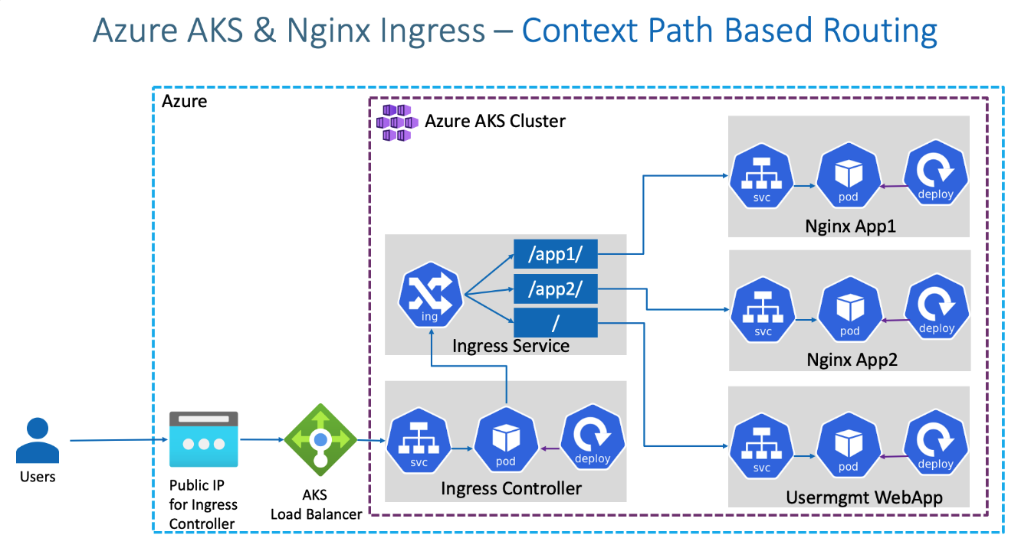

## Step-02: Review k8s Application Manifests

* 01-NginxApp1-Manifests
* 02-NginxApp2-Manifests
* 03-UserMgmtmWebApp-Manifests

## Step-03: Review Ingress Service Manifests

* 04-IngressService-Manifests

## Step-04: Deploy and Verify

# Deploy Apps

kubectl apply -R -f kube-manifests/

# List Pods

kubectl get pods

# List Services

kubectl get svc

# List Ingress

kubectl get ingress

# Verify Ingress Controller Logs

kubectl get pods -n ingress-basic

kubectl logs -f <pod-name> -n ingress-basic

## Step-05: Access Applications

# Access App1

http://<Public-IP-created-for-Ingress>/app1/index.html

# Access App2

http://<Public-IP-created-for-Ingress>/app2/index.html

# Access Usermgmt Web App

http://<Public-IP-created-for-Ingress>

Username: admin101

Password: password101

## Step-06: Clean-Up Applications

# Delete Apps

kubectl delete -f kube-manifests/

# Delete Azure Disk created for Usermgmt Web App

Go to All Services -> Azure Disks -> Delete disk