AI-Driven Adaptive Transaction Batching for Cardano Decentralized Exchanges
Ms. B. Mamatha¹  Guide, CSE (Data Science)  Vignana Bharathi Institute of Technology, Hyderabad, India | Vikranth Sai²  UG Scholar, CSE (Data Science)  Vignana Bharathi Institute of Technology, Hyderabad, India  Email: 23p61a67f1@vbithyd.ac.in
Ganesh³  UG Scholar, CSE (Data Science)  Vignana Bharathi Institute of Technology, Hyderabad, India  Email: 23p61a67f0@vbithyd.ac.in | Sowmya⁴  UG Scholar, CSE (Data Science)  Vignana Bharathi Institute of Technology, Hyderabad, India  Email: 23p61a67h8@vbithyd.ac.in

Abstract—A Cardano decentralized exchange keeps each liquidity pool in one UTXO, and only one transaction per block can spend it, so off-chain batchers settle many swaps together. Batchers in use today fire every M orders or T seconds without reading the chain, and because Cardano fees are fixed, a badly timed batch costs users time, not money. We treat batching as control of a shared pool lock under uncertain confirmation time. Over 388,781 mainnet blocks (92 days) the median block is only 3.0% full and just 0.56% pass 80%, so the bottleneck is the pool lock, not congestion. A discrete-event simulator replays these blocks to compare tuned static batchers with a LightGBM fill forecaster, a forecast-driven decision rule (P2) and a masked DQN agent behind a runtime safety shield. At matched load on held-out data, P2 cuts the fee per user by 18.9% against greedy submission for 5.1 s more average wait, and it is both faster and cheaper than the tuned interval batcher. No adaptive policy beats greedy on tail latency on today’s lightly loaded chain. Without its shield the agent let 35.7% of orders expire under heavy load; with it, none expired. Chaining two batches nearly halves the heavy-load 95th-percentile wait, and a minimal Aiken exchange settled a batch from our batcher on the Cardano preprod testnet.
Index Terms—Cardano, eUTXO, Transaction Batching, Decentralized Exchange, Reinforcement Learning, Congestion Forecasting, Discrete-Event Simulation.

I. INTRODUCTION
Cardano records ownership with the extended UTXO (eUTXO) model [1]. A decentralized exchange (DEX) keeps each liquidity pool in one UTXO that holds the pool’s state, and every swap must spend it and create a new one. A UTXO can be spent only once, so at most one transaction per block can use a given pool: if a hundred users swap at once, one succeeds and the rest fail. Exchanges therefore rely on batchers, off-chain agents that collect the orders users have locked at an order address and settle many of them in one transaction that spends the pool once [2], [3].
The batchers in production fire on constants: every M orders, or every T seconds. They do not look at how full recent blocks were, how long the oldest order has waited, or how long their own batch is likely to take to confirm. This matters because a sent batch locks the pool until it is included. A badly timed batch delays every order behind it, a batch that is too small spreads the fixed fee over few users, and a batch that waits too long delays the users it holds.
Cardano’s fees follow a fixed formula, with no bidding:
fee = 44s + 155,381 + 0.0577m + 0.0000721c (1)
C_{user} = fee(n) / n (2)
where s is the size in bytes, m and c are the memory and CPU-step units, n is the number of orders in the batch and fees are in lovelace. A transaction costs the same on an idle chain and on a full one, so bad timing costs time, not money. The goal is therefore short waits and a low cost per user C_{user}, not low fees, which is why fee-market work for account-based chains such as Ethereum [4] does not carry over. The project began from a claim that Cardano blocks run 80–90% full. We tested it on 92 days of mainnet data before building on it, and it did not hold: the median block is 3.0% full (Section IV-A).
The problem is therefore narrower than a general call for intelligent batching: from the state of the queue and of the chain, decide at every block whether to send a batch and how many orders to put in it, when the shared resource is the pool lock, confirmation time is uncertain and protocol limits must never be broken. We make four contributions. First, a 92-day measurement showing that the bottleneck is the pool lock, not congestion. Second, a formulation of batching with two hard capacity gates. Third, a LightGBM forecaster, a forecast-driven decision rule and a masked DQN agent made safe by a runtime shield, together with batch chaining and one-price clearing. Fourth, an evaluation against tuned static batchers on held-out data, which finds that cost and fairness improve while tail latency does not beat greedy submission on today’s chain. Section III describes the system and Sections IV and V evaluate it.

II. RELATED WORK
Chakravarty et al. formalize the eUTXO model with datums, redeemers and validator scripts [1]. It gives deterministic fees and local validation, but also the single-UTXO concurrency bottleneck for any state that many users share. Nguyen Quang proposes deterministic batching in which orders posted as individual UTXOs are aggregated into one pool-state update [2]. This resolves contention without incentivized agents, but the policy that decides when to batch is static. Bruhwiler analyzes the same concurrency problem for AMM-style exchanges and implements a concurrent DEX prototype [3]; the work concerns correctness, not batch timing or size under load.
Outside Cardano, Roughgarden analyzes transaction-fee mechanism design for EIP-1559, where a demand-responsive base fee prices block space [4]. The model describes Ethereum and does not transfer to Cardano, where congestion produces delay and not a higher price. Mao et al. show that deep reinforcement learning can learn multi-resource scheduling policies that match hand-tuned heuristics [5], but their setting is datacenter jobs, with no block limits and no pool lock. Angeris and Chitra study constant-function market makers, the pool model against which the batcher settles [6]. Table I summarizes the comparison.
TABLE I. Comparison of the related work.
Work | Approach | Limitation here
eUTXO model [1] | Formal ledger specification | Single-UTXO concurrency bottleneck
MELD batching [2] | Deterministic order batching | Static policy; not congestion-aware
Concurrent DEX [3] | Concurrent DEX prototype | No batch timing or sizing
EIP-1559 [4] | Fee-mechanism analysis | Inapplicable to fixed fees
DeepRM [5] | Deep RL scheduling | Not blockchain-aware

The gap is therefore clear. Existing Cardano batchers use fixed rules and ignore the state of the chain; no published method adapts batch size or timing to forecast capacity and queue state; and the adjacent literature optimizes fees, which is the wrong objective here. We found no congestion-aware, learning-based batcher that optimizes latency and per-user cost under Cardano’s transaction and block limits.

III. SYSTEM DESIGN

A. Problem Formulation
At each block slot the batcher observes the queue of pending orders (depth, oldest wait, and the size and execution units of each order), whether the pool is locked, and a forecast of how full the next blocks will be. It chooses WAIT or SUBMIT(n), the first n orders of the queue. A submitted batch locks the pool until it is included or its validity interval expires; while it is in flight there is nothing to decide and orders pile up behind it. The goal is to minimize waiting time and C_{user} under three constraints: the per-transaction limits (Gate A), the predicted room in the next block (Gate B), and a deadline D_{max} on the oldest order.

B. Architecture
The system is an event-driven control loop around a forecast-then-decide pipeline, with an offline simulator that can stand in for the live chain (Fig. 1). The batcher is a server-side process, because a wallet sees only its owner’s funds and aggregation is the batcher’s job. A collector (M1) reads blocks into a feature store, a forecaster (M2) predicts block fill, a queue manager (M3) tracks pending orders, a policy (M4) chooses the action, and a builder (M5) re-checks Gate A, signs and submits the batch. Three facts shape the design: the batcher sees the chain only partly, the pool lock is the one shared resource, and capacity limits come from the protocol, so they are enforced by construction rather than learned.
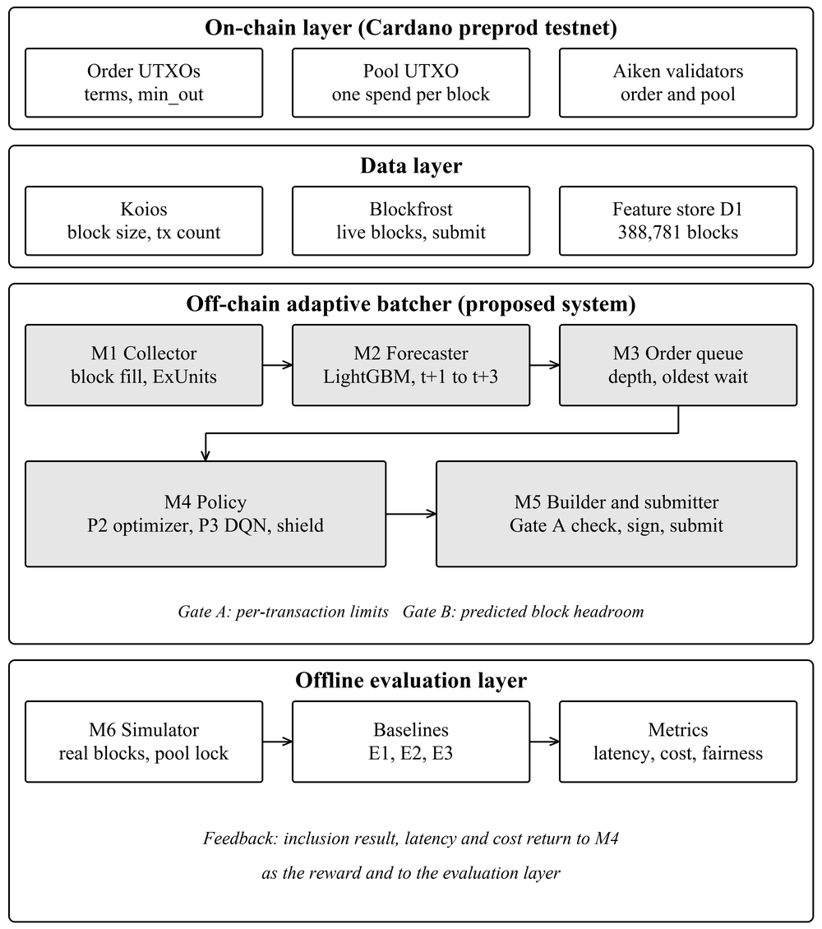
Fig. 1. Architecture of the proposed system: the on-chain layer, the data layer, the off-chain adaptive batcher and the offline evaluation layer.

C. Congestion Forecaster
For each block t we build a feature vector x_{t} from the fill, execution units and transaction counts of the last 20 blocks, their rolling statistics and the time of day. A LightGBM model [7], trained on a chronological split so that the future never leaks into training, predicts the fill of the next three blocks:
f̂_{t+h} = g_{LGBM}(x_{t}), h = 1, 2, 3 (3)
A moving average over the last 20 blocks is the reference the forecaster must beat. The forecast is a secondary, defensive input: it lets the policy avoid the rare full block and wait for a quieter one.

D. Constrained Batch Optimizer
The policy P2 is a forecast-driven rule whose decision flow is shown in Fig. 2. Gate A caps the batch by the per-transaction limits and Gate B by the room predicted in the next block:
n_{A} = max{n : s(n) ≤ 16,384, m(n) ≤ 14×10⁶} (4)
n_{B} = max{n : f̂_{t+1}·S_{max} + s(n) ≤ S_{max}} (5)
where S_{max} = 90,112 bytes is the block size limit; Gate B applies the same check to memory and steps. Let n* = min(n_{A}, n_{B}) and let w be the wait of the oldest order. If the pool is locked or the queue is empty, P2 waits. If w ≥ D_{max} = 120 s, it submits n_{A} at once, whatever the cost. Otherwise it decides
a_{t} = WAIT if n* < N_{min} and min(f̂_{t+2}, f̂_{t+3}) < f̂_{t+1} (6)
a_{t} = SUBMIT(n*) otherwise
so a small batch waits for a quieter block and shares the fixed fee more widely. N_{min} sets the trade between cost and delay: N_{min} = 1 turns P2 into greedy submission, and larger values buy cheaper batches with longer waits. The amortization curve (Fig. 4) suggests starting near 8; on the validation split, N_{min} = 4 is the setting that beats the tuned interval batcher on both cost and tail latency, so it is the one reported in Section V. Both gates are enforced inside the rule, so an infeasible batch is never proposed. The rule is deterministic, runs in O(|Q|) and is explainable.

E. Learning Agent and Safety Shield
The agent P3 is a masked DQN [8] that picks between WAIT and SUBMIT(n) for n in {1, 4, 8, 12, 16, 20, 25, 30}; illegal actions are removed before selection. Its state holds the queue depth, the oldest and mean wait, the forecast fill and room, and the recent success rate. Its reward is
r_{t} = −(w_{C}Ĉ_{t} + w_{L}L̂_{t} + w_{S}Ŝ_{t} + w_{K}K̂_{t}) (7)
where the hatted terms are the normalized fee share, squared waiting time, slippage and pool-lock time, so the tail is penalized harder than the mean. A learned policy can fail outside its training range, so a runtime shield wraps it: a forced submission always uses n_{A}, states outside the trained range of queue depth or oldest wait are passed to P2, and every action is clamped to legal limits.
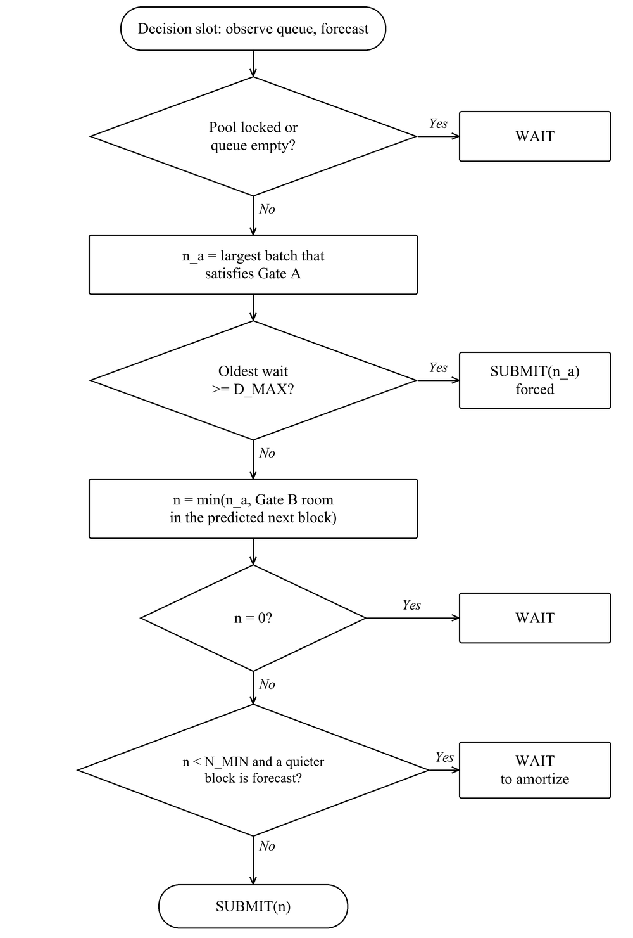
Fig. 2. Decision flow of the constrained optimizer P2 in one decision slot.

F. Chaining and Uniform Clearing
In the simulator a new batch may spend the pool output of a batch still in the mempool, so several batches can leave at one decision point; they resolve in order, and if a parent is rolled back or expires, its children go with it. In the batch builder, each direction clears at one price and opposite directions net against each other, so only the imbalance touches the pool. With a lovelace and b tokens sold into a pool holding x and y, and g = 1 − fee rate, the clearing price is
P = g(y + b) / (x + g·a) (8)
The outcome does not depend on queue order, so no order gains from its place in the queue and the batcher cannot reorder trades for its own profit.

G. Hardening of the Live Batcher
The live daemon reuses the simulator’s decision rules and adds protections found by reviewing the code against hostile and degraded conditions. An admission guard refuses orders with non-positive amounts, negative margins or undecodable addresses. Unfillable orders are quarantined, and a failed build is bisected to isolate a poison order without submitting. A watchdog releases the pool when a batch’s inputs disappear. Chain access retries with capped jittered backoff, trips a circuit breaker and fails over between providers, and a batch is considered settled only at a depth of three blocks. A self-calibrating capacity gate learns per-dimension corrections to its size and execution-unit estimates from measured transactions.

IV. EXPERIMENTAL SETUP

A. Data
The block history D1 holds 388,781 mainnet blocks over 92 days, collected from Koios with a Blockfrost fallback, resumable and checksummed, and split chronologically 70/15/15 into training, validation and test sets. Each row records the height, slot, body size, fill, transaction count and memory and step execution units. Fig. 3 shows its distribution: the median block is 3.0% full, 0.56% of blocks exceed 80% and 0.39% exceed 90%. A 30-order batch fails to fit a block only above about 89% fill, which happens in about one block in 180 and never for longer than five minutes at a stretch. The order stream D2 is simulated, with Poisson arrivals, a fitted daily shape and bursts, at three rates (light, matched and heavy). The measurements D4 are the size, execution units and fee of real batch transactions on the preprod testnet, and they calibrate Gate A.
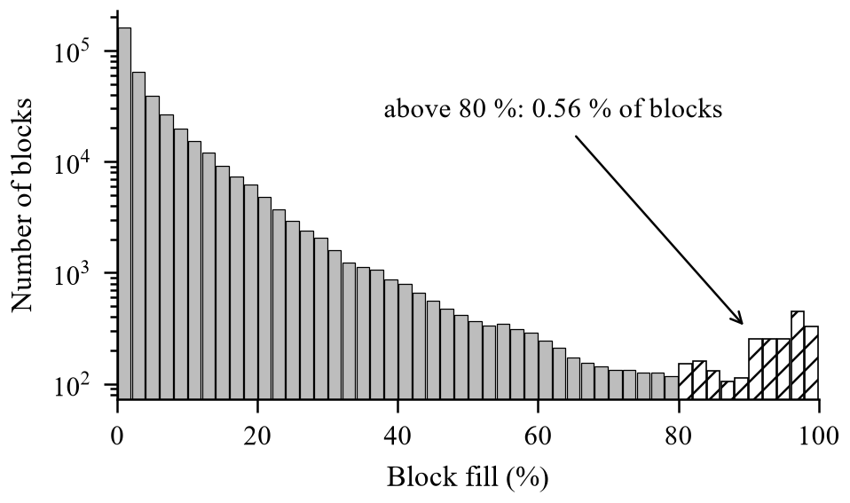
Fig. 3. Distribution of block fill over the 92-day collection window.
The per-transaction limits of 16,384 bytes and 14 million memory units cap a batch at 24 orders. Fig. 4 shows why batching pays: C_{user} falls steeply with batch size and flattens near ten orders, which bounds the useful range of N_{min}.
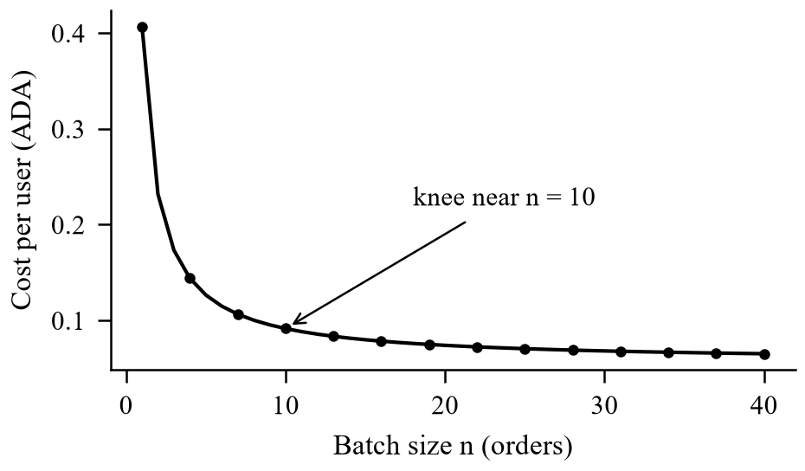
Fig. 4. Cost per user against batch size; the curve flattens near n = 10.

B. Simulator, Baselines and Parameters
The simulator replays the recorded blocks slot by slot with a first-in first-out queue, the pool lock, a Gate A and Gate B check on every submission, expiry of a batch after 600 slots and of an order after 3,600 slots, and rare rollbacks. The static baselines are E1 (submit when M orders have gathered), E2 (submit every T seconds) and E3 (greedy: submit everything every block); a null policy gives a reference. E1 and E2 were tuned on the validation split (M = 16, T = 20 s), and the tuned values are disclosed so that the comparison does not rest on a straw man. The test split was evaluated once. The principal parameters are listed in Table II. The simulation is slightly pessimistic, since a block producer might in reality include the batch in place of a marginal transaction.
TABLE II. Principal parameters.
Parameter | Value | Role
D_{max} | 120 s | Deadline for the oldest order
N_{min} | 4 orders (swept 1–20) | Amortization threshold
Forecast horizon | 3 blocks | Policy lookahead
Moving-average window | 20 blocks | Forecast reference
Batch / order TTL | 600 / 3,600 s | Expiry intervals
DQN training | 200,000 steps | 5 seeds (0 to 4)
Evaluation | 100 paired episodes | Per rate, test split

C. Metrics and Statistics
Latency runs from the arrival of an order to its settlement and is reported as the mean (L-mean) and the 95th percentile (L-p95, the slowest 5% of orders) in seconds; one slot is one second. Cost per user (C-user) is C_{user} from (2), in lovelace. The expiry rate (X-rate) is the share of orders that expire unsettled, and fairness is the Jain index [9] over per-order waits. An expired order counts at its wait until expiry, so an unsafe policy cannot hide its failures by dropping orders from the average. Policies are compared on paired episodes with 95% bootstrap confidence intervals, and Wilcoxon tests with Holm correction are applied to the family of comparisons.

V. RESULTS AND DISCUSSION

A. Congestion and Forecast Accuracy
The premise check comes first. Capacity rarely binds, and the limit on throughput is structural: one batch per decision point, through the pool lock, times the Gate A maximum of 24 orders. On the test split LightGBM has a lower mean absolute error than the moving average at every horizon (Table III and Fig. 5) and calls 74.2% of changes in the right direction. The root-mean-square errors are close, so the gain is in the typical error and in direction, not in rare spikes. A perfect forecast adds little to the policy: an oracle forecast gives a mean latency of 59.8 s against 60.9 s for P2 at matched load, as expected when capacity seldom binds.
TABLE III. Forecast accuracy on the test split (fill fraction).
Model | MAE t+1 | MAE t+3 | RMSE t+1 | Direction
LightGBM | 0.0458 | 0.0466 | 0.0836 | 74.2%
Moving average | 0.0516 | 0.0524 | 0.0836 | 71.0%
Historical mean | 0.0607 | 0.0607 | 0.0887 | 66.2%
Last value | 0.0607 | 0.0639 | 0.1004 | n/a

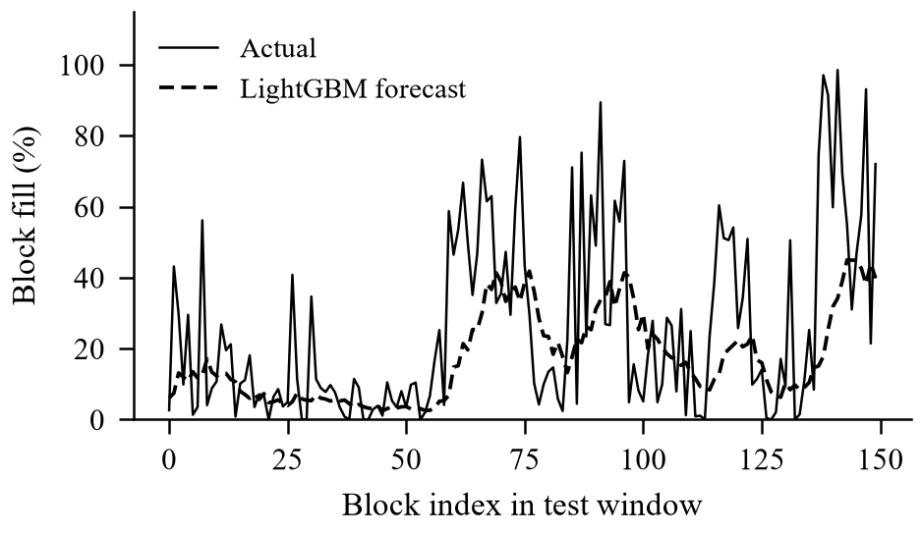
Fig. 5. Forecast against actual block fill over a 150-block window of the test split.

B. Cost and Latency
Table IV and Table V compare the policies at the matched and heavy arrival rates, as medians over 100 paired episodes. At matched load, P2 cuts C-user by 18.9% against greedy submission (127,738 against 157,445 lovelace) for 5.1 s more average wait (60.9 s against 55.8 s). Against the tuned interval batcher E2 it is faster on average (60.9 s against 63.4 s, with non-overlapping confidence intervals) and 1.5% cheaper. At the light rate the trade is larger, 25% cheaper for 20% more average wait; at the heavy rate it is 12% cheaper for 3% more. No adaptive policy beats greedy on tail latency, because on this chain capacity rarely binds and the gain to be had is in cost and fairness.
Reading Table IV. Each row is one batching policy. L-mean and L-p95 give the average and the 95th-percentile wait, C-user the fee each user pays and X-rate the share of orders that expired; lower is better in all four. Greedy (E3) is fastest but dearest, since it sends small batches every block. The size trigger E1 is cheap but slow, because orders sit until 16 have gathered. P2 sits in between, faster and cheaper than the tuned interval batcher E2. The oracle, which is P2 fed the true future fill, is only about one second faster than P2. The unshielded DQN is cheap but 59% slower than greedy on average.
TABLE IV. Test split, matched arrival rate (medians).
Policy | L-mean | L-p95 | C-user | X-rate
Null policy | 116.7 | 191.0 | 79,451 | 0.00
E1 size (M = 16) | 106.0 | 183.3 | 82,906 | 0.00
E2 interval (T = 20) | 63.4 | 130.5 | 129,729 | 0.00
E3 greedy (= P2, N = 1) | 55.8 | 119.0 | 157,445 | 0.00
P2 (N = 4) | 60.9 | 125.0 | 127,738 | 0.00
Oracle (N = 4) | 59.8 | 124.0 | 124,567 | 0.00
DQN (unshielded) | 88.9 | 158.6 | 89,704 | 0.00

TABLE V. Test split, heavy arrival rate (medians).
Policy | L-mean | L-p95 | C-user | X-rate
E1 size (M = 16) | 253.5 | 1,202.8 | 78,638 | 0.00
E2 interval (T = 20) | 88.7 | 253.5 | 95,427 | 0.00
E3 greedy (= P2, N = 1) | 66.2 | 162.0 | 116,556 | 0.00
P2 (N = 4) | 68.0 | 164.5 | 103,022 | 0.00
DQN (unshielded) | 220.9 | 863.3 | 85,187 | 0.07

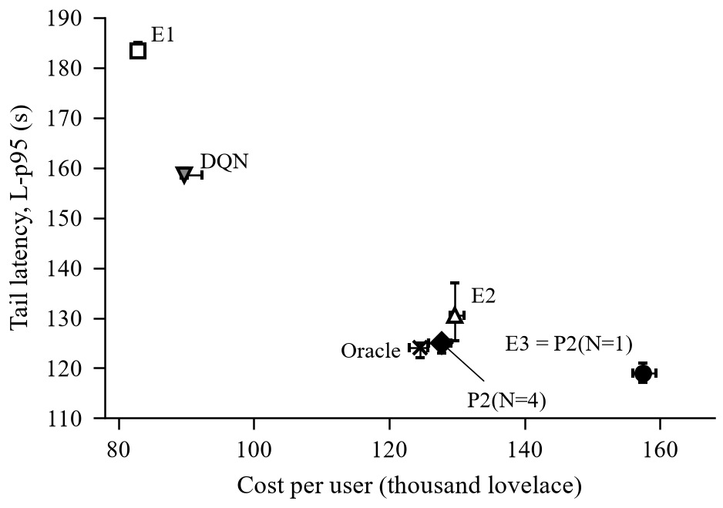
Fig. 6. Tail latency (L-p95, s) against cost per user at the matched rate, with 95% confidence intervals; lower-left is better.
Reading Fig. 6. Each point is one policy. Moving right costs more and moving up means longer waits, so lower-left is best. P2 sits below and to the left of E2, beating it on both counts. Only greedy waits less, and it charges each user 23% more. E1 and the DQN are the cheapest but have the longest tails. The oracle almost overlaps P2, so a perfect forecast would save only about one second, because block space rarely runs out.

C. Behaviour Under Load
The unshielded DQN reaches a low cost but pays for it in waiting (L-p95 158.6 s against 125.0 s for P2 at matched load), and it fails at heavy load, where its L-p95 is 863 s and 7% of orders expire on the test split (Fig. 7). On validation days at heavy load the recorded agent let 35.7% of orders expire at the median and 58.6% in the worst case. The size trigger E1 also collapses there, with an L-p95 of 1,203 s, while P2 stays within 2% of greedy (164.5 s against 162.0 s).
Reading Table VI. Each row adds one safeguard to the recorded agent. Forcing the largest legal batch at the deadline already stops all expiries. Passing unfamiliar states to P2 keeps that safety and gives the lowest cost of any safe option, because about 40% of decisions are then forced or delegated to P2.
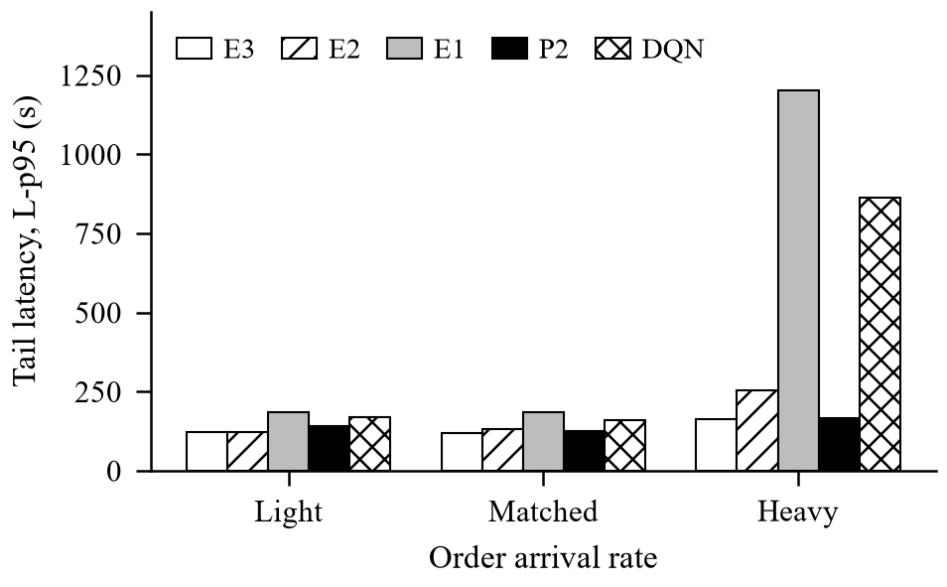
Fig. 7. Tail latency across the light, matched and heavy arrival rates.
TABLE VI. Heavy rate, validation episodes: effect of the safety shield.
Policy | L-p95 | Expired | C-user
DQN as recorded | 3,605 | 35.7% | 116,445
DQN + largest batch | 255.0 | 0% | 106,861
Shield (DQN to P2) | 245.5 | 0% | 79,487
P2 (N = 4) | 245.5 | 0% | 100,662

D. Chaining and Testnet Demonstration
A diagnosis on validation days found that no batch expired behind a full block at heavy load, while 7–10% of submissions left a backlog larger than one Gate A batch. The ceiling was therefore one batch per decision point, not congestion, which is why a deadline-aware policy alone did not help and chaining did. Allowing two chained batches nearly halves the heavy-load L-p95, from 245.5 s to 120.0 s, and cuts the share of orders settled after D_{max} from 16.4% to 5.0%, for 1.2% more cost. On the preprod testnet the batcher settled a batch transaction (one order, fee 322,697 lovelace) against the deployed pool validator. The transaction measured 2,682 bytes against an estimate of 800, which is why the capacity gate learns size corrections from real transactions instead of trusting a fixed estimate.

E. Discussion and Limitations
The central finding is a correction. The motivating claim of a congested chain was false: blocks are mostly empty, so forecasting capacity helps only defensively, and the real limit is the single lock on the pool. Greedy submission is therefore already close to optimal for latency, and the useful work of an adaptive policy is to trade a few seconds for fewer, fuller batches and so a lower cost per user, and to stay safe when load rises. The results should be read within their limits. They come from simulation on a single 92-day window and a single pool, with a synthetic order stream. Chaining exists only in the simulator, and the live daemon still locks the pool until settlement. The capacity calibrator’s error matching is text-based and has not been tested against real Ogmios or Blockfrost error bodies, and the testnet run settled a single-order batch. Both validators hard-wire one batcher key and orders carry no on-chain deadline. Finally, uniform clearing redistributes price impact across a batch by design, which is the defining property of a fair batch auction but remains a choice.

VI. CONCLUSION AND FUTURE WORK
This paper treated batching on a Cardano exchange as control of a shared pool lock under uncertain confirmation time. A measurement of 388,781 mainnet blocks showed that the bottleneck is the pool lock, not congestion. Against tuned static batchers, a forecast-driven rule cuts the cost per user by about 19% at matched load for about 5 s more average wait, a learned agent is safe only behind a shield, and no adaptive policy beats greedy submission on tail latency on today’s chain. The contributions are a measured correction of the premise, a simulator and evaluation protocol with disclosed baseline tuning, a hard-gated policy family with a safety shield, chaining and one-price clearing, and a working preprod demonstration.
Future work follows from the limitations. The first step is to enable chaining in the live daemon and to calibrate Gate A against multi-order live batches. The second is to evaluate on several pools, longer windows and recorded real order flow instead of a synthetic stream. The third is to repeat the study as protocol parameters change, since a larger block or a faster confirmation mechanism would change where capacity binds.
REFERENCES
[1] M. Chakravarty, J. Chapman, K. MacKenzie, O. Melkonian, M. Peyton Jones, and P. Wadler, “The extended UTXO model,” in Financial Cryptography and Data Security Workshops (FC), 2020.
[2] H. Nguyen Quang, “Concurrent & deterministic batching on the UTXO ledger,” MELD, Tech. Rep., 2021.
[3] P. Bruhwiler, “A concurrent DEX on Cardano,” B.Sc. thesis, Univ. of Bern, Bern, Switzerland, 2021.
[4] T. Roughgarden, “Transaction fee mechanism design: An economic analysis of EIP-1559,” in Proc. ACM Conf. Economics and Computation (EC), 2021.
[5] H. Mao, M. Alizadeh, I. Menache, and S. Kandula, “Resource management with deep reinforcement learning,” in Proc. ACM Workshop on Hot Topics in Networks (HotNets), 2016.
[6] G. Angeris and T. Chitra, “Improved price oracles: Constant function market makers,” in Proc. ACM Conf. Advances in Financial Technologies (AFT), 2020.
[7] G. Ke et al., “LightGBM: A highly efficient gradient boosting decision tree,” in Advances in Neural Information Processing Systems (NeurIPS), 2017.
[8] V. Mnih et al., “Human-level control through deep reinforcement learning,” Nature, vol. 518, no. 7540, pp. 529–533, 2015.
[9] R. Jain, D. Chiu, and W. Hawe, “A quantitative measure of fairness and discrimination for resource allocation in shared computer systems,” Digital Equipment Corp., Tech. Rep. DEC-TR-301, 1984.

