AI-Driven Adaptive Transaction Batching for Cardano Decentralized Exchanges
Vikranth Sai, Ganesh, Sowmya, Ms. B. Mamatha (Guide)
Department of Computer Science and Engineering (Data Science), Vignana Bharathi Institute of Technology, Hyderabad, India
[author e-mail IDs]

ABSTRACT
On Cardano a decentralized-exchange (DEX) liquidity pool is a single UTXO that can be consumed once per block, so swap orders are aggregated by off-chain batchers. Deployed batchers submit on constant triggers (every M orders or every T seconds) and never read the chain. Because Cardano fees are deterministic, a mistimed batch costs time rather than money: it holds the pool lock and delays every order behind it. We study batching as a control problem under a shared lock and uncertain confirmation time. We measured 388,781 mainnet blocks over 92 days and found a median block fill of 3.0% and only 0.56% of blocks above 80%, so the binding constraint is concurrency, not congestion. We build a discrete-event simulator that replays these blocks, and compare tuned static batchers with a LightGBM congestion forecaster, a forecast-then-optimize constrained policy (P2) and a masked DQN agent (P3) wrapped in a safety shield. At matched load on a held-out split, P2 lowers cost per user by 18.9% against greedy batching and keeps mean latency within 9%; no adaptive policy improves tail latency over greedy on today’s lightly loaded chain, and the unshielded DQN is unsafe at heavy load (35.7% of orders expired), a failure the shield removes. A minimal Aiken DEX settled a batch on the Cardano preprod testnet.
KEYWORDS
Cardano; eUTXO; transaction batching; decentralized exchange; reinforcement learning; congestion forecasting; discrete-event simulation

1. INTRODUCTION
1.1 Background
Cardano uses the extended UTXO (eUTXO) accounting model [1]. A constant-product liquidity pool is represented by one UTXO carrying the pool state, and every swap must spend and re-create it. A UTXO can be spent only once, so within a block at most one transaction can touch a given pool: a hundred users cannot swap against the pool independently, because one succeeds and the rest fail. The ecosystem solves this with batchers, off-chain agents that collect users’ swap orders (each a UTXO locked at an order address) and settle many of them in a single transaction that spends the pool once [2], [3].
1.2 Research Problem
The batchers in production fire on constants: every M orders, or every T seconds. They do not read block fullness, queue age or the confirmation delay they are about to incur. A submitted batch locks the pool until it confirms, so a mistimed submission blocks the head of the queue; a batch that is too small wastes the fixed transaction cost; a batch that waits too long delays users. No published batcher chooses when to submit and how many orders to include from the state of the chain.
1.3 Motivation
Cardano fees are deterministic, fee = 44·size + 155,381 + 0.0577·mem + 0.0000721·steps lovelace, with no bidding. A transaction costs the same on an idle and a saturated chain. Waiting therefore does not cost money; it costs time. The relevant objectives are confirmation latency and amortized per-user cost, not fees, which separates this problem from congestion-pricing analyses written for account-based chains such as Ethereum [4]. The project was originally motivated by a claim that Cardano blocks run at 80–90% capacity; we tested that claim before building on it (Section 5.1), and it did not hold.
1.4 Objectives
• Measure Cardano block congestion over a long window and establish whether it constrains batching.
• Build a trace-driven simulator with the pool lock, transaction limits, expiry and rollbacks, and tune the static baselines fairly.
• Design a forecaster, a constrained optimizer and a reinforcement-learning agent that decide WAIT or SUBMIT(n), with protocol limits enforced as hard gates.
• Evaluate against tuned baselines with paired episodes and confidence intervals, and demonstrate the pipeline on the preprod testnet.
1.5 Contributions of the Research
• A measured premise correction. Over 388,781 mainnet blocks the median fill is 3.0% and the longest run above 80% is 10 blocks (five minutes); the binding problem is one writer per pool per block.
• A batching formulation under a shared lock, with two hard capacity gates (per transaction and per block) that are enforced structurally rather than learned.
• Three policies and a safety shield: a LightGBM forecaster, a forecast-then-optimize policy, and a masked DQN agent protected by a runtime shield; plus transaction chaining and uniform-price clearing.
• An honest evaluation: cost and fairness improve; tail latency does not beat greedy on today’s chain, and the unshielded agent fails under load it was not trained on.

2. RELATED WORK / LITERATURE REVIEW
2.1 Existing Research
Chakravarty et al. formalize the eUTXO model with datums, redeemers and validator scripts, giving deterministic fees and local validation but also the single-UTXO concurrency bottleneck for shared state [1]. Nguyen Quang (MELD) proposes deterministic batching in which orders posted as UTXOs are aggregated into one pool-state update, resolving contention without incentivized agents but with a static policy [2]. Bruhwiler analyzes the concurrency problem for AMM-style DEXs and implements a concurrent DEX prototype, focusing on correctness rather than batch timing [3].
Roughgarden analyzes transaction-fee mechanism design for EIP-1559, where a demand-responsive base fee prices block space [4]. That model does not transfer to Cardano, where congestion produces latency rather than a higher price. Mao et al. show that deep reinforcement learning can learn multi-resource scheduling policies that match hand-tuned heuristics [5]; it is built for datacenter jobs and is unaware of block limits and eUTXO batching. Angeris and Chitra study constant-function market makers, the pool model the batcher settles against [6].
2.2 Existing Methods / Approaches
Table 1. Literature comparison.
Work | Method | Advantages | Limitations
eUTXO model [1] | Formal eUTXO specification | Deterministic, verified validation | Single-UTXO concurrency bottleneck
MELD batching [2] | Deterministic order batching | Resolves contention; amortizes cost | Static, not congestion-aware
Concurrent DEX [3] | Concurrent DEX prototype | Scalable concurrent swaps | No congestion-aware batching
EIP-1559 [4] | Fee-mechanism analysis | Models congestion pricing | Inapplicable to fixed fees
DeepRM [5] | Deep RL scheduling | Learns adaptive policies | Not blockchain-aware

The static batchers used as baselines in this work are E1 (submit when M orders have gathered), E2 (submit every T seconds) and E3 (greedy: submit everything every block). A fourth reference, E4, is a moving-average congestion estimate used only as a forecasting baseline.
2.3 Research Gap
Existing Cardano batchers use fixed rules and ignore the state of the chain; no method adapts batch size or timing to forecast capacity and queue state; and the surrounding literature optimizes fees, which is the wrong metric on Cardano. We found no congestion-aware, learning-based batcher that optimizes latency and per-user cost under Cardano’s transaction and block limits.

3. PROBLEM STATEMENT
3.1 Problem Definition
At each block slot the batcher observes the queue of pending orders (depth, oldest wait, per-order size and execution units), whether the pool is locked, and a forecast of the next blocks’ fill. It chooses WAIT or SUBMIT(n), the first n orders in the queue. Submission locks the pool until the batch is included or its validity interval expires. The goal is to minimize confirmation latency and amortized cost per user, subject to (i) per-transaction limits (Gate A), (ii) the predicted per-block headroom (Gate B), and (iii) a starvation deadline D_MAX on the oldest order.
3.2 Scope of the Research
The system is an off-chain, server-side batcher. It has no website, browser extension or wallet code: a wallet sees only its own owner’s funds, so aggregation is inherently the batcher’s job. Results are obtained by replaying real mainnet blocks against a simulated order stream; a minimal Aiken DEX on the preprod testnet demonstrates the pipeline. Wallet changes, protocol changes and mainnet deployment are out of scope.
3.3 Research Questions / Objectives
• RQ1. Does block congestion constrain batching on today’s Cardano chain, and is it predictable at a short horizon?
• RQ2. Does a congestion-aware policy reduce latency or per-user cost against tuned static batchers, and at which arrival rates?
• RQ3. Can a learned agent be made safe under load beyond its training distribution?

4. PROPOSED METHODOLOGY / SYSTEM
4.1 Overview of Proposed Approach
The system is an event-driven control loop around a forecast-then-decide pipeline, with an offline simulator that can substitute for the live chain. Three properties drive the design. The environment is partially observable: the batcher cannot know how full the next block will be or how long its own batch will take. There is one shared resource, the pool UTXO, so the system is a lock manager under uncertain service time. And the constraints are hard and external: capacity limits come from the protocol and are enforced structurally.
4.2 System Architecture / Framework
Figure 1 shows four layers. The on-chain layer holds order UTXOs, the pool UTXO and the Aiken validators. A data layer collects blocks from Koios and Blockfrost into a feature store. The off-chain batcher consists of a collector (M1), forecaster (M2), order-queue manager (M3), policy (M4) and builder/submitter (M5). An offline layer (M6) replays real blocks, runs baselines and computes metrics.
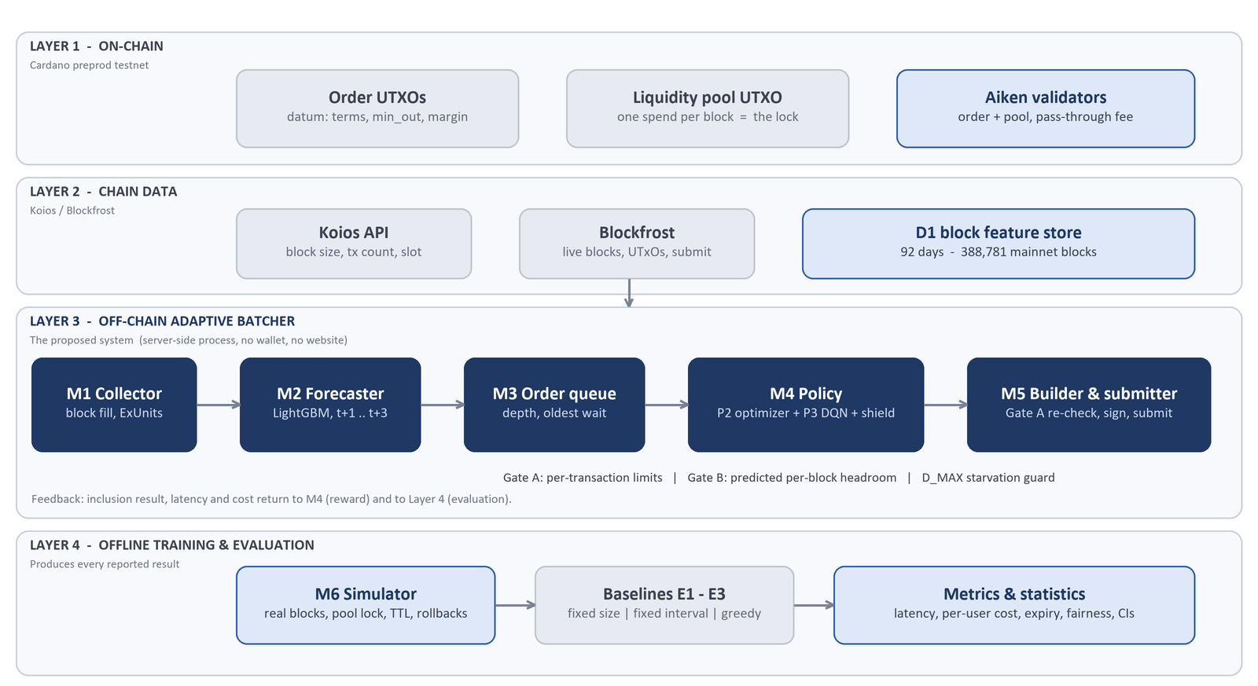
Fig. 1. System architecture: on-chain, data, off-chain adaptive batcher and offline evaluation layers.
4.3 Method / Algorithm
Gates. Gate A bounds the batch by per-transaction limits (16,384 bytes and 14 million memory units); in practice this caps a transaction at 24 orders. Gate B bounds the batch by the predicted headroom of the next block. Both are enforced inside the policy loop so an infeasible batch is never proposed.
P1, congestion forecaster. LightGBM predicts the fill of blocks t+1 to t+3 from lagged fill, execution units and transaction counts, rolling statistics and time features, trained on a chronological split. A moving average over the last 20 blocks (E4) is kept as the reference the forecaster must beat.
P2, forecast-then-optimize. If the pool is locked or the queue is empty, WAIT. Otherwise compute the largest feasible batch n under Gate A and Gate B. If the oldest order has waited at least D_MAX (120 slots), SUBMIT the Gate A maximum. If n = 0, WAIT. If n is below N_MIN (8, near the knee of the amortization curve) and a quieter block is forecast within the horizon, WAIT to amortize; otherwise SUBMIT(n). The rule is deterministic, runs in O(|Q|) and is explainable.
P3, RL agent. A masked DQN over the actions WAIT and SUBMIT(n) for n in {1, 4, 8, 12, 16, 20, 25, 30}, with illegal actions masked. The state combines queue depth, oldest and mean wait, forecast fill, forecast headroom and the recent success rate; the reward penalizes per-user cost, latency and expiry.
Safety shield. Around P3, a forced submission always uses the Gate A maximum once the deadline is reached; observations outside the trained range (queue depth or oldest wait) hand the decision to P2; every action is clamped to legal limits.
Chaining and uniform clearing. In the simulator a new batch may spend the pool output of a batch still in the mempool, so several batches can leave at one decision point; a parent’s rollback or expiry takes its children down. In the batch builder, all same-direction orders in a batch clear at one price and opposite-direction orders net against each other, which makes the outcome order-independent and removes the batcher’s ability to reorder for its own benefit.
4.4 Workflow / Process
A user locks funds at the order address with a datum (terms, minimum output, margin). The collector reads each new block; the forecaster produces fill predictions; the policy combines them with the queue state and returns an action; the builder re-checks Gate A, builds a fee-exact transaction in two passes, signs and submits it. The pool stays locked until the batch is included at depth three (or expires after a 600-slot validity interval), after which swapped tokens appear at each user’s return address.
4.5 Implementation Approach
The batcher is implemented in Python. The live daemon reuses the simulator’s decision rules and adds an admission guard (rejecting non-positive amounts, negative margins and undecodable addresses), quarantine with bisection for unfillable orders, an input-liveness watchdog that releases the pool when a batch’s inputs vanish, resilient chain access (capped jittered retries, a circuit breaker and provider failover), settlement depth with a grace re-check at expiry, and a self-calibrating capacity gate that learns per-dimension size and execution-unit corrections from measured transactions.

5. EXPERIMENTAL SETUP / IMPLEMENTATION
5.1 Dataset / Data Description
D1, block history (secondary, collected). 388,781 mainnet blocks over 92 days from Koios with a Blockfrost fallback, resumable and checksummed, split chronologically 70/15/15 into training, validation and test. Each row holds height, slot, body size, fill percentage, transaction count and memory and step execution units. Figure 2 shows the distribution of block fill: the median is 3.0%, 0.56% of blocks exceed 80% and 0.39% exceed 90%.
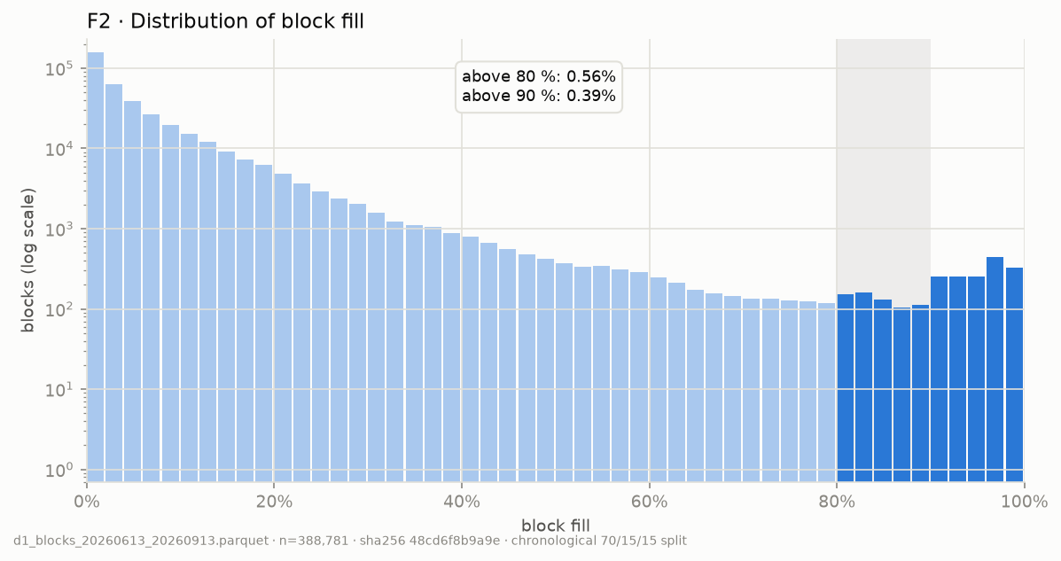
Fig. 2. Distribution of block fill over the collection window (log-scaled counts).
D2, order stream (primary, simulated). Poisson arrivals with a fitted daily shape and bursts, drawn at three rates (light, matched, heavy). D4, testnet measurements. Size, execution units and fee of real batch transactions on preprod, used to calibrate Gate A. Figure 3 shows the amortization curve that motivates batching: per-user cost falls steeply and flattens near ten orders.
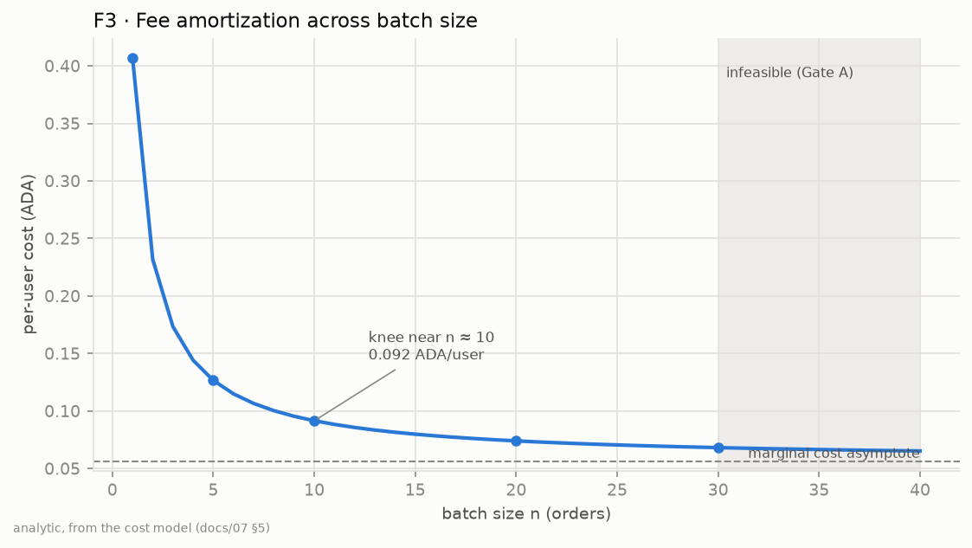
Fig. 3. Per-user cost against batch size; the curve flattens near n = 10.
5.2 Hardware and Software
All reported results come from a single Python process on a laptop with no GPU and no network. Live mode, used only for the testnet demonstration, adds Koios/Blockfrost access and a signing key held outside the repository.
5.3 Tools / Technologies
Python 3.12; LightGBM for forecasting; PyTorch and Gymnasium for the DQN and its environment; PyCardano with Koios and Blockfrost for chain access; Aiken (Plutus V3) for the order and pool validators; pytest and ruff with a CI secret scan for quality.
5.4 Experimental Parameters
Table 2. Principal parameters.
Parameter | Value | Role
D_MAX | 120 slots | Starvation deadline for the oldest order
N_MIN | 8 orders | Amortization threshold (knee of cost curve)
Forecast horizon / window | 3 blocks / 20 blocks | Policy lookahead / moving-average baseline
Batch TTL / order TTL | 600 / 3,600 slots | Validity interval / order lifetime in queue
Action buckets | 1, 4, 8, 12, 16, 20, 25, 30 | DQN SUBMIT(n) choices (clamped to Gate A)
DQN training | 200,000 steps, 5 seeds | Seeds 0 to 4
Evaluation | 100 paired episodes per rate | Test split; 95% bootstrap confidence intervals

Static baselines were tuned on the validation split (E1 with M = 16, E2 with T = 20 s) and the tuned values are disclosed, so that the comparison does not rest on a straw man. The test split was evaluated once.
5.5 Evaluation Metrics
Mean and 95th-percentile confirmation latency (L-mean, L-p95, seconds from order arrival to settlement); mean cost per user (C-user, lovelace, fee divided by orders in the batch); order-expiry rate (X-rate); throughput (orders settled per 1,000 slots); and fairness as the Jain index [9] over per-order waiting times. Latency in the reported tables counts expired orders at their wait until expiry, so an unsafe policy cannot hide its failures. Paired episodes, bootstrap confidence intervals and Wilcoxon tests with Holm correction are used.

6. RESULTS
6.1 Experimental Results
Premise (RQ1). Median block fill is 3.0%, 0.56% of 388,781 blocks exceed 80%, and the longest unbroken run above 80% is 10 blocks (five minutes). A 30-order batch fails to fit a block only above roughly 89% fill, about one block in 180. Capacity rarely binds; the limit on throughput is structural, one batch per decision point (the pool lock) times the Gate A maximum of 24 orders.
Forecast. On the test split LightGBM improves mean absolute error over the moving average at every horizon (Table 3). Root-mean-square error is comparable, so the gain is in typical error and direction rather than in rare spikes. An oracle forecast adds little over P2 (59.8 s against 60.9 s mean latency at matched load), which is consistent with how rarely capacity binds.
Table 3. Forecast accuracy on the test split (fill fraction).
Model | MAE t+1 | MAE t+2 | MAE t+3 | RMSE t+1 | Direction t+1
LightGBM | 0.0458 | 0.0462 | 0.0466 | 0.0836 | 74.2%
Moving average (E4) | 0.0516 | 0.0520 | 0.0524 | 0.0836 | 71.0%
Historical mean | 0.0607 | 0.0607 | 0.0607 | 0.0887 | 66.2%
Last value | 0.0607 | 0.0623 | 0.0639 | 0.1004 | n/a

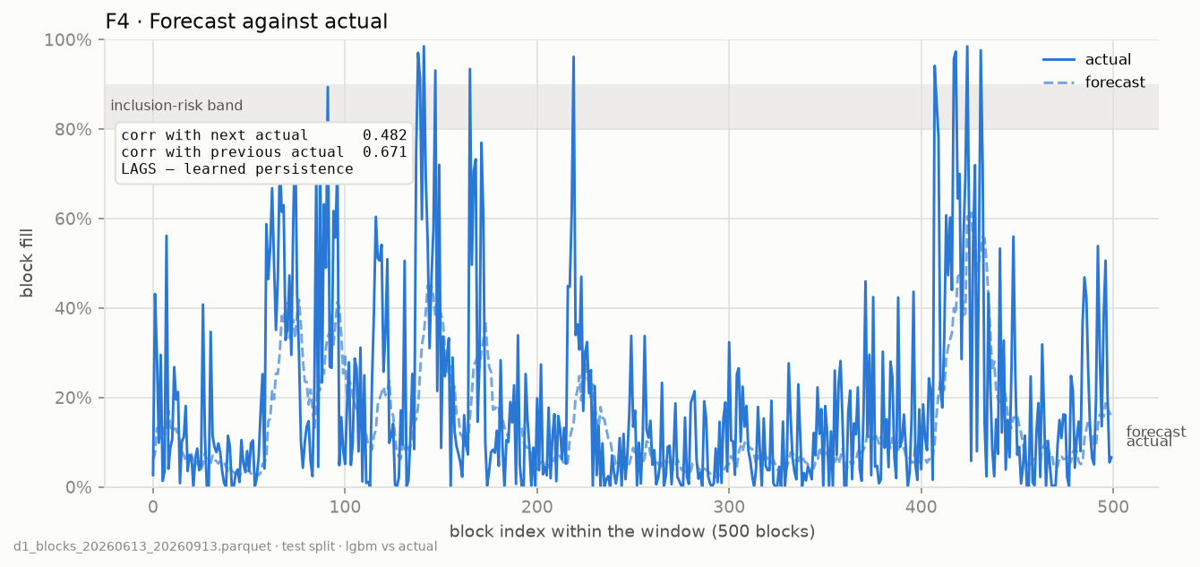
Fig. 4. Forecast against actual block fill over a 500-block window.
6.2 Tables
Table 4 gives the matched-rate comparison and Table 5 the heavy-rate comparison on the test split. Values are medians over 100 paired episodes.
Table 4. Test split, matched arrival rate (medians).
Policy | L-mean (s) | L-p95 (s) | C-user (lovelace) | X-rate
Null policy (reference) | 116.7 | 191.0 | 79,451 | 0.00
E1 fixed size (M = 16) | 106.0 | 183.3 | 82,906 | 0.00
E2 fixed interval (T = 20) | 63.4 | 130.5 | 129,729 | 0.00
E3 greedy (= P2, N = 1) | 55.8 | 119.0 | 157,445 | 0.00
P2 (D = 120, N = 4) | 60.9 | 125.0 | 127,738 | 0.00
Oracle forecast (N = 4) | 59.8 | 124.0 | 124,567 | 0.00
P3 DQN (unshielded) | 88.9 | 158.6 | 89,704 | 0.00

Table 5. Test split, heavy arrival rate (medians).
Policy | L-mean (s) | L-p95 (s) | C-user (lovelace) | X-rate
E1 fixed size (M = 16) | 253.5 | 1,202.8 | 78,638 | 0.00
E2 fixed interval (T = 20) | 88.7 | 253.5 | 95,427 | 0.00
E3 greedy (= P2, N = 1) | 66.2 | 162.0 | 116,556 | 0.00
P2 (D = 120, N = 4) | 68.0 | 164.5 | 103,022 | 0.00
P3 DQN (unshielded) | 220.9 | 863.3 | 85,187 | 0.07

6.3 Graphs / Figures
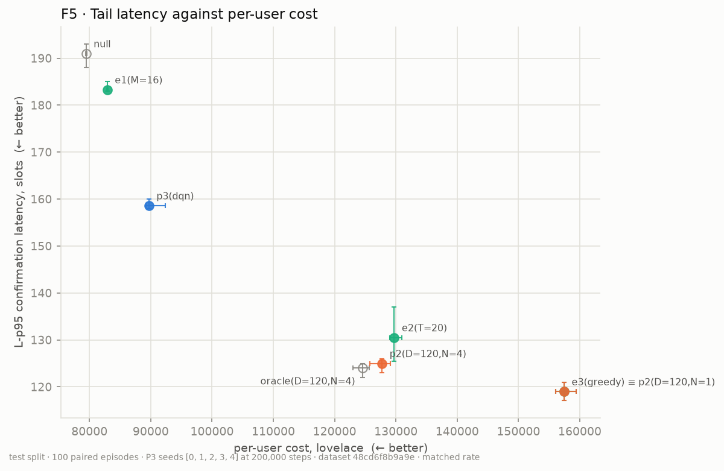
Fig. 5. Tail latency against per-user cost at matched rate, with 95% confidence intervals.
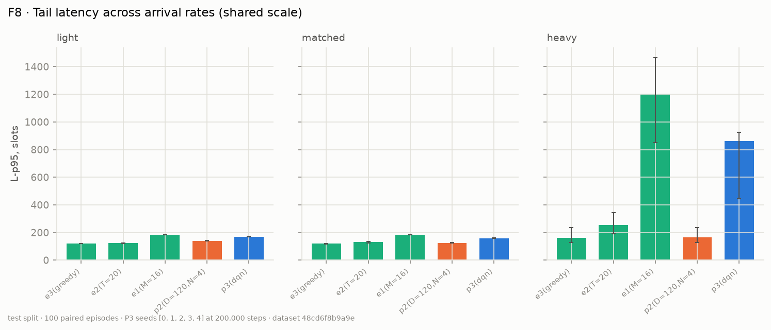
Fig. 6. Tail latency across light, matched and heavy arrival rates (shared scale).
6.4 Performance Evaluation
Cost and latency (RQ2). At matched load P2 (N = 4) reduces cost per user by 18.9% against greedy batching (127,738 against 157,445 lovelace) at a mean latency 9% higher (60.9 s against 55.8 s). Against the tuned fixed-interval batcher E2 it is better on mean latency (60.9 against 63.4 s, non-overlapping confidence intervals) and similar on cost. At the light rate the trade is larger (cost −25%, latency +20%); at the heavy rate it is cost −12% for +3% latency. No adaptive policy beats greedy on tail latency, because on this chain capacity rarely binds and the achievable gain is cost and fairness. The fixed-size batcher E1 collapses at heavy load (L-p95 1,203 s).
The learned agent (RQ3). The unshielded DQN reaches low cost but pays for it in latency (L-p95 158.6 s against 125.0 s for P2 at matched load) and fails outright at heavy load (L-p95 863 s, 7% expiry on the test split). On validation days at heavy load the recorded agent expired 35.7% of orders on median (58.6% worst case). Table 6 shows that the shield removes the failure: expiry falls to zero and, because about 40% of decisions are forced or delegated to P2, cost per user is the lowest of the safe options.
Table 6. Heavy rate, validation episodes: effect of the safety shield (medians).
Policy | L-p95 (s) | Expired (median / max) | C-user (lovelace)
DQN as recorded | 3,605 | 35.7% / 58.6% | 116,445
DQN + largest-batch repair | 255.0 | 0 / 0 | 106,861
Shield (DQN → P2) | 245.5 | 0 / 0 | 79,487
P2 (N = 4) | 245.5 | 0 / 0 | 100,662

Chaining. Diagnosis on validation days found that no batch expired behind a full block at heavy load, while 7–10% of submissions left a backlog larger than one Gate A batch: the ceiling was one batch per decision point, not congestion. Allowing two chained batches cuts L-p95 from 245.5 to 120.0 s and the share of orders settled after D_MAX from 16.4% to 5.0%, at +1.2% cost.
Testnet demonstration. On preprod the batcher settled a batch transaction (one order, fee 322,697 lovelace) against the deployed pool validator. The measured transaction was 2,682 bytes against an estimate of 800, which is why the capacity gate learns size corrections from real transactions instead of trusting a static estimate.

7. DISCUSSION
7.1 Interpretation of Results
The central finding is a correction. The motivating claim of a congested chain was false: blocks are mostly empty, so forecasting capacity helps only defensively, and the real limit is the single lock on the pool. The consequence is visible in the results. Greedy submission is already near-optimal for latency, so the useful work of an adaptive policy is to trade a few seconds for fewer, fuller batches and therefore a lower cost per user, and to stay safe when load rises.
7.2 Key Findings
• Congestion is rare on Cardano (median fill 3.0%); concurrency is the binding constraint.
• LightGBM beats a moving average on MAE (0.0458 against 0.0516) and direction (74.2% against 71.0%), but a perfect forecast adds almost nothing to the policy.
• P2 lowers cost per user by about 19% at matched load for a 9% rise in mean latency, and is not worse than the tuned fixed-interval batcher.
• An unshielded RL agent is unsafe beyond its training distribution; a runtime shield and chaining remove the failure without retraining.
7.3 Advantages
Hard gates make capacity violations impossible by construction; the optimizer is deterministic and explainable and doubles as the shield’s fallback; uniform clearing is order-independent and prevents reordering for the batcher’s benefit; and every result is reproducible from run manifests with paired statistics.
7.4 Limitations
• Results are obtained in simulation on one 92-day window and a single pool, with a synthetic order stream.
• Chaining exists only in the simulator; the live daemon still locks the pool until settlement.
• The capacity calibrator’s error matching is text-based and untested against real Ogmios or Blockfrost error bodies; the testnet run settled a single-order batch.
• Both validators hard-wire one batcher key, with no rotation, and orders carry no on-chain deadline.
• Uniform clearing redistributes price impact across a batch by design.

8. CONCLUSION AND FUTURE WORK
8.1 Conclusion
We formulated Cardano DEX batching as control of a shared pool lock under uncertain confirmation time, measured the chain to find that concurrency rather than congestion is the binding constraint, and compared tuned static batchers with a forecast-then-optimize policy and a shielded RL agent. The constrained optimizer reduces cost per user by about 19% at matched load for a small latency increase, the learned agent is safe only behind a shield, and no adaptive policy beats greedy on tail latency on today’s chain.
8.2 Research Contribution
A measured correction of the congestion premise; a simulator and evaluation protocol with disclosed baseline tuning; a hard-gated policy family with a safety shield, chaining and uniform clearing; and a working preprod demonstration.
8.3 Future Work
Enable chaining in the live daemon; calibrate Gate A against multi-order live batches; evaluate on multiple pools, longer windows and recorded real order flow; and re-run the study as protocol parameters change, since a larger block or a faster confirmation mechanism would change where capacity binds.

REFERENCES
[1] M. Chakravarty, J. Chapman, K. MacKenzie, O. Melkonian, M. Peyton Jones and P. Wadler, “The Extended UTXO Model,” in Financial Cryptography and Data Security Workshops (FC), 2020.
[2] H. Nguyen Quang (MELD), “Concurrent & Deterministic Batching on the UTXO Ledger,” MELD Technical Report, 2021.
[3] P. Bruhwiler, “A Concurrent DEX on Cardano,” B.Sc. thesis, University of Bern, 2021.
[4] T. Roughgarden, “Transaction Fee Mechanism Design: An Economic Analysis of EIP-1559,” in Proc. ACM Economics and Computation (EC), 2021.
[5] H. Mao, M. Alizadeh, I. Menache and S. Kandula, “Resource Management with Deep Reinforcement Learning,” in Proc. ACM HotNets, 2016.
[6] G. Angeris and T. Chitra, “Improved Price Oracles: Constant Function Market Makers,” in Proc. ACM Advances in Financial Technologies (AFT), 2020.
[7] G. Ke et al., “LightGBM: A Highly Efficient Gradient Boosting Decision Tree,” in Advances in Neural Information Processing Systems (NeurIPS), 2017.
[8] V. Mnih et al., “Human-level control through deep reinforcement learning,” Nature, vol. 518, pp. 529–533, 2015.
[9] R. Jain, D. Chiu and W. Hawe, “A Quantitative Measure of Fairness and Discrimination for Resource Allocation in Shared Computer Systems,” DEC Technical Report TR-301, 1984.

