AI-Driven Adaptive Transaction Batching for Cardano Decentralized Exchanges
Ms. B. Mamatha¹  Guide, CSE (Data Science)  Vignana Bharathi Institute of Technology, Hyderabad, India | Vikranth Sai²  UG Scholar, CSE (Data Science)  Vignana Bharathi Institute of Technology, Hyderabad, India  Email: 23p61a67f1@vbithyd.ac.in
Ganesh³  UG Scholar, CSE (Data Science)  Vignana Bharathi Institute of Technology, Hyderabad, India  Email: 23p61a67f0@vbithyd.ac.in | Sowmya⁴  UG Scholar, CSE (Data Science)  Vignana Bharathi Institute of Technology, Hyderabad, India  Email: 23p61a67h8@vbithyd.ac.in

Abstract—This work belongs to the area of blockchain systems and applied machine learning, specifically the batching of swap orders on a Cardano decentralized exchange. A liquidity pool on Cardano is a single UTXO that can be spent once per block, so off-chain batchers aggregate orders; the batchers in use submit on constant triggers and never read the chain, and because Cardano fees are deterministic a mistimed batch costs time, not money. This paper treats batching as control of a shared lock under uncertain confirmation time. Over 388,781 mainnet blocks the median block is 3.0% full and only 0.56% exceed 80%, so the binding constraint is concurrency, not congestion. A discrete-event simulator replays these blocks to compare tuned static batchers with a LightGBM congestion forecaster, a forecast-then-optimize policy (P2) and a masked DQN agent behind a safety shield. At matched load on a held-out split, P2 lowers the cost per user by 18.9% against greedy submission for a 9% rise in mean latency; no adaptive policy improves tail latency over greedy on today’s lightly loaded chain, and the unshielded agent expires 35.7% of orders at heavy load, a failure the shield removes. A minimal Aiken exchange settled a batch on the Cardano preprod testnet.
Index Terms—Cardano, eUTXO, Transaction Batching, Decentralized Exchange, Reinforcement Learning, Congestion Forecasting, Discrete-Event Simulation.

I. INTRODUCTION
Cardano records ownership with the extended UTXO (eUTXO) model [1]. The liquidity pool of a decentralized exchange (DEX) is held in one UTXO that carries the pool’s state, and every swap must spend and re-create it. Because a UTXO can be spent only once, at most one transaction can touch a given pool in a block: a hundred users cannot swap against it independently, since one succeeds and the rest fail. The ecosystem therefore uses batchers, off-chain agents that collect the swap orders users have locked at an order address and settle many of them in a single transaction that spends the pool once [2], [3].
The batchers in production trigger on constants: every M orders, or every T seconds. They do not read how full recent blocks were, how old the oldest order is, or how long their own batch is likely to take to confirm. This matters because a submitted batch locks the pool until it is included. A batch sent at the wrong moment blocks every order behind it, a batch that is too small spreads the fixed transaction cost over few users, and a batch that waits too long delays the users it holds.
Cardano’s fees are deterministic: fee = 44·size + 155,381 + 0.0577·mem + 0.0000721·steps lovelace, with no bidding. A transaction costs the same on an idle chain and on a saturated one, so waiting does not cost money; it costs time. The objective is therefore confirmation latency and amortized cost per user, not fees, which separates the problem from the congestion-pricing analyses written for account-based chains such as Ethereum [4]. The project was first motivated by a claim that Cardano blocks run at 80–90% of capacity. We tested the claim on 92 days of mainnet data before building on it, and it did not hold: the median block is 3.0% full (Section IV-A).
The problem addressed in this paper is therefore narrower than a general call for intelligent batching. It is how to choose, from the state of the queue and of the chain, when to submit a batch and how many orders to include, when the shared resource is the pool lock, when confirmation time is uncertain, and when protocol limits must never be violated. We make four contributions. We report a measurement of block congestion that corrects the premise and identifies concurrency as the binding constraint. We formulate batching under a pool lock with two hard capacity gates. We design a LightGBM forecaster, a forecast-then-optimize policy and a masked DQN agent protected by a runtime safety shield, together with transaction chaining and uniform-price clearing. And we evaluate them against tuned static batchers on held-out data, finding that cost and fairness improve while tail latency does not beat greedy submission on today’s chain. The system is described in Section III and evaluated in Sections IV and V.

II. RELATED WORK
Chakravarty et al. formalize the eUTXO model with datums, redeemers and validator scripts [1]. It gives deterministic fees and local validation, but also the single-UTXO concurrency bottleneck for any state that many users share. Nguyen Quang proposes deterministic batching in which orders posted as individual UTXOs are aggregated into one pool-state update [2]. This resolves contention without incentivized agents, but the policy that decides when to batch is static. Bruhwiler analyzes the same concurrency problem for AMM-style exchanges and implements a concurrent DEX prototype [3]; the work concerns correctness, not batch timing or size under load.
Outside Cardano, Roughgarden analyzes transaction-fee mechanism design for EIP-1559, where a demand-responsive base fee prices block space [4]. The model describes Ethereum and does not transfer to Cardano, where congestion produces delay and not a higher price. Mao et al. show that deep reinforcement learning can learn multi-resource scheduling policies that match hand-tuned heuristics [5], but their setting is datacenter jobs, with no block limits and no pool lock. Angeris and Chitra study constant-function market makers, the pool model against which the batcher settles [6]. Table I summarizes the comparison.
TABLE I. Comparison of the related work.
Work | Approach | Limitation here
eUTXO model [1] | Formal ledger specification | Single-UTXO concurrency bottleneck
MELD batching [2] | Deterministic order batching | Static policy; not congestion-aware
Concurrent DEX [3] | Concurrent DEX prototype | No batch timing or sizing
EIP-1559 [4] | Fee-mechanism analysis | Inapplicable to fixed fees
DeepRM [5] | Deep RL scheduling | Not blockchain-aware

The gap is therefore clear. Existing Cardano batchers use fixed rules and ignore the state of the chain; no published method adapts batch size or timing to forecast capacity and queue state; and the adjacent literature optimizes fees, which is the wrong objective here. We found no congestion-aware, learning-based batcher that optimizes latency and per-user cost under Cardano’s transaction and block limits.

III. SYSTEM DESIGN

A. Problem Formulation
At each block slot the batcher observes the queue of pending orders (depth, oldest wait, and the size and execution units of each order), whether the pool is locked, and a forecast of the fill of the next blocks. It chooses WAIT or SUBMIT(n), the first n orders of the queue. Submission locks the pool until the batch is included or its validity interval expires, and while a batch is in flight no further decision exists; orders accumulate behind it. The goal is to minimize confirmation latency and amortized cost per user subject to three constraints: the per-transaction limits (Gate A), the predicted headroom of the next block (Gate B), and a starvation deadline D_MAX on the oldest order.

B. Architecture
The system is an event-driven control loop around a forecast-then-decide pipeline, with an offline simulator that can replace the live chain (Fig. 1). The batcher is a server-side process; it has no website, extension or wallet code, because a wallet sees only its owner’s funds and aggregation is inherently the batcher’s job. A collector (M1) reads blocks from Koios and Blockfrost into a feature store, a forecaster (M2) predicts block fill, a queue manager (M3) tracks pending orders, a policy (M4) chooses the action, and a builder (M5) re-checks Gate A, signs and submits the batch. Three properties drive the design: the environment is partially observable, the pool lock is the one shared resource, and capacity limits come from the protocol and are enforced structurally, not learned.
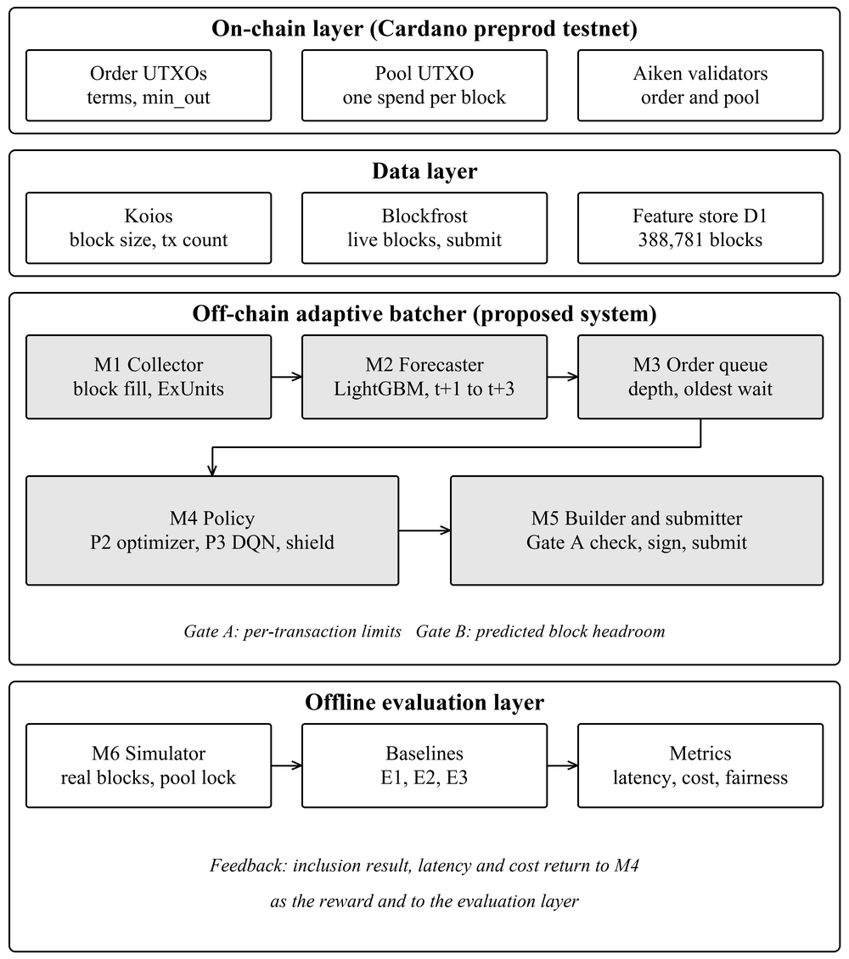
Fig. 1. Architecture of the proposed system: the on-chain layer, the data layer, the off-chain adaptive batcher and the offline evaluation layer.

C. Congestion Forecaster
LightGBM predicts the fill of blocks t+1 to t+3 from lagged fill, execution units and transaction counts, rolling statistics and time-of-day features, and it is trained on a chronological split so that the future never leaks into training [7]. A moving average over the last 20 blocks serves as the reference that the forecaster must beat. The forecast is a secondary, defensive input: it lets the policy avoid the rare full block and wait for a quieter one.

D. Constrained Batch Optimizer
The policy P2 is a forecast-then-optimize rule whose decision flow is shown in Fig. 2. If the pool is locked or the queue is empty it waits. Otherwise it computes the largest batch that satisfies Gate A, and if the oldest order has waited at least D_MAX (120 s) it submits that batch regardless of cost. It then limits the batch to the room predicted in the next block (Gate B) and waits if nothing fits. Finally, if the batch is smaller than N_MIN (8 orders, near the knee of the amortization curve) and a quieter block is forecast within three blocks, it waits so that the fixed cost can be shared; otherwise it submits. Both gates are enforced inside the rule, so an infeasible batch is never proposed. The rule is deterministic, runs in O(|Q|) and is explainable.

E. Learning Agent and Safety Shield
The agent P3 is a masked DQN [8] over the actions WAIT and SUBMIT(n) for n in {1, 4, 8, 12, 16, 20, 25, 30}, with illegal actions removed before selection. Its state holds the queue depth, the oldest and mean wait, the forecast fill and headroom and the recent success rate, and its reward penalizes cost per user, latency and expiry. Because a learned policy can fail outside its training range, a runtime shield wraps it. A forced submission always uses the Gate A maximum, observations outside the trained range of queue depth or oldest wait are delegated to P2, and every action is clamped to legal limits.
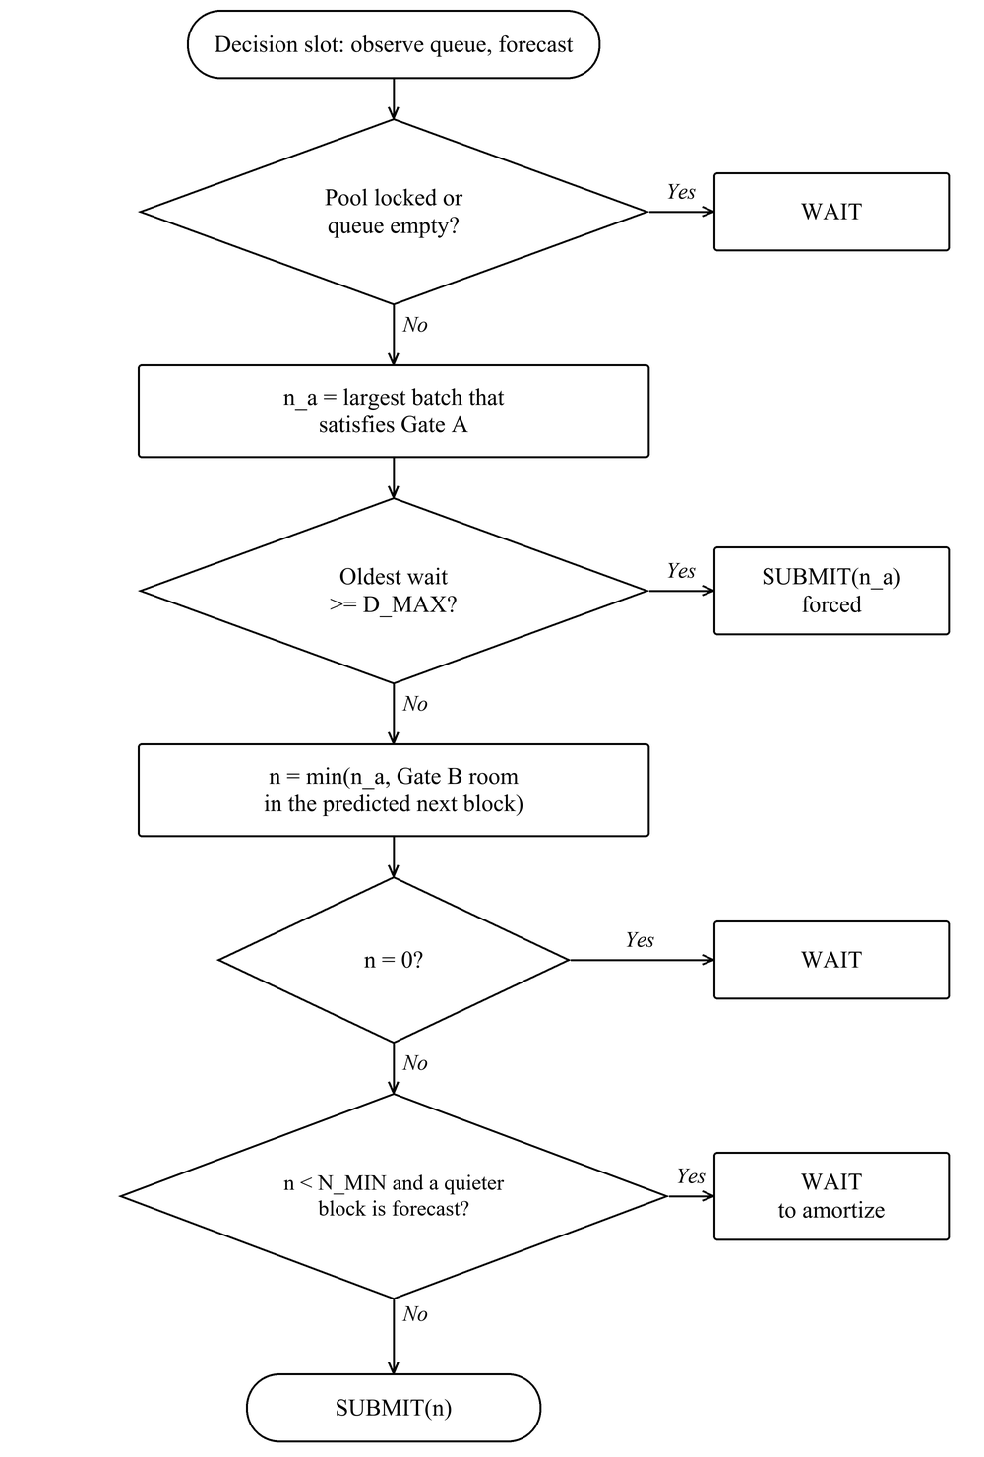
Fig. 2. Decision flow of the constrained optimizer P2 in one decision slot.

F. Chaining and Uniform Clearing
In the simulator a new batch may spend the pool output of a batch still in the mempool, so several batches can leave at one decision point; they resolve in order, and the rollback or expiry of a parent takes its children down. In the batch builder, all orders of one direction clear at a single price and opposite directions net against each other, so that only the imbalance touches the pool. The outcome is then independent of order and the batcher cannot reorder orders for its own benefit.

G. Hardening of the Live Batcher
The live daemon reuses the simulator’s decision rules and adds protections found by reviewing the code against hostile and degraded conditions. An admission guard refuses orders with non-positive amounts, negative margins or undecodable addresses. Unfillable orders are quarantined, and a failed build is bisected to isolate a poison order without submitting. A watchdog releases the pool when a batch’s inputs disappear. Chain access retries with capped jittered backoff, trips a circuit breaker and fails over between providers, and a batch is considered settled only at a depth of three blocks. A self-calibrating capacity gate learns per-dimension corrections to its size and execution-unit estimates from measured transactions.

IV. EXPERIMENTAL SETUP

A. Data
The block history D1 holds 388,781 mainnet blocks over 92 days, collected from Koios with a Blockfrost fallback, resumable and checksummed, and split chronologically 70/15/15 into training, validation and test sets. Each row records the height, slot, body size, fill, transaction count and memory and step execution units. Fig. 3 shows its distribution: the median block is 3.0% full, 0.56% of blocks exceed 80% and 0.39% exceed 90%. A 30-order batch fails to fit a block only above about 89% fill, which happens in about one block in 180 and never for longer than five minutes at a stretch. The order stream D2 is simulated, with Poisson arrivals, a fitted daily shape and bursts, at three rates (light, matched and heavy). The measurements D4 are the size, execution units and fee of real batch transactions on the preprod testnet, and they calibrate Gate A.
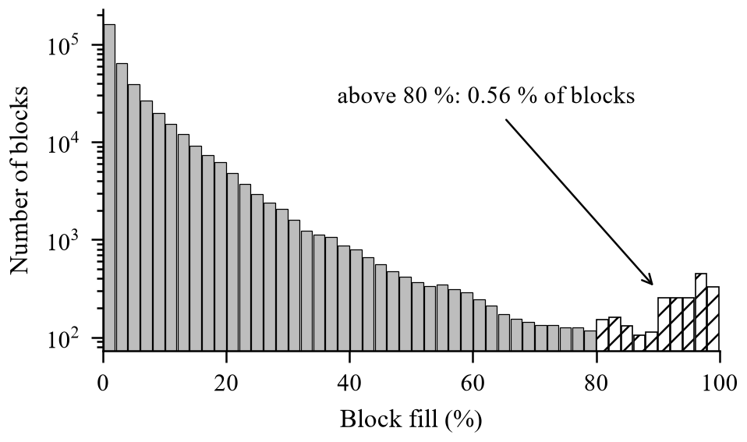
Fig. 3. Distribution of block fill over the 92-day collection window.
The per-transaction limits of 16,384 bytes and 14 million memory units cap a batch at 24 orders. Fig. 4 shows why batching pays: the cost per user falls steeply with batch size and flattens near ten orders, which is where N_MIN is set.
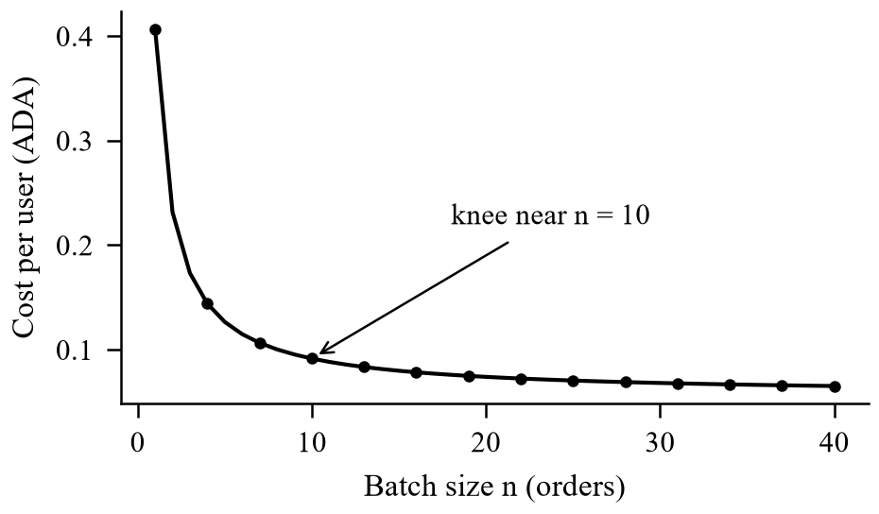
Fig. 4. Cost per user against batch size; the curve flattens near n = 10.

B. Simulator, Baselines and Parameters
The simulator replays the recorded blocks slot by slot with a first-in first-out queue, the pool lock, a Gate A and Gate B check on every submission, expiry of a batch after 600 slots and of an order after 3,600 slots, and rare rollbacks. The static baselines are E1 (submit when M orders have gathered), E2 (submit every T seconds) and E3 (greedy: submit everything every block); a null policy gives a reference. E1 and E2 were tuned on the validation split (M = 16, T = 20 s), and the tuned values are disclosed so that the comparison does not rest on a straw man. The test split was evaluated once. The principal parameters are listed in Table II. The simulation is slightly pessimistic, since a block producer might in reality include the batch in place of a marginal transaction.
TABLE II. Principal parameters.
Parameter | Value | Role
D_MAX | 120 s | Deadline for the oldest order
N_MIN | 8 orders | Amortization threshold
Forecast horizon | 3 blocks | Policy lookahead
Moving-average window | 20 blocks | Forecast reference
Batch / order TTL | 600 / 3,600 s | Expiry intervals
DQN training | 200,000 steps | 5 seeds (0 to 4)
Evaluation | 100 paired episodes | Per rate, test split

C. Metrics and Statistics
Latency is measured from the arrival of an order to its settlement, reported as the mean (L-mean) and the 95th percentile (L-p95) in seconds. Cost per user (C-user) is the transaction fee divided by the orders in the batch, in lovelace. The expiry rate (X-rate) is the share of orders that expire unsettled, and fairness is the Jain index [9] over per-order waiting times. Latency counts an expired order at its wait until expiry, so that an unsafe policy cannot hide its failures by dropping orders from the average. Policies are compared on paired episodes with 95% bootstrap confidence intervals, and Wilcoxon tests with Holm correction are applied to the family of comparisons.

V. RESULTS AND DISCUSSION

A. Congestion and Forecast Accuracy
The premise measurement stands first. Capacity rarely binds, and the limit on throughput is structural: one batch per decision point, through the pool lock, times the Gate A maximum of 24 orders. On the test split LightGBM improves the mean absolute error of the moving average at every horizon (Table III and Fig. 5). The root-mean-square errors are close, so the gain lies in the typical error and in direction rather than in rare spikes. A perfect forecast adds little to the policy: an oracle forecast gives a mean latency of 59.8 s against 60.9 s for P2 at matched load, which is consistent with how seldom capacity binds.
TABLE III. Forecast accuracy on the test split (fill fraction).
Model | MAE t+1 | MAE t+3 | RMSE t+1 | Direction
LightGBM | 0.0458 | 0.0466 | 0.0836 | 74.2%
Moving average | 0.0516 | 0.0524 | 0.0836 | 71.0%
Historical mean | 0.0607 | 0.0607 | 0.0887 | 66.2%
Last value | 0.0607 | 0.0639 | 0.1004 | n/a

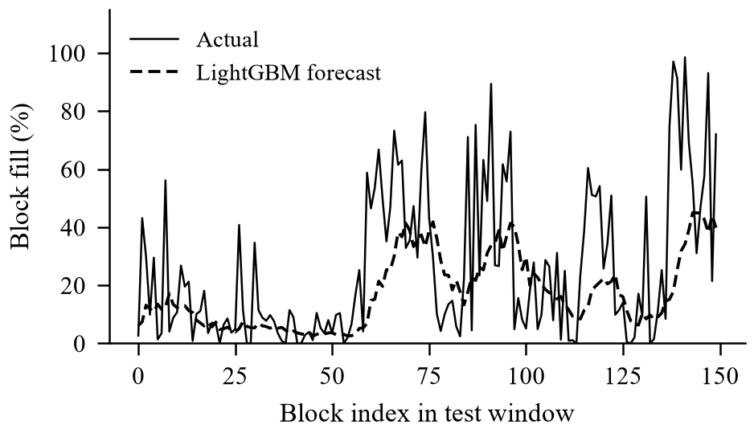
Fig. 5. Forecast against actual block fill over a 150-block window of the test split.

B. Cost and Latency
Table IV and Table V give the comparison at the matched and heavy arrival rates, as medians over 100 paired episodes. At matched load, P2 with N = 4 reduces the cost per user by 18.9% against greedy submission (127,738 against 157,445 lovelace) at a mean latency 9% higher (60.9 s against 55.8 s). Against the tuned fixed-interval batcher E2 it is better on mean latency (60.9 s against 63.4 s, with non-overlapping confidence intervals) and similar on cost. At the light rate the trade is larger, with cost lower by 25% and latency higher by 20%; at the heavy rate it is cost lower by 12% for latency higher by 3%. Fig. 6 shows the trade-off. No adaptive policy beats greedy submission on tail latency, because on this chain capacity rarely binds and the achievable gain is in cost and fairness.
TABLE IV. Test split, matched arrival rate (medians).
Policy | L-mean | L-p95 | C-user | X-rate
Null policy | 116.7 | 191.0 | 79,451 | 0.00
E1 size (M = 16) | 106.0 | 183.3 | 82,906 | 0.00
E2 interval (T = 20) | 63.4 | 130.5 | 129,729 | 0.00
E3 greedy (= P2, N = 1) | 55.8 | 119.0 | 157,445 | 0.00
P2 (N = 4) | 60.9 | 125.0 | 127,738 | 0.00
Oracle (N = 4) | 59.8 | 124.0 | 124,567 | 0.00
DQN (unshielded) | 88.9 | 158.6 | 89,704 | 0.00

TABLE V. Test split, heavy arrival rate (medians).
Policy | L-mean | L-p95 | C-user | X-rate
E1 size (M = 16) | 253.5 | 1,202.8 | 78,638 | 0.00
E2 interval (T = 20) | 88.7 | 253.5 | 95,427 | 0.00
E3 greedy (= P2, N = 1) | 66.2 | 162.0 | 116,556 | 0.00
P2 (N = 4) | 68.0 | 164.5 | 103,022 | 0.00
DQN (unshielded) | 220.9 | 863.3 | 85,187 | 0.07

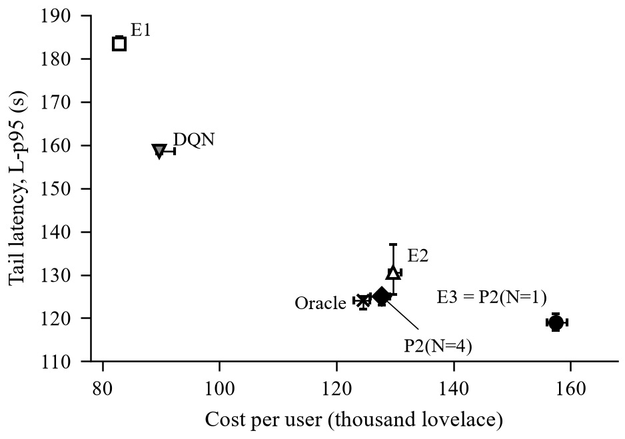
Fig. 6. Tail latency against cost per user at the matched rate, with 95% confidence intervals.

C. Behaviour Under Load
The unshielded DQN reaches a low cost but pays for it in latency (L-p95 158.6 s against 125.0 s for P2 at matched load), and it fails at heavy load, where its L-p95 is 863 s and 7% of orders expire on the test split (Fig. 7). On validation days at heavy load the recorded agent expired 35.7% of orders at the median and 58.6% in the worst case. The fixed-size batcher E1 also collapses there, with an L-p95 of 1,203 s. Table VI shows the effect of the shield. Expiry falls to zero, and because about 40% of decisions are forced or delegated to P2, the cost per user is the lowest of the safe options.
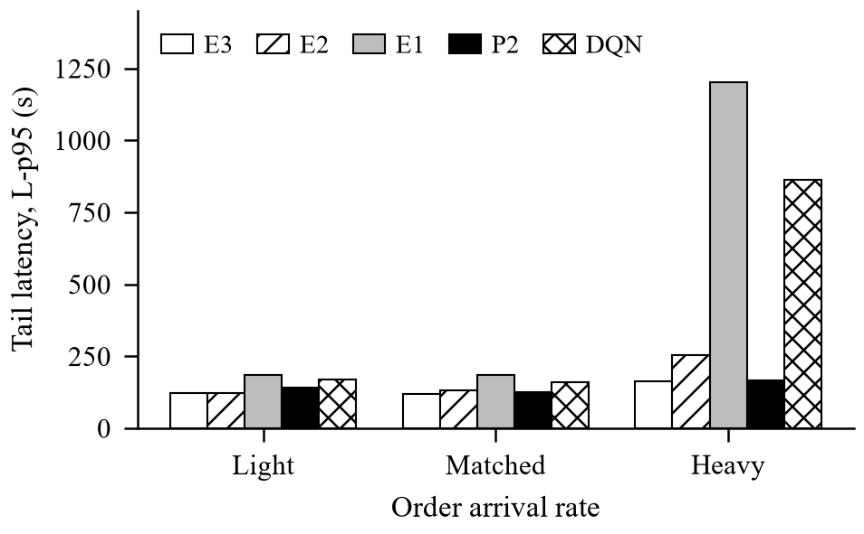
Fig. 7. Tail latency across the light, matched and heavy arrival rates.
TABLE VI. Heavy rate, validation episodes: effect of the safety shield.
Policy | L-p95 | Expired | C-user
DQN as recorded | 3,605 | 35.7% | 116,445
DQN + largest batch | 255.0 | 0% | 106,861
Shield (DQN to P2) | 245.5 | 0% | 79,487
P2 (N = 4) | 245.5 | 0% | 100,662

D. Chaining and Testnet Demonstration
A diagnosis on validation days found that no batch expired behind a full block at heavy load, while 7–10% of submissions left a backlog larger than one Gate A batch. The ceiling was therefore one batch per decision point and not congestion, which is why a deadline-aware policy alone did not help and chaining did. Allowing two chained batches cuts the L-p95 from 245.5 s to 120.0 s and the share of orders settled after D_MAX from 16.4% to 5.0%, at 1.2% higher cost. On the preprod testnet the batcher settled a batch transaction (one order, fee 322,697 lovelace) against the deployed pool validator. The measured transaction was 2,682 bytes against an estimate of 800, which is why the capacity gate learns size corrections from real transactions instead of trusting a static estimate.

E. Discussion and Limitations
The central finding is a correction. The motivating claim of a congested chain was false: blocks are mostly empty, so forecasting capacity helps only defensively, and the real limit is the single lock on the pool. Greedy submission is therefore already close to optimal for latency, and the useful work of an adaptive policy is to trade a few seconds for fewer, fuller batches and so a lower cost per user, and to stay safe when load rises. The results should be read within their limits. They come from simulation on a single 92-day window and a single pool, with a synthetic order stream. Chaining exists only in the simulator, and the live daemon still locks the pool until settlement. The capacity calibrator’s error matching is text-based and has not been tested against real Ogmios or Blockfrost error bodies, and the testnet run settled a single-order batch. Both validators hard-wire one batcher key and orders carry no on-chain deadline. Finally, uniform clearing redistributes price impact across a batch by design, which is the defining property of a fair batch auction but remains a choice.

VI. CONCLUSION AND FUTURE WORK
This paper treated batching on a Cardano exchange as control of a shared pool lock under uncertain confirmation time. Measurement of 388,781 mainnet blocks showed that concurrency, not congestion, is the binding constraint. Against tuned static batchers, a forecast-then-optimize policy reduces the cost per user by about 19% at matched load for a small increase in latency, a learned agent is safe only behind a shield, and no adaptive policy beats greedy submission on tail latency on today’s chain. The contribution is a measured correction of the premise, a simulator and evaluation protocol with disclosed baseline tuning, a hard-gated policy family with a safety shield, chaining and uniform clearing, and a working preprod demonstration.
Future work follows from the limitations. The first step is to enable chaining in the live daemon and to calibrate Gate A against multi-order live batches. The second is to evaluate on several pools, longer windows and recorded real order flow instead of a synthetic stream. The third is to repeat the study as protocol parameters change, since a larger block or a faster confirmation mechanism would change where capacity binds.
REFERENCES
[1] M. Chakravarty, J. Chapman, K. MacKenzie, O. Melkonian, M. Peyton Jones, and P. Wadler, “The extended UTXO model,” in Financial Cryptography and Data Security Workshops (FC), 2020.
[2] H. Nguyen Quang, “Concurrent & deterministic batching on the UTXO ledger,” MELD, Tech. Rep., 2021.
[3] P. Bruhwiler, “A concurrent DEX on Cardano,” B.Sc. thesis, Univ. of Bern, Bern, Switzerland, 2021.
[4] T. Roughgarden, “Transaction fee mechanism design: An economic analysis of EIP-1559,” in Proc. ACM Conf. Economics and Computation (EC), 2021.
[5] H. Mao, M. Alizadeh, I. Menache, and S. Kandula, “Resource management with deep reinforcement learning,” in Proc. ACM Workshop on Hot Topics in Networks (HotNets), 2016.
[6] G. Angeris and T. Chitra, “Improved price oracles: Constant function market makers,” in Proc. ACM Conf. Advances in Financial Technologies (AFT), 2020.
[7] G. Ke et al., “LightGBM: A highly efficient gradient boosting decision tree,” in Advances in Neural Information Processing Systems (NeurIPS), 2017.
[8] V. Mnih et al., “Human-level control through deep reinforcement learning,” Nature, vol. 518, no. 7540, pp. 529–533, 2015.
[9] R. Jain, D. Chiu, and W. Hawe, “A quantitative measure of fairness and discrimination for resource allocation in shared computer systems,” Digital Equipment Corp., Tech. Rep. DEC-TR-301, 1984.

