A Major Project Report on
AI-DRIVEN ADAPTIVE TRANSACTION BATCHING FOR CARDANO DECENTRALIZED EXCHANGES

Submitted in partial fulfilment of the requirements for the award of the degree of
BACHELOR OF TECHNOLOGY
in
COMPUTER SCIENCE AND ENGINEERING (DATA SCIENCE)

Submitted by
Vikranth Sai (23P61A67F1)
Ganesh (23P61A67F0)
Sowmya (23P61A67H8)
EDIT: confirm team member names and roll numbers

Under the guidance of
Ms. B. Mamatha
EDIT: guide designation

Department of Computer Science and Engineering (Data Science)
VIGNANA BHARATHI INSTITUTE OF TECHNOLOGY
EDIT: affiliation, accreditation line, address
Academic Year 2026–27

Certificate
This is to certify that the project report entitled “AI-Driven Adaptive Transaction Batching for Cardano Decentralized Exchanges” is a bonafide record of work carried out by team member names and roll numbers in partial fulfilment of the requirements for the award of the degree of Bachelor of Technology in Computer Science and Engineering (Data Science) at Vignana Bharathi Institute of Technology during the academic year 2026–27.

Project Guide Head of the Department
Ms. B. Mamatha EDIT: HoD name

External Examiner

Declaration
We hereby declare that the project report entitled “AI-Driven Adaptive Transaction Batching for Cardano Decentralized Exchanges” submitted to Vignana Bharathi Institute of Technology is a record of original work done by us under the guidance of Ms. B. Mamatha. The results embodied in this report have not been submitted to any other university or institute for the award of any degree or diploma.
Every quantitative result in this report is produced by a script in the project repository from a checksummed dataset, and can be regenerated from the run manifest recorded alongside it.

EDIT: names, roll numbers and signatures

Acknowledgement
We express our sincere gratitude to our guide, Ms. B. Mamatha, for her guidance, patience and critical feedback throughout this project. We thank the Head of the Department and the project review committee of the Department of Computer Science and Engineering (Data Science) for their evaluation and suggestions at each review.
We also thank the maintainers of the Koios community API, whose free and open access to Cardano chain data made the 92-day block dataset at the centre of this work possible, and the developers of the open-source libraries on which the implementation is built.
EDIT: personalise as required

Abstract
Decentralized exchanges on Cardano store each liquidity pool as a single unspent transaction output (UTXO), which can be consumed by only one transaction per block. Exchanges therefore rely on off-chain batchers that collect many user orders and settle them together in one transaction. Batchers deployed today trigger on constants — a fixed batch size, a fixed interval, or greedily — and never read the chain before deciding.
This project designs, implements and evaluates an adaptive batcher that decides, at every block, whether to wait or to submit a batch of n orders. Because Cardano fees are deterministic and do not rise with demand, the objective is confirmation latency and amortized per-user cost, not fees. Batch size is bounded by per-transaction limits (Gate A), while block capacity governs only inclusion (Gate B). A submitted batch holds the pool UTXO until it confirms, so every order behind it waits: head-of-line blocking is the real cost of a poor decision.
A dataset of 388,781 mainnet blocks over 92 days was collected from the Koios API. It overturned the project’s original premise: median block fill is 2.95 %, only 0.564 % of blocks exceed 80 %, and the longest congested run is ten blocks. The work was therefore reframed around concurrency rather than congestion. A deterministic, slot-accurate simulator replays the recorded blocks against a synthetic order stream fitted to the chain’s diurnal activity. Against it we evaluate three tuned static baselines, a LightGBM congestion forecaster, a constrained optimizer (P2) and a Deep Q-Network agent (P3) with structural action masking, using paired episodes, Wilcoxon signed-rank tests, bootstrap confidence intervals and Holm–Bonferroni correction.
The forecaster beats a moving-average baseline by 11.2 % in MAE but lags the series it predicts. Every policy, including the learned agent, produced zero capacity violations. An ablation shows the DQN agent is queue-aware rather than congestion-aware.
On the held-out test split — 100 paired episodes at three arrival rates, evaluated once — no adaptive policy beats greedy batching on tail latency: where capacity rarely binds, greedy is latency-optimal. The result is therefore a trade-off frontier rather than dominance. At the matched rate the optimizer with a minimum batch of four cuts per-user cost by 19 % for 5 % more tail latency and Pareto-dominates the tuned fixed-interval baseline by median; the DQN agent cuts cost by 43 % with the best fairness of any proposed policy, but one of its five seeds breaks down under heavy load.
The project also delivers a minimal on-chain DEX for the Cardano preprod test network: Aiken validators that enforce each user’s slippage floor and a pass-through batcher fee, so the amortization the policies optimise reaches users rather than the operator, together with a live batcher that runs the simulator’s decision loop against the chain. The DEX is deployed on preprod, where the live batcher has settled its first end-to-end swap.
Keywords: Cardano, eUTXO, decentralized exchange, transaction batching, reinforcement learning, DQN, LightGBM, discrete-event simulation, Aiken, Plutus.

Table of Contents

Right-click the table above and choose Update Field if page numbers are missing.

List of Abbreviations
Table 1: Abbreviations used in this report
Abbreviation | Meaning
ADA | The native currency of Cardano (1 ADA = 1,000,000 lovelace)
ADR | Architecture Decision Record
AMM | Automated Market Maker
CDF | Cumulative Distribution Function
CI | Confidence Interval
CIP-30 | Cardano wallet–web connector standard
C-user | Mean per-user cost, in lovelace
DEX | Decentralized Exchange
DFD | Data Flow Diagram
DQN | Deep Q-Network
eUTXO | Extended Unspent Transaction Output
ExUnits | Plutus execution units (memory and CPU steps)
F-jain | Jain’s fairness index over waiting times
L-mean / L-p95 | Mean / 95th-percentile confirmation latency, in slots
MAE / RMSE | Mean Absolute Error / Root Mean Square Error
MDP | Markov Decision Process
MEV | Maximal Extractable Value
NFT | Non-Fungible Token (here, the token that identifies the pool)
Plutus V3 | The Cardano smart-contract execution language targeted by Aiken
PPO | Proximal Policy Optimization
RL | Reinforcement Learning
TTL | Time To Live (transaction validity bound)
UTXO | Unspent Transaction Output
X-rate | Order expiry rate

Chapter 1: Introduction

1.1 Domain: Cardano and the eUTXO Model
Cardano is a proof-of-stake blockchain whose ledger follows the extended UTXO (eUTXO) model [1]. Value lives in discrete outputs; each output can be spent exactly once, and may carry a datum (arbitrary data) and be guarded by a validator script. Validation is local and deterministic, so the success and cost of a transaction are known before it is submitted.
Cardano’s Ouroboros consensus [3] divides time into one-second slots. Each slot produces a block with probability f = 0.05, so blocks arrive every 20 seconds on average, with geometrically distributed gaps. Blocks and transactions are each bounded in serialized size and in script execution units (memory and CPU steps).

1.2 Why Batching Exists — the Concurrency Constraint
A decentralized exchange (DEX) keeps each liquidity pool as a single UTXO. Because that UTXO can be consumed once per block, a hundred users swapping against the same pool at the same moment cannot all succeed: only one transaction can spend the pool, and the rest conflict.
The ecosystem’s answer is batching. A user does not swap directly. They place an order — funds locked at the DEX script address with a datum stating the swap terms, a minimum acceptable output and a return address. An off-chain batcher scans the chain, collects pending orders and settles many of them in a single transaction against the pool. Batching exists to solve concurrency; cost amortization is a secondary benefit.

1.3 Problem Statement
Batchers deployed today decide using constants: submit when the queue reaches M orders, submit every T seconds, or submit whatever is queued immediately. None reads the chain before deciding. The decision matters because a submitted batch holds the pool UTXO until it confirms: while it is in flight no second batch can be built, and every order that arrives meanwhile waits behind it.
The problem addressed by this project is therefore: at each block, decide whether to WAIT or to SUBMIT a batch of n orders, so as to minimise confirmation latency and per-user cost, without ever constructing a transaction that violates Cardano’s capacity limits and without allowing any order to starve.

1.4 The Latency-Not-Fees Insight
The intellectual pivot of this project
Cardano transaction fees are deterministic: fee = 44·size + 155,381 + 0.0577·mem + 0.0000721·steps lovelace. There is no gas auction and no priority bidding; an identical transaction costs the same on an idle chain and on a busy one.
Waiting on Cardano therefore does not cost money — it costs time. A batch that does not confirm promptly keeps every user inside it waiting and, because it holds the pool UTXO, every order behind it too.
The objective is consequently confirmation latency and amortized per-user cost, not fee reduction. Any framing that promises “lower gas fees during congestion” is technically wrong on Cardano. The contrast with Ethereum’s demand-responsive EIP-1559 base fee [10] is what justifies this objective.

This argument does not require blocks to be full, and — as Chapter 8 shows — on the current mainnet they almost never are. The waiting that matters is caused by the pool lock, not by block capacity.

1.5 Objectives
Table 1.1: Project goals
ID | Goal
G1 | Reduce mean and 95th-percentile confirmation latency for user orders versus static batchers
G2 | Reduce average per-user cost by amortizing the flat fee component across larger batches
G3 | Never construct a transaction that violates Cardano capacity limits
G4 | Guarantee that no order starves, regardless of congestion
G5 | Produce a reproducible, publishable evaluation against static baselines
G6 | Require no change to wallets, to CIP-30, or to the Cardano protocol

1.6 Scope and Limitations
The following are explicitly out of scope:
- Reducing Cardano fees during congestion — fees are demand-independent, so the premise does not exist.
- A wallet, browser extension or consumer web application — a wallet sees only its owner’s funds and has nothing to aggregate.
- Integration with Minswap or another deployed DEX — their validators require whitelisted, licensed batchers.
- Multi-pool routing, order-book matching and cross-DEX arbitrage.
- Mainnet deployment — all live work targets the preprod test network, enforced by a configuration guard.
- Security audit, MEV protection and batcher decentralisation.
Every reported result is produced in a simulator that replays real mainnet blocks. Its assumptions are stated in Section 5.9 and their effect on validity is discussed in Section 8.13.

1.7 Organisation of the Report
Chapter 2 surveys the literature and identifies the research gap. Chapter 3 analyses the existing and proposed systems and their feasibility. Chapter 4 lists hardware, software and protocol requirements. Chapter 5 presents the system design, including the two capacity gates, the cost model, the pool-lock failure model and the learning formulations. Chapter 6 describes the implementation, Chapter 7 the testing and simulator validation, and Chapter 8 the results. Chapter 9 concludes and outlines future work.

Chapter 2: Literature Survey

2.1 eUTXO Foundations
Chakravarty et al. [1] formally define the extended UTXO model that underlies Cardano. Extending Bitcoin-style outputs with datums and validator scripts gives expressive smart contracts while keeping validation local and deterministic. Two consequences are foundational to this project: fees and execution costs are known before submission, and a contract’s state — here a liquidity pool — lives in a single output that only one transaction can consume. The paper defines the concurrency problem but does not solve it. Its multi-asset extension [2] provides the native tokens that a DEX exchanges.

2.2 Batching for eUTXO Concurrency
MELD’s technical report [5] establishes batching as the accepted solution to eUTXO concurrency: orders are placed as separate UTXOs and a batcher later settles them deterministically. Brühwiler [6] gives an academic treatment of the same problem with a working concurrent-DEX prototype on Cardano, and Hryniuk [7] describes fan-out, batching and order-book patterns for contention. All three are concerned with correctness of concurrent settlement. The batching they describe is static and rule-based: none addresses when to submit or how many orders to include.

2.3 Transaction Fee Mechanism Design
Roughgarden [10] analyses Ethereum’s EIP-1559, in which a base fee rises as blocks fill, making congestion expensive in money. This work is cited as a contrast: Cardano has no such mechanism. It establishes precisely what Cardano does not do, and therefore why the objective of this project is latency rather than fees.

2.4 Learned Resource Scheduling
Mao et al.’s DeepRM [15] trains a reinforcement-learning agent in simulation to pack arriving jobs with multi-dimensional resource demands into capacity-limited slots. Structurally this is the same problem as packing orders with size, memory and step costs into capacity-limited transactions and blocks, and DeepRM serves as the method template for this project. Decima [16] extends the approach to learned scheduling for data-processing clusters. Neither knows anything about eUTXO, block limits or the latency–cost trade-off.

2.5 Supporting Work
- Ouroboros [3] — the source of the one-second slot and active-slot coefficient, hence the geometric block cadence the simulator replays.
- Ouroboros Leios [4] — a protocol-level throughput upgrade; this project is a complementary application-layer optimisation.
- Constant-function market makers [8], [9] — the theory behind the x·y = k pool and the endogenous slippage model.
- Transaction reordering [11] — supports the fairness discussion and independently states that a pool admits one interaction per block.
- Methods — Sutton and Barto [12] for the MDP formulation, DQN [13], PPO [14] and LSTM [17].

2.6 Comparison of Existing Work
Table 2.1: Comparison of the core literature
Ref. | Work | Supplies | Leaves open
[1] | Extended UTXO Model | The platform, deterministic fees, the single-pool-UTXO bottleneck | Defines the concurrency problem; does not solve it
[5] | MELD batching | Batching as the accepted solution | Batching is static and rule-based
[6] | Concurrent DEX thesis | Academic validation and a prototype | Targets correctness, not timing
[10] | EIP-1559 analysis | Demand-responsive fees on account-based chains | Does not apply to Cardano — which is the point
[15] | DeepRM | RL for resource packing under capacity limits, trained in simulation | No eUTXO, block limits or latency–cost trade-off

EDIT: merge in the rows of the existing literature-survey comparison table from the Review 1 deck if required

2.7 Research Gap
Research gap
[5] and [6] establish batching but batch statically; [15] shows that this class of packing problem is learnable in simulation; [10] shows why the objective on Cardano must be latency rather than fees; and [1] explains why the constraint exists. No existing work applies a learned or forecast-driven policy to the timing and sizing of eUTXO batches, evaluated against tuned static baselines on replayed mainnet data. That is the contribution of this project.

Chapter 3: System Analysis

3.1 Existing System: Static Batching
Deployed batchers follow one of three fixed rules. In this report they are implemented as baselines E1–E3 and subjected to exactly the same structural rules as the proposed policies: they cannot submit while the pool is locked, and cannot exceed the per-transaction capacity limit.
E1 fixed size if len(Q) >= M: submit(Q[0:M])
E2 fixed interval if slot - last_submit >= T: submit(Q[0:n_max])
E3 greedy if len(Q) > 0: submit(Q[0:n_max])
M and T are tuned on the validation split rather than guessed, because comparing against a badly configured baseline would invalidate the comparison. The tuned values are E1 M = 16 and E2 T = 20 slots.

3.2 Limitations of the Existing System
- The chain is never read before deciding. A static batcher cannot react to queue depth, block cadence or the rare full block.
- The pool lock is ignored. A fixed rule does not account for the fact that every submission blocks the pool until confirmation.
- A single operating point. Each rule fixes one point on the latency–cost trade-off; greedy minimises latency at the highest per-user cost, large fixed sizes do the opposite.
- No explicit starvation guarantee. A fixed-size rule can leave a small queue waiting indefinitely in a quiet period unless a deadline is imposed externally.

3.3 Proposed System
The proposed system is an event-driven control loop wrapped around a forecast-then-decide pipeline, with an offline simulator that can substitute for the live chain. At each block it observes the order queue and a forecast of block fill, and a policy decides WAIT or SUBMIT(n). Three properties drive the design:
- The environment is partially observable — the batcher cannot know how full the next block will be or how long its batch will take to confirm.
- There is one shared resource — the pool UTXO; the system is fundamentally a lock manager under uncertain service time.
- Constraints are hard and external — capacity limits come from the protocol and are enforced structurally by the environment, never learned by the policy.
Two decision-makers are proposed: P2, an explainable constrained optimizer, and P3, a DQN agent with action masking. A LightGBM forecaster (P1) supplies predicted block fill to both.

3.4 Comparison: Existing versus Proposed
Table 3.1: Existing and proposed systems compared
Aspect | Existing (static) | Proposed (adaptive)
Decision input | A constant (M, T) or nothing | Queue depth, oldest wait, predicted fill, pool-lock state, feasible batch size
Capacity handling | Implicit or by hand | Gate A enforced by the environment; Gate B checked against a forecast
Starvation | Not guaranteed | Deadline D_MAX masks WAIT once reached
Trade-off | One fixed point | Tunable frontier (P2) or learned (P3)
Evaluation | Rarely measured | Paired episodes, non-parametric tests, confidence intervals

3.5 Feasibility Study

3.5.1 Technical feasibility
All components are free and run on a laptop CPU. The capacity limits were verified against the Cardano protocol parameter guide. Per-transaction execution memory bounds a batch at 24 orders under the cost estimates used, so the action space is small and discrete, making DQN genuinely tractable. Training five agents took about three hours of CPU time in total.

3.5.2 Economic feasibility
The project has zero monetary cost. The Koios API requires no key, Blockfrost has a free tier, no GPU or Cardano node is required, and preprod test tokens have no value.

3.5.3 Operational feasibility
The batcher is a single background process with no inbound ports, no database server and no user-facing surface. Users continue to place orders from any Cardano wallet; the batcher is invisible to them.

3.6 Requirements

3.6.1 Functional requirements
Table 3.2: Functional requirements
ID | Requirement | Priority
FR-1 | Collect per-block congestion data from public APIs | Must
FR-2 | Persist collected data as a versioned, reproducible dataset | Must
FR-3 | Forecast next-block fill percentage from recent history | Must
FR-4 | Maintain a queue of pending orders with arrival slot, size and execution cost | Must
FR-5 | Decide each block whether to WAIT or SUBMIT(n), n bounded by capacity | Must
FR-6 | Reject any batch violating per-transaction limits before construction | Must
FR-7 | Force submission when the oldest order reaches the deadline D_MAX | Must
FR-8 | Refuse to submit while a previous batch holds the pool UTXO | Must
FR-9 | Record every decision to a structured log (D3) | Must
FR-10 | Replay historical blocks in a discrete-event simulator | Must
FR-11 | Provide baselines E1–E3 and forecaster baseline E4 | Must
FR-12 | Compute the full metric set with paired statistical comparison | Must
FR-13 | Build, sign and submit a real batch via PyCardano | Should
FR-14 | Deploy Aiken order and pool validators on preprod | Could
FR-15 | Provide a local dashboard of the decision loop | Could

3.6.2 Non-functional requirements
Table 3.3: Non-functional requirements
ID | Requirement | Target
NFR-1 | Decision latency | < 1 s per decision
NFR-2 | RL training on a laptop CPU | < 6 h per agent
NFR-3 | Experiments reproducible from a seed | Bit-identical metric output
NFR-4 | Protocol limits defined in exactly one module | Single source of truth, enforced by test
NFR-5 | Data collection inside free API tiers | No paid plan
NFR-6 | No secrets committed to the repository | Enforced by .gitignore and a pre-commit scan
NFR-7 | Testnet keys only | Hard network guard in configuration

Chapter 4: System Requirements

4.1 Hardware Requirements
Table 4.1: Hardware requirements
Component | Requirement | Notes
Processor | Any modern multi-core x86-64 CPU | No GPU required (NFR-2)
Memory | 8 GB RAM | 16 GB comfortable for RL training
Disk | ~2 GB free | D1 parquet, models, experiment outputs
Network | Internet access | Only for one-off data collection

EDIT: add the exact specification of the machine used for the reported runs

4.2 Software Requirements
Table 4.2: Software and libraries, with the reason for each choice
Layer | Choice | Why this and not the alternative
Language | Python 3.11 | One language across data, ML and transaction building; PyCardano exists
Chain data | Koios REST (primary), Blockfrost (fallback) | Free, no node required; cardano-db-sync needs hundreds of GB and days of synchronisation
Dataframes | pandas + pyarrow | Parquet keeps D1 compact and typed
Forecaster | LightGBM | Gradient boosting suits tabular lag features and trains in minutes on CPU
RL | Stable-Baselines3 + Gymnasium | Standard, maintained implementations of DQN with a standard environment API
Statistics | SciPy | Wilcoxon signed-rank test
Simulator | Hand-written event loop | SimPy adds an unneeded process abstraction; the loop must be exactly auditable
Plots | Matplotlib | Deterministic output for the report
Testing | pytest, hypothesis, pytest-cov | Unit and property tests, coverage enforced in CI
Tooling | uv, ruff, pre-commit, GitHub Actions | Reproducible environments, linting and continuous integration
Tx building (Phase 7) | PyCardano 0.14 | Builds, balances and signs transactions in pure Python and submits through Blockfrost; no Cardano node required
On-chain (Phase 7) | Aiken v1.1.23, stdlib v3.1.0 | Compiles to Plutus V3 with a built-in unit-test runner; the language Minswap V2 itself is written in

4.3 Protocol Parameters
The design is built against these exact Cardano mainnet values, which makes them a requirement rather than a design choice. Each appears in exactly one source module, src/batcher/config/protocol.py, and a test fails if any is written as a literal elsewhere.
Table 4.3: Cardano protocol parameters used
Parameter | Value | Meaning
maxTxSize | 16,384 B | Maximum serialized size of one transaction
maxTxExecutionUnits.memory | 14,000,000 | Plutus memory units per transaction
maxTxExecutionUnits.steps | 10,000,000,000 | Plutus CPU steps per transaction
maxBlockBodySize | 90,112 B | Maximum block body size
maxBlockExecutionUnits.memory | 62,000,000 | Plutus memory units per block
maxBlockExecutionUnits.steps | 40,000,000,000 | Plutus CPU steps per block
minFeeA / minFeeB | 44 lovelace/B / 155,381 lovelace | Size coefficient / flat component
priceMemory / priceSteps | 0.0577 / 0.0000721 lovelace | Execution unit prices
Slot duration / active slot coefficient | 1 s / 0.05 | Blocks every 20 s on average, geometric gaps

Chapter 5: System Design

5.1 Architecture Overview
The system is organised in four layers. L1, on-chain, holds order UTXOs and the pool UTXO on Cardano preprod. L2, the off-chain batcher, is the deliverable: a forecaster and an order queue feed a policy, which drives a batch builder. L3, data, collects block history into dataset D1. L4, offline training and evaluation, replays D1 through the simulator to train and score every policy. L2 is the product, L3 supplies the signal, and L4 is where every reported result is produced.
L4 OFFLINE M6 Simulator -> Baselines E1-E3 -> Metrics, statistics, figures
L3 DATA Koios -> M1 Collector -> D1 block history
L2 BATCHER M2 Forecaster + M3 Queue -> M4 Policy -> M5 Builder -> outcome
L1 ON-CHAIN User wallet -> Order UTXOs -> Pool UTXO (one spend per block)

5.2 Module Design
Table 5.1: Modules and responsibilities
ID | Module | Responsibility | Owns
M1 | Chain Data Collector | Poll block endpoints, normalise, persist resumably | D1
M2 | Congestion Forecaster | Predict fill for blocks t+1..t+3 | P1, E4
M3 | Order Queue Manager | Strict FIFO queue with ages, sizes, execution costs, expiry | Queue state
M4 | Adaptive Batching Policy | Decide WAIT or SUBMIT(n) | E1–E3, P2, P3
M5 | Batch Builder / Estimator | Estimate size, execution units and fee; enforce Gate A | Transaction construction
M6 | Simulator and Evaluation | Replay blocks, model mempool and pool lock, score policies | D2, D3, metrics
M7 | On-chain DEX (optional) | Order and pool validators on preprod | D4

The queue is strictly FIFO: a batch is always the prefix Q[0:n], never a chosen subset. This is a deliberate fairness property that removes order-selection manipulation from the design space.

5.3 The Two Capacity Gates
A batch is one transaction submitted into one block, and two independent constraint sets apply. Conflating them is the most consequential error available in this design, and it was present in the project’s early material.
Gate A - feasibility (per transaction, always binding)
tx_size(n) = TX_OVERHEAD + sum(order_size[i]) <= 16,384
tx_mem(n) = POOL_MEM + sum(order_mem[i]) <= 14,000,000
tx_steps(n) = POOL_STEPS + sum(order_steps[i]) <= 10,000,000,000

Gate B - inclusion (per block, congestion dependent)
blk.size + tx_size(n) <= 90,112
blk.mem + tx_mem(n) <= 62,000,000
blk.steps + tx_steps(n) <= 40,000,000,000
Table 5.2: Gate A and Gate B contrasted
 | Gate A | Gate B
Bounds | Maximum batch size | Whether the batch fits now
Depends on congestion | No | Yes
Violation means | Invalid transaction — a defect | Wait for a later block — normal
Enforced by | Environment clamp and builder assertion | Forecast at decision time; the real block at inclusion

An empty block does not permit a larger batch. A formulation such as capacity = (1 − fill_hat) × 90,112 would propose invalid transactions on an idle chain. With per-order estimates of 300 B, 0.5 M memory units and 200 M steps, execution memory binds first and Gate A caps a batch at 24 orders.

5.4 Cost Model and Amortization
The fee decomposes into a flat part, paid once per batch, and a marginal part paid for every order:
fee(n) = FLAT + n * MARGINAL
FLAT = 155,381 + 44*TX_OVERHEAD + 0.0577*POOL_MEM + 0.0000721*POOL_STEPS
= 350,461 lovelace
MARGINAL = 44*order_bytes + 0.0577*order_mem + 0.0000721*order_steps
= 56,470 lovelace
cost_per_user(n) = FLAT / n + MARGINAL
Table 5.3: Amortization under the default cost estimates
Batch size n | Total fee (ADA) | Per user (ADA)
1 | 0.407 | 0.407
5 | 0.633 | 0.127
10 | 0.915 | 0.092
20 | 1.480 | 0.074
24 (Gate A cap) | 1.706 | 0.071

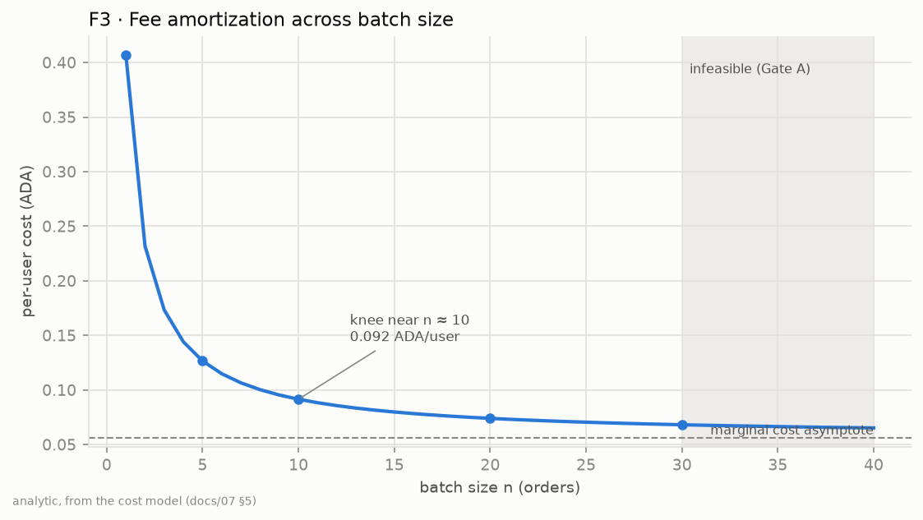
Figure 5.1: F3 — per-user cost against batch size
Only the flat term amortizes. The curve flattens quickly: most of the saving is realised by n ≈ 10, and growing from 10 to 24 orders saves a further 22 %. There is therefore little economic reason to hoard orders, which is why latency dominates the objective.

5.5 The Pool Lock and Head-of-Line Blocking
A batch consumes the pool UTXO and produces a new one. Until the batch confirms, the new pool output does not exist, so a second batch cannot be constructed: at most one batch per pool is in flight. A submitted transaction that does not fit the next block is not rejected — it waits in the mempool and is retried against each subsequent block. The real cost of a mistimed submission is therefore head-of-line blocking: every order queued behind the in-flight batch waits. Genuine failures come from only three sources: TTL expiry, mempool rejection and rollback. This replaced a “bounce penalty” in the original design that modelled a rejection which does not occur.

5.6 Algorithm Design

5.6.1 Forecasters
E4, the baseline, predicts the mean fill of the last 20 blocks, repeated across the horizon; a second naive baseline, E4b, decays from the current block toward that mean and was added for ablation A2 (Section 8.10). P1, a LightGBM regressor, uses fill lags 1–20, rolling means and standard deviations over 5, 10 and 20 blocks, slot-gap cadence features, transaction-count lags and hour-of-day encoded as sine and cosine. Data is split chronologically 70/15/15 and never shuffled. A planned LSTM variant was cut on scope grounds once the predictability analysis (Section 8.2) was complete.

5.6.2 P2 — constrained optimizer
decide(obs):
if pool_locked or queue empty: return WAIT
n_feasible = max n satisfying Gate A
if oldest_wait >= D_MAX: return SUBMIT(n_feasible) # fairness
n = min(n_feasible, max n satisfying Gate B at fill_hat[t+1])
if n == 0: return WAIT # predicted no room
if n < N_MIN and quieter block: return WAIT # wait to amortize
return SUBMIT(n)
P2 is deterministic and explainable, cannot fail to converge, and separates how much of any gain comes from forecasting versus from learning. Its ORACLE variant receives the true next-block fill instead of a forecast, bounding what any forecaster could achieve.

5.7 MDP Formulation and Reward (P3)
State — an 11-dimensional vector normalised to [0, 1]: queue depth, oldest and mean wait relative to D_MAX, forecast fill for t+1..t+3, memory headroom, the Gate A maximum batch size, pool-lock flag, slots in flight, and hour of day as sine and cosine. Including the Gate A maximum lets the agent see its own feasible action range.
Action — WAIT, or SUBMIT(n) for n in the buckets {1, 4, 8, 12, 16, 20, 25, 30, n_max}.
Action masking — illegal actions are made unavailable rather than penalised: only WAIT while the pool is locked; WAIT is illegal once the oldest order reaches D_MAX; every SUBMIT(n) above the Gate A maximum is illegal. The mask is enforced inside the environment’s step as well as exposed, so an agent that ignores it still cannot act illegally.
r = -( w_cost * flat_fee_share(n)
+ w_latency * sum(wait_i ^ 2) / NORM
+ w_slip * slippage(n)
+ w_lock * slots_pool_locked )
Only the flat fee share enters the reward, since the marginal part is constant per order. Waiting is penalised quadratically to encode the tail-latency objective. There is no inclusion-failure penalty, because no such event exists. Each term is normalised to unit scale on a reference episode before weighting: left raw, the latency term is about 19 times the cost term and cost would be numerically invisible.

5.8 Dataset Design
Table 5.4: Datasets
ID | Dataset | Content | Source
D1 | Block history | Height, absolute slot, size, fill %, transaction count; execution units on a sample | Koios, mainnet, 388,781 blocks, 92 days
D2 | Order stream | Arrival slot, size, memory, steps, TTL per order | Generated: diurnal Poisson with bursts fitted to D1
D3 | Decision log | One row per observed block per episode per policy | Simulator
D4 | Preprod log | Live submissions and outcomes | Optional live mode

Execution units cannot be collected for every block within free API limits, so D1 records size for all 92 days and execution units for two 2-day samples (17,280 blocks) taken from a quiet and a congested window. Blocks outside the sample carry an explicit “absent” marker, never zero, because zero would make them look empty and corrupt every congestion statistic.

5.9 Simulator Design
The simulator replays recorded blocks on their real slot clock — a fixed 20-second tick would understate tail latency, the very metric the project claims to improve. At each block it admits arriving orders and evicts expired ones; if a batch is in flight it resolves it against the real block (confirm if Gate B holds, expire at TTL, otherwise head-of-line wait with no decision); otherwise it builds an observation, asks the policy, and enforces the structural rules outside the policy.
Paired episodes present an identical block window, identical order stream and identical seed to every policy, so differences are attributable to the decision logic. The episode set deliberately includes a 25 % share of congested windows. Stated assumptions: recorded block usage is fixed background load (conservative); one batcher and one pool; no transaction chaining (conservative); perfect execution-unit estimation (bounded by ablation A5); homogeneous order costs; rare independent rollbacks; endogenous slippage from a constant-product pool.

5.10 UML and Flow Diagrams
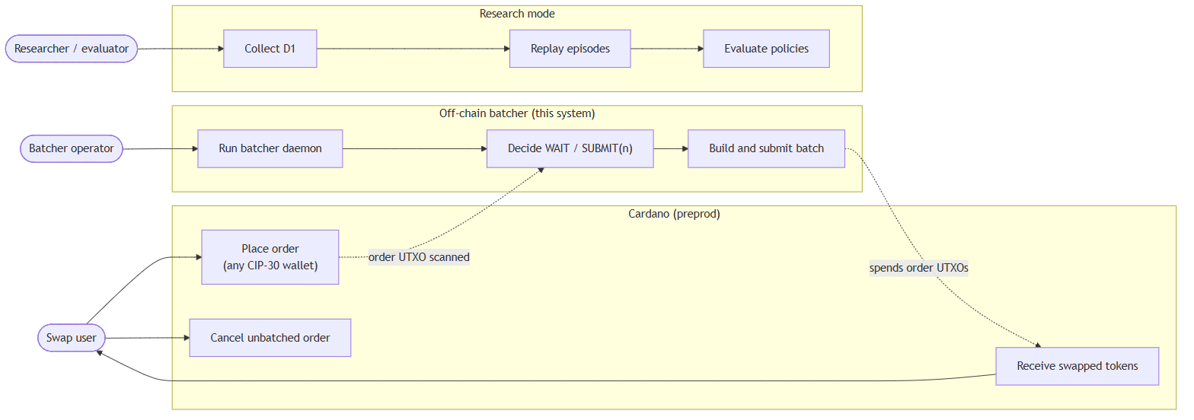
Figure 5.2: Use case diagram — the swap user never interacts with the batcher
P3 is not a Policy subclass in the class diagram that follows: the DQN agent acts through BatchingEnv, the Gymnasium wrapper around the same event loop, and is scored through the same metrics path.

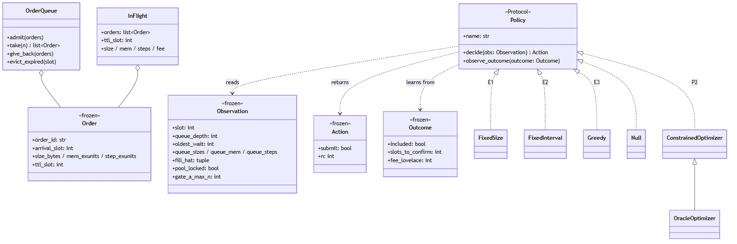
Figure 5.3: Class diagram — every policy reads the same Observation and returns the same Action
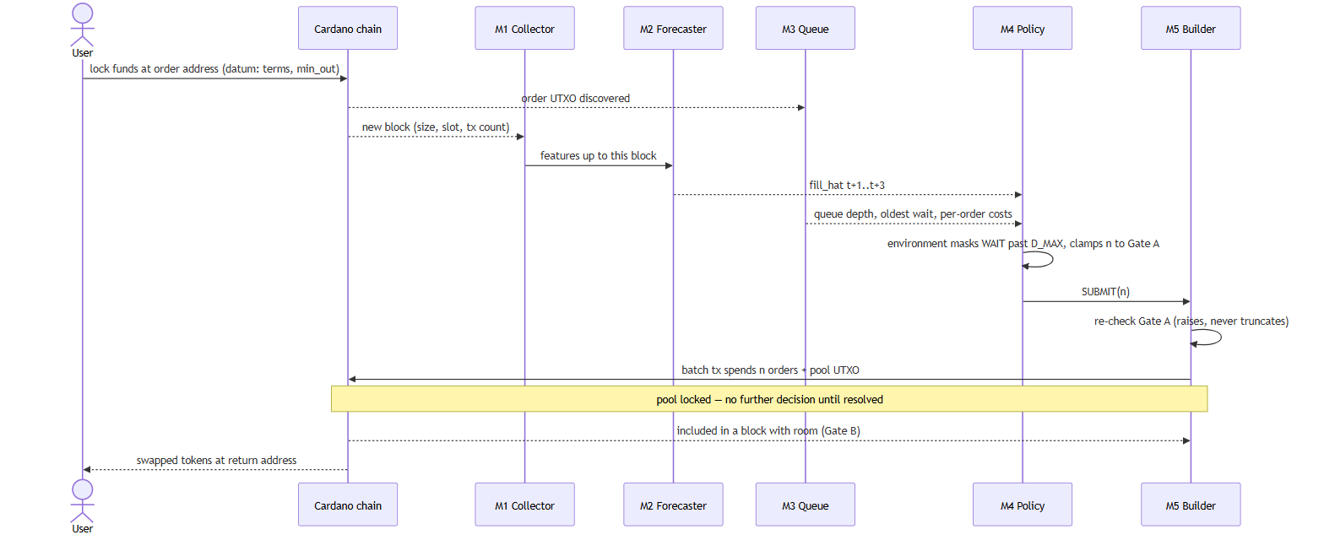
Figure 5.4: Sequence diagram — one order from placement to settlement

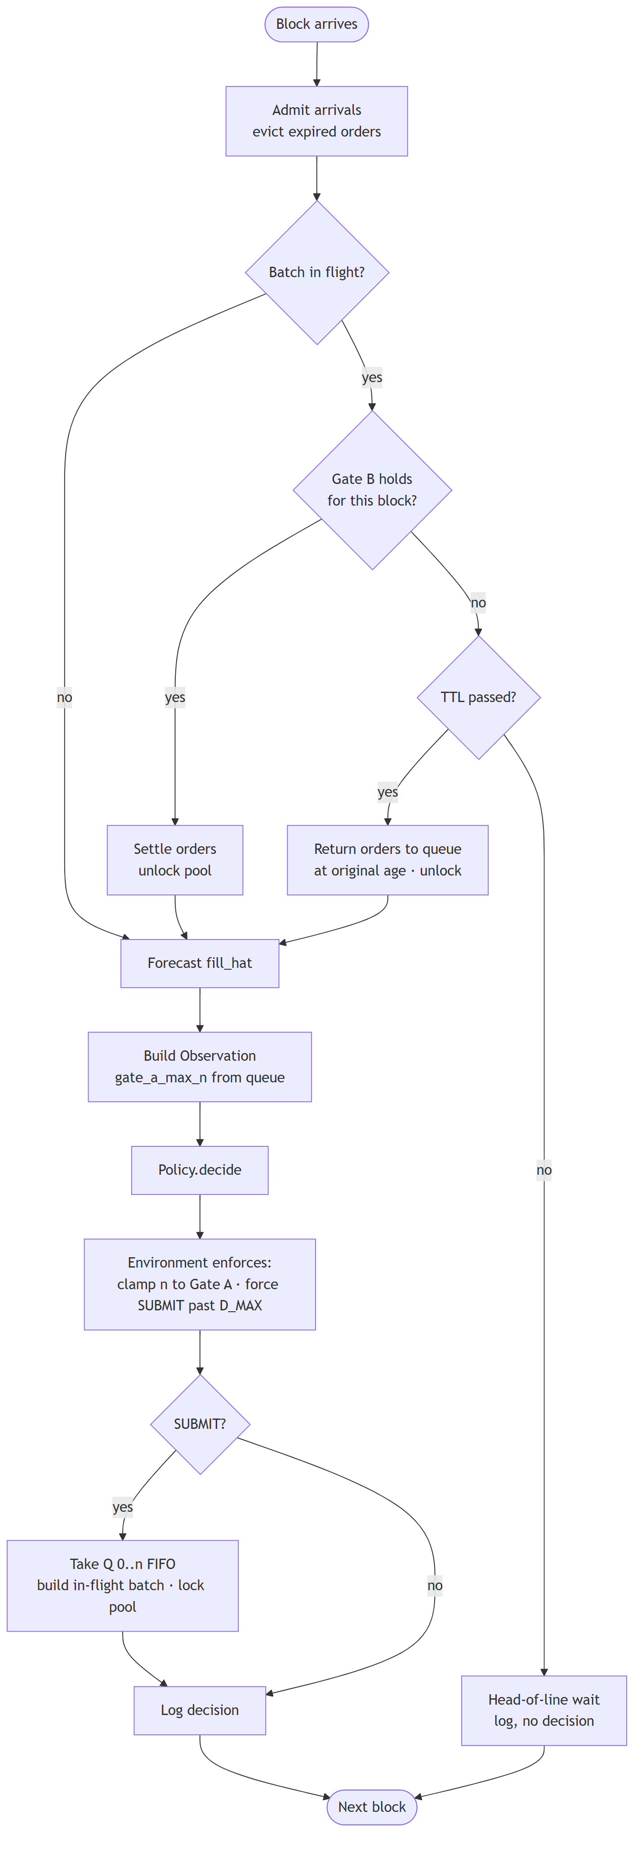
Figure 5.5: Activity diagram — the control loop for one block
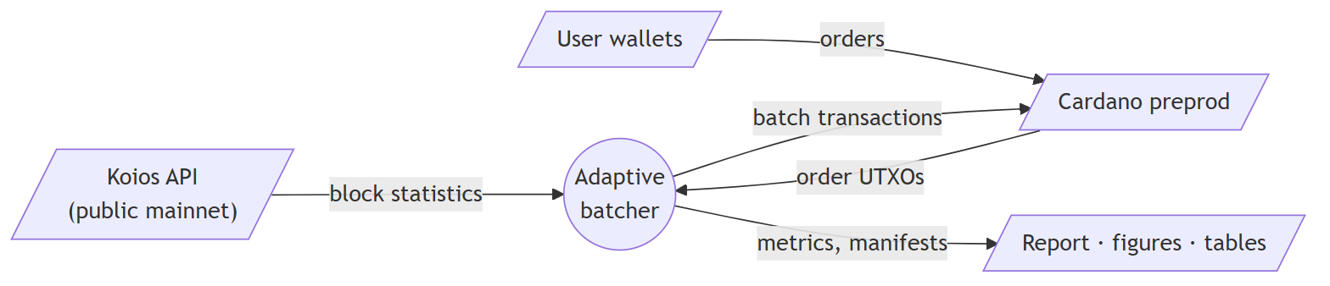
Figure 5.6: Data flow diagram, level 0
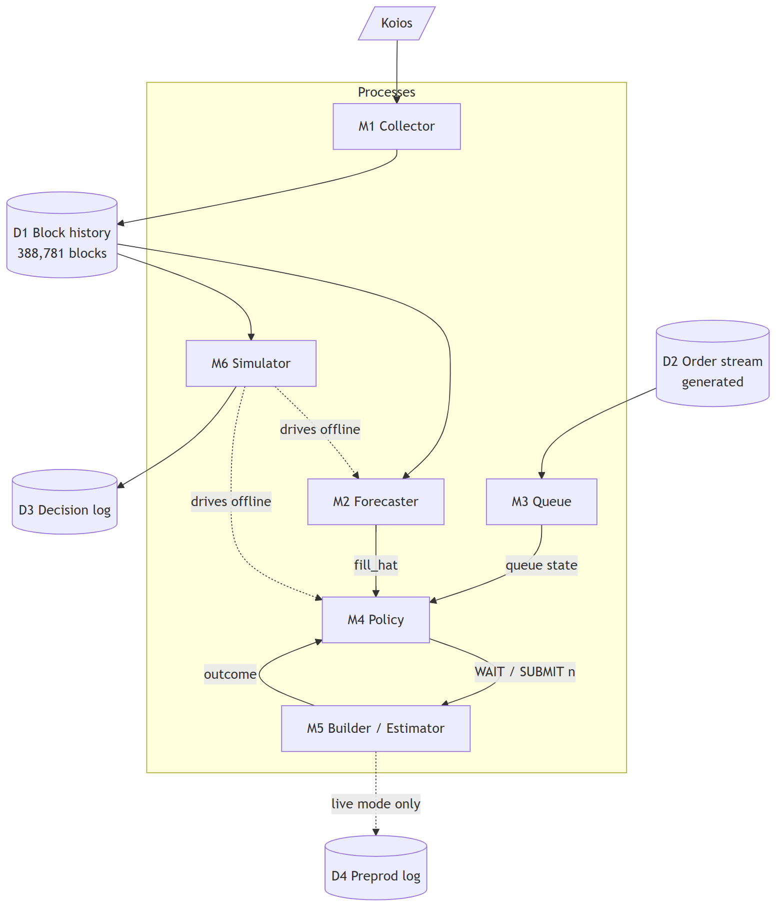
Figure 5.7: Data flow diagram, level 1

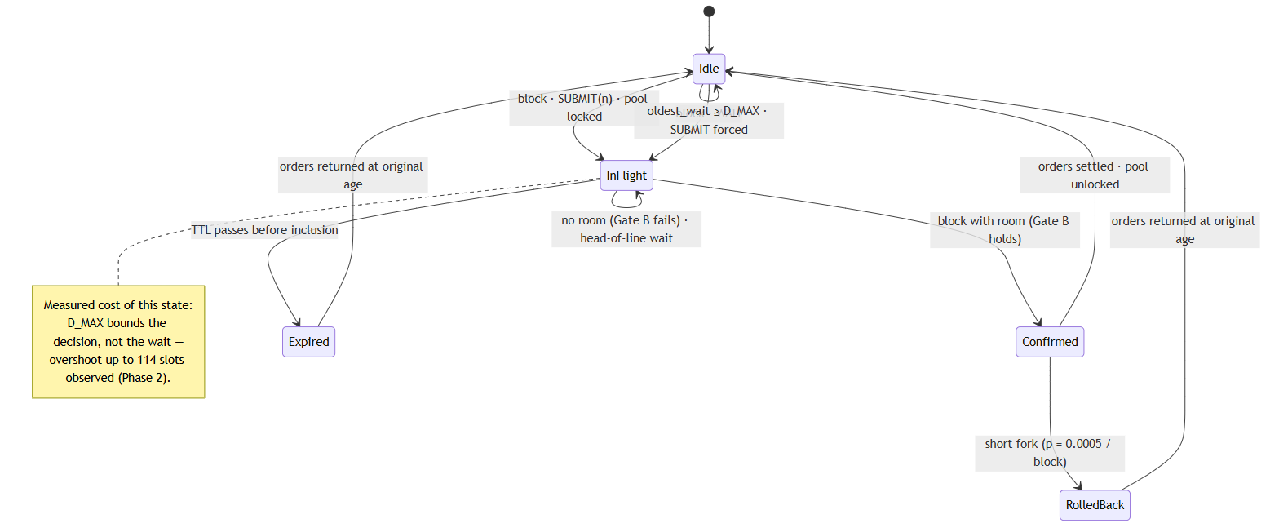
Figure 5.8: State diagram — the pool lock. There is no rejected or bounced state

The state diagram is where the mechanism that makes the project non-trivial becomes visible. While the pool is in the InFlight state no decision exists, and orders accumulate behind the batch. The deadline D_MAX bounds when a decision is forced, not how long an order waits: an order can pass D_MAX and wait until the next moment a block arrives and the pool is free — an overshoot of up to 114 slots was measured.
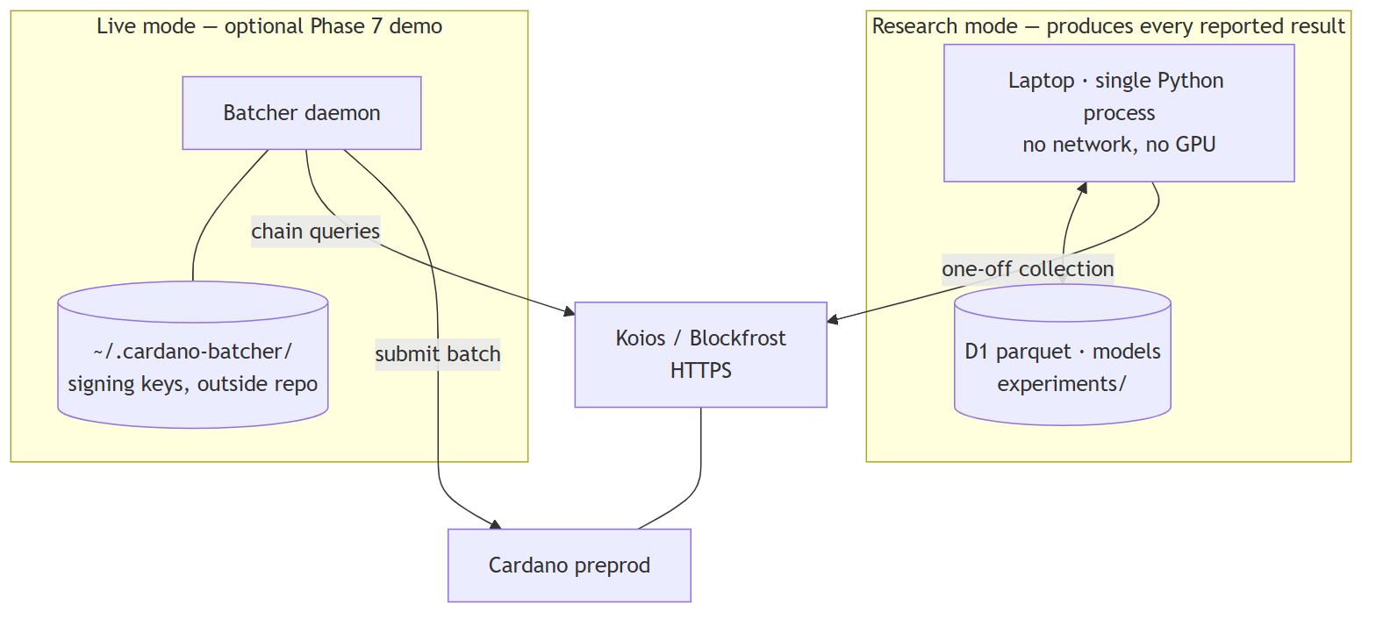
Figure 5.9: Deployment diagram — research mode and optional live mode

5.11 On-Chain DEX Design
Deployed DEXes bind their orders to their own validators and license their batchers, so a third-party batcher cannot serve them (ADR-003). The project therefore defines the smallest DEX that lets a batcher be demonstrated on the preprod test network: two Aiken validators compiled to Plutus V3, both parameterised by the batcher’s key hash. The batcher is untrusted for correctness: the validators, not the batcher, decide whether a user was treated fairly.
Table 5.5: Rules enforced on chain
Validator | Rule | Test
order.ak — Cancel | The order’s owner has signed; they can always reclaim an unbatched order | T-O1
order.ak — Execute | Only the authorised batcher key executes | T-O3
order.ak — Execute | The user is paid at least min_out of the output asset, at the return address in the datum | T-O2
order.ak — Execute | At most fee / n + margin lovelace is kept back from the user, where n is the number of orders in the batch | T-O5
order.ak — Execute | The payout carries the order’s own output reference as its datum, so one payment cannot satisfy two orders | Double satisfaction
pool.ak | Batcher-signed; exactly one continuing pool output, still holding the pool NFT; pool parameters unchanged | T-O4
pool.ak | After fees on each asset’s net inflow, the constant product does not decrease | T-O4

5.11.1 The pass-through fee
On a flat-fee DEX each order pays a fixed batcher fee, so a larger batch lowers the operator’s cost but not the user’s. Here the order validator reads the actual transaction fee and counts the order inputs, and allows the batcher to keep only fee / n + margin from each user (ADR-006). The amortization that the policies optimise is thereby delivered to users by the ledger, not by the operator’s goodwill, and the per-user cost C-user measures something a user actually pays.

5.11.2 The pool invariant
inflow_x = max(x_new - x, 0) inflow_y = max(y_new - y, 0)
adjusted_x = x_new * 10000 - inflow_x * fee_bps
adjusted_y = y_new * 10000 - inflow_y * fee_bps
valid = adjusted_x * adjusted_y >= x * y * 10000 * 10000
The fee is charged on the net inflow of each asset, so a batch can net buy and sell orders together and still never extract value from the pool.

5.11.3 A pool identity that cannot be forged
The pool token and the pool NFT are minted under a native-script policy that requires the batcher’s signature and a validity bound: nothing can be minted after a slot fixed at deployment. Once that slot passes, no second pool NFT can exist, so the NFT that identifies the pool is unique by construction rather than by the batcher’s good behaviour.

Chapter 6: Implementation

6.1 Repository Structure
src/batcher/
config/ protocol.py (constants), params.py (tunables), settings.py (preprod guard)
data/ sources.py (Koios client), collector.py (resumable M1), features.py
build/ estimator.py (fee, Gate A, Gate B), submitter.py, tx_builder.py
queue/ manager.py (FIFO order queue, M3)
forecast/ baseline.py (E4), lgbm.py (P1), evaluate.py
policy/ base.py (interfaces), static.py (E1-E3, NULL), optimizer.py (P2, ORACLE)
sim/ env.py (event loop), mempool.py, orders.py (D2), episodes.py, gym_env.py
eval/ metrics.py, stats.py, plots.py, manifest.py, rl_diagnostics.py
scripts/ collect, verify_dataset, analyze_congestion, train_forecaster,
tune_baselines, evaluate, train_rl, evaluate_rl,
final_evaluation, run_stats, make_figures, ...
onchain/ datums.py, blueprint.py, deployment.py (Phase 7)
live/ chain.py, daemon.py (Phase 7 live batcher)
onchain/ Aiken: validators/order.ak, validators/pool.ak, plutus.json
tests/ 339 Python tests in 26 files; 16 Aiken tests in onchain/
Every number in this report is produced by a script under scripts/ that writes a run manifest recording the seed, git revision, configuration hash and dataset checksum. No result reaches the report through a notebook.

6.2 Protocol Constants Module
All capacity limits and fee coefficients live in config/protocol.py and nowhere else (NFR-4). Test T-C2 walks the source tree and fails if any of these literals appears outside that module, so a governance change to a parameter is a one-line edit that cannot be missed. A companion settings module refuses to load any network other than preprod, so mainnet key material cannot be used by configuration error.

6.3 Data Collection (M1)
The collector pages through Koios block endpoints, requesting only the needed fields. It is resumable — interrupted runs continue from the last written height and produce a byte-identical file — and it retries transient failures, including truncated HTTP responses that surfaced during the 92-day collection. The block range is pinned by explicit start and end heights so the dataset can be regenerated exactly. The final dataset of 388,781 blocks has SHA-256 checksum 48cd6f8b9a9e…, verified to have no height gaps and strictly increasing slots.

6.4 Feature Engineering
Features are lags of fill 1–20, rolling means and standard deviations over 5, 10 and 20 blocks, slot gap and its rolling mean, transaction-count lags and hour of day as sine and cosine. The anti-leakage rule is that every feature at block t must be computable from data at or before t; a test asserts it. A defect found here is instructive: the evaluation script originally did not build features before calling the forecaster, which silently fell back to the moving average. Missing feature columns now raise an error instead of degrading quietly.

6.5 P1 Forecaster
LightGBM is trained with an L1 objective on the training split, with early stopping on validation MAE. The model is frozen after training and wrapped with a cache so the simulator can query forecasts cheaply during thousands of episodes. If the model artifact fails to load, prediction falls back to E4 and reports that it has done so.

6.6 Gate Implementation
The gates embody the ADR-002 decision in their signatures: Gate A cannot see a block at all, and the fee function takes no block or congestion argument, so the corrected errors are not even expressible.
def fee_lovelace(size: int, mem: int, steps: int) -> int:
"""The Cardano fee formula. Deterministic; no congestion term."""
return int(MIN_FEE_A * size + MIN_FEE_B + PRICE_MEM * mem + PRICE_STEPS * steps)

def gate_a(n, sizes=None, mems=None, steps=None) -> bool:
"""Feasibility. Always binding, and independent of congestion."""
return (tx_size(n, sizes) <= MAX_TX_SIZE
and tx_mem(n, mems) <= MAX_TX_EX_MEM
and tx_steps(n, steps) <= MAX_TX_EX_STEPS)

def gate_b(n, block_size, block_mem, block_steps,
sizes=None, mems=None, steps=None) -> bool:
"""Inclusion. Congestion dependent; evaluated against a forecast or a block."""
return (block_size + tx_size(n, sizes) <= MAX_BLOCK_SIZE
and block_mem + tx_mem(n, mems) <= MAX_BLOCK_EX_MEM
and block_steps + tx_steps(n, steps) <= MAX_BLOCK_EX_STEPS)
Test T-G5 asserts that the maximum batch size for a completely empty block equals the Gate A maximum. It is the permanent regression guard against the original error in which an empty block was thought to permit a larger batch, and it is marked in the source as never to be deleted.

6.7 P2 Optimizer
P2 follows the pseudocode of Section 5.6.2 directly. Notably it never clamps for safety: Gate A clamping, the pool lock and the starvation deadline are enforced by the environment, so the policy’s decisions are preferences, not permissions. Duplicating the enforcement inside the policy would hide a bug in whichever copy was wrong.

6.8 P3 Reinforcement-Learning Agent
The Gymnasium environment wraps the same event loop. Its action mask implements the three rules of Section 5.7 and is re-applied inside step:
def step(self, action):
mask = self.action_masks()
# Enforced here as well as exposed: an agent that ignores the mask
# still cannot act illegally.
if not mask[action]:
self.mask_hits += 1
action = int(np.argmax(mask))
n = self._action_to_n(action)
if n > 0:
taken = self.queue.take(n)
self.in_flight = build_in_flight(taken, self.current_slot, self.ttl_slots)
# Move past this block before seeking the next decision point,
# or the episode never advances on WAIT.
self.index += 1
locked_slots = self._seek_decision()
...
The last comment records a real defect the environment tests caught: the first implementation did not advance on WAIT, so an episode looped on one block indefinitely. DQN (Stable-Baselines3) was trained for 200,000 steps on each of five seeds — a tenth of the 2,000,000 steps originally specified. The reduction was a recorded team decision: five seeds is non-negotiable, and at roughly six hours per seed the full budget would have required about 30 hours of CPU time. Results must therefore be read as a lower bound on what DQN could achieve.

6.9 Simulator
The event loop in sim/env.py advances on recorded absolute slots. Each episode uses one seeded random generator passed explicitly; there is no global random state and no wall-clock time in any decision path, so two runs with the same seed produce byte-identical metrics. Order conservation — orders in equal settled plus expired plus still queued — is asserted at the end of every episode, so an accounting leak fails the run rather than silently corrupting throughput.

6.10 Statistical Evaluation
eval/stats.py implements the paired analysis: the Wilcoxon signed-rank test on per-episode differences, the median paired difference with a seeded 10,000-resample bootstrap 95 % confidence interval, and Holm–Bonferroni correction across the primary metrics. An improvement is declared significant only if its adjusted p-value is below 0.05 and its confidence interval excludes zero.

6.11 On-Chain Validators
The validators are written in Aiken v1.1.23 against stdlib v3.1.0 and compile to Plutus V3 scripts of 944 bytes (order) and 864 bytes (pool). The core of the order validator is short enough to read in full:
Execute -> {
expect Some(own_input) = transaction.find_input(self.inputs, own_ref)
let own_credential = own_input.output.address.payment_credential
let n = list.count(self.inputs,
fn(input) { input.output.address.payment_credential == own_credential })
let charge = self.fee / n + request.margin // ADR-006: pass-through fee

let tag: Data = own_ref // against double satisfaction
expect Some(payout) = list.find(self.outputs, fn(output) {
output.address == request.return_address && output.datum == InlineDatum(tag) })

let user_made_whole = when request.direction is {
AtoB -> paid_token >= request.min_out
&& paid_lovelace >= deposit - request.amount_in - charge
BtoA -> paid_lovelace >= deposit + request.min_out - charge
}
and { list.has(self.extra_signatories, batcher), user_made_whole }
}
The compiler writes a blueprint, plutus.json, describing every datum and redeemer. The Python side mirrors those types as PyCardano Plutus data, and a test checks every constructor index and field order against the blueprint, so the two cannot drift: a mis-encoded datum is not a type error anywhere, only a transaction rejected on chain without explanation. A second test checks that PyCardano derives the same script hashes the compiler recorded. Parameters — the batcher key, the pool token — are applied with aiken blueprint apply, the compiler that produced the code, rather than by editing scripts in Python.
One defect is worth recording. The first order validator bound its datum to a local variable named order, the validator’s own name. It failed to compile with no diagnostic at all, because the compiler prints errors only to an interactive terminal; the cause was found by compiling halves of the file.

6.12 Transaction Building
Live batching is planned before it is built. plan_batch takes queued orders oldest first, quotes each against the pool with the constant-product formula, and drops any order the pool cannot fill at its min_out — then recomputes everyone’s fee share for the smaller batch, since n has changed. It re-checks Gate A and raises on a violation, and it imports gate_a and fee_lovelace from the same estimator the simulator uses, a property tested by object identity (T-N6).
Building the transaction with PyCardano adds one subtlety. Users are charged for the fee the plan assumed, but order.ak checks against the fee the transaction actually carries; if the built fee came in lower, users would have been overcharged and the batch rejected. Settling the fee after the build is not enough on its own, as the first live batch showed (Section 8.12): the node evaluates the scripts during the build, against a fee not yet known. The builder therefore works in two passes — a probe that charges margins only, valid at any fee, to obtain execution units; then a final build with those units fixed, charging users for the fee the transaction really carries:
probe_plan = plan_batch(queued, x, y, deployment.fee_bps, network_fee=0) # margins only
probe = _assemble(context, batcher_skey, deployment, scripts, pool_utxo, by_ref, probe_plan, ttl)
units = _probe_units(probe) # the node evaluates exactly once, here

plan = plan_batch(queued, x, y, deployment.fee_bps, network_fee=probe.transaction_body.fee)
for _ in range(MAX_FEE_ROUNDS):
tx = _assemble(context, batcher_skey, deployment, scripts, pool_utxo, by_ref, plan, ttl, units)
fee = tx.transaction_body.fee
if plan.network_fee <= fee <= plan.network_fee + FEE_TOLERANCE_LOVELACE:
return _measure(tx, plan, ttl)
# Charge users for the fee this transaction actually carries, then rebuild.
plan = plan_batch(queued, x, y, deployment.fee_bps, network_fee=fee)
Deployment is derived deterministically from the batcher key and the minting deadline. The committed deployment record holds hashes only; on load the scripts are re-derived and checked against it, so rebuilding the validators with different code after deploying fails loudly instead of producing scripts that cannot spend the deployed pool. Every script that can submit a transaction is a dry run unless `--submit` is given.

6.13 The Live Batcher
scripts/run_batcher.py runs the simulator’s control loop against preprod through a narrow chain interface, so the whole loop is testable against a fake. Each new block it resolves any batch in flight (included, expired, or still waiting); while the pool is held no decision is made; otherwise it reads the queue and the pool, forms the same Observation the simulator builds, asks the policy, and repairs the decision with the simulator’s own structural rules — the very function object, not a copy. The forecast in live mode is E4 over real recent blocks: the learned forecaster needs a 20-block feature history the first version of the loop does not maintain. Since ablation A2 found LightGBM does help P2 on cost, running it live is listed as future work.
- Shadow mode is the default: the batcher decides and builds and signs the exact batch it would send, then logs it without submitting. A policy can be watched on live traffic before it is trusted with the key.
- A lagging API can still show the pool UTxO that the batcher’s own confirmed batch spent; the loop recognises it and waits rather than building a transaction that would be rejected.
- Rejected submissions are logged and counted, and leave the pool free; a Gate A violation, being a defect, stops the daemon.
- Shutdown is only clean with the pool free: a stop request waits for any batch in flight to resolve and starts no new batch.
- Safety: the settings guard makes mainnet unreachable, keys are generated outside the repository and refused inside it, and the pre-commit secret scan was extended to the JSON key files PyCardano writes, proven on a real generated key.

6.14 The Presentation Dashboard
FR-15 asked for a local dashboard of the decision loop. src/batcher/dashboard/ provides it as a small read-only web application, served by scripts/dashboard.py on the loopback interface. Its design rule is that the page stores no results of its own: every figure it shows is either recomputed at request time from the committed experiment artefacts, replayed through the simulator itself, or read from the chain. A number that changes in the repository therefore changes on the screen, and a number cannot be quietly edited into the presentation.
Table 6.1: What each view shows, and where its numbers come from
View | Shows | Source of truth
Overview | The problem, the measured chain, the policies compared and the outcome | Figures quoted from Chapters 4 and 8
Simulator | One held-out day replayed block by block: queue depth, pool lock, both gate limits, the decision and its reason, and running metrics | run_episode on the same test episodes, seed 42, with the trained LightGBM forecaster
Results | Median metrics with 95 % confidence intervals for every policy and arrival rate, the trade-off scatter and the latency distribution | experiments/phase6-final-evaluation/episode_metrics.parquet, re-aggregated per request
Live | The deployed pool, the waiting order queue, the recorded end-to-end swap and the contract addresses | Blockfrost through the same chain adapter the live batcher uses, plus the Phase 7 manifest

The server is standard library only: a threading HTTP server, four JSON routes and a fixed list of static files. It refuses to bind anything but the loopback interface, so the dashboard cannot be exposed on a network by configuration; it declines a port already in use rather than silently sharing it; unknown paths and attempts to escape the static directory return 404; a request made before the dataset has finished loading returns 503 with the loading message, and a malformed replay request returns 400. The episode library reads D1 in a background thread, so the page answers immediately and reports its own progress.
The browser side is plain JavaScript with SVG and canvas — no framework, no build step and no content delivery network — so the Simulator and Results views work with no internet connection and only the Live view needs one. The interface opens with a short generated title sequence that can be skipped with a button, Enter, Space or Escape; the pages themselves use decoded headings, counted-up figures, reveal-on-scroll cards and a background of light strands that changes shape as the page scrolls. All of it is suppressed for viewers whose system asks for reduced motion, and the palette tokens are recorded in docs/design/palettes.md so the look can be restored or replaced without hunting through the stylesheet.
Why the dashboard recomputes instead of storing
It is the only artefact in the project a viewer can operate, and therefore the most likely place for a number to drift away from the evidence. Its agreement with Table 8.4 is asserted by a test that fails if either side moves.

Chapter 7: Testing

7.1 Strategy and Coverage
In a research codebase the main danger is not a crash but a quietly wrong number that survives into the report. The test suite targets that: every number that reaches the report is produced by code covered by a test that would fail if the number were wrong. The suite contains 356 Python tests in 27 files and 16 Aiken tests for the validators; the Python suite runs on every push in GitHub Actions and enforces a minimum of 90 % line coverage, and measured coverage is 93.9 %.
Table 7.1: Test levels
Level | Scope | Tooling
Unit | Estimator, gates, fee, metrics, queue, statistics | pytest
Property | Invariants that must hold for all inputs | hypothesis
Integration | Collector to D1, D1 to features, policy to simulator | pytest with API fixtures
System | Full episodes, every policy, determinism | pytest
Validation | Simulator behaviour against known-correct expectations | pytest and scripts

7.2 Invariant Tests
Table 7.2: Critical invariants — any failure invalidates the results
ID | Invariant | Result
T-I1 | No submitted transaction violates Gate A | Pass — also zero violations across every evaluation run
T-I2 | No decision opportunity past D_MAX results in WAIT | Pass (restated; see Section 7.4)
T-I3 | No submission while the pool is locked | Pass
T-I4 | The chronological split never leaks | Pass
T-I5 | Same seed twice gives byte-identical metrics | Pass

7.3 Unit and Property Tests
Table 7.3: Selected unit and property tests
ID | Test | Expected | Result
T-C2 | No protocol literal outside the constants module | Only protocol.py matches | Pass
T-C3 | Network guard | Non-preprod settings raise | Pass
T-F2 | Fee for a known transaction | Matches hand computation to the lovelace | Pass
T-F3 | Fee function takes no block state (ADR-001) | Enforced across the cost model | Pass
T-F5 | Amortization flattens | cost(10)−cost(30) < cost(1)−cost(10) | Pass
T-G1 | Gate A independent of block state | Same result for empty and 90 %-full block | Pass
T-G3 | Memory binds before size | Memory is the limiting dimension | Pass
T-G5 | Empty block does not raise the Gate A cap (ADR-002) | max_n(fill=0) = max_n_gate_a | Pass
T-Q1/Q2 | FIFO; returned orders keep their arrival slot | Oldest first, no age reset | Pass
T-M1/M2 | Jain bounds; p95 against numpy.percentile | 1.0 for equal waits; exact match | Pass
T-P3 | Conservation: in = settled + expired + queued | Holds on random episodes | Pass
T-N2 | Collector resumability | Resumed run byte-identical | Pass
T-L1 | Leakage check on identical rows | Leaked features help (+2.6 %); clean pipeline does not leak | Pass
T-L3 | Random agent over 10,000 steps | No illegal action executed | Pass
T-L4 | Reward terms commensurable | Comparable magnitude after normalisation | Pass
T-L6 | Collapse detector | Always-WAIT entropy 0.0; trained agent 0.68 | Pass
T-L5 | Checkpoint reproducibility | Reloaded checkpoint reproduces metrics | Pass — unit test, and all 5 committed P3 checkpoints reproduce every recorded metric exactly

7.4 Simulator Validation
A simulation-based result is only as credible as the simulator. This section answers the question a reviewer will ask: why should the simulator be believed?
Table 7.4: Simulator validation checks V1–V4
Check | Expected | Outcome
V1 / T-S2 — NULL policy never submits | Zero throughput; every order expires | Pass
V2 / T-S3 — greedy shape | E3 gives the lowest latency and highest per-user cost | Pass in unit tests and on replayed D1 at all three arrival rates
V3 / T-S4 — E1 with M above n_max | Behaves like NULL until D_MAX forces submission | Pass
V4 / T-F6 — fee replay on 200 real mainnet transactions | Formula never exceeds the actual fee | Pass on 200/200; median residual 0.39 % on simple transactions
T-S5 — head-of-line blocking (ADR-004, ADR-008) | Queue grows monotonically while locked, on a quiet and a congested fixture | Pass
T-S6 — real slot clock (ADR-007) | Episode duration equals the recorded slot span | Pass

V2 is the strongest single check. Greedy producing the lowest latency and the highest per-user cost follows directly from the cost model; had it failed, something upstream of every result would have been wrong, and the project would have stopped there.
V4 found a real gap. On script-bearing transactions the formula under-estimates the actual fee by a median of 29 %, almost certainly the Conway-era reference-script surcharge, which the fee formula predates. DEX batches are script-bearing, so absolute per-user costs in this report are understated. Policy comparisons are unaffected because every policy is priced by the same estimator, and because the missing term is charged per transaction it is a flat component that would strengthen, not weaken, the amortization argument.
A specification gap. Invariant I2 and goal G4 read as though D_MAX bounds how long an order waits. It bounds the decision: a decision exists only when a block arrives and the pool is free, so an order can pass D_MAX and wait for the next such moment — up to 114 slots of overshoot was measured. The invariant that actually holds, and is tested, is that no decision opportunity past the deadline results in WAIT.

7.5 On-Chain and Live-Mode Tests
Phase 7 moves the batcher from a simulator onto a real ledger, where a mistake costs a rejected transaction or, worse, a user short-changed by a buggy batcher. Everything that can be checked without submitting a transaction is checked offline: the validators in Aiken’s own test runner, and the Python side against a fake chain context on which PyCardano still performs its real coin selection, balancing and fee calculation.
Table 7.5: On-chain and live-mode tests
ID | Test | Result
T-O1 | The owner can cancel an order; a stranger or the batcher cannot | Pass (Aiken)
T-O2 | A payout below min_out, or paid to any other address, is rejected | Pass (Aiken)
T-O3 | A batch signed by any key but the batcher’s is rejected | Pass (Aiken)
T-O4 | A fair swap is accepted; ignoring the fee, losing the NFT, rewriting pool parameters or a non-batcher signer is rejected | Pass (Aiken)
T-O5 | fee / n + margin is accepted, one lovelace more is rejected, and the allowed share halves when n = 2 | Pass (Aiken)
— | One payout cannot satisfy two orders (double satisfaction) | Pass (Aiken)
— | Every Python datum matches the compiled blueprint; PyCardano’s script hashes match the compiler’s | Pass
T-N6 | The live planner uses the simulator’s gate_a and fee_lovelace — the same objects | Pass
— | Property test: 200 random mixes of buy and sell orders never break the pool invariant | Pass
— | A built batch satisfies the order validator’s fee rule for the fee it actually pays | Pass
P7-5 | Keys are refused inside the repository and never overwritten; the secret scan blocks a real generated key file | Pass
P7-8 | Live loop: one decision per block, none while locked, expiry retried, rejection counted, stale API view, clean shutdown | Pass
T-O6 | One end-to-end swap settles on preprod | Pass — batch b5201c0a…c73af1, verified on chain

7.6 Defects Found by Testing
Table 7.6: Defects caught before they reached a result
Defect | Effect had it survived | Fix and guard
Queue admission cap silently dropped orders | Throughput and expiry both wrong | Queue made unbounded; conservation asserted per episode
Arrival process ran 4.5× hot | E1 appeared to fail catastrophically (68 % expiry) | Bursts expressed as onsets per day
Decision log recorded post-action queue depth | Deadline assertion silently defeated | Log records what the policy observed
Forecaster silently fell back to moving average | LightGBM results would have been E4’s | Missing features raise an error
RL environment never advanced on WAIT | Episodes looped forever | Act, advance, seek next decision; regression test
Leakage check compared different rows | False “leaking” verdict | Both models scored on identical rows
.gitignore rule hid src/batcher/build | CI import failure on a clean checkout | Anchored rule; test that no source file is ignored
Live: Blockfrost’s raw-CBOR datums unreadable | Every real order silently skipped | Accept raw CBOR; regression test with datums as Blockfrost returns them
Live: users charged for the estimated fee | First batch rejected by order.ak during evaluation | Two-pass build; fake chain enforcing the fee rule during evaluation
Dashboard: pool-lock tile counted locked decisions, not slots | Lock occupancy displayed as 0 % instead of 49 % | Cumulative locked slots; agrees with the recorded lock occupancy of 0.486
Dashboard: the replay view gave up after one failed request | Simulator view stuck on “server unreachable” after a restart | Retry with backoff; Load disabled until the data is ready
Dashboard: a second server silently shared the port on Windows | Requests split between two processes, stale figures on screen | Exclusive bind, message naming a free port, regression test
Title sequence dismissed by a reload’s repeated Enter key | Opening sequence vanished instantly when reloading from the address bar | Held keys ignored, and all keys ignored for its first 1.2 s

7.7 Regression Guards for Corrected Assumptions
Table 7.7: Permanent guards for each architecture decision
Decision | Guard | Status
ADR-001 latency, not fees | Cost model takes no block state | Live
ADR-002 transaction limits, not block limits | T-G5 | Live
ADR-004 pool-lock failure model | T-S5; no bounce outcome exists | Live
ADR-005 sampled execution units | Absent values are null, never zero | Live
ADR-006 pass-through fee | T-O5 in the order validator’s Aiken tests | Live
ADR-007 real slot clock | T-S6 | Live
ADR-008 concurrency, not congestion | T-S5 on a quiet fixture | Live

7.8 Dashboard Tests and Demonstration Scenarios
The dashboard is tested on two levels. Fourteen automated tests in tests/test_dashboard.py cover the data it serves and the server that serves it: that a replay payload is exactly the simulator’s own decision log, that no submission is shown while the pool is held, that the per-block gate never exceeds the per-transaction gate, that every payload is strict JSON, that the comparison view reproduces the median tail latency of Table 8.4, that the latency distribution is monotone, that the live view reads a pool and a queue from a fake chain, and that the server answers 503 while loading, 400 for a malformed request and 404 for anything outside its static directory, refuses a non-loopback address and refuses a port already in use.
Because a demonstration fails in ways a unit test cannot see, ten end-to-end scenarios were also exercised against the running dashboard. Nine passed outright; the tenth could be confirmed only by inspection, because the operating system’s reduced-motion setting cannot be toggled from the test harness.
Table 7.8: Demonstration scenarios exercised against the running dashboard
Scenario | What was checked | Result
Cold start | Server boots, the title sequence plays, the site takes over with its text visible | Pass
Reload behaviour | The sequence plays on every reload and survives a held Enter key; a direct #page link loads with that page behind it | Pass
Skip paths | Skip button, Enter, Space and Escape, and replaying the sequence from the footer | Pass
Simulator replay | Catalogue of 5 policies × 3 rates × 100 days; P2 (N=4) on test-000 ends at 125 s tail latency, 0.128 ADA per user, 49 % locked and 0 expired; play, pause, step and scrub by button and keyboard | Pass
Results correctness | Highlights and table match the recorded evaluation: greedy 119 s / 0.157 ADA, P2 125 s / 0.128 ADA, P3 159 s / 0.090 ADA, and E1 at 1,203 s under heavy load | Pass
Live view, online | Pool of 110.00 tADA and 909,339 TEAM11 carrying its NFT, empty queue, four swap transactions with explorer links, working refresh | Pass
Live view, offline | With an invalid project token the view reports the failure and still lists the four recorded transactions, as valid JSON | Pass
Server robustness | Traversal and unknown paths 404, malformed replay 400, busy port refused with guidance, non-loopback bind refused | Pass
Phone and tablet | At 375 px and 768 px nothing overflows on any view, the page never scrolls sideways, and the selected tab scrolls into view | Pass
Reduced motion | Animation suppressed and the content still readable | Verified by inspection

Chapter 8: Results and Discussion
Status of this chapter
Sections 8.5–8.9 and 8.11 report the held-out test split, evaluated exactly once: 8 policies × 3 arrival rates × 100 paired episodes, with P3 run for all five seeds and seed-averaged per episode before pairing. Every configuration was fixed on validation beforehand. Validation tables from Phases 4 and 5 are retained for context and labelled as such.

8.1 Congestion Analysis
The project was originally motivated by a widely repeated claim that Cardano blocks run 80–90 % full at peak, leaving no room for a batch. D1 was collected to quantify that claim. It does not hold on the current chain.
Table 8.1: Block occupancy over 92 days of mainnet (388,781 blocks)
Statistic | Measured
Mean block fill | 6.83 %
Median block fill | 2.95 %
95th percentile | 25.39 %
Blocks above 80 % / 90 % | 0.564 % / 0.395 %
Transactions per block | 3.76
Congested blocks (>80 %) | 2,193 in 1,679 separate episodes
Longest unbroken congested run | 10 blocks (5 minutes)
Share of congestion in the busiest 5 of 93 days | 64 %
Busiest single day | 11.2 % of its blocks above 80 %

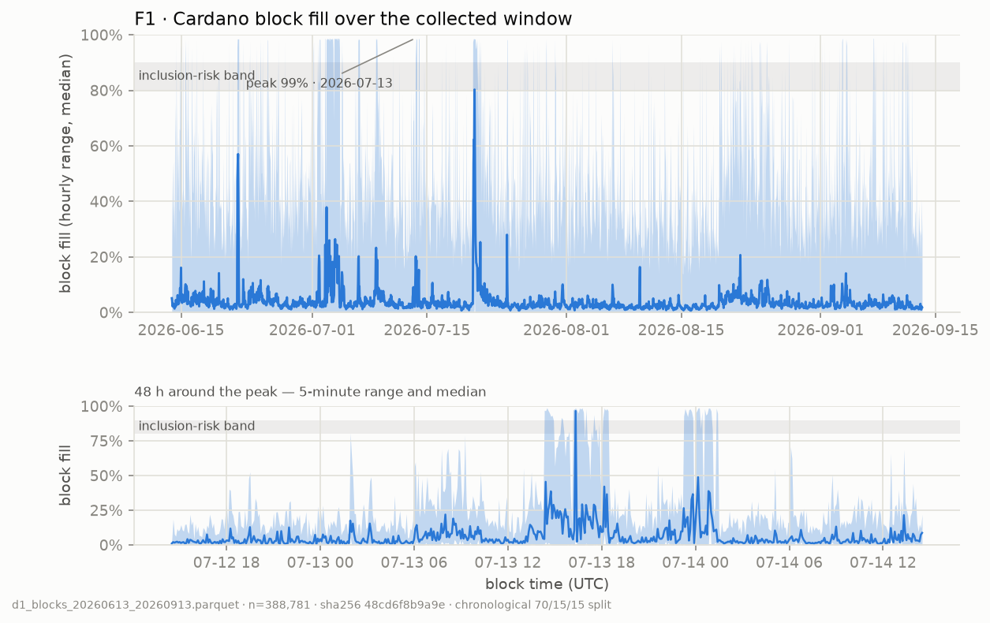
Figure 8.1: F1 — block fill over the 92-day window, with the 80–90 % band shaded
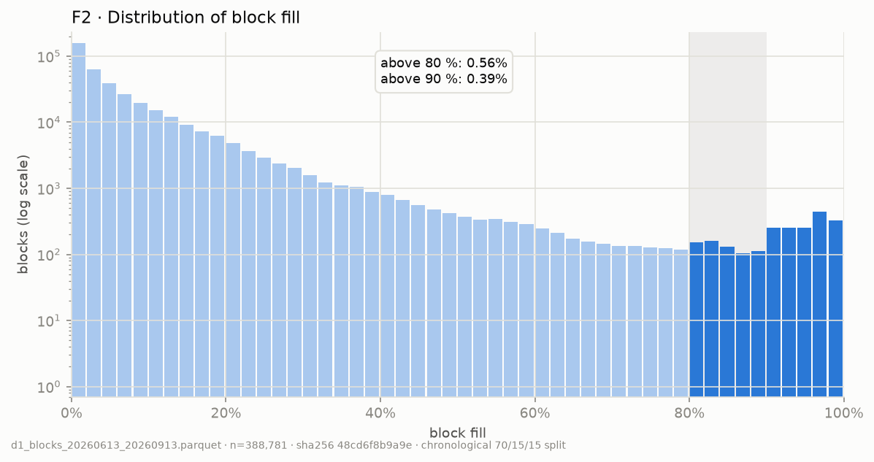
Figure 8.2: F2 — distribution of block fill
Congestion is real but rare and interleaved, never sustained. A batcher never faces a run of blocks it cannot enter, only isolated ones it can wait out. Gate B binds on a 30-order batch only above about 89 % fill — roughly one block in 180. An early version of F1 plotted 5-minute maxima, which painted the series at 100 % for any window containing a single full block and read as hours of saturation; the episode measurement contradicted it, and the figure now plots range and median.
Reframing (ADR-008)
The problem that is real is concurrency, not congestion. The pool lock binds on every batch regardless of how full blocks are. The project was reframed accordingly, following a fallback pre-authorised in the risk register; the objective and goals G1–G6 were unchanged. The congestion measurement is retained as a first-class empirical result about the chain.

The size-based fill is a valid proxy for execution-unit fill: correlation is 0.912 in the congested sample, 0.588 in the quiet one (where half the blocks run no scripts) and 0.852 pooled. Execution steps never exceeded 49.9 % of the block budget in 17,280 sampled blocks.

8.2 Predictability of Congestion
Table 8.2: Predictability on the full window
Measure | Value
Autocorrelation at lag 1 / 5 / 20 | 0.372 / 0.322 / 0.272
MAE, lag-1 persistence | 0.06069
MAE, global mean | 0.06065
MAE, rolling mean (k = 20) | 0.05157 — 15.0 % better than the global mean

Lag-1 persistence ties the global mean, yet a rolling mean beats it by 15 % and autocorrelation persists to lag 20. On a spiky right-skewed series scored by MAE, persistence copies each spike forward and is penalised twice, while smoothing is not. The series has exploitable structure — at the level of slowly varying congestion, not individual spikes.

8.3 Forecaster Results
Table 8.3: Forecaster performance on the test split (58,316 rows, touched once)
Model | MAE | RMSE | Directional accuracy
P1 LightGBM | 0.04578 | 0.08364 | 0.742
E4 moving average | 0.05157 | 0.08355 | 0.710
Global mean | 0.06065 | 0.08867 | 0.662
Lag-1 persistence | 0.06069 | 0.10044 | 0.000

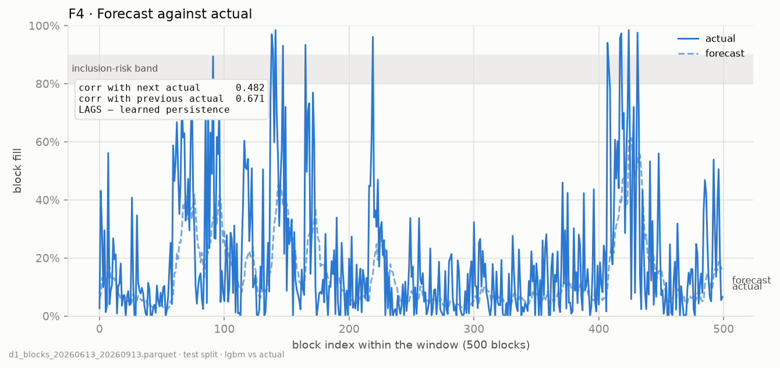
Figure 8.3: F4 — forecast against actual fill on a test window
S1 passes: LightGBM beats E4 by 11.2 % in MAE and 3.1 points in directional accuracy, though E4 is marginally better on RMSE, as expected from training on an L1 objective. The pass does not mean what it appears to: the forecast correlates 0.399 with the value it predicts and 0.616 with the value before it. It is a smoothed lag that learns the level of congestion and exploits mean reversion, but never anticipates a spike — and spikes are all that Gate B cares about.

8.4 Amortization Curve
Figure F3 (Section 5.4) shows per-user cost falling from 0.407 ADA for a single order to 0.092 ADA at n = 10 and 0.071 ADA at the Gate A cap of 24. Beyond about 15 orders a policy pays latency for a saving that has already flattened out, which is why the latency-optimal and cost-optimal policies sit at opposite ends of a frontier rather than at one point.

8.5 Policy Comparison
Tables 8.4–8.6 give the median over 100 paired test episodes with its 95 % bootstrap confidence interval for the primary metrics. L-p95 and L-mean are in slots, C-user in lovelace, TP in orders settled per 1,000 slots. P2 with N_MIN = 1 was byte-identical to greedy on every metric at every rate and is shown as one row.
Table 8.4: Test split, matched arrival rate
Policy | L-mean | L-p95 [95 % CI] | C-user [95 % CI] | X-rate | TP | F-jain
NULL (deadline only) | 116.7 | 191.0 [188.0, 193.0] | 79,451 [79,341, 79,580] | 0.00 | 117.2 | 0.86
E1 (M=16) | 106.0 | 183.3 [183.0, 185.0] | 82,906 [82,812, 83,001] | 0.00 | 117.3 | 0.83
E2 (T=20) | 63.4 | 130.5 [125.5, 137.0] | 129,729 [128,962, 131,007] | 0.00 | 117.3 | 0.78
E3 greedy ≡ P2 (N=1) | 55.8 | 119.0 [117.2, 121.0] | 157,445 [156,022, 159,366] | 0.00 | 117.4 | 0.75
P2 (D=120, N=4) | 60.9 | 125.0 [123.0, 126.0] | 127,738 [125,776, 129,084] | 0.00 | 117.3 | 0.77
P3 DQN, 5 seeds | 88.9 | 158.6 [158.0, 160.0] | 89,704 [89,273, 92,374] | 0.00 | 116.5 | 0.83
ORACLE (N=4) | 59.8 | 124.0 [122.0, 125.0] | 124,567 [123,005, 125,696] | 0.00 | 117.4 | 0.76

Table 8.5: Test split, light arrival rate
Policy | L-mean | L-p95 [95 % CI] | C-user [95 % CI] | X-rate | TP | F-jain
NULL (deadline only) | 114.1 | 188.0 [187.0, 189.8] | 97,556 [97,156, 99,099] | 0.00 | 58.2 | 0.86
E1 (M=16) | 107.7 | 185.0 [183.4, 185.5] | 99,080 [98,552, 100,436] | 0.00 | 58.2 | 0.84
E2 (T=20) | 61.0 | 123.0 [122.0, 124.0] | 184,974 [183,392, 190,218] | 0.00 | 58.3 | 0.79
E3 greedy ≡ P2 (N=1) | 56.5 | 120.6 [119.0, 122.0] | 210,933 [209,227, 215,863] | 0.00 | 58.3 | 0.75
P2 (D=120, N=4) | 67.8 | 140.0 [139.0, 141.9] | 158,255 [156,602, 164,282] | 0.00 | 58.3 | 0.77
P3 DQN, 5 seeds | 97.9 | 170.5 [169.4, 171.1] | 117,670 [116,359, 121,019] | 0.00 | 58.2 | 0.85
ORACLE (N=4) | 64.2 | 133.3 [132.0, 135.0] | 154,965 [153,372, 157,793] | 0.00 | 58.3 | 0.76

Table 8.6: Test split, heavy arrival rate
Policy | L-mean | L-p95 [95 % CI] | C-user [95 % CI] | X-rate | TP | F-jain
NULL (deadline only) | 132.3 | 260.0 [212.5, 363.0] | 72,098 [72,066, 72,153] | 0.00 | 236.0 | 0.81
E1 (M=16) | 253.5 | 1,202.8 [851.0, 1,466.0] | 78,638 [78,612, 78,650] | 0.00 | 234.9 | 0.38
E2 (T=20) | 88.7 | 253.5 [192.0, 342.0] | 95,427 [94,849, 95,861] | 0.00 | 236.1 | 0.62
E3 greedy ≡ P2 (N=1) | 66.2 | 162.0 [128.0, 234.0] | 116,556 [114,987, 117,637] | 0.00 | 236.2 | 0.66
P2 (D=120, N=4) | 68.0 | 164.5 [129.0, 234.0] | 103,022 [101,644, 104,387] | 0.00 | 236.2 | 0.67
P3 DQN, 5 seeds | 220.9 | 863.3 [444.0, 925.7] | 85,187 [80,508, 96,383] | 0.07 [0.03, 0.10] | 214.0 | 0.68
ORACLE (N=4) | 67.9 | 161.5 [129.0, 234.0] | 101,506 [100,807, 102,353] | 0.00 | 236.2 | 0.67

Bold marks the best value among non-reference policies. NULL is labelled “deadline only” because in the final environment it never chooses to submit, but the environment forces a submission once the oldest order reaches D_MAX; it therefore behaves as pure deadline batching, which is why it settles orders at all.
Three patterns hold across the tables. Greedy has the lowest latency at every rate, and E1 the lowest cost among the non-reference policies. No policy expires orders except P3 at the heavy rate. And E1, tuned at the matched rate, collapses at the heavy rate — tail latency of 1,203 slots and fairness 0.38 — which is precisely the over-fitting to a single arrival rate that the three-rate sweep was designed to expose.
Table 8.7: Paired differences on the test split — median of per-episode differences (candidate − reference) with 95 % bootstrap CI
Comparison | Metric | Light | Matched | Heavy
P2 (N=4) − greedy | L-p95 | +19.0 [+18.2, +20.3] * | +6.0 [+5.5, +6.0] * | +1.0 [0.0, +1.0]
P3 − greedy | L-p95 | +50.2 [+49.4, +50.8] * | +40.2 [+39.4, +41.1] * | +547.2 [+31.7, +591.0] *
P2 (N=4) − E2 | L-p95 | +17.0 [+15.0, +18.0] * | −5.1 [−14.5, +0.5] | −60.5 [−74.0, −41.0] *
P2 (N=4) − E2 | C-user | −28,120 [−30,797, −25,968] * | −2,894 [−3,442, −2,112] * | +7,441 [+7,087, +7,903] *
P3 − E1 | L-p95 | −14.2 [−14.7, −13.5] * | −23.2 [−24.6, −22.2] * | −392.2 [−714.6, −95.0] *
P3 − E1 | C-user | +18,509 [+17,603, +20,584] * | +6,884 [+6,385, +8,530] * | +6,547 [+1,880, +17,776] *
P3 − E2 | C-user | −68,378 [−71,805, −66,362] * | −40,500 [−41,662, −40,051] * | −8,479 [−14,432, +2,232]
ORACLE − P2 (N=4) | L-p95 | −7.0 [−7.2, −6.0] * | −1.0 [−1.0, −1.0] * | 0.0 [0.0, 0.0]

* significant: Wilcoxon signed-rank with Holm–Bonferroni adjustment within its family, adjusted p < 0.05 and a confidence interval excluding zero. The comparisons against greedy are the pre-registered family (every proposed policy against the best static baseline on each primary metric); the others are a supplementary family chosen to locate each policy on the frontier. Negative is better for both metrics.
For context, the validation split (matched arrival rate, ten paired episodes) swept P2’s minimum batch size and traced this frontier, which is what fixed the configurations evaluated above:
Table 8.8: Validation frontier — P2 on LightGBM against tuned static baselines
Policy | L-p95 (slots) | C-user (lovelace) | Mean batch | Lock share
p2(N=1) ≡ greedy | 120.0 | 160,439 | 3.4 | 0.69
p2(N=4) | 127.0 | 127,469 | 4.9 | 0.46
p2(N=8) | 142.0 | 113,604 | 6.1 | 0.37
p2(N=12) | 156.0 | 108,876 | 6.7 | 0.34
p2(N=20) | 165.0 | 106,920 | 7.0 | 0.32
e2(T=20), tuned | 133.0 | 131,593 | 4.7 | 0.50
e1(M=16), tuned | 181.5 | 82,986 | 13.2 | 0.17

S2 — zero Gate A violations — passed across every policy, arrival rate and episode, by construction. Tuning P2 on tail latency alone selects p2(N=1), which is byte-identical to greedy: with Gate B binding about once in 180 blocks, nothing is left to decide. On a chain where capacity does not bind, the latency-optimal batcher is greedy. The informative artefact is therefore the frontier: p2(N=4) dominates the tuned e2(T=20) on both axes, and no static baseline dominates any P2 point.

8.6 Pareto Analysis
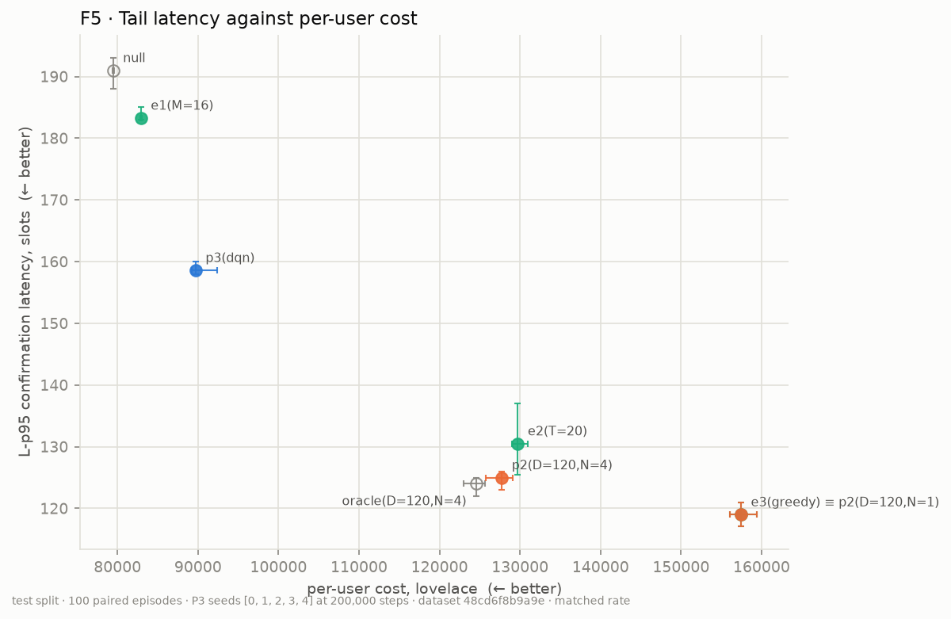
Figure 8.4: F5 — tail latency against per-user cost, test split, matched rate, with 95 % CIs on both axes
At the matched rate the static and proposed policies do not collapse onto one line; they spread along a frontier running from greedy (fastest, most expensive) to E1 (cheapest, slowest). P2 with N_MIN = 4 Pareto-dominates the tuned E2 by median — 125.0 against 130.5 slots and 127,738 against 129,729 lovelace. Paired, the cost saving is significant (−2,894 lovelace) but the latency difference is not (−5.1 slots, CI [−14.5, +0.5]), so the defensible statement is that P2 is cheaper and no slower than E2, not strictly better on both axes. The dominance does not carry to the other rates: at the light rate E2 is 17 slots faster and P2 28,120 lovelace cheaper, and at the heavy rate P2 is 60.5 slots faster but 7,441 lovelace dearer — trade-offs, not dominance.
P3 occupies an operating point no static rule reaches. Against E1 it is significantly faster at every rate (23.2 slots at matched) for a modest extra cost (6,884 lovelace); against E2 it is 40,500 lovelace cheaper for 35.8 more slots. Nothing dominates it at the light or matched rate. The ORACLE point sits almost on top of P2: a perfect next-block forecast is worth 1 slot at the matched rate and nothing measurable at the heavy rate — the fourth independent confirmation that forecasting congestion has little to offer latency on this chain. Ablation A2 (Section 8.10) shows where a forecast does matter: in how cheaply P2 can buy larger batches.
The comparison of P3 against the whole P2 sweep below was made on validation; configurations N = 8, 12 and 20 were not carried into the one-shot test run, so that claim is not re-tested here.
Table 8.9: P3 (DQN) against the P2 frontier, validation split
Policy | L-p95 (slots) | C-user (lovelace)
e3(greedy) ≡ p2(N=1) | 114.0 | 150,168
p2(N=4) | 121.5 | 116,759
p2(N=8) | 131.0 | 102,729
p2(N=12) | 150.3 | 98,062
p2(N=20) | 156.3 | 96,457
P3, mean of 5 seeds | 149.0 ± 13.1 | 87,669 ± 6,211

On validation, P3 dominated p2(N=12) and p2(N=20) on both axes and was dominated by nothing, reaching a per-user cost 9 % below any P2 configuration. It thus extends the achievable frontier, at a tenth of the specified training budget. Every seed produced zero Gate A violations and zero expired orders, and none collapsed. Seed variance is real: seed 0 behaves like a different policy (L-p95 123.5, mean batch 8.9 against about 13 for the others).

8.7 Latency Distributions
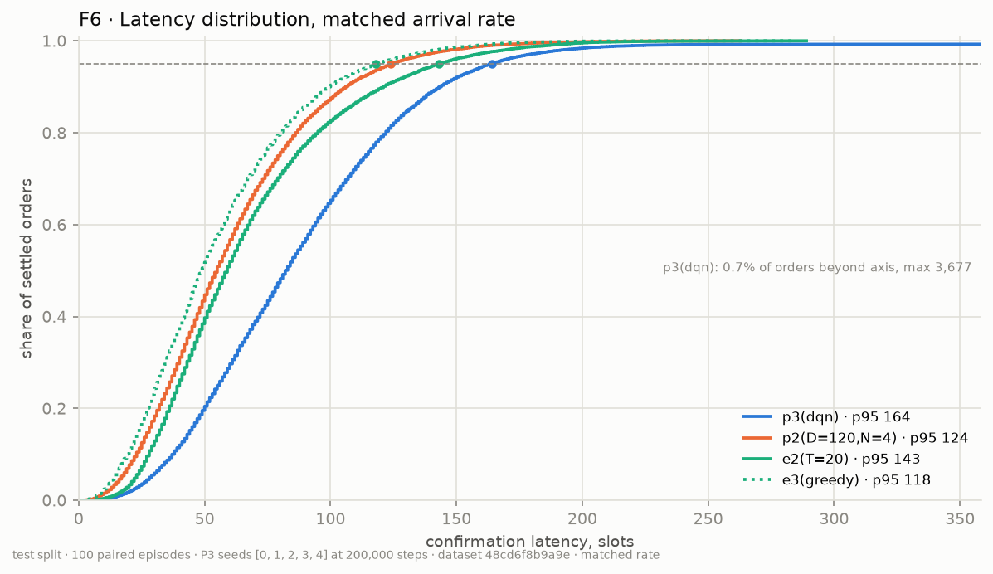
Figure 8.5: F6 — confirmation latency CDF, test split, matched rate
F6 pools the settled orders of all 100 matched-rate episodes, so its p95 readings (greedy 118, P2 124, E2 143, P3 164 slots) are quantiles of the pooled distribution and differ slightly from the medians of per-episode p95 in Table 8.4. The curves of greedy, P2 and E2 nearly coincide across the whole distribution; the gain of P2 over E2 is a tail effect, consistent with the non-significant paired latency difference. P3’s curve is shifted right at every quantile — it waits deliberately to build larger batches, 11.1 orders on average against 4.9 for P2 — and it carries a thin long tail: 0.73 % of its orders wait more than 600 slots, up to 3,677, close to the 3,600-slot order lifetime. The quantile table behind the figure is written to tables/F6_latency_quantiles.csv.

8.8 Does the Agent Adapt?
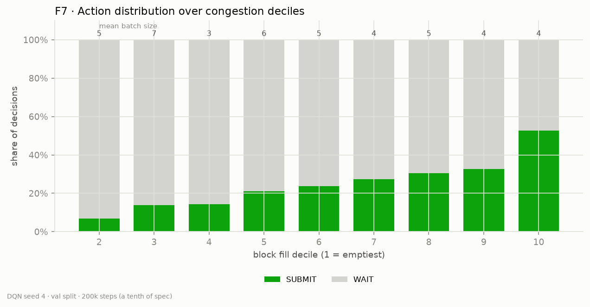
Figure 8.6: F7 — P3 action distribution across congestion deciles
F7 is not flat: the submit rate climbs from 7 % in the emptiest decile to 53 % in the fullest. On its own that would suggest congestion reasoning. It is not. Zeroing the forecast inputs at inference time changes L-p95 by a mean of only 2.3 %, and four of five seeds are slightly better without the forecast. The rising profile is a queue-depth confound: fuller blocks coincide with busier periods, longer slot gaps and deeper queues.
Finding
The agent is queue-aware, not congestion-aware. This is the third independent route to the ADR-008 conclusion, after the F4 lag diagnostic and the ORACLE gap. Retraining the agent without the forecast (A3, Section 8.10) costs about 4 % of tail latency and nothing in cost — a small, consistent contribution from the forecast, not congestion reasoning.

8.9 Robustness Across Arrival Rates
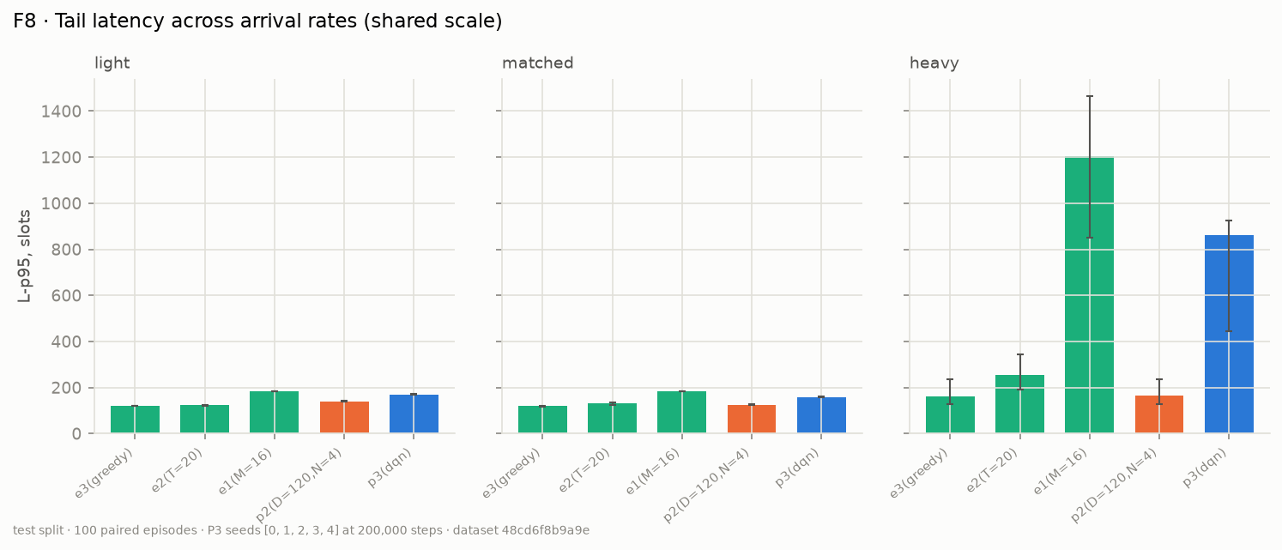
Figure 8.7: F8 — tail latency across arrival rates on one shared scale, test split
At the light and matched rates every policy stays within a narrow band. At the heavy rate greedy (162.0) and P2 with N_MIN = 4 (164.5) barely move, E2 degrades to 253.5 slots and E1 to 1,203 — the two fixed rules tuned at one rate are the brittle ones. The adaptive optimizer is the most robust policy across load: it tracks greedy’s latency at every rate while costing 12–25 % less.
P3’s heavy-rate median of 863 slots is not the behaviour of the agent in general but of one seed. Seed 3 reaches a median tail latency of 3,604 slots and lets 34 % of orders expire, with expiry in 65 of 100 episodes; at the matched rate the same seed behaves normally. The other four seeds, pooled, give a tail latency of 186.5 slots [152.5, 253.9], zero expiry, fairness 0.77 and a per-user cost of 77,916 lovelace — cheaper than E1 (78,638) at a sixth of its tail latency. Checkpoints were selected on validation at the matched rate, and seed 3 was not distinguishable there, so this is reported as a genuine finding about training brittleness under the reduced budget rather than excluded after the fact.

8.10 Ablations

A1 — what forecast error costs
Table 8.10: P2 on LightGBM against P2 with the true next-block fill (validation)
N_MIN | L-p95, forecast | L-p95, oracle | Gap
4 | 127.0 | 126.0 | 0.8 %
8 | 142.0 | 134.0 | 5.6 %
12 | 156.0 | 143.0 | 8.3 %
20 | 165.0 | 151.0 | 8.5 %

A perfect forecast is worth 5–9 % of tail latency at equal cost, and the gap widens as the policy leans on the forecast.

A2 — naive versus learned forecaster, re-specified
As first run, A2 was confounded. P2 driven by E4 was identical to greedy at every N_MIN, because a moving average is flat across the forecast horizon and the “quieter block predicted” condition compares equal numbers, so it never fires. That compared a flat forecast with a varying one, not a naive forecast with a learned one.
A2 was therefore re-specified with a second naive baseline, E4b (mean-reverting): fill_hat(t+h) = m_t + φ^h · (fill_t − m_t), where m_t is E4’s 20-block rolling mean and φ the lag-1 autocorrelation of the deviation from it, fitted on the training split. It is as naive as E4 — one fitted number — but varies across the horizon. The configuration was committed before the run, and it used the same 12 validation episodes at the matched rate as the original Phase 4 ablations.
Table 8.11: Forecasters on the validation split — whether each can make P2’s quieter-block branch fire
Forecaster | Branch fires | MAE t+1 | Directional accuracy
E4 moving average (flat) | 0.0 % | 0.0586 | 0.712
E4b mean-reverting (φ = 0.084) | 36.2 % | 0.0582 | 0.712
P1 LightGBM | 67.4 % | 0.0530 | 0.740
ORACLE | 64.7 % | 0 | 1.000

The zero for E4 confirms the confound directly. The fitted φ is small — deviations from the recent level barely persist — so E4b’s forecasts stay close to the level, but they still vary enough for the branch to fire on about a third of blocks.
Table 8.12: P2 by forecaster across N_MIN — median over 12 paired validation episodes (L-p95 slots / C-user lovelace)
N_MIN | E4b naive | P1 LightGBM | ORACLE | E4 flat
1 | 120.5 / 151,557 | 120.5 / 151,557 | 120.0 / 151,557 | 120.5 / 151,557
4 | 123.5 / 137,596 | 127.0 / 120,945 | 124.5 / 120,608 | 120.5 / 151,557
8 | 134.3 / 127,523 | 142.5 / 108,672 | 135.0 / 108,217 | 120.5 / 151,557
12 | 143.4 / 124,229 | 156.5 / 103,841 | 143.5 / 103,184 | 120.5 / 151,557
20 | 149.5 / 122,915 | 165.5 / 101,747 | 148.5 / 101,064 | 120.5 / 151,557

Table 8.13: A2 — P2 on LightGBM minus P2 on E4b, paired over 12 episodes, Holm–Bonferroni across the family
N_MIN | L-p95 difference [95 % CI] | C-user difference [95 % CI]
1 | 0.0 [0.0, 0.0] | 0 [0, 0]
4 | +2.0 [+1.5, +3.0] * | −17,186 [−20,785, −14,489] *
8 | +7.2 [+6.0, +9.0] * | −21,348 [−25,858, −17,395] *
12 | +13.0 [+10.4, +15.7] * | −22,582 [−27,817, −18,148] *
20 | +15.0 [+12.0, +18.5] * | −23,332 [−28,872, −18,627] *

At equal N_MIN the two forecasters do not produce a better and a worse policy; they produce different operating points. LightGBM lets the branch fire about twice as often, so P2 waits more, builds batches 26–47 % larger, and trades 2–15 slots of tail latency for 17,000–23,000 lovelace less per user — every difference significant. Equal N_MIN is therefore not a like-for-like comparison, and the question A2 asks is answered by the frontier instead.
On the frontier, the learned forecaster helps the policy. LightGBM at N_MIN = 4 (127.0 slots, 120,945 lovelace) is at least as fast and cheaper than E4b at N_MIN = 8, 12 and 20, so it dominates three of E4b’s five points; no LightGBM point is dominated by E4b. E4b cannot reach below about 123,000 lovelace at any setting, because its weak reversion rarely justifies a long wait, while LightGBM reaches 101,747. LightGBM also matches ORACLE on per-user cost at every N_MIN, to within 0.7 %; its gap to ORACLE is in tail latency (up to 17 slots at N_MIN = 20), consistent with the lagging forecast of F4.
The answer to A2 is therefore yes, but only for cost: a learned forecaster lets P2 buy larger batches more cheaply than a naive one, while contributing nothing to latency — the same division A1, A3 and the test-split ORACLE gap each point to. The frontier comparison rests on medians over 12 validation episodes and is descriptive; the equal-N_MIN paired tests are the formal result.

A3 and A4 — agent ablations
Both ablations retrain five DQN seeds from scratch with the Phase 5 configuration — 200,000 steps, the same training windows and reward calibration — changing one thing each: A3 removes the forecast from the state (the three fill_hat inputs are constant zero), and A4 replaces the quadratic latency penalty with a linear one, recalibrated to unit scale. All ten agents are scored through the standard metric path on the same four validation episodes as Phase 5; the test split is not used again.
Table 8.14: Ablations A3 and A4 against the Phase 5 agent, per seed, validation split
Seed | L-p95 P3 | L-p95 A3 | L-p95 A4 | C-user P3 | C-user A3 | C-user A4
0 | 123.5 | 134.5 | 120.5 | 99,886 | 97,643 | 105,808
1 | 157.5 | 170.0 | 169.5 | 83,869 | 88,197 | 84,495
2 | 152.0 | 156.5 | 147.0 | 84,089 | 82,843 | 84,104
3 | 152.0 | 154.0 | 152.0 | 86,786 | 85,285 | 87,122
4 | 160.0 | 160.5 | 155.0 | 83,717 | 83,147 | 86,219
Mean ± sd | 149.0 ± 13.1 | 155.1 ± 11.7 | 148.8 ± 16.0 | 87,669 ± 6,211 | 87,423 ± 5,457 | 89,550 ± 8,204

Every one of the ten agents produced zero Gate A violations and zero expired orders, and none collapsed (action entropy 0.30–0.97).
A3 — the forecast contributes a little, and only to latency. Retrained without a forecast, the agent’s tail latency is 4.1 % higher on average (155.1 against 149.0 slots) at an unchanged per-user cost (−0.3 %). The direction is consistent — all five seeds are slower without the forecast, by 0.5 to 12.5 slots — but the mean effect is smaller than the seed-to-seed standard deviation and rests on four validation episodes, so it is suggestive rather than established. The retrained result reverses the sign of the inference-time test in Section 8.8, where zeroing the forecast on an agent trained with it made four of five seeds slightly faster; the retrained comparison is the one the protocol specifies, because an agent trained with the input has never learned to act without it. Either way the effect is a few percent: the verdict remains queue-aware, with the forecast as a minor secondary input.
A4 — the quadratic penalty is not what controls the tail. With a linear latency penalty, tail latency is unchanged (148.8 against 149.0 slots) and per-user cost is 2.1 % higher, both well inside seed variation. The tail is already bounded structurally by the D_MAX mask, which forbids waiting past the deadline, so reshaping the latency term leaves little for the reward to do. The quadratic form is retained as specified, but the report does not credit it with the agent’s tail behaviour.

A5 — estimation error against Gate A
Table 8.15: Effect of estimation error, validation split at heavy arrival rate (21,359 batches)
True cost vs estimate | Real Gate A cap | Invalid batches
−10 %, −5 %, 0 % | 24 | 0
+5 % | 22 | 8.1 %
+10 % | 21 | 8.2 %

S2’s zero is exact only under perfect estimation. Over-estimation is harmless, but a 5 % under-estimate invalidates about one batch in twelve, because heavy-rate batches sit at the cap. A safety margin of three orders below the estimated cap would have kept every batch valid and should be applied in live operation until the estimator is calibrated. The fee replay already showed under-estimation on script-bearing transactions, so this direction of error is not hypothetical.

8.11 Success Metrics
Table 8.16: Success metrics S1–S6
ID | Criterion | Measured | Verdict
S1 | P1 MAE below E4 on test | 0.04578 vs 0.05157 (+11.2 %) | Pass
S2 | Zero Gate A violations | 0 across 8 policies × 3 rates × 100 episodes, P3 over 5 seeds | Pass
S3 | L-p95 below best static baseline, significant | Best static on L-p95 is greedy at every rate. P2 (N=1) identical (diff 0); P2 (N=4) +6.0 slots; P3 +40.2 slots (matched) | Fail at all rates
S4 | Expiry not worse than baseline | P2 zero at all rates; P3 zero at light and matched, 0.07 [0.03, 0.10] at heavy (one seed) | Pass for P2; P3 fails at heavy
S5 | Pareto dominance on (L-p95, C-user) | P2 (N=4) dominates E2 by median at matched (latency difference not significant); none at light or heavy | Partial — matched only
S6 | Fairness not worse than baseline | P3 0.85 / 0.83 / 0.68 overlaps or exceeds best static; P2 (N=4) 0.77 vs E1 0.84 / 0.83 at light / matched | Pass for P3; P2 fails at light and matched

Read together, the verdicts describe a trade-off result, not a dominance result. The one safety criterion, S2, holds without exception. The latency criterion S3 fails for a reason the data predicted: Phase 1 found capacity binding about once in 180 blocks, and in a system where capacity does not bind the latency-optimal batcher is greedy, which no policy can beat by waiting. What the adaptive policies deliver instead is controllable movement along the latency–cost frontier — robustly for the optimizer, with a better fairness profile but seed-level brittleness for the learned agent. S3 failing while S2 holds is, in the evaluation protocol’s own terms, a publishable outcome stated rather than hidden.

8.12 On-Chain Demonstration
Status
The DEX is deployed on the Cardano preprod test network and has settled its first end-to-end swap (T-O6). A user order was placed from a separate key, the live batcher running P2 found it on chain, submitted a batch, held the pool lock until inclusion, and stopped cleanly; the result was verified on chain. Every submission was made only with the team’s explicit approval. The D4 calibration rests on this single one-order batch and is reported as a first measurement, not a calibration.

Table 8.17: Preprod deployment
Item | Value
Deployment transaction | 555ee19bd06d2151931035039dac883b560d9f93bb35b3fd1efa24a30f767372
Block / slot | 5,178,709 / 133,767,575
Network fee | 181,913 lovelace (0.18 tADA), 603 bytes
Minted | 10,000,000 TEAM11 and one POOL NFT; minting closed after slot 133,774,747
Pool, verified on chain | 100 tADA + 1,000,000 TEAM11 + 1 POOL NFT, inline datum equal to the recorded deployment (fee 30 bps)
Pool script hash | 2c9aee89dbbc6c7e30f720c2e0e76d7850b1eaf1bb5b53a517a96475
Order script hash | 1676fbd256ca880594c30dc1e024439748dca693788786ac54f98567

The first live read found a defect the offline tests could not. Blockfrost returns inline datums as raw CBOR bytes, whereas locally built outputs carry typed Plutus data. The order reader handled only the latter, so every real order would have been treated as undecodable and silently skipped: the live batcher would have watched an apparently empty queue indefinitely. It was caught while verifying the deployed pool’s datum, before any order was placed, fixed, and pinned with a regression test that feeds the builders datums in the form Blockfrost delivers them.
Table 8.18: The first end-to-end swap on preprod, verified on chain
Item | Value
Order transaction | 6ffd8101fa74be32c6729f255b7f29e5f6b11edab050d3fc0f07c220a525ac41
Order | Sell 10 tADA for at least 85,000 TEAM11; margin 1 tADA; 15 tADA locked
Batch transaction | b5201c0a0843f5e258a7c9d9dba4b9b7cb66f88f1c0810baa2e6ad7337c73af1
Submitted → included | slot 133,785,075 → slot 133,785,125 (block 5,179,501): 50 slots with the pool locked
Network fee | 322,697 lovelace, 2,681 bytes
User received | 90,661 TEAM11 and 3.679758 tADA, in an output tagged with the order’s reference
User’s charge | 1 tADA margin + 0.320242 tADA fee share (n = 1) — at or below the 322,697-lovelace fee the transaction carries, as order.ak requires
Pool after | 110 tADA and 909,339 TEAM11, NFT carried; no orders left at the order script

The first live batch then found a second defect — and the order validator caught it. The batch was planned with the estimator’s fee of 406,931 lovelace, but the real fee was 320,242; users were therefore overcharged, and order.ak refused the transaction during the node’s script evaluation. The fee-settling loop of Section 6.12 could not recover, because evaluation happens inside the build, before any fee is known. Nothing was submitted: the order stayed safely at its script. The builder now works in two passes — a probe charging margins only, which is valid at any fee, to obtain execution units, then a final build with those units fixed and users charged for the real fee — and the daemon logs a failed build instead of stopping. A fake chain that enforces the fee rule during evaluation reproduces the failure and pins the fix. The validator doing exactly its job against the project’s own batcher is the clearest evidence in the report that the batcher is untrusted for correctness by design.
The demonstration is scripted as five steps, each a dry run until explicitly submitted: deploy the pool and mint its NFT; run the batcher in shadow mode to confirm its decisions on live chain state; place an order from a separate user key; run the batcher live until that order settles; and compare estimated with actual transaction size and execution units from the D4 log.
Table 8.19: Phase 7 exit criteria
Criterion | Status
T-O1 … T-O5, including the security tests T-O2 and T-O3 | Pass — Aiken unit tests
T-O6 — one swap settles on preprod, transaction hash recorded | Pass
Estimator within ±5 % on size and ±10 % on execution units against D4 | Not met on the one sample — see the calibration table below
07-CONSTRAINTS-COST-MODEL.md §4 per-order costs updated from measurement | Not yet — needs multi-order batches

Table 8.20: First estimator calibration against D4 — one batch, n = 1
Quantity | Estimated | Actual | Error
Transaction size | 800 B | 2,682 B | actual 3.4× the estimate
Execution memory | 2,500,000 | 473,756 | estimate 5.3× the actual
Execution steps | 1,000,000,000 | 166,037,580 | estimate 6.0× the actual
Network fee | 406,931 lovelace | 322,697 lovelace | estimate 26 % high

The ±5 % / ±10 % criterion is not met, and one one-order batch could not calibrate per-order costs even if it were — the flat and marginal components cannot be separated from a single n. The direction of each error is nonetheless informative. Execution units are over-estimated about fivefold, the safe direction for Gate A: the simulator’s cap of 24 orders is conservative on memory, which ADR-006 had feared the on-chain fee / n computation would tighten. Size is under-estimated 3.4-fold, the unsafe direction — ablation A5 showed a 5 % size under-estimate already invalidates one heavy-rate batch in twelve. The cause is known: the estimator models order and pool bytes but not the roughly 1.8 KB of validator scripts attached to every batch, nor the batcher’s fee input and change output. Referencing the scripts from an on-chain UTxO instead of attaching them removes most of the gap, and multi-order live batches are then needed to fit the marginal cost per order. Until that is done, live batch sizes should be capped with the A5 safety margin.

8.13 Threats to Validity
Table 8.21: Threats to validity and their mitigation
Threat | Mitigation and residual risk
Synthetic order arrivals | Diurnal shape fitted to real D1 transaction counts; sweep across three arrival rates. Absolute latencies depend on the modelled rate
Counterfactual injection into recorded blocks | Recorded usage treated as fixed background; conservative direction
No transaction chaining | Pool lock stricter than reality; measured latency is an upper bound
Perfect estimation assumed | Bounded by A5: a 5 % under-estimate invalidates 8 % of heavy-rate batches
Fee model omits the reference-script surcharge | Absolute costs understated; rankings unaffected (V4)
Reduced RL training budget | 200k instead of 2M steps; P3 results are a lower bound
Overfitting to the test period | Chronological split enforced by test; test split used exactly once
Straw-man baselines | E1 and E2 tuned on validation; values reported
Single-seed RL result | Five seeds; mean and standard deviation reported
Cherry-picked episodes | Fixed paired episode set, 25 % congested share, fixed before evaluation
Code provenance of manifests | Earlier experiments ran from uncommitted code, so their manifests record the parent revision. The test run was launched before its tooling was committed, and its manifest records the revision current when it finished (0a5c7d5, clean tree), not at launch; the evaluated source is believed identical apart from automatic formatting, but the manifest cannot prove it. Data and parameters are pinned by checksum and configuration hash. It is stated rather than re-run, since re-running would spend the test split twice
Checkpoint selection at one arrival rate | P3 checkpoints were chosen on validation at the matched rate; one of five seeds fails at the heavy rate. Reported with all five seeds included
Rollback asymmetry | Simulator models rollback (p = 0.0005 per block); the RL training environment does not

Chapter 9: Conclusion and Future Work

9.1 Summary of Contributions
- A measured characterisation of Cardano mainnet block occupancy over 92 days and 388,781 blocks, showing that the widely repeated 80–90 % congestion claim does not describe the current chain: median fill is 2.95 %, and the longest congested run is ten blocks.
- A corrected constraint and cost model for eUTXO batching: batch size bounded by per-transaction limits rather than block capacity; latency and amortized cost, not fees, as the objective; head-of-line blocking rather than rejection as the failure model — each guarded by a permanent regression test.
- A validated, deterministic, slot-accurate simulator that replays recorded mainnet blocks, with paired episodes, conservation checks and four validation checks including a fee replay against real transactions.
- A constrained optimizer and a masked DQN agent that never violated a capacity limit, together with an honest analysis showing what drives their behaviour.
- A reproducible evaluation pipeline with run manifests, checksummed data and pre-registered non-parametric statistics.
- A local, read-only dashboard that replays a held-out day block by block, re-derives the comparison table from the committed evaluation and reads the deployed pool from preprod, so the work can be demonstrated without a single number being retyped (FR-15).
- A minimal on-chain DEX whose validator enforces a pass-through batcher fee, so amortization reaches users, with each user’s slippage floor and batcher authorisation checked by the ledger; and a live batcher that reuses the simulator’s own decision rules, with a shadow mode for watching a policy on live traffic before it submits.

9.2 Objectives Revisited
Table 9.1: Goals G1–G6 against the evidence
Goal | Status | Evidence
G1 Reduce mean and p95 latency vs static batchers | Partially achieved | Not against greedy, which is latency-optimal when capacity rarely binds (S3 fails). P2 (N=4) is 60.5 slots faster than tuned E2 at heavy load; P3 is significantly faster than E1 at every rate
G2 Reduce per-user cost by amortization | Achieved, as a trade-off | Test, matched rate: P2 (N=4) −19 % and P3 −43 % per-user cost against greedy, for +5 % and +33 % tail latency; E1 remains cheapest
G3 Never violate capacity limits | Achieved, with a stated condition | Zero Gate A violations across the whole test evaluation; exact only under perfect estimation (A5)
G4 No order starves | Partially achieved | No decision past D_MAX results in WAIT; the wait itself can overshoot D_MAX by up to 114 slots
G5 Reproducible evaluation | Partially achieved | Seeds, checksums and configuration hashes pinned; all five P3 checkpoints reproduce their recorded metrics exactly (T-L5); earlier manifests record the parent code revision
G6 No change to wallets, CIP-30 or protocol | Achieved | The batcher interacts only with order UTXOs on chain

9.3 Limitations
- Single pool, single batcher — multi-pool scheduling is a different and harder problem.
- Modelled order arrivals — no DEX publishes per-order data; mitigated by fitting to D1 and sweeping three rates.
- No transaction chaining — conservative, but real batchers can exploit it.
- Estimator not yet calibrated against live transactions — per-order costs are estimates, and the fee formula omits the reference-script surcharge.
- Under-trained and brittle agent — P3 was trained at a tenth of the specified budget, and one of five seeds fails under heavy load.
- One live batch is not a calibration — the end-to-end swap settled on preprod, but a single one-order batch cannot separate flat from per-order costs, and the estimator under-estimates transaction size 3.4-fold while scripts are attached inline.
- No latency gain over greedy — on the current chain no adaptive policy beat greedy on tail latency; the benefit is cost and fairness at a stated latency price.
- Replay of the recent past — Ouroboros Leios and changing activity will alter block dynamics.

9.4 Future Work
- Checkpoint selection across all three arrival rates, the full 2M-step training budget, and seed ensembling to remove the heavy-load failure of a single seed.
- Transaction chaining, relaxing the pool lock (simulator assumption A3).
- Joint, end-to-end training of forecaster and policy, or giving the agent raw history instead of a forecast.
- Multi-pool scheduling across a DEX.
- Fairness-aware and MEV-resistant order selection.
- Re-evaluation under Ouroboros Leios block dynamics, and on a historical window with sustained congestion.
- Heterogeneous order costs, already supported by the dataset schema.
- Calibrate the estimator from multi-order live batches on preprod, separating flat from per-order size and execution costs, and fold in the reference-script fee term.
- Reference scripts for the validators, removing roughly 1.8 KB of script bytes from every batch transaction and so raising the Gate A cap.
- The LightGBM forecaster in the live loop, which ablation A2 found lets P2 buy larger batches more cheaply than a naive forecast.

9.5 Concluding Remarks
This project set out to build an AI batcher that predicts congestion. Measurement showed that the congestion it was meant to predict is almost absent from the current chain, while the constraint that makes batching hard — a pool that admits one batch at a time — is present on every block. Reframing around that constraint, and following the evidence where it led, produced results that are more modest in headline but considerably more defensible: a batcher that never breaks a ledger rule, a clear latency–cost frontier that adaptive policies extend, and an honest account of what the learned agent does and does not use. On held-out data the adaptive policies did not beat greedy batching on latency — the expected consequence of capacity that rarely binds — but they gave an operator a controllable, statistically characterised trade-off between latency and per-user cost, and the optimizer held that trade-off across traffic levels at which the fixed rules tuned for one level broke down.

References
[1] M. M. T. Chakravarty, J. Chapman, K. MacKenzie, O. Melkonian, M. Peyton Jones, and P. Wadler, “The Extended UTXO Model,” in Financial Cryptography and Data Security (FC 2020) Workshops, Springer, 2020.
[2] M. M. T. Chakravarty et al., “Native Custom Tokens in the Extended UTXO Model,” in ISoLA 2020, Springer, 2020.
[3] A. Kiayias, A. Russell, B. David, and R. Oliynykov, “Ouroboros: A Provably Secure Proof-of-Stake Blockchain Protocol,” in CRYPTO 2017, Springer, pp. 357–388.
[4] Input Output Research, “Ouroboros Leios: Design Goals and Concepts,” technical report.
[5] H. Nguyen Quang, “Concurrent & Deterministic Batching on the UTXO Ledger,” MELD technical report, 2021.
[6] P. Brühwiler, “A Concurrent DEX on Cardano: How to Write Scalable Apps on a UTXO Blockchain,” BSc thesis, University of Bern, 2021.
[7] O. Hryniuk, “Concurrency and all that: Cardano smart contracts and the EUTXO model,” IOHK, 2021.
[8] G. Angeris and T. Chitra, “Improved Price Oracles: Constant Function Market Makers,” in ACM AFT ’20, 2020, pp. 80–91.
[9] G. Angeris, H.-T. Kao, R. Chiang, C. Noyes, and T. Chitra, “An Analysis of Uniswap Markets,” Cryptoeconomic Systems, 2020.
[10] T. Roughgarden, “Transaction Fee Mechanism Design for the Ethereum Blockchain: An Economic Analysis of EIP-1559,” arXiv:2012.00854, 2020.
[11] “SoK: Preventing Transaction Reordering Manipulations in Decentralized Finance,” arXiv:2203.11520, 2022.
[12] R. S. Sutton and A. G. Barto, Reinforcement Learning: An Introduction, 2nd ed. MIT Press, 2018.
[13] V. Mnih et al., “Human-level Control through Deep Reinforcement Learning,” Nature, vol. 518, pp. 529–533, 2015.
[14] J. Schulman, F. Wolski, P. Dhariwal, A. Radford, and O. Klimov, “Proximal Policy Optimization Algorithms,” arXiv:1707.06347, 2017.
[15] H. Mao, M. Alizadeh, I. Menache, and S. Kandula, “Resource Management with Deep Reinforcement Learning,” in ACM HotNets ’16, 2016, pp. 50–56.
[16] H. Mao, M. Schwarzkopf, S. B. Venkatakrishnan, Z. Meng, and M. Alizadeh, “Learning Scheduling Algorithms for Data Processing Clusters,” in ACM SIGCOMM ’19, 2019, pp. 270–288.
[17] S. Hochreiter and J. Schmidhuber, “Long Short-Term Memory,” Neural Computation, vol. 9, no. 8, pp. 1735–1780, 1997.
[18] Cardano Foundation, “Protocol parameters guide,” docs.cardano.org.
[19] Koios, “Koios API documentation,” api.koios.rest.
EDIT: verify every entry against the publisher before submission

