Learning When to Batch: Adaptive, Safety-Shielded Transaction Batching for Cardano Decentralized Exchanges
Vikranth Sai  UG Scholar  Computer Science & Engineering (Data Science)  Vignana Bharathi Institute of Technology, Hyderabad, India  Email: 23p61a67f1@vbithyd.ac.in | Ms. B. Mamatha  Project Guide  Computer Science & Engineering (Data Science)  Vignana Bharathi Institute of Technology, Hyderabad, India
Ganesh  UG Scholar  Computer Science & Engineering (Data Science)  Vignana Bharathi Institute of Technology, Hyderabad, India  Email: 23p61a67f0@vbithyd.ac.in | Sowmya  UG Scholar  Computer Science & Engineering (Data Science)  Vignana Bharathi Institute of Technology, Hyderabad, India  Email: 23p61a67h8@vbithyd.ac.in

Theme: Applied AI for Sustainable Development Discipline: Computer Engineering
Keywords: Cardano; transaction batching; decentralized exchange; congestion forecasting; reinforcement learning; safe AI
1. Background and Problem
Decentralized exchanges (DEXs) on Cardano run on the extended UTXO (eUTXO) ledger [1], where a liquidity pool lives in a single output that every swap must consume and recreate. An output can be spent only once, so only one transaction per block can touch a given pool. Exchanges work around this with off-chain batchers that collect orders and settle them together in one transaction [2], [3].
Today’s batchers fire on fixed rules (every M orders or every T seconds) and never look at the chain or queue first. This matters because a submitted batch holds the pool until it confirms; sent at a bad moment, it makes every order behind it wait. Cardano fees are also deterministic, with no bidding, so a poorly timed batch costs users time rather than money, and fee-market ideas developed for Ethereum [4] do not carry over.
2. Objective
To build an off-chain batcher that decides, block by block, whether to wait or submit and how many orders to include, lowering both the cost each user pays and the time they wait, without ever breaking Cardano’s transaction limits or starving an order.
3. Methodology
(a) Testing the premise. The project began from a common claim that Cardano blocks run 80–90% full. We collected 92 days of mainnet history, 388,781 blocks, from Koios with Blockfrost as a fallback. The claim did not hold: the median block was 3.0% full and only 0.56% passed 80%. The real bottleneck is concurrency on the pool, not block space.
(b) Forecasting block fill. A LightGBM model [5] predicts the fill of the next three blocks from lagged fill, execution units, transaction counts and time-of-day features, trained on a strictly chronological 70/15/15 split. It is used defensively, to steer around the occasional full block.
(c) Constrained optimiser (P2). A deterministic forecast-then-optimise rule waits while the pool is locked. Otherwise it finds the largest batch that fits the 16,384-byte and 14-million-memory-unit transaction limits (about 24 orders), trims it to the forecast headroom of the next block, and holds a small batch back when a quieter block is near, so the fixed fee is shared by more users. Any order older than 120 s forces a submission, and an infeasible batch is never proposed.
(d) Learning agent with a safety shield (P3). A masked deep Q-network [6] chooses between waiting and eight batch sizes, rewarded for low cost, low latency and no expiry. Because a learned policy can misbehave outside its training range, a runtime shield clamps every action to legal limits and passes unfamiliar states to P2.
(e) Fair settlement and evaluation. Orders in one direction clear at a single price and opposite orders net against each other, so the batcher gains nothing by reordering them. A discrete-event simulator replays the recorded blocks with the pool lock, both capacity limits, rollbacks and expiry. Static baselines were tuned on validation data (M = 16, T = 20 s), and the held-out test split was used once, with 100 paired episodes per load level and bootstrap confidence intervals.
4. Results
At matched load on the test split, P2 cut the cost per user by 18.9% compared with greedy submission (127,738 against 157,445 lovelace) for a 9% rise in mean latency (60.9 s against 55.8 s), and it beat the tuned fixed-interval batcher on mean latency at similar cost (Table 1, Fig. 1). No adaptive policy beat greedy on tail latency, as expected on a mostly empty chain. The forecaster lowered mean absolute error relative to a 20-block moving average (0.0458 against 0.0516) and called the direction of change correctly 74.2% of the time.
Table 1. Test split, matched arrival rate (medians of 100 paired episodes)
Policy | Mean latency (s) | p95 latency (s) | Cost per user (lovelace)
Static, size trigger (M = 16) | 106.0 | 183.3 | 82,906
Static, fixed interval (T = 20 s) | 63.4 | 130.5 | 129,729
Greedy, submit every block | 55.8 | 119.0 | 157,445
Proposed optimiser P2 (N = 4) | 60.9 | 125.0 | 127,738
DQN agent, no shield | 88.9 | 158.6 | 89,704

The shield proved essential. On heavy-load validation days the unshielded agent let 35.7% of orders expire; with the shield, expiry fell to zero and cost per user was the lowest of every safe option. Allowing two chained batches per decision point roughly halved 95th-percentile latency at heavy load (245.5 s to 120.0 s) for 1.2% more cost. A small exchange written in Aiken and deployed on the Cardano preprod testnet settled a real batch transaction end to end.
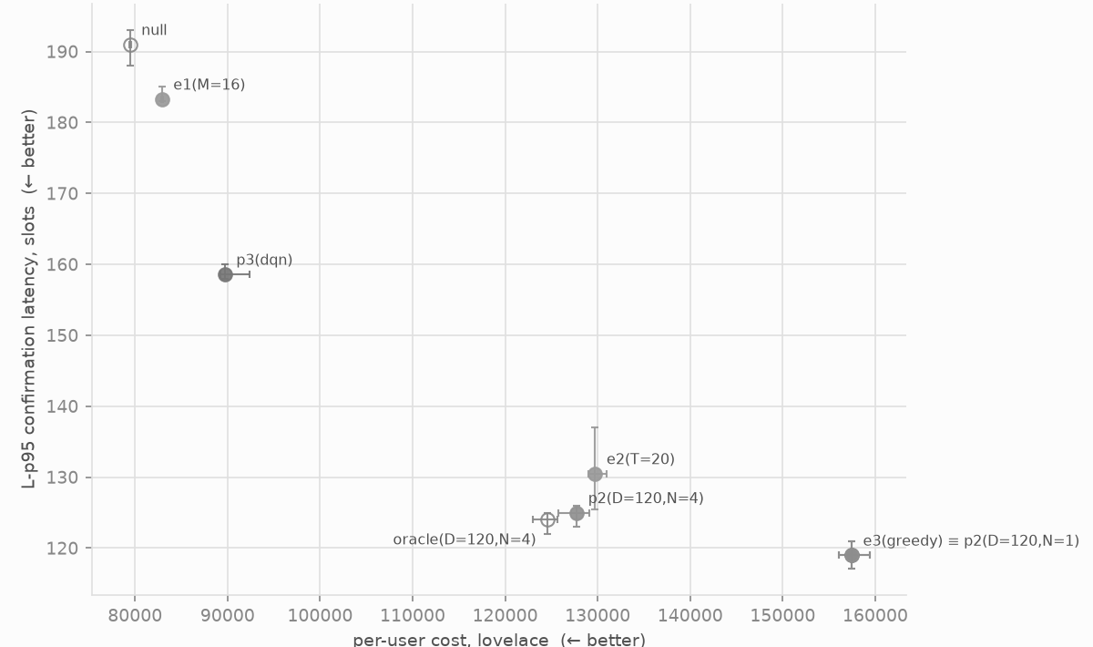
Fig. 1. Tail (95th-percentile) latency against cost per user at the matched arrival rate on the test split, with 95% confidence intervals; lower-left is better.
5. Relevance to Applied AI for Sustainable Development
Fewer, fuller batches settle the same trading in fewer transactions, lowering the fee each user carries. This matters most to small retail traders, for whom a fixed fee is a large share of a modest trade. Cardano runs on proof of stake with a small energy footprint, and fuller transactions use that capacity more efficiently. Uniform-price clearing removes the batcher’s power to reorder orders for its own gain, making the market fairer. The work also offers a practical pattern for deploying learned controllers in finance: test the premise with data, keep hard limits outside the model, and shield the learner.
6. Limitations and Conclusion
The evaluation covers one 92-day window, one pool and a simulated order stream. Chaining is not yet live, and the testnet batch held one order; real order flow across several pools is the next step. Even so, the study shows that on Cardano the binding constraint is the pool lock rather than congestion, and that a forecast-aware, hard-gated policy, with a shielded learning agent beside it, lowers what users pay while keeping every order safe.
References
[1] M. Chakravarty, J. Chapman, K. MacKenzie, O. Melkonian, M. Peyton Jones, and P. Wadler, “The extended UTXO model,” in Financial Cryptography and Data Security Workshops (FC), 2020.
[2] H. Nguyen Quang, “Concurrent & deterministic batching on the UTXO ledger,” MELD, Tech. Rep., 2021.
[3] P. Bruhwiler, “A concurrent DEX on Cardano,” B.Sc. thesis, Univ. of Bern, Switzerland, 2021.
[4] T. Roughgarden, “Transaction fee mechanism design: An economic analysis of EIP-1559,” in Proc. ACM Conf. Economics and Computation (EC), 2021.
[5] G. Ke et al., “LightGBM: A highly efficient gradient boosting decision tree,” in Advances in Neural Information Processing Systems (NeurIPS), 2017.
[6] V. Mnih et al., “Human-level control through deep reinforcement learning,” Nature, vol. 518, no. 7540, pp. 529–533, 2015.

