Learning When to Batch: Adaptive, Safety-Shielded Transaction Batching for Cardano Decentralized Exchanges
Vikranth Sai  UG Scholar  Computer Science & Engineering (Data Science)  Vignana Bharathi Institute of Technology, Hyderabad, India  Email: 23p61a67f1@vbithyd.ac.in | Ms. B. Mamatha  Project Guide  Computer Science & Engineering (Data Science)  Vignana Bharathi Institute of Technology, Hyderabad, India
Ganesh  UG Scholar  Computer Science & Engineering (Data Science)  Vignana Bharathi Institute of Technology, Hyderabad, India  Email: 23p61a67f0@vbithyd.ac.in | Sowmya  UG Scholar  Computer Science & Engineering (Data Science)  Vignana Bharathi Institute of Technology, Hyderabad, India  Email: 23p61a67h8@vbithyd.ac.in

Theme: Applied AI for Sustainable Development Discipline: Computer Engineering
Keywords: Cardano; transaction batching; decentralized exchange; congestion forecasting; reinforcement learning; safe AI
1. Background and Problem
Cardano uses the extended UTXO (eUTXO) model [1], and a decentralized exchange (DEX) on it keeps each liquidity pool inside one output. Every swap has to spend that output and create a fresh one. An output can be spent only once, so in any block just one transaction gets to use the pool. Exchanges work around this with off-chain batchers that settle many swaps in one transaction [2], [3].
The batchers running today follow simple fixed rules. They send a batch every M orders or every T seconds without looking at the chain or the queue. That matters, because a batch that has been sent holds the pool until it confirms, and every new order waits behind it. Fees on Cardano come from a fixed formula, not from bidding, so a badly timed batch does not cost users more money. It costs them time, which is why fee-market work written for Ethereum [4] does not carry over.
2. Objective
We set out to build a batcher that checks the queue and the chain at every block and decides whether to send a batch now and how many orders to include. The aim was lower cost per user and shorter waits, without breaking Cardano’s transaction limits or leaving an old order stuck.
3. Methodology
(a) Checking the starting assumption. A common claim is that Cardano blocks run 80–90% full, so we checked it. We downloaded 92 days of mainnet data, 388,781 blocks, through Koios with Blockfrost as a backup. The median block was only 3.0% full and just 0.56% of blocks went past 80%. So the real limit is the pool lock, not block space.
(b) Forecasting block fill. We trained a LightGBM model [5] to predict how full each of the next three blocks will be from recent fill levels, execution units, transaction counts and time of day, with the data split 70/15/15 in date order. It mainly serves as a safety check against the rare full block.
(c) Rule-based optimiser (P2). If the pool is busy, it waits. If not, it works out the largest batch that fits in 16,384 bytes and 14 million memory units (about 24 orders) and trims it to the room the next block is expected to have. When the batch is small and a quieter block is close, it holds on so the fixed fee is split among more people. Any order that has waited 120 s forces a send.
(d) Learning agent with a safety shield (P3). P3 is a masked deep Q-network [6] that picks between waiting and eight batch sizes and is rewarded for keeping cost, delay and expired orders low. A learned agent can act oddly in situations it never met in training, so we wrapped it in a shield that keeps every action inside the legal limits and hands unfamiliar cases over to P2.
(e) Fair pricing and testing. Inside a batch, all orders going the same way get one price, and opposite orders cancel against each other first, so the batcher gains nothing by shuffling trades. To compare policies we built a simulator that replays the recorded blocks with the pool lock, both size limits, rollbacks and order expiry. The fixed-rule baselines were tuned on validation data (M = 16, T = 20 s), and the test data was used only once, with 100 paired episodes per load level.
4. Results
At matched load on the test data, P2 cut the cost per user by 18.9% compared with sending a batch every block, from 157,445 to 127,738 lovelace. Users waited about 9% longer in return (60.9 s against 55.8 s). Against the tuned fixed-interval batcher, P2 gave shorter average waits at about the same cost (Table 1, Fig. 1). No adaptive policy beat the greedy one on worst-case delay, as you would expect when most blocks are nearly empty.
Table 1. Test split, matched arrival rate (medians of 100 paired episodes)
Policy | Mean latency (s) | p95 latency (s) | Cost per user (lovelace)
Static, size trigger (M = 16) | 106.0 | 183.3 | 82,906
Static, fixed interval (T = 20 s) | 63.4 | 130.5 | 129,729
Greedy, submit every block | 55.8 | 119.0 | 157,445
Proposed optimiser P2 (N = 4) | 60.9 | 125.0 | 127,738
DQN agent, no shield | 88.9 | 158.6 | 89,704

Without its shield, the learning agent struggled under heavy load and let 35.7% of orders expire on validation days. With the shield switched on, no order expired and the cost per user was the lowest of all the safe options. Chaining two batches per decision point nearly halved the heavy-load 95th-percentile wait, from 245.5 s to 120.0 s, for just 1.2% more cost. Finally, we wrote a small exchange in Aiken, deployed it on the Cardano preprod testnet, and our batcher settled a real batch against it.
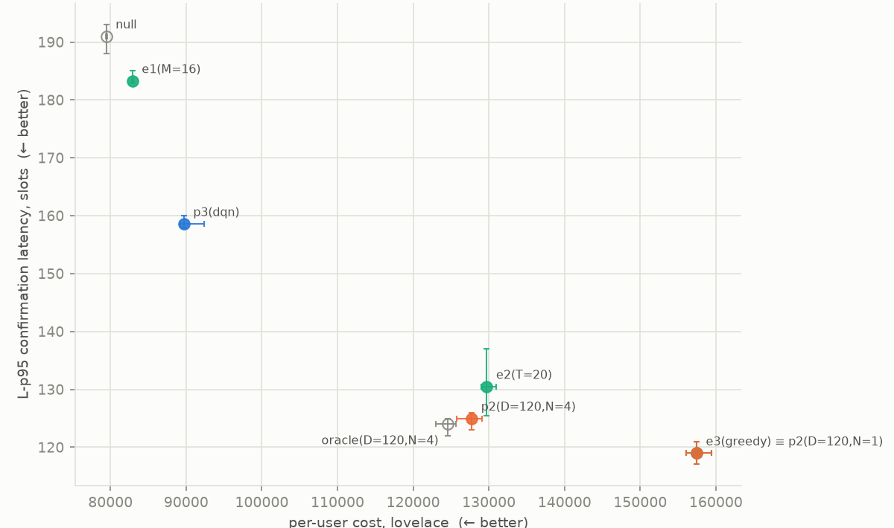
Fig. 1. Tail (95th-percentile) latency against cost per user at matched load (test split, 95% confidence intervals); lower-left is better.
5. Relevance to Applied AI for Sustainable Development
When the same trading is packed into fewer, fuller transactions, each person pays a smaller share of the fee. Small traders gain the most, since a fixed fee takes a big bite out of a small trade. Cardano already runs on proof of stake and uses little energy, and fuller transactions make better use of each block. Because everyone in a batch gets the same price, the batcher cannot reorder trades for its own profit, which keeps the market fair.
6. Limitations and Conclusion
We used one 92-day window, one pool and order flow that we generated rather than recorded. Chaining works in the simulator but is not yet on in the live batcher, and the testnet batch held a single order. Real order flow across several pools is next. On Cardano the bottleneck is the pool lock, not congestion, and a chain-aware batcher with hard limits and a shielded learner can lower what users pay without putting orders at risk.
References
[1] M. Chakravarty, J. Chapman, K. MacKenzie, O. Melkonian, M. Peyton Jones, and P. Wadler, “The extended UTXO model,” in Financial Cryptography and Data Security Workshops (FC), 2020.
[2] H. Nguyen Quang, “Concurrent & deterministic batching on the UTXO ledger,” MELD, Tech. Rep., 2021.
[3] P. Bruhwiler, “A concurrent DEX on Cardano,” B.Sc. thesis, Univ. of Bern, Switzerland, 2021.
[4] T. Roughgarden, “Transaction fee mechanism design: An economic analysis of EIP-1559,” in Proc. ACM Conf. Economics and Computation (EC), 2021.
[5] G. Ke et al., “LightGBM: A highly efficient gradient boosting decision tree,” in Advances in Neural Information Processing Systems (NeurIPS), 2017.
[6] V. Mnih et al., “Human-level control through deep reinforcement learning,” Nature, vol. 518, no. 7540, pp. 529–533, 2015.

