Learning When to Batch: Adaptive, Safety-Shielded Transaction Batching for Cardano Decentralized Exchanges
Vikranth Sai  UG Scholar  Computer Science & Engineering (Data Science)  Vignana Bharathi Institute of Technology, Hyderabad, India  Email: 23p61a67f1@vbithyd.ac.in | Ms. B. Mamatha  Project Guide  Computer Science & Engineering (Data Science)  Vignana Bharathi Institute of Technology, Hyderabad, India
Ganesh  UG Scholar  Computer Science & Engineering (Data Science)  Vignana Bharathi Institute of Technology, Hyderabad, India  Email: 23p61a67f0@vbithyd.ac.in | Sowmya  UG Scholar  Computer Science & Engineering (Data Science)  Vignana Bharathi Institute of Technology, Hyderabad, India  Email: 23p61a67h8@vbithyd.ac.in

Theme: Applied AI for Sustainable Development Discipline: Computer Engineering
Keywords: Cardano; transaction batching; decentralized exchange; congestion forecasting; reinforcement learning; safe AI
1. Background and Problem
Cardano uses the extended UTXO (eUTXO) model [1]. A decentralized exchange (DEX) on it keeps each liquidity pool in one output, and every swap must spend that output and create a new one. An output can be spent only once, so only one transaction per block can use a pool. Exchanges therefore rely on off-chain batchers that settle many swaps together [2], [3]. Current batchers fire every M orders or T seconds, blind to the chain and queue. A sent batch locks the pool until it confirms, so a badly timed one makes everyone behind it wait. Fees follow a fixed formula:
fee = 44s + 155,381 + 0.0577m + 0.0000721c, C_{user} = fee(n) / n (1)
where s is the size in bytes, m and c are memory and CPU-step units, and n is the number of orders in the batch. With no bidding, bad timing costs users time rather than money, so fee-market work for Ethereum [4] does not carry over.
2. Objective and Novelty
We set out to build a batcher that decides at every block whether to send a batch and how many orders to include, lowering C_{user} and waiting time without breaking transaction limits or starving any order. What is new here: (i) a 92-day measurement showing that the bottleneck is the pool lock, not congestion; (ii) batching framed with two hard capacity gates; (iii) a forecast-driven decision rule; (iv) a learning agent kept safe by a runtime shield; and (v) one-price clearing with batch chaining, tested end to end on the Cardano testnet.
3. Methodology
Step 1: Collect and check the data. We downloaded 388,781 mainnet blocks (92 days) through Koios, with Blockfrost as backup, and split them 70/15/15 in date order. The median block was only 3.0% full and just 0.56% passed 80%, far below the often-quoted 80–90%.
Step 2: Predict block fill. For each block t we build a feature vector x_{t} from the last 20 fill values, memory and step units, transaction counts, rolling averages and time of day. A LightGBM model [5], trained to minimise absolute error, then predicts the fill of the next three blocks:
f̂_{t+h} = g_{LGBM}(x_{t}), h = 1, 2, 3 (2)
Step 3: Apply the capacity gates. Gate A caps the batch by the per-transaction limits; Gate B caps it by the room predicted in the next block:
n_{A} = max{n : s(n) ≤ 16,384, m(n) ≤ 14×10⁶}, n_{B} = max{n : f̂_{t+1}S_{max} + s(n) ≤ S_{max}} (3)
Step 4: Decide (policy P2). Let n* = min(n_{A}, n_{B}) and let w be the wait of the oldest order. If the pool is locked, the batcher waits. If w ≥ D_{max} = 120 s, it submits n_{A} at once. Otherwise:
a_{t} = WAIT if n* < N_{min} and min(f̂_{t+2}, f̂_{t+3}) < f̂_{t+1}; SUBMIT(n*) otherwise (4)
Here N_{min} = 8, so a small batch waits for a quieter block and shares the fee more widely.
Step 5: Learn (P3) and shield. A masked deep Q-network [6] picks between WAIT and eight batch sizes, using the reward
r_{t} = −(w_{C}Ĉ_{t} + w_{L}L̂_{t} + w_{S}Ŝ_{t} + w_{K}K̂_{t}) (5)
where the hatted terms are normalised cost, delay, slippage and pool-lock time. Illegal actions are masked out, and a runtime shield clamps every action to Gate A and hands states outside the training range to P2.
Step 6: Clear fairly and test. All orders in one direction get one price. With a lovelace and b tokens sold into a pool holding x and y, and g = 1 − fee rate, the pool trades only the net imbalance, at
P = g(y + b) / (x + g·a) (6)
so no order gains from its place in the queue. A simulator replays the recorded blocks against static batchers tuned on validation data (M = 16, T = 20 s), using the test split once with 100 paired episodes per load.
4. Results
At matched load, P2 cut C_{user} by 18.9% against greedy submission (127,738 vs 157,445 lovelace) for about 9% longer average waits (60.9 s vs 55.8 s), and it beat the tuned fixed-interval batcher on average wait at similar cost (Table 1, Fig. 1). The forecaster’s error was 0.0458 against 0.0516 for a 20-block moving average, with 74.2% of directions right. No adaptive policy beat greedy on tail delay.
Table 1. Matched load, test split (medians of 100 paired episodes)
Policy | Mean latency (s) | p95 latency (s) | Cost per user (lovelace)
Static, size trigger (M = 16) | 106.0 | 183.3 | 82,906
Static, fixed interval (T = 20 s) | 63.4 | 130.5 | 129,729
Greedy, submit every block | 55.8 | 119.0 | 157,445
Proposed optimiser P2 (N = 4) | 60.9 | 125.0 | 127,738
DQN agent, no shield | 88.9 | 158.6 | 89,704

Without its shield, the learning agent let 35.7% of orders expire under heavy load; with it, none expired and cost was the lowest of all safe options. Chaining two batches per decision point nearly halved the heavy-load 95th-percentile wait (245.5 s to 120.0 s) for 1.2% more cost. A small Aiken exchange on the Cardano preprod testnet settled a real batch from our batcher.
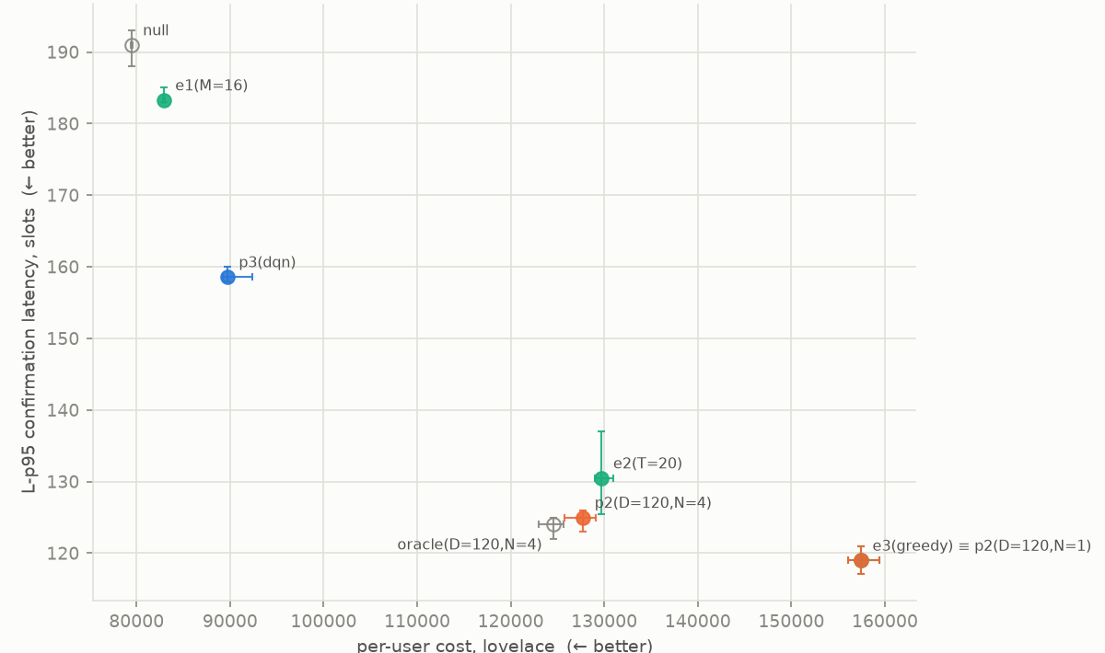
Fig. 1. 95th-percentile latency against cost per user at matched load; lower-left is better.
5. Relevance to Applied AI for Sustainable Development
Packing the same trading into fewer, fuller transactions cuts the fee each person pays, which helps small traders most. On a low-energy proof-of-stake chain, fuller transactions also make better use of every block. One price per batch also stops the batcher from reordering trades for profit.
6. Limitations and Conclusion
We used one 92-day window, one pool and generated order flow; chaining is not yet live, and the testnet batch held one order. Still, on Cardano the bottleneck is the pool lock, not congestion, and a chain-aware batcher with hard gates and a shielded learner can cut user costs without putting orders at risk.
References
[1] M. Chakravarty, J. Chapman, K. MacKenzie, O. Melkonian, M. Peyton Jones, and P. Wadler, “The extended UTXO model,” in Financial Cryptography and Data Security Workshops (FC), 2020.
[2] H. Nguyen Quang, “Concurrent & deterministic batching on the UTXO ledger,” MELD, Tech. Rep., 2021.
[3] P. Bruhwiler, “A concurrent DEX on Cardano,” B.Sc. thesis, Univ. of Bern, Switzerland, 2021.
[4] T. Roughgarden, “Transaction fee mechanism design: An economic analysis of EIP-1559,” in Proc. ACM Conf. Economics and Computation (EC), 2021.
[5] G. Ke et al., “LightGBM: A highly efficient gradient boosting decision tree,” in Advances in Neural Information Processing Systems (NeurIPS), 2017.
[6] V. Mnih et al., “Human-level control through deep reinforcement learning,” Nature, vol. 518, no. 7540, pp. 529–533, 2015.

