Designing Battleship – Design Phase and Review Session
Vikrant
ISTG – 6010
1. Introduction
This assignment focuses on the early design phase of the Battleship application. Instead of building the system directly, paper-based wireframes were created to visualize the user interface and game flow. This approach helps identify design issues early and allows feedback to be collected before development begins. The goal is to ensure clarity, usability, and completeness in the system design.
2. Design Phase (Paper Wireframes)
The wireframes were created using a notebook and pen to simulate a real-world design process. The sketches include all major screens, including the start screen, player setup, ship placement, gameplay, and result display. Each screen is clearly labeled to show user interaction and the flow between steps. The diagram shows the full game flow.
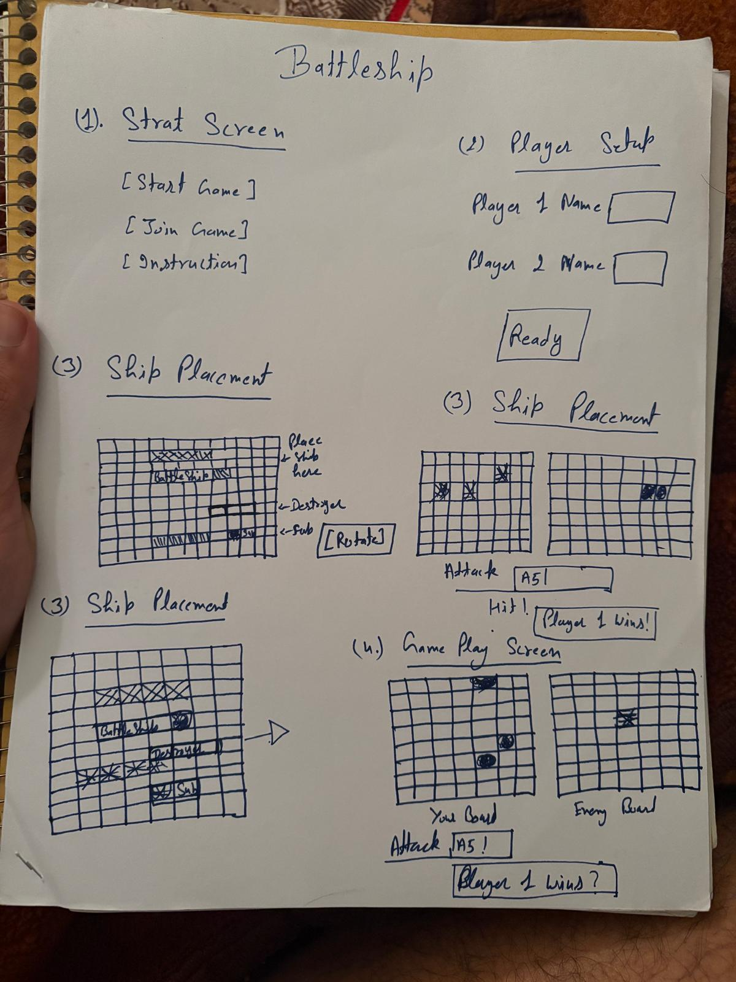
The start screen lets players start or join a game. The player setup screen collects player names. The ship placement screens allow users to position ships and rotate them. The gameplay screen includes two grids: one for the player and one for tracking the opponent. The attack system supports coordinate-based input, such as A5, and displays hit/miss feedback and the winner.
3. Review Session
The design was presented to two reviewers. The walkthrough included explaining each screen and simulating gameplay using paper wireframes. Reviewers were asked to interact with the design and provide feedback based on usability, clarity, and completeness. This interactive session helped identify areas for improvement.
4. Feedback Analysis
Clarity: Reviewers understood the flow easily but suggested clearer labels for attack input and gameplay instructions.
Completeness: All core features were present. Reviewers suggested adding a restart option and an instructions screen.
Consistency: Most elements were consistent, but button styles and naming can be improved.
Scalability: The design supports future enhancements such as single-player mode or an AI opponent.
Usability: The dual-grid system makes the game intuitive and easy to follow.
Adherence to Requirements: The design fully adheres to the Battleship rules, including ship placement, turn-based play, and win conditions.
Technical Feasibility: The design is simple and can be implemented using standard programming tools.
Optimization Opportunities: Some layout elements can be simplified to improve readability.
Security Considerations: Player boards and ship locations should remain hidden from opponents.
Innovation and Creativity: The structured layout and clear separation of boards improve user understanding.
5. Improvements
Based on feedback, improvements will include enhancing label clarity, adding a restart/play-again option, improving consistency in UI elements, and simplifying the layout for better usability. Additional features, such as instructions and enhanced guidance, will also be considered

