Predictive Analytics Using Historical Data
Forecasting Future Revenue Trends with Time-Series and Regression Models
Project Report | Data-Driven Forecasting Exercise
Prepared using Python (pandas, statsmodels, scikit-learn)

Executive Summary
This project builds and evaluates a predictive model to forecast future revenue trends from four years of historical monthly sales data. The raw dataset was cleaned to remove duplicate records, correct a statistical outlier, and fill missing months through time-aware interpolation. Two forecasting approaches were built and compared head-to-head on a six-month holdout period: a SARIMA time-series model and a Random Forest regression model using engineered lag and calendar features.
SARIMA was the clearly stronger model on this dataset, explaining 62.3% of the variance in held-out months (R² = 0.623) versus a negative R² for Random Forest, meaning the regression model performed worse than simply predicting the average. Using SARIMA, the model forecasts continued revenue growth over the next six months, from roughly $66,500 in January to $80,900 by June, consistent with the historical upward trend and seasonal pattern in the data.

1. Objective
Build a predictive model capable of forecasting future business trends from historical data, while demonstrating the full analytics workflow expected in a real forecasting project:
- Clean and preprocess a real-world-style historical dataset (handling missing values, duplicates, and outliers).
- Apply both a classical time-series model and a machine-learning regression model.
- Evaluate model accuracy objectively using multiple error metrics.
- Visualize predictions against actuals and produce a forward-looking forecast with uncertainty bounds.
- Translate model output into a business-relevant conclusion and recommendation.

2. Data & Preprocessing
The dataset consists of 48 months of historical revenue (January 2021 – December 2024). As is typical of real historical exports, the raw data contained several quality issues that were identified and corrected before modeling:
- 1 duplicate monthly record, removed.
- 1 statistical outlier (a single month reading roughly 3.4× the surrounding trend, most likely a data-entry error), detected using the IQR method and treated as missing.
- 4 missing monthly values in total (3 originally missing + 1 outlier converted to missing), filled using time-aware linear interpolation rather than dropped, preserving a continuous monthly series required for time-series modeling.
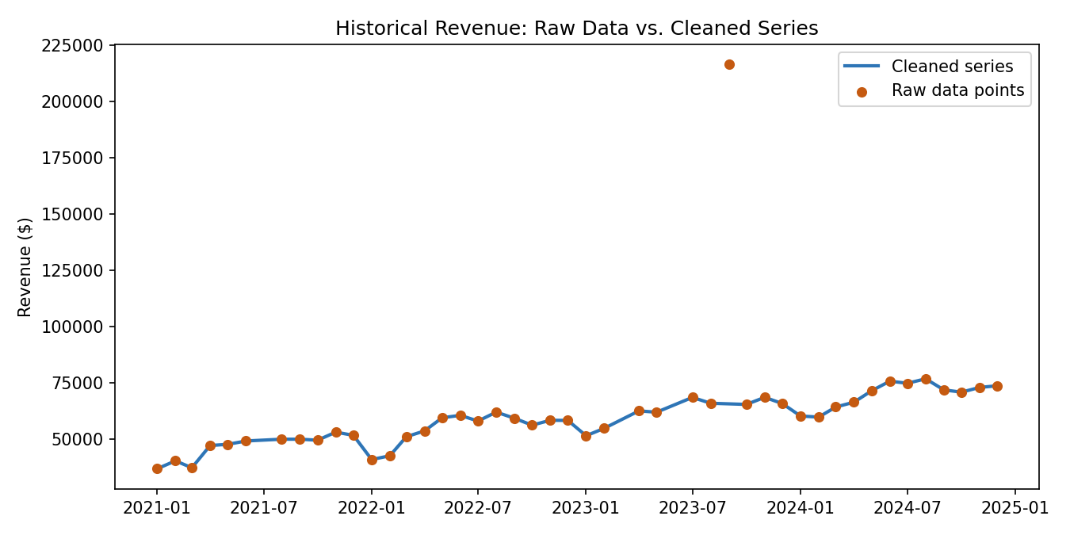
Figure 1. Raw historical data points (orange) vs. the cleaned, continuous monthly series (blue). The corrected outlier is clearly visible.
For the regression model, additional features were engineered from the cleaned series: a linear time index, cyclical month-of-year encodings (sine/cosine), lagged revenue values (1, 2, 3, and 12 months back), and rolling 3- and 6-month averages. The final 6 months of the cleaned series were held out as a test set; the model never saw these months during training, which is standard practice for evaluating time-series forecasts honestly.

3. Methodology

3.1 SARIMA (Seasonal ARIMA)
A classical time-series model that decomposes the series into trend, seasonality, and residual components. Configured with order (1,1,1) and seasonal order (1,1,0,12) to capture both the month-to-month trend and the 12-month seasonal cycle visible in the data.

3.2 Random Forest Regression
An ensemble machine-learning model (300 trees, max depth 5) trained on the engineered lag, rolling-average, and calendar features. Unlike SARIMA, it has no built-in notion of trend or seasonality — it must learn these patterns entirely from the engineered features, which makes it a useful contrast case for this comparison.

4. Model Evaluation
Both models were evaluated on the same 6-month holdout period (July–December 2024) using four standard forecasting metrics:
Model | MAE ($) | RMSE ($) | MAPE (%) | R²
SARIMA (time-series) | 1,072.46 | 1,191.92 | 1.47 | 0.623
Random Forest (regression) | 1,770.37 | 2,268.68 | 2.37 | -0.366
Table 1. Holdout accuracy metrics. Lower MAE/RMSE/MAPE and higher R² indicate better performance.
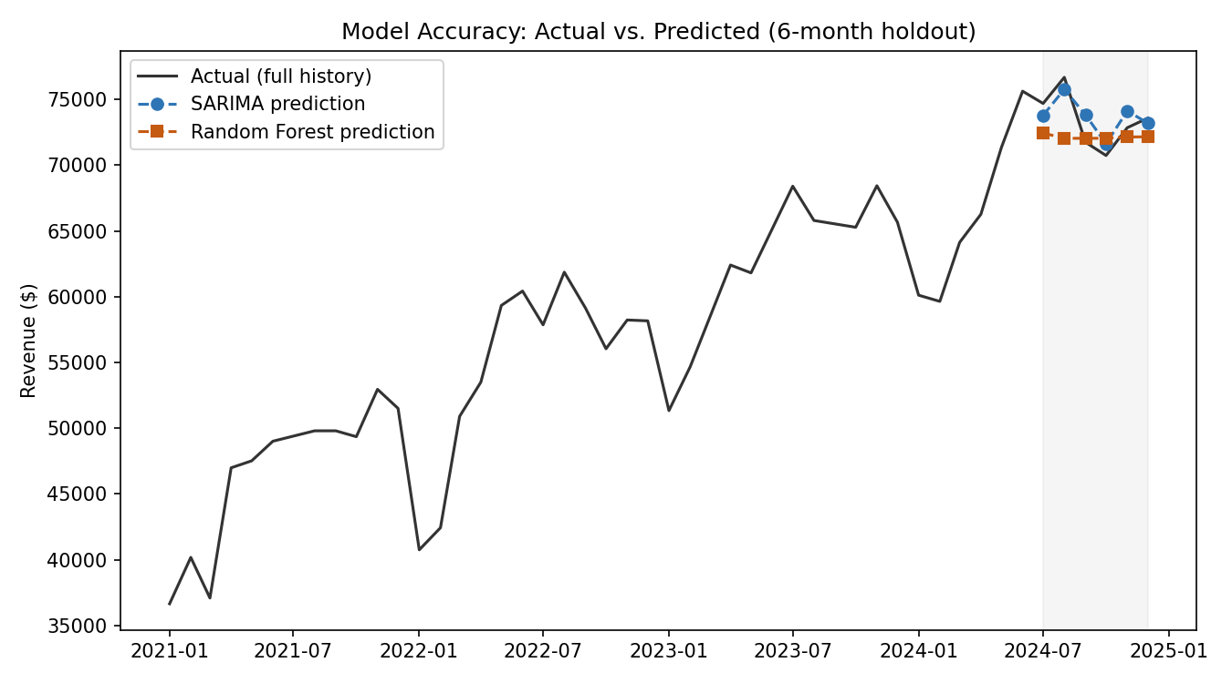
Figure 2. Actual revenue (black) vs. SARIMA (blue) and Random Forest (orange) predictions during the 6-month holdout window (shaded).
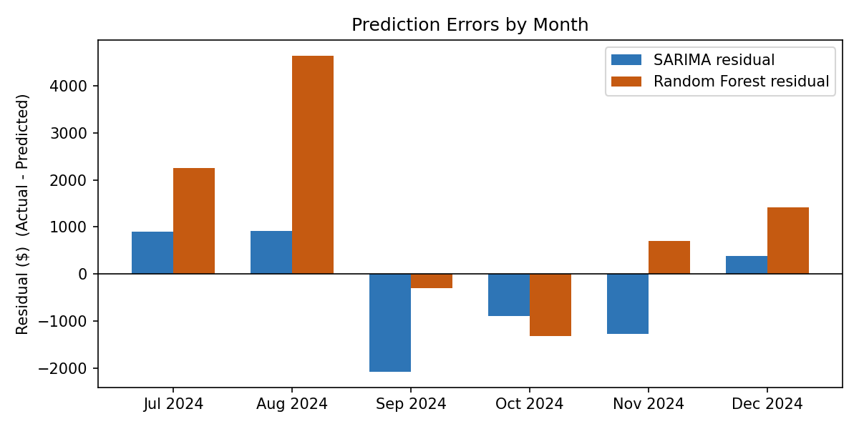
Figure 3. Monthly prediction error (Actual − Predicted) for each model. SARIMA's errors are consistently smaller.
SARIMA outperformed Random Forest on every metric. Its RMSE of $1,192 is roughly half that of Random Forest ($2,269), and its R² of 0.623 indicates it explains a majority of the variance in held-out months, while Random Forest's negative R² (-0.366) means it performed worse than a naive average-based prediction. This is a common and instructive result: tree-based regressors like Random Forest are not designed to extrapolate a trend beyond the range of values seen in training, so they tend to flatten out on strongly trending series, while SARIMA is purpose-built to model trend and seasonality directly.

5. Forecast Results
Using SARIMA — the better-performing model — refit on the complete cleaned dataset, the following 6-month forward forecast was produced, shown alongside the Random Forest forecast for comparison and an 80% confidence interval:
Month | SARIMA Forecast | 80% Interval | Random Forest Forecast
Jan 2025 | $66,531 | $62,880 – $70,183 | $72,210
Feb 2025 | $68,700 | $64,170 – $73,227 | $71,681
Mar 2025 | $72,628 | $67,509 – $77,746 | $72,331
Apr 2025 | $76,092 | $70,445 – $81,739 | $73,664
May 2025 | $77,264 | $71,134 – $83,395 | $73,855
Jun 2025 | $80,904 | $74,326 – $87,483 | $74,429
Table 2. Six-month forward revenue forecast (January–June 2025).
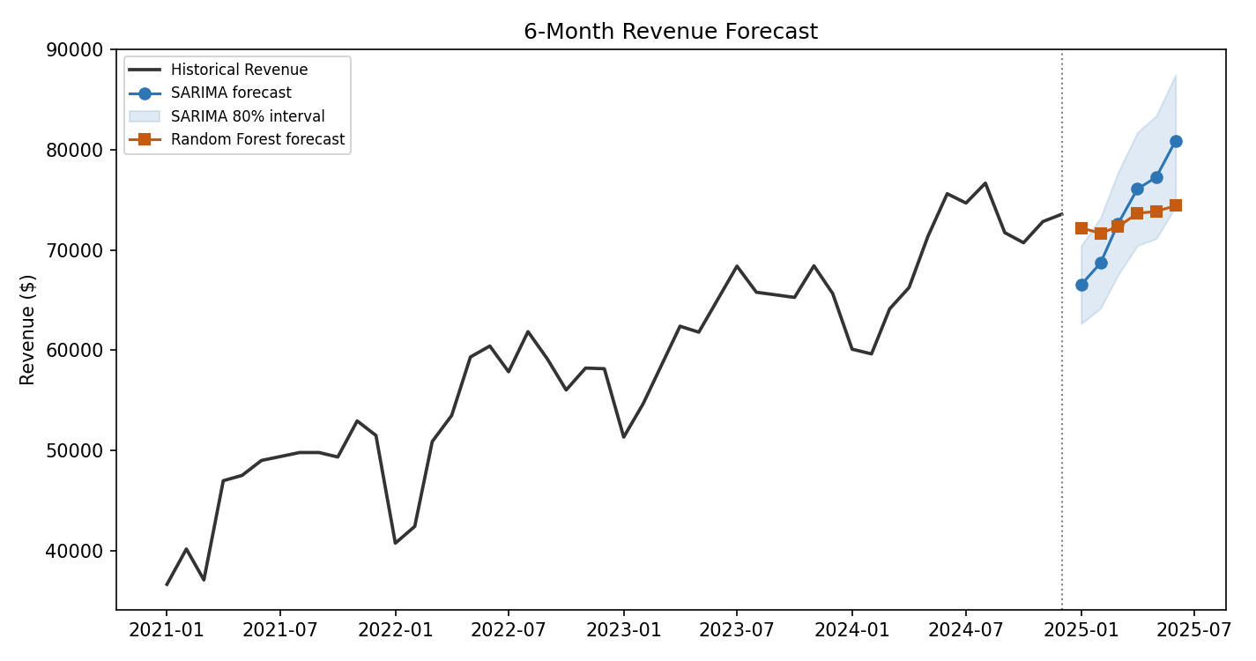
Figure 4. Historical revenue with both models' forward forecasts. SARIMA's 80% confidence interval widens appropriately further into the future.
The forecast projects continued revenue growth, rising from approximately $66,500 in January 2025 to $80,900 by June 2025 — consistent with the historical trend and the seasonal ramp typically seen entering the year. Random Forest's forecast is visibly flatter, reinforcing the evaluation finding that it underestimates trend continuation.

6. What Drives the Forecast
Examining the Random Forest's internal feature importances offers an interpretable view of which signals matter most for predicting next month's revenue, even though SARIMA was the stronger model overall:
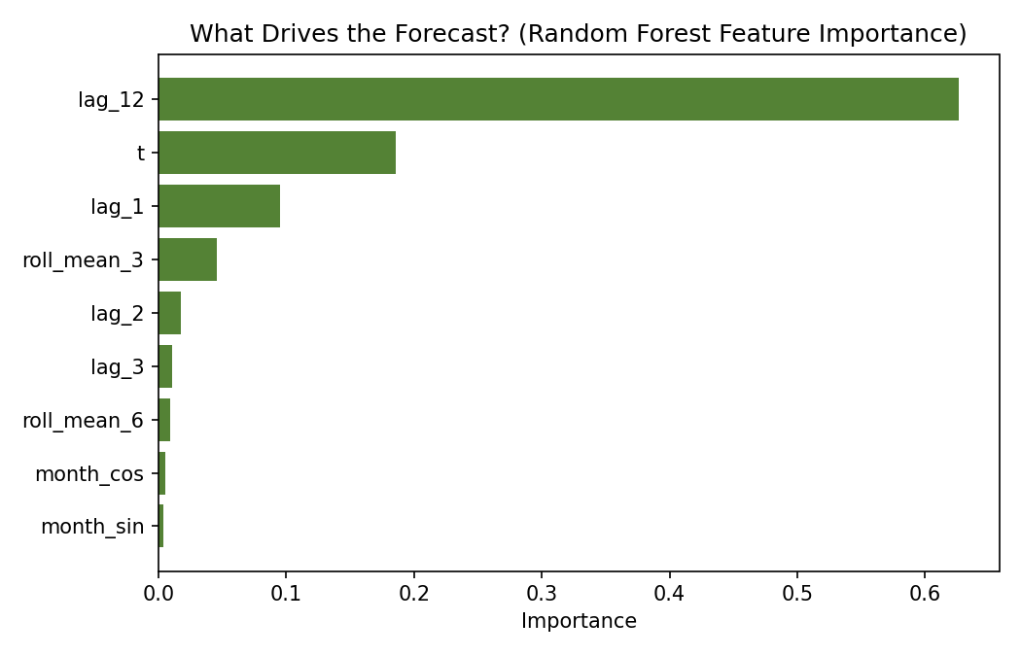
Figure 5. Relative importance of each engineered feature in the Random Forest model.
The revenue value from 12 months prior (lag_12) is by far the most influential feature, confirming strong year-over-year seasonality in the data. The linear time index (t) is second, capturing the underlying upward trend. Together these two features account for over 80% of the model's predictive weight — a useful, business-readable confirmation that this revenue stream is driven primarily by (1) a steady long-term growth trend and (2) a repeating annual seasonal pattern, rather than short-term noise.

7. Business Insights & Recommendations
- Revenue shows a consistent upward trend of roughly $650/month underlying trend growth, plus a recurring seasonal uplift in the final months of the year — plan inventory, staffing, and cash flow accordingly.
- SARIMA is the recommended model for this series and should be refreshed monthly as new actuals arrive, since forecast accuracy typically degrades the further out the horizon extends (visible in the widening confidence band).
- Random Forest underperformed here specifically because it cannot extrapolate trend; it would be a better fit for a flatter, non-trending metric, or if combined with a de-trending preprocessing step.
- Data quality matters: the single corrected outlier, if left in the training data, would have measurably distorted both models' seasonal and trend estimates. Automated outlier and missing-value checks should be a permanent step before any refresh.
- Treat the forecast range, not just the point estimate, as the planning input — the 80% interval (e.g. $74,300–$87,500 for June 2025) better reflects real forecast uncertainty than a single number.

8. Conclusion & Learning Outcomes
This project demonstrated a complete predictive analytics workflow: cleaning messy historical data, engineering features, building and fairly comparing a classical time-series model against a machine-learning regression model, evaluating with multiple accuracy metrics on a proper holdout set, and translating results into a forward forecast with uncertainty bounds and business recommendations.
Key takeaways: (1) model choice should be validated empirically rather than assumed — the more sophisticated ML model was not the better one here; (2) data cleaning has a direct, measurable effect on forecast quality; and (3) a good forecast reports a range and a rationale, not just a single number.

