Data Cleaning & Reporting Automation
An Automated Pipeline for Cleaning Messy Data and Generating Quality Reports
Project Report | Data Preprocessing & Automation Exercise
Prepared using Python (pandas, matplotlib)

Executive Summary
This project builds a reusable, automated pipeline that cleans messy order data and generates a data-quality report, without any manual, row-by-row intervention. The pipeline was tested on a raw export of 542 orders containing the kinds of problems real business data typically has: inconsistent text casing, three different date formats, currency-formatted numbers stored as text, erroneous negative amounts, missing values, and duplicate records.
After running automatically, the pipeline reduced the dataset to 520 clean, deduplicated rows with zero missing values in any numeric or categorical field, standardized 22 inconsistent category labels down to 5, and flagged (rather than silently altering) 18 statistical outliers and 27 invalid email addresses for human review. Every single change the pipeline made is captured in a machine-generated audit log, and the entire process can be re-run on any new data export with one command.

1. Objective
Build an automation pipeline — not a one-off script — that can take any raw, messy CSV export and reliably:
- Detect and handle missing values, duplicate records, and inconsistent formatting without manual editing.
- Preserve a complete, transparent log of every change made, so nothing is silently altered or lost.
- Generate a visual, before/after data-quality report automatically as part of the same run.
- Be reusable: point it at a different raw file and it produces a fresh, accurate report every time.

2. The Raw Data
The input is a 542-row order export containing nine fields (Order ID, Customer Name, Email, Order Date, Category, Region, Amount, Quantity, Status). It was deliberately representative of a real-world messy export, containing:
- 22 different text variants of just 5 true categories (e.g. 'Electronics', 'electronics', ' ELECTRONICS ').
- 17 variants/typos of 4 order statuses (e.g. 'Shipped', 'shiped', 'PENDNG').
- Order dates in three different formats mixed within the same column (2024-01-05, 01/05/2024, 05-Jan-2024).
- Amount values stored as text with '$' signs and comma thousands separators.
- 25 negative amounts (sign errors), 18 statistical outliers, missing values across four columns, 27 malformed/missing emails, and 22 exact duplicate rows.

3. Automated Cleaning Pipeline
The pipeline is a single Python function, clean_and_report(), that performs the following steps in order, logging each action it takes:
Step | Action Taken
1 | Standardized Category text: collapsed 22 casing/whitespace variants into 5 clean categories
2 | Standardized Status text: collapsed 17 variants/typos (e.g. 'shiped', 'PENDNG') into 4 clean statuses
3 | Parsed 3 mixed date formats (ISO, US, text-month) into one consistent datetime column
4 | Stripped currency symbols and thousands separators from Amount, converted to numeric
5 | Converted 25 negative Amount values to positive (data-entry sign errors)
6 | Flagged 18 statistical outliers in Amount (IQR method) for manual review — not deleted
7 | Imputed 24 missing Amount values using the median for that product category
8 | Imputed 16 missing Quantity values using the overall median
9 | Labeled 8 missing Region values as 'Unknown' rather than dropping the row
10 | Validated email format; flagged 27 missing/malformed addresses rather than fabricating them
11 | Removed 22 exact duplicate rows (identical on every field except the row ID)
12 | Checked for re-keyed near-duplicates (same customer/date/amount, different ID) — none remained after step 11
Table 1. Full automated cleaning log — every transformation applied to the raw data, in execution order.
A key design principle: the pipeline flags problems it cannot safely resolve on its own (outliers, invalid emails) rather than guessing or deleting data silently. This keeps a human reviewer in the loop for judgment calls, while fully automating the mechanical cleaning work.

4. Before / After Results
Metric | Before | After
Total rows | 542 | 520
Exact duplicate rows | 22 | 0
Missing values (Amount/Qty/Region/Date) | 48 | 0
Category field variants | 22 | 5
Status field variants | 17 | 4
Negative (erroneous) amounts | 25 | 0
Statistical outliers | 18 (undetected) | 18 (flagged for review)
Invalid/missing emails | 27 (undetected) | 27 (flagged for review)
Table 2. Data quality metrics before and after the automated pipeline.
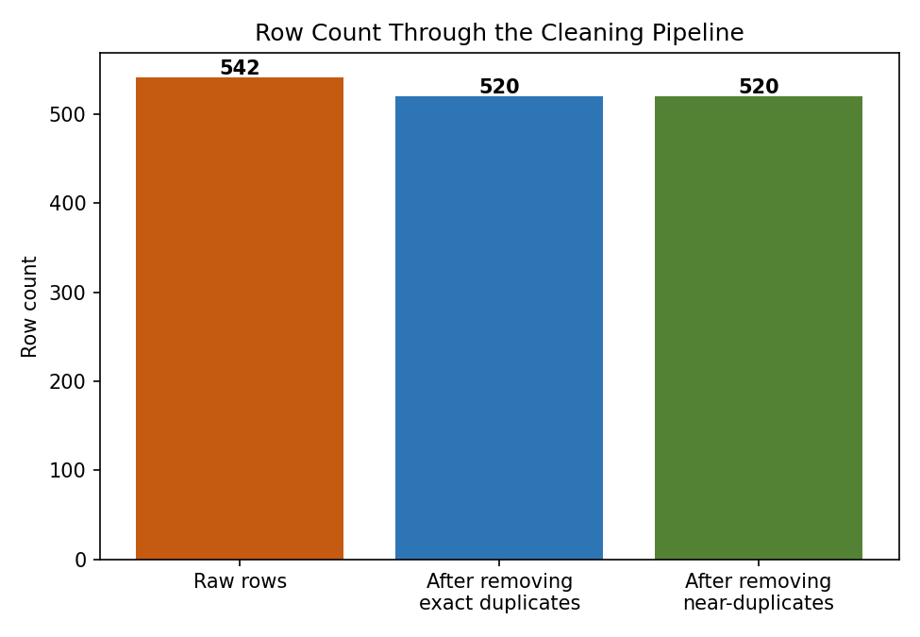
Figure 1. Row count through the pipeline: 22 exact duplicates removed; no further near-duplicates remained.
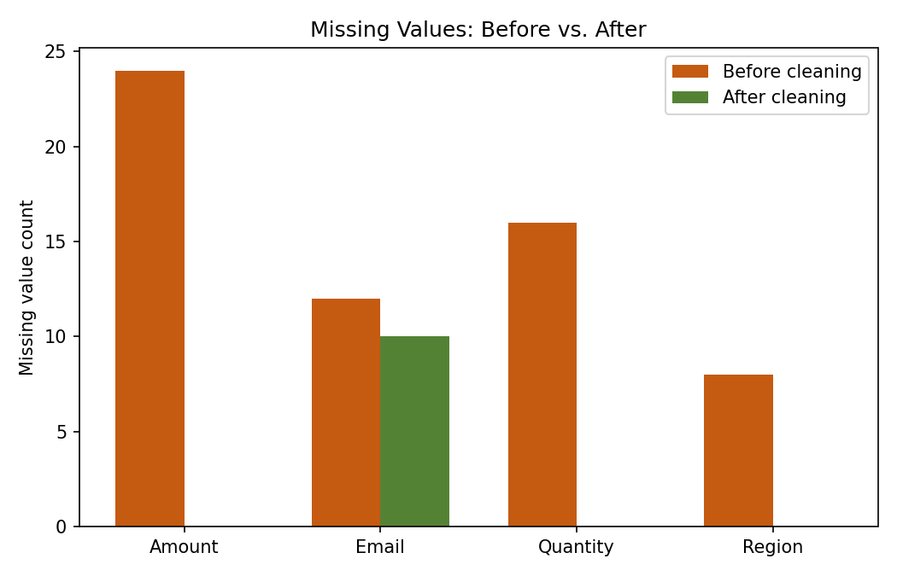
Figure 2. Missing values before vs. after, by column. Email is intentionally left partially flagged rather than fabricated — see Section 5.

5. Standardization & Outlier Handling
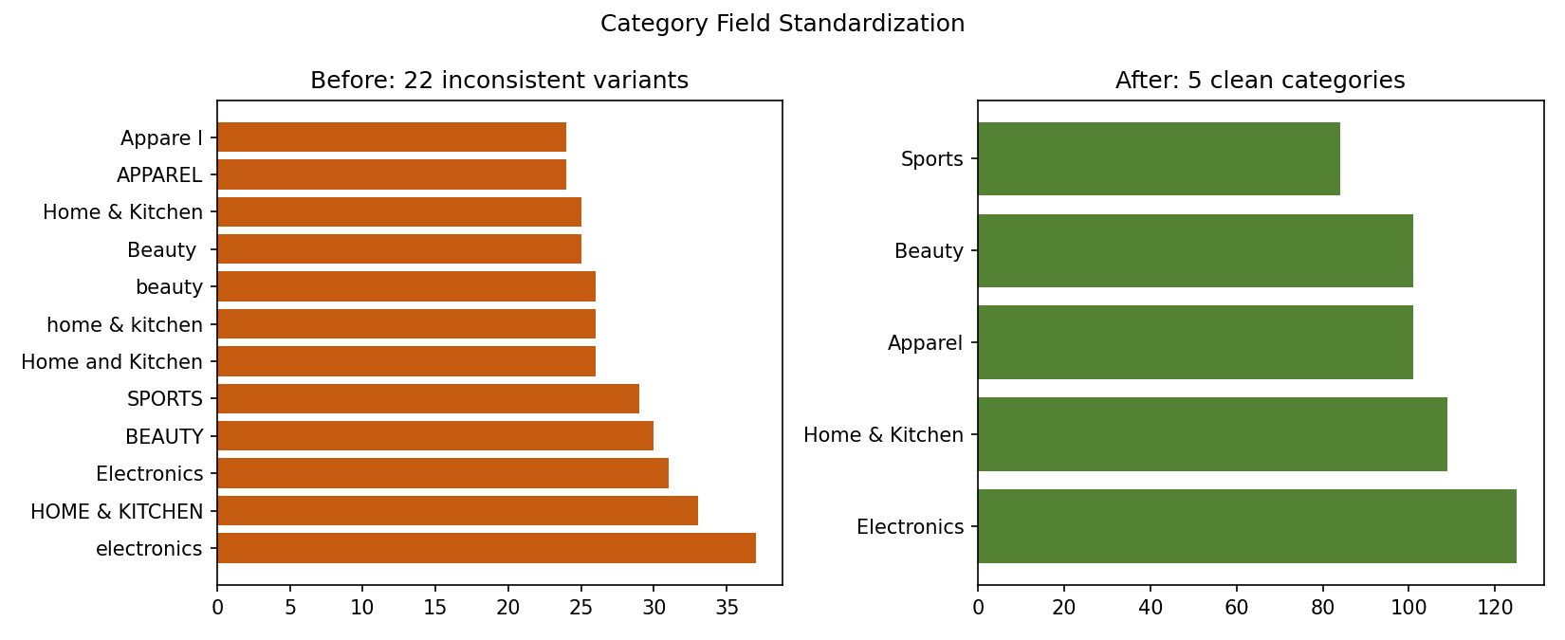
Figure 3. The Category field before (22 inconsistent text variants) and after (5 clean categories) automated standardization.
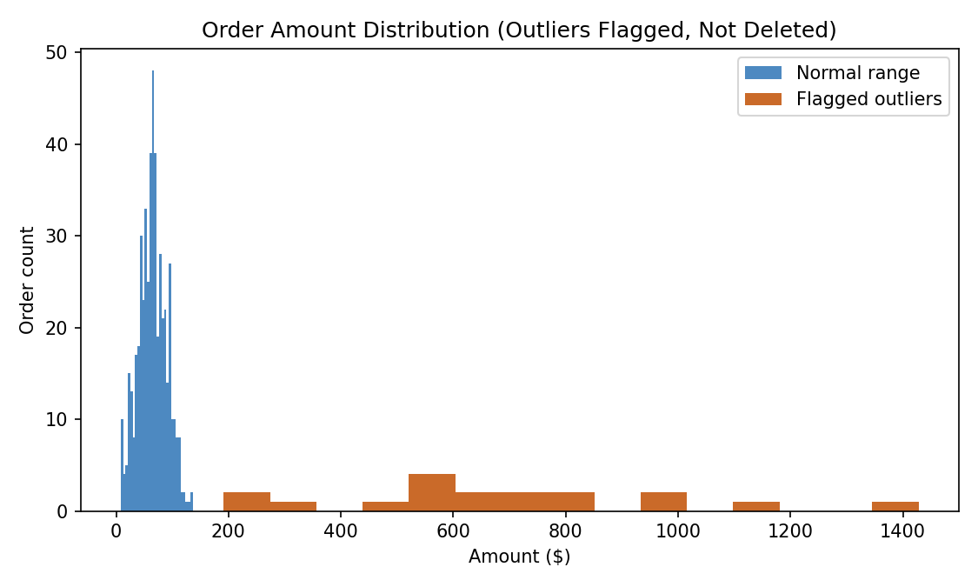
Figure 4. Order amount distribution after cleaning. Outliers are flagged (orange) for review, not deleted — a real outlier could be a legitimate large order.
Emails were validated against a standard format check rather than repaired: a malformed or missing email cannot be safely guessed, so the pipeline flags it (Email_Valid = False) for a human to follow up on. This is a deliberate design choice — automation should fix what it can verify and flag what it can't, rather than fabricate data to make a report look cleaner than the underlying reality.

6. Automation & Reusability
The cleaning logic lives in one function, clean_and_report(input_csv, output_dir), decoupled from the demo dataset used here. Running the script end-to-end on a new raw export automatically regenerates:
- A cleaned CSV file, ready for downstream use in Excel, Power BI, or further analysis.
- A complete cleaning log CSV, documenting every change for audit purposes.
- All four data-quality charts in this report, rebuilt from the new data.
This makes the pipeline suitable for a scheduled job (e.g. a nightly cron task or an Airflow/Power Automate trigger): each time new raw data lands, the same script produces a fresh, consistent report with zero manual cleaning effort.

7. Conclusion & Learning Outcomes
This project demonstrated the core preprocessing techniques required in real data workflows — handling missing values, removing duplicates, standardizing inconsistent categorical data, parsing mixed formats, and detecting outliers — packaged as a single reusable automation rather than manual, ad-hoc fixes.
Key takeaways: (1) automation should distinguish between problems it can safely fix (formatting, duplicates, parseable dates) and problems that need human judgment (outliers, invalid contact data), flagging the latter rather than guessing; (2) a transparent action log is essential — automated cleaning without an audit trail is difficult to trust or debug; and (3) building the pipeline as a reusable function, not a one-off script, is what turns data cleaning from a repeated manual chore into genuine reporting efficiency.

