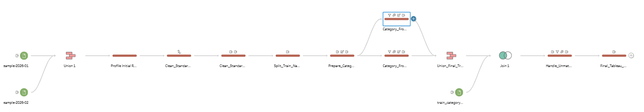
Important note about this document
- This is written as my own roadmap.
- The main point is not just what I clicked in Tableau Prep, but why I did each step.
- Whatever I deemed unnecessary was slimed outta the idea sheet.

1. Where the Project Stands Right Now:-
At this point, I have completed the Tableau Prep cleaning foundation of the project. I loaded the January and February Deutsche Bahn samples, unioned them into one combined dataset, profiled the raw data, cleaned text fields, created a usable train category, joined a lookup table, handled unmatched lookup categories, and created the final fields needed before Python. The dataset is now ready for the Python script phase.
The most important thing I achieved so far is that the project is no longer just raw train data. It now has cleaned station names, cleaned train names, a final train category, service group descriptions, readable train status, and readable delay status. The only big thing I intentionally left for Python is missing arrival/departure time logic, because that needs conditional logic across multiple columns.
Area | Current Status | Why It Matters
Raw files loaded | January, February, and lookup CSV files loaded | This gave me the complete starting point for the Tableau Prep workflow.
Union completed | January + February combined into 100,000 rows | Cleaning one combined dataset is cleaner than cleaning two separate months.
Initial profiling completed | Missing values, cancellations, delay range, and train type issues identified | Cleaning decisions were based on actual observed issues, not guesses.
Train category cleaned | Created final_train_category using split, remove numbers, branches, and union | This fixed the issue where train_type was not reliable as a clean category.
Lookup enrichment completed | Added train_service_group and service_description | Short train codes became understandable for analysis and presentation.
Final Tableau cleaning completed | Created final_station_name, train_status, and delay_status | The dataset became easier to explain and ready for Python.
Python not started yet | Time-field nulls intentionally left for Python | This gives a proper reason to use Python integration in the project.

2. Project Setup and Dataset Understanding:-

Step 1 :- Project Structure
What I did:- I first defined the project structure before touching the data. The project is about cleaning, profiling, and assessing data quality in Deutsche Bahn train data using Tableau Prep, and then using Python inside Tableau Prep later.
Why I did it:- I did not want to randomly start clicking around in Tableau Prep. The final exam expects a clean story: dataset introduction, problem statement, identified issues, Tableau Prep transformations, Python integration, final processed data, and insights. So the first thing was to make the roadmap clear.

Step 2 :- Raw Files and Field Dictionary:-
What I did:-
- I checked what files I had and what every field meant.
- I had two monthly train datasets and one lookup table.
- Both January and February had the same 17 columns, which made them suitable for unioning later.
Why I did it:-
- Before cleaning data, I needed to know what each field actually represents.
- For example, station_name is not the same thing as xml_station_name, and train_type is not always the real train category.
- If I skipped this part, later cleaning steps would look random and I would not be able to defend them properly in the presentation.
File | Rows | Columns | Role in Project
sample-2026-01.csv | 50,000 | 17 | January 2026 raw train data
sample-2026-02.csv | 50,000 | 17 | February 2026 raw train data
train_category_lookup.csv | 65 | 3 | Lookup table for train category meaning

Field | Meaning in simple words | Use in this project
station_name | Normal station name | Human-readable station analysis and reporting
xml_station_name | Station name from the XML/source system | Backup station name when station_name is missing
eva | Station identifier/code | Safer station identifier than text names
train_name | Full train display name such as EB RB50 or S S2 | Used to derive the clean train category
final_destination_station | Final destination of the train | Destination-level analysis
delay_in_min | Delay in minutes | Main delay analysis field
time | Main event timestamp | Time-based analysis
is_canceled | Whether the train was cancelled | Cancellation analysis and status labels
train_type | Raw type/operator/category value | Used carefully because it is not always reliable
train_line_ride_id | ID for the train journey/ride | Links stops that belong to the same ride
train_line_station_num | Station sequence number within a ride | Route order and stop sequence
arrival_planned_time | Planned arrival time | Missing time issue and later Python cleaning
arrival_change_time | Changed/actual arrival time | Missing time issue and later Python cleaning
departure_planned_time | Planned departure time | Missing time issue and later Python cleaning
departure_change_time | Changed/actual departure time | Missing time issue and later Python cleaning
id | Unique row/stop identifier | Duplicate checking
source_month | Source month of the row | Confirms whether a row came from January or February

My simple interpretation of one row
- One row represents one train event at one station.
- It tells me where the event happened, which train it was, whether it was delayed or cancelled, what time was planned, what time changed, and which month the row came from.

3. Loading, Unioning, and Profiling the Data:-

Step 3 - Load the Files in Tableau Prep:-
What I did:-
I loaded the January file, February file, and train category lookup file into Tableau Prep as separate input nodes.
Why I did it:-
- Keeping the three files separate at the start made the flow easier to understand.
- January and February are main data files, while the lookup file is not a data month.
- It is only for adding meaning later.
Input Node / File | Purpose
sample-2026-01.csv | Raw January train data
sample-2026-02.csv | Raw February train data
train_category_lookup.csv | Lookup table for train category labels and descriptions

Step 4 - Union January and February:-
What I did:--
I slammed (UNION) the January and February datasets into one combined dataset.
Why I did it:--
- The two monthly files had the same 17 columns, so a union was the correct operation.
- A union stacks rows on top of each other.
- I did this because I wanted to clean one combined dataset instead of repeating the same cleaning steps separately for January and February.
Before Union | Rows | Columns
January 2026 dataset | 50,000 | 17
February 2026 dataset | 50,000 | 17
After union | 100,000 | 17

Fields created in this step | Created from | Purpose
None | Not applicable | No new fields were created. Existing fields were preserved.
source_month was preserved | CSV source files | Used to confirm that both months remained in the unioned dataset.

Why this matters
Without the union, I would either clean January and February separately or accidentally analyze only one month. The union made the dataset complete for the project scope.

Step 5 - Initial Profiling of the Raw Combined Data:-
What I did:-
- After the union, I created a profiling step.
- I checked row count, column count, source_month, missing values, cancellation values, delay range, negative delays, large delays, and whether train_type looked reliable.
Why I did it:-
- This step is honestly one of the most important steps because it tells me what actually needs cleaning.
- If I clean without profiling, I am just guessing.
- The profiling step gave me the reasons for the later transformations.
Profiling Question | Observation
Rows after union | 100,000 rows
Columns after union | 17 columns
source_month values | 2026-01 and 2026-02
Time fields missing values? | Yes
is_canceled has True and False? | Yes
delay_in_min has negative values? | Yes
delay_in_min has large values? | Yes
train_type fully reliable? | No

Column | Missing Values in Combined Dataset | Why it matters
station_name | 7 | Small issue, can be fixed using XML station name
arrival_planned_time | 7,234 | Important time-field issue
arrival_change_time | 7,227 | Important time-field issue
departure_planned_time | 7,395 | Important time-field issue
departure_change_time | 7,387 | Important time-field issue

Delay Check | Result
Minimum delay | -28 minutes
Maximum delay | 200 minutes
Average delay | 2.16
Median delay | 1 minutes
Negative delay records | 693
Delay greater than 60 minutes | 155 minutes

Fields created in this step | Created from | Purpose
None | Not applicable | This was a profiling/checking step. It created the evidence for later cleaning.

4. Basic Cleaning and Readability Improvements:-

Step 6 - Standardize Data Types:-

What I did:-
- I checked and standardized important data types.
- The main idea was that ID-like fields should be treated as labels, not as numbers used in calculations.
Why I did it:-
- Fields like eva, id, and train_line_ride_id may look numeric, but they are identifiers.
- I do not average them, add them, or subtract them.
- Treating IDs as text prevents accidental mathematical interpretation.
Field | How I treated it | Why
eva | String/Text identifier | It identifies stations; it is not a mathematical value.
id | String/Text identifier | It identifies one train stop/event row.
train_line_ride_id | String/Text identifier | It identifies a ride/journey, not a number to calculate.
delay_in_min | Number | This is used for delay calculations and categories.
time and arrival/departure fields | Date & Time | These fields represent timestamps.
is_canceled | Boolean | This field stores True/False cancellation status.

Fields created in this step | Created from | Purpose
None | Not applicable | This step changed/checks types. No new analysis field was needed here.

Step 7 - Standardize Text Fields:-
What I did:-
- I created cleaned versions of important text fields.
- The cleaning mostly removed extra spaces and converted selected train fields to uppercase.
Why I did it:-
- Joins, grouping, and comparisons can break because of small text problems.
- For example, " re re7 " and "RE RE7" should not be treated differently.
- This is why I created clean fields instead of directly trusting the raw ones.
New Field Created | Created From | Formula / Method | Why
clean_station_name | station_name | TRIM([station_name]) | Removes accidental leading/trailing spaces.
clean_xml_station_name | xml_station_name | TRIM([xml_station_name]) | Keeps XML station name clean and usable as backup.
clean_train_name | train_name | UPPER(TRIM([train_name])) | Makes train names consistent for splitting and category work.
clean_final_destination_station | final_destination_station | TRIM([final_destination_station]) | Prepares destination for analysis.
clean_train_type | train_type | UPPER(TRIM([train_type])) | Makes train_type easier to compare later.

Example Raw Value | Cleaned Result | Reason
" re re7 " | RE RE7 | Spaces removed and uppercase applied
" Köln Hbf " | Köln Hbf | Spaces removed
"Bus SEV" | BUS SEV | Uppercase makes later splitting cleaner

5. Train Category Cleaning:-
- This was the longest part of the Tableau Prep work because the train category was not as simple as it first looked.
- The field train_type looked useful at first, but then I saw examples where it behaved like an operator code instead of a clean service category.
train_name | train_type | Better Category
EB RB50 | EB | RB
ARV RE9 | ARV | RE
HLB RB75 | HLB | RB
SBH S5 | SBH | S
NEB RB12 | NEB | RB

Why this was a real data quality issue
If I used train_type directly, I would mix operator codes with train categories. That would make the final analysis misleading. So I derived a better category from clean_train_name.

Step 8 - Split clean_train_name:-
What I did:-
- I split clean_train_name into two fields using the space between words.
Why I did it:-
- Train names contain multiple pieces of information together. For example, ABR RB20 contains an operator/code in the first part and the train line in the second part.
- Splitting made the structure visible.
clean_train_name | clean_train_name - Split 1 | clean_train_name - Split 2
ABR RB20 | ABR | RB20
ARV RE9 | ARV | RE9
S S7 | S | S7
ICE 100 | ICE | 100
BUS SEV | BUS | SEV

Fields created in this step | Created from | Purpose
clean_train_name - Split 1 | clean_train_name | Stores the first part of the train name.
clean_train_name - Split 2 | clean_train_name | Stores the second part of the train name.

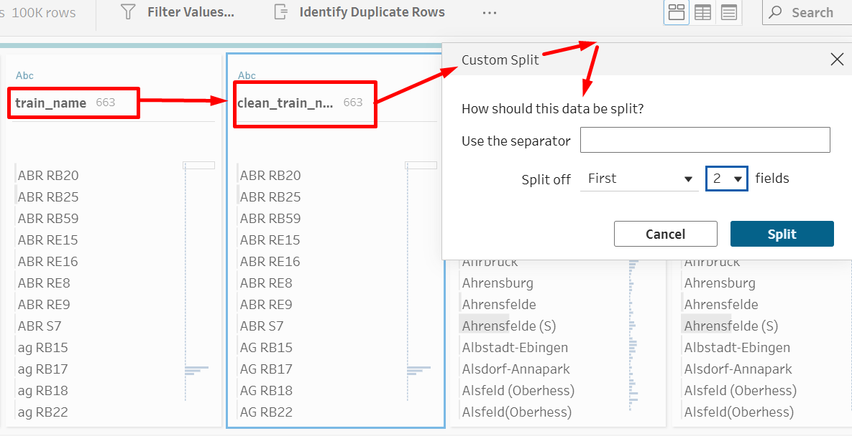

Step 9 - Create category_candidate_from_split_2:-
What I did:-
- I duplicated clean_train_name - Split 2 and removed numbers from the duplicate.
- This created category_candidate_from_split_2.
Why I did it:-
- Values like RB20, RE15, and S7 are too specific for category-level analysis.
- The letters tell the train category, while the numbers tell the specific line number.
- For joining with the lookup table, I needed RB, RE, and S, not RB20, RE15, and S7.
Original Split 2 | After Removing Numbers | Category Candidate
RB20 | RB | RB
RB25 | RB | RB
RE15 | RE | RE
S7 | S | S
RS1 | RS | RS
100 | blank / NULL | blank / NULL

Field created in this step | Created from | Method | Purpose
category_candidate_from_split_2 | clean_train_name - Split 2 | Duplicate field, then Remove Numbers | Creates a category candidate such as RB, RE, S, MEX, or RS.

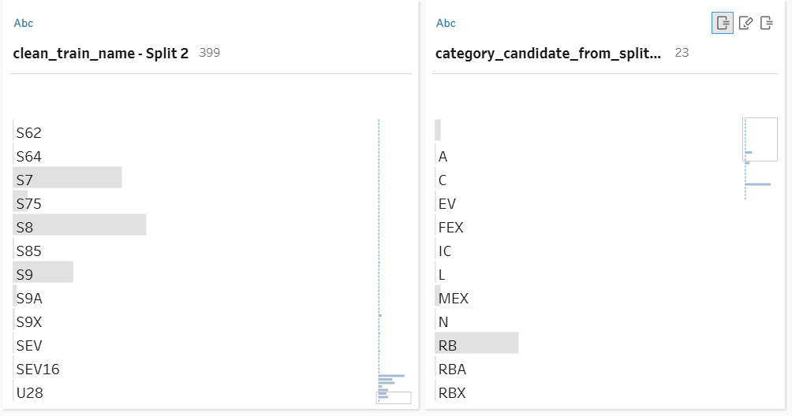

Step 10 - Create final_train_category:-
What I did:-
- I created final_train_category using a no-complicated-formula method.
- I used two branches.
- Branch A handled rows where category_candidate_from_split_2 had a useful value.
- Branch B handled rows where category_candidate_from_split_2 was NULL and the category had to come from clean_train_name - Split 1.

Case | Which Branch Handles It? | Reason | final_train_category
ABR RB20 | Branch A | Split 2 candidate is RB | RB
ARV RE9 | Branch A | Split 2 candidate is RE | RE
S S7 | Branch A | Split 2 candidate is S | S
SWE RS1 | Branch A | Split 2 candidate is RS | RS
ICE 100 | Branch B | Split 2 becomes NULL after number removal | ICE
IC 103 | Branch B | Split 2 becomes NULL after number removal | IC

Field created in this step | Created from | Where created | Purpose
final_train_category | category_candidate_from_split_2 | Branch A: Category_From_Split_2 | Uses the cleaned category from Split 2 when it exists.
final_train_category | clean_train_name - Split 1 | Branch B: Category_From_Split_1_When_Split_2_Empty | Uses Split 1 when Split 2 has no useful category.

A small but important correction was also made here:-
- Blank values in category_candidate_from_split_2 were converted to NULL first.
- Then Branch A excluded NULL and Branch B kept only NULL.
- This made the missing-category logic cleaner and easier to explain.
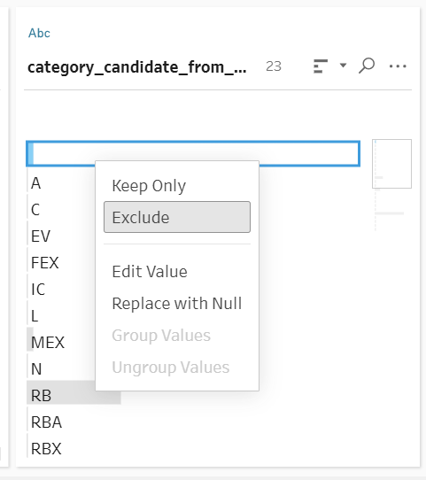

6. Lookup Join and Unmatched Category Handling:-

Step 11 - Join the Train Category Lookup Table:-
What I did:-
- I joined the main dataset with train_category_lookup.csv.
- The join condition was final_train_category = clean_train_category_from_name.
- I used a left join.
Why I did it:-
- final_train_category gives short codes like RB, RE, S, ICE, and IC.
- Those are useful, but for a report and presentation I also need readable service information.
- The lookup table adds train_service_group and service_description, which make the data easier to explain.
Main Dataset Field | Lookup Table Field | Join Type
final_train_category | clean_train_category_from_name | Left Join

Fields added in this step | Came from | Purpose
clean_train_category_from_name | train_category_lookup.csv | Lookup category key.
train_service_group | train_category_lookup.csv | Groups categories into readable service groups.
service_description | train_category_lookup.csv | Explains the category in words.

Step 12 - Handle Unmatched Lookup Values:-
What I did:-
- After the left join, some categories did not match the lookup table.
- That created NULL values in train_service_group and service_description.
- I replaced those NULLs with clear review labels.
Why I did it:-
- I did not delete unmatched rows because the train records are still real.
- Only the lookup meaning was missing.
- So instead of hiding the problem, I marked it clearly as Unmapped / Needs Review.
Example final_train_category | Problem
RS | No matching lookup value found
SX | No matching lookup value found
SA | No matching lookup value found
C | No matching lookup value found
REA | No matching lookup value found
A | No matching lookup value found
REB | No matching lookup value found
L | No matching lookup value found
RBX | No matching lookup value found

Field cleaned | Original problem | Replacement value | Why
train_service_group | NULL after lookup join | Unmapped / Needs Review | Shows the category needs review without deleting the row.
service_description | NULL after lookup join | No matching category found in lookup table | Explains why the description is missing.

Fields created in this step | Created from | Purpose
None as a new final business field | Not applicable | This step cleaned existing lookup output fields.
Optional duplicate-check helper visible in flow: Is Duplicate Row? | id | Used to validate that duplicate IDs were not a real issue. It did not change the business meaning of the dataset.

About duplicates
The dataset had 0 duplicate id values and 0 full duplicate rows in profiling. I did not treat duplicate removal as a main problem because there was no actual duplicate issue. If the flow contains a duplicate validation helper, it is only a validation/check step, not a major cleaning decision.

7. Final Tableau Prep Cleaning Before Python:-

Step 13 - Create Final Fields Before Python:-
What I did:-
- I created the last Tableau Prep cleaning step before Python. In this step I created final_station_name, train_status, and delay_status.
Why I did it:-
- This step made the dataset more readable and fixed the simple issues that Tableau Prep can handle easily.
- I did not want to force the missing arrival/departure time logic in Tableau Prep because that logic is better for Python.
New Field | Created From | Formula / Logic | Why I Created It
final_station_name | clean_station_name + clean_xml_station_name | If clean_station_name is NULL, use clean_xml_station_name; otherwise keep clean_station_name. | Fixes missing station names without deleting records.
train_status | is_canceled | If is_canceled is TRUE, label as Cancelled; otherwise Running / Not Cancelled. | Makes cancellation easier to read in the report/dashboard.
delay_status | delay_in_min | Early, On Time, Small Delay, Delayed, or Severe Delay / Outlier Check. | Turns numeric delay into a readable category.

Example Input | Output Field | Result
clean_station_name = NULL, clean_xml_station_name = Marktoberdorf Nord | final_station_name | Marktoberdorf Nord
is_canceled = TRUE | train_status | Cancelled
is_canceled = FALSE | train_status | Running / Not Cancelled
delay_in_min = -5 | delay_status | Early
delay_in_min = 0 | delay_status | On Time
delay_in_min = 3 | delay_status | Small Delay
delay_in_min = 20 | delay_status | Delayed
delay_in_min = 120 | delay_status | Severe Delay / Outlier Check

Actual Missing Station Name Examples From the Dataset
eva | xml_station_name used as backup | train_name | source_month
8003889 | Marktoberdorf Nord | BRB RB77 | 2026-01
8003889 | Marktoberdorf Nord | BRB RB77 | 2026-01
8003889 | Marktoberdorf Nord | BRB RB77 | 2026-02
8003889 | Marktoberdorf Nord | BRB RB77 | 2026-02
8003889 | Marktoberdorf Nord | BRB RB77 | 2026-02
8002796 | Herten(Westf)-Westerholt | S S9 | 2026-02
8003889 | Marktoberdorf Nord | BRB RB77 | 2026-02

Fields created in Step 13 | Created from | Purpose
final_station_name | clean_station_name, clean_xml_station_name | Final station name to use in reporting and later analysis.
train_status | is_canceled | Readable cancellation status.
delay_status | delay_in_min | Readable delay category.

Why I left time nulls for Python
The missing time fields are not simple one-column problems. For example, filling arrival_planned_time may depend on arrival_change_time, departure times, cancellation status, and later quality flags. That is why the missing arrival/departure time logic is a good reason to use Python integration.

Time Field Left for Python | Missing Values | Reason
arrival_planned_time | 7,234 | Needs conditional logic using other time columns.
arrival_change_time | 7,227 | Needs conditional logic using planned/change values.
departure_planned_time | 7,395 | Needs conditional logic using other time columns.
departure_change_time | 7,387 | Needs conditional logic using planned/change values.

8. What Has Been Achieved So Far:-
So far, the Tableau Prep part has already covered more than 10 meaningful transformation actions. This is useful for the final exam because the project requires at least 10 transformation steps.
Transformation / Action | Where it happened | Why it counts
Load January data | Input step | Raw file ingestion
Load February data | Input step | Raw file ingestion
Load lookup table | Input step | Lookup enrichment preparation
Union January + February | Union step | Combines both months into one dataset
Initial profiling | Profile step | Identifies real data quality issues
Data type standardization | Clean step | Makes IDs/text/date fields safer
Text standardization | Clean step | Creates clean text fields
Train name split | Split step | Separates operator/category/line information
Remove numbers from Split 2 | Prepare category step | Creates category candidate
Branch A and Branch B | No-formula category logic | Creates final_train_category visually
Union category branches | Union step | Returns the dataset to one complete table
Left join with lookup | Join step | Adds service group and description
Unmatched lookup handling | Clean/remap step | Marks categories needing review
Final station/status/delay fields | Final clean step | Prepares dataset for Python and reporting

8. What We Have Now:-
Field Name | Where It Came From | Created From / Based On | What It Represents | Why This Field Is Important in Our Project | Example From Dataset / Project
station_name | Raw January and February train datasets | Original field from sample-2026-01.csv and sample-2026-02.csv | The normal station name where the train event happened | This tells us the station related to each train record. It is important for station-level analysis, such as checking which stations have more delays or cancellations. | Backnang, Bebra, Poppenhausen
xml_station_name | Raw January and February train datasets | Original field from the source/XML-style data | The station name as it appeared in the source system | This is useful because sometimes station_name can be missing, but xml_station_name still has the correct station name. We used it as a backup for missing station names. | Marktoberdorf Nord, Herten(Westf)-Westerholt
eva | Raw January and February train datasets | Original station identifier field | A station identifier/code used to identify stations | This is important because station names can sometimes be written differently, but the station ID is more reliable. We used this field to understand which station was missing when station_name had null values. | 8003889, 8002796
train_name | Raw January and February train datasets | Original field | The full train display name, usually containing operator code, train category, and train line/number | This became one of the most important fields because train_type was not always reliable. We used train_name to create a cleaner train category. | ABR RB20, ARV RE15, S S7, ICE 100
final_destination_station | Raw January and February train datasets | Original field | The final destination of the train journey | This field helps explain where the train was going. It can be used later for destination-based insights, such as delay patterns by destination. | Hof Hbf, Bad Kissingen, Filderstadt
delay_in_min | Raw January and February train datasets | Original field | The delay of the train in minutes | This is one of the main analysis fields. It helps us identify early trains, on-time trains, delayed trains, and severe delay/outlier cases. | -5, 0, 3, 20, 200
time | Raw January and February train datasets | Original field | The main event timestamp for the train record | This field can be used for time-based analysis, such as checking delay trends by hour, day, or month. | 2026-01-01 00:00:00
is_canceled | Raw January and February train datasets | Original field | Shows whether the train record was cancelled or not | This is important because cancelled trains should not be deleted blindly. Cancellation is meaningful operational information. We later created a readable status field from it. | True, False
train_type | Raw January and February train datasets | Original field | Raw train type/operator/category value | During profiling, we found that this field was not fully reliable as a clean train category. Sometimes it contained operator codes instead of actual train categories. | EB, ARV, S, RB, RE
train_line_ride_id | Raw January and February train datasets | Original field | Identifier for a full train ride/journey | This field links multiple station stop records that belong to the same train journey. It is useful for journey-level or route-level analysis. | -4308194344089473191
train_line_station_num | Raw January and February train datasets | Original field | The station sequence number within a train journey | This helps understand the order of stops in a train route. It is useful for checking route progression and journey sequence. | 1, 2, 3, 18
arrival_planned_time | Raw January and February train datasets | Original field | The planned arrival time at the station | This field is important for comparing planned vs changed arrival time. It still has missing values, so we intentionally left it for Python processing. | 2025-12-31 23:59:00
arrival_change_time | Raw January and February train datasets | Original field | The changed/actual arrival time at the station | This field helps understand actual or updated arrival time. Missing values here are important data quality issues. | 2026-01-31 23:59:00
departure_planned_time | Raw January and February train datasets | Original field | The planned departure time from the station | This is important for departure delay and schedule comparison. Missing values are left for Python logic. | 2026-01-01 00:00:00
departure_change_time | Raw January and February train datasets | Original field | The changed/actual departure time from the station | This shows the updated departure time. It is important for real delay and schedule-change analysis. | 2026-02-01 00:00:00
id | Raw January and February train datasets | Original field | Unique identifier for each train stop/event row | This field is important for duplicate checking. Since every row should have a unique id, we used it to confirm that duplicate records were not an issue. | -4308194344089473191-2512312351-3
source_month | Raw January and February train datasets | Added during sample file creation / available in monthly CSVs | Shows which month/file the record came from | This field is important after unioning January and February because it lets us confirm both months are present and compare data by month. | 2026-01, 2026-02
clean_train_category_from_name | Lookup table | Original field from train_category_lookup.csv | Clean train category code in the lookup table | This is the lookup key used to connect train category codes with readable service group information. | RB, RE, S, ICE, IC
train_service_group | Lookup table, added after join | Joined from train_category_lookup.csv | Broader train service group | This makes train categories easier to understand in the report and presentation. Instead of only showing codes like RB, we can show meaningful groups such as regional or long-distance service. | Regional, Long Distance, S-Bahn, Unmapped / Needs Review
service_description | Lookup table, added after join | Joined from train_category_lookup.csv | Description of the train service category | This gives human-readable meaning to the train category. It helps make the final dataset easier to interpret. | Regionalbahn service, No matching category found in lookup table
clean_station_name | Tableau Prep Step 6: Text standardization | Created from station_name | Cleaned version of station name | We created this field to remove extra spaces and make station names more consistent. The original field was preserved, and this cleaner field was used later. | Berlin Hbf, Köln Hbf
clean_xml_station_name | Tableau Prep Step 6: Text standardization | Created from xml_station_name | Cleaned version of XML/source station name | This was used as a backup when clean_station_name was missing. It helped us create final_station_name. | Marktoberdorf Nord
clean_train_name | Tableau Prep Step 6: Text standardization | Created from train_name | Cleaned train name, usually trimmed and standardized | This field was needed because train_name contained the useful train category information. We later split this field into parts. | ABR RB20, ARV RE15, ICE 100
clean_final_destination_station | Tableau Prep Step 6: Text standardization | Created from final_destination_station | Cleaned version of final destination station | This makes the destination field more reliable for grouping, filtering, or later analysis. | Hof Hbf, Bad Kissingen
clean_train_type | Tableau Prep Step 6: Text standardization | Created from train_type | Cleaned version of raw train type | This allowed us to compare the original train type with the cleaner train category we created from train_name. | EB, ARV, S, RB
clean_train_name - Split 1 | Tableau Prep Step 7: Split train name | Created by splitting clean_train_name using space | First part of the train name | This field often contains either an operator code or an actual train category. It was later used when Split 2 did not provide a useful category. | ABR, ARV, S, ICE, IC, BUS
clean_train_name - Split 2 | Tableau Prep Step 7: Split train name | Created by splitting clean_train_name using space | Second part of the train name | This field often contains the train line or train number. It helped us extract category candidates such as RB, RE, and S. | RB20, RE15, S7, 100, SEV
category_candidate_from_split_2 | Tableau Prep Step 8: Prepare category from train line | Duplicated from clean_train_name - Split 2, then numbers were removed | A possible train category extracted from Split 2 | This field helped convert detailed train lines into broader train categories. For example, RB20 became RB, so similar services could be grouped together. | RB20 → RB, RE15 → RE, S7 → S
final_train_category | Tableau Prep Step 9: Final train category creation | Created using the no-formula two-branch method | Final standardized train category used for lookup join | This is one of the most important created fields. It solved the issue where the useful category was sometimes in Split 2 and sometimes in Split 1. It was used to join with the lookup table. | RB, RE, S, ICE, IC, NJ, BUS
final_station_name | Tableau Prep Step 13: Final Tableau cleaning before Python | Created from clean_station_name and clean_xml_station_name | Final station name after handling missing station values | This field fixed missing station names by using clean_xml_station_name when clean_station_name was missing. This gives us a safer station field for final analysis. | Null + Marktoberdorf Nord → Marktoberdorf Nord
train_status | Tableau Prep Step 13: Final Tableau cleaning before Python | Created from is_canceled | Readable cancellation status | This makes the cancellation field easier to understand in the final report and visualizations. Instead of showing only True or False, it shows readable labels. | True → Cancelled, False → Running / Not Cancelled
delay_status | Tableau Prep Step 13: Final Tableau cleaning before Python | Created from delay_in_min | Delay category label | This field makes numerical delay values easier to explain. It helps separate early trains, on-time trains, small delays, normal delays, and severe delay/outlier cases. | -5 → Early, 0 → On Time, 3 → Small Delay, 120 → Severe Delay / Outlier Check
Recommended Final Fields to Keep Before Python:-
Field Name | Keep? | NULL Values? | Why Keep It?
id | Keep | No | Unique record identifier. Useful for tracking every row.
source_month | Keep | No | Shows whether the record came from January or February.
eva | Keep | No | Station identifier. Very important if we later create maps or join station coordinates.
final_station_name | Keep | No | Final cleaned station name. Use this instead of station_name.
train_name | Keep | No | Original train name. Useful for traceability and explaining how category was created.
final_train_category | Keep | No | Final cleaned train category. Very important for analysis.
train_service_group | Keep | No | Joined lookup field. Useful for readable analysis.
service_description | Keep | No | Explains what the train category means.
clean_final_destination_station | Keep | No | Cleaned final destination. Better than raw final_destination_station.
delay_in_min | Keep | No | Main delay analysis field.
delay_status | Keep | No | Readable delay category created in Step 13.
is_canceled | Keep | No | Original Boolean cancellation field. Useful for Python and calculations.
train_status | Keep | No | Readable cancellation label.
time | Keep | No | Main event timestamp. Useful for time-based analysis.
train_line_ride_id | Keep | No | Journey/ride identifier. Useful for route-level Python logic.
train_line_station_num | Keep | No | Stop sequence number. Useful for route/order analysis.
arrival_planned_time | Keep for Python | Yes | Needed for Python missing-time handling. NULLs are expected here.
arrival_change_time | Keep for Python | Yes | Needed for Python missing-time handling. NULLs are expected here.
departure_planned_time | Keep for Python | Yes | Needed for Python missing-time handling. NULLs are expected here.
departure_change_time | Keep for Python | Yes | Needed for Python missing-time handling. NULLs are expected here.

Fields You Can Delete From the Final Output:-
Field Name | Delete? | Why It Can Be Deleted
station_name | Delete | Has NULL values. Replaced by final_station_name.
xml_station_name | Delete | Used only as backup. Replaced by final_station_name.
final_destination_station | Delete | Replaced by clean_final_destination_station.
train_type | Delete | Not fully reliable. Replaced by final_train_category.
clean_train_category_from_name | Delete | Lookup join key from lookup table. Some unmatched rows may have NULL here. Not needed after join.
clean_station_name | Delete | Has NULL values. Replaced by final_station_name.
clean_xml_station_name | Delete | Helper field used to create final_station_name.
clean_train_name | Delete or Optional | Helper field used for splitting. Not needed if you keep train_name and final_train_category.
clean_train_type | Delete | Helper field. Not needed for final analysis.
clean_train_name - Split 1 | Delete | Helper field used only to create final_train_category.
clean_train_name - Split 2 | Delete | Has NULLs. Helper field only.
category_candidate_from_split_2 | Delete | Has NULLs. Helper field only.
id-1 | Delete | Duplicate of id. Not needed.
Is Duplicate Row? | Delete | Only used for duplicate-checking. Since duplicates are already handled/not present, it is not needed in final output.

