**Report of the analysis**

1. Firstly , this analysis is based on the Amazon prime streaming service dataset. In this we have various details of the movies and tvshows that has been released since the year 1925 to 2021.
2. I have used colab for getting the insights of the dataset and the columns which I have used for my analysis are ‘type’, ‘rating’, ‘country’, ‘title’, ‘director’, ‘release_year’.
3. The first step is importing the necessary libraries such as Pandas, Seaborn, Matplotlib.
4. Then I have doen some data preprocessing steps like head(), info(), isnull().sum(), shape, columns.
5. After that I had found some of the columns have missing values in them ,so I started to impute the missing values with the fillna() function.
6. The ‘director’ column has almost 2634 missing values so I filled it as ‘Unknown’. Then I used iloc function to get the insight of the ‘type’ and the ‘release_year’ columns. From that i have plotted a histogram based on it to get the count and the variation between the movies and the tvshows.

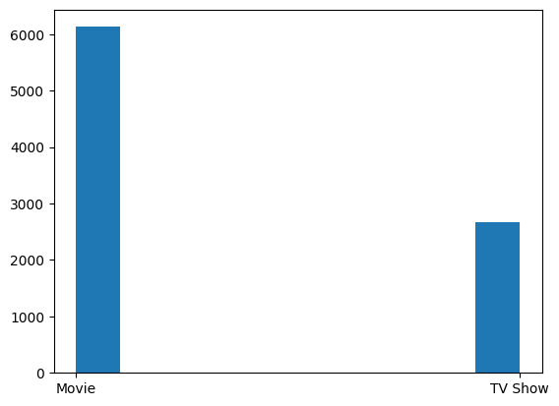

1. Then I used seaborn histplot for the purpose of knowing in which year the movies or tvshows has been released more. From this plot we may notice that in the year 2017,2018,2019 there had been more releases compared to other years.

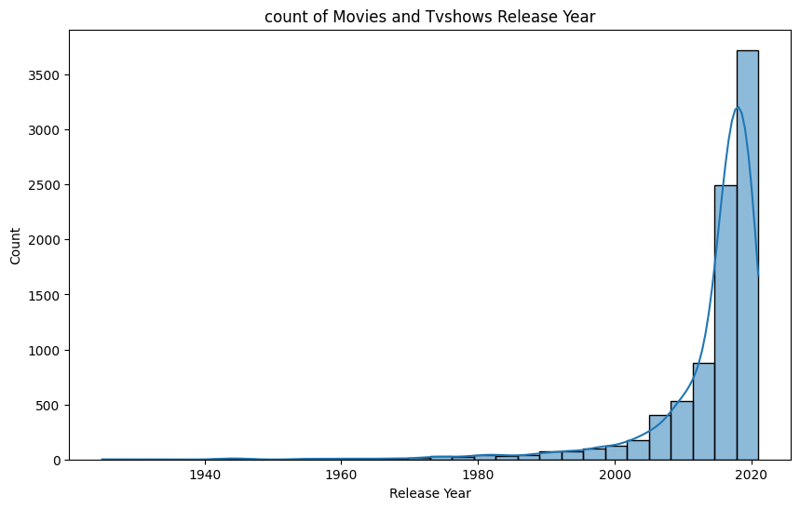

1. After that I used mode function to fill the missing values of the ‘rating’ column. Then I grouped the rating and type column to the release year to get the which rating has more count. Then I plotted an histogram to visualise it.

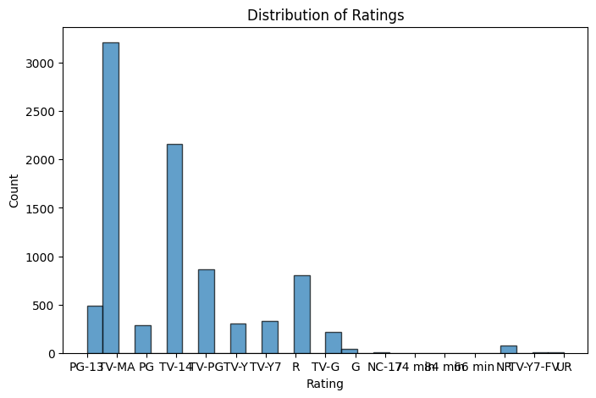

1. At last I filled the missing values of the country column with unknown and I used barplot to visualise the top 10 countries which has more releases of movies or tv shows.

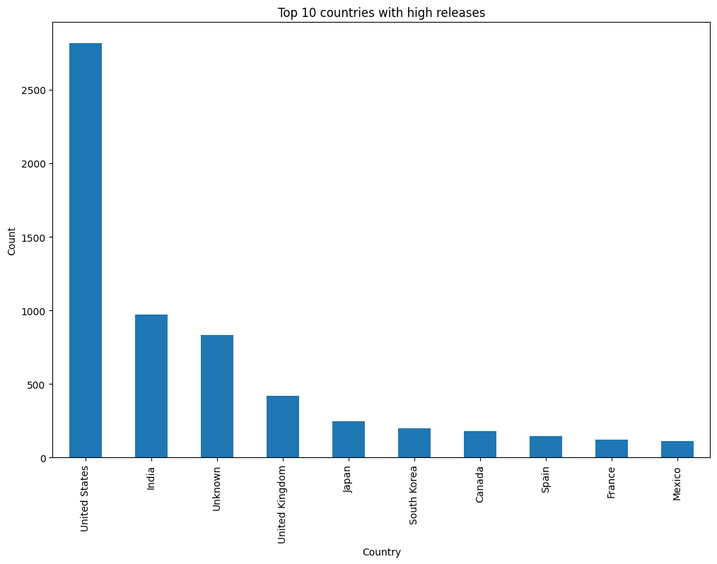

1. Finally I had an overall insight of amazon prime dataset from this i found that the United states has released more movies or tv shows so it shows that the people in us are more interested in watching movies and tv shows, and then people have started watching movies or tv shows more in the year of 2017 which shows that amazon prime has been used by many people in that year.