**Report of the analysis**

1. Firstly , this analysis is based on the video games dataset. In this we have various details of the games that has been released since the by many gaming companies like Electronic Arts , Nintendoe, etc.
2. I have used colab for getting the insights of the dataset and the columns which I have used for my analysis are ‘game title’, ‘review’, ‘country’, ‘publisher’, ‘global’, etc.
3. The first step is importing the necessary libraries such as Pandas, Seaborn, Matplotlib.
4. Then I have doen some data preprocessing steps like head(), info(), isnull().sum(), shape, columns.
5. After that I had found some of the columns have missing values in them ,so I started to impute the missing values with the fillna() function.
6. The ‘Publisher’ column has 2 missing values so I filled it as ‘Unknown’. Then the ‘Year’ column has 29 missing values so I imputed it with mode function. Then I used barplot to visualise the top publishers of games in the world.

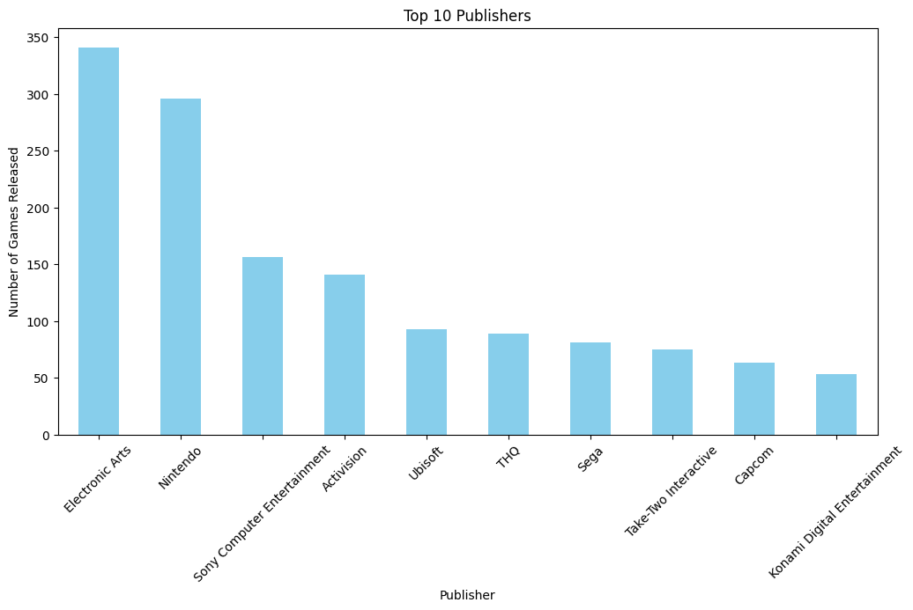

1. Then I countplot for the purpose of knowing which genre of games have been mostly played by the gamers. From the plot it was found that gamers paly sports genre games more.

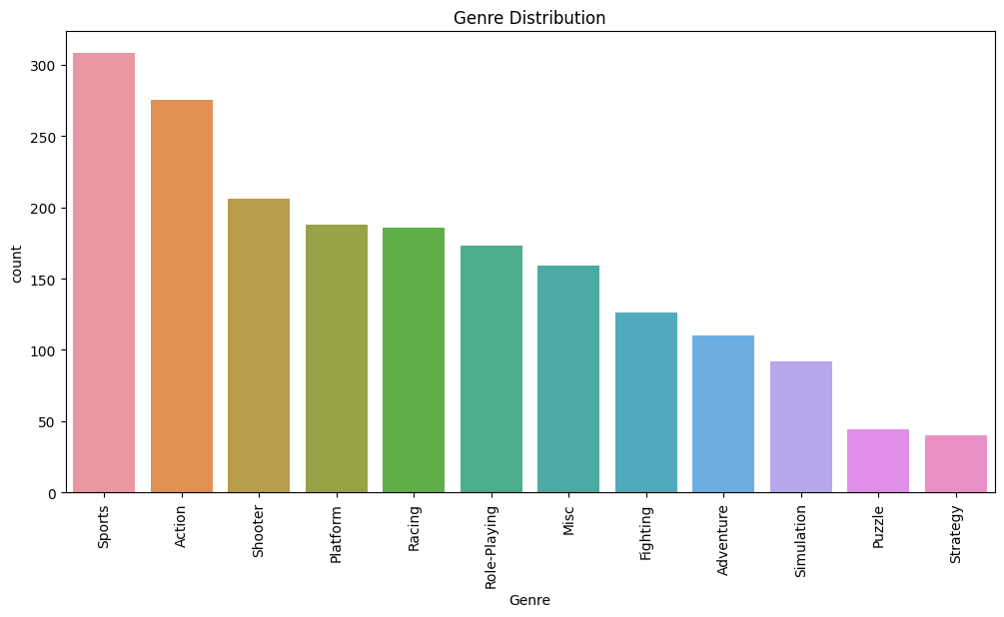

1. Then I visualised the sales report of the games in various regions like North America, Japan, Europe, etc. An it showed that North America has more no.of than the rest of the world. And I found the which game has sold more.

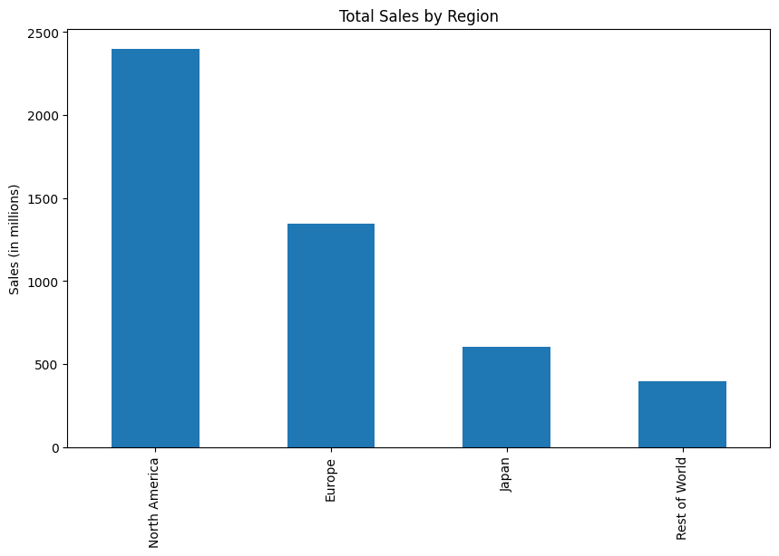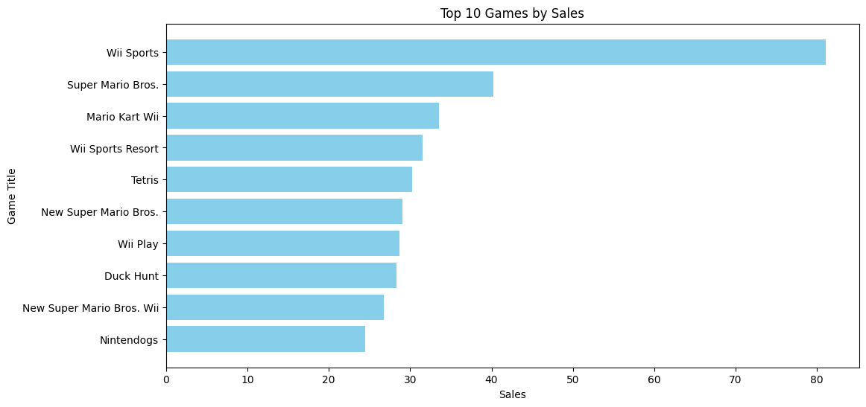

1. And I used horizontal barplot to see which game has the highest review and then i visualised the most used gaming platform.

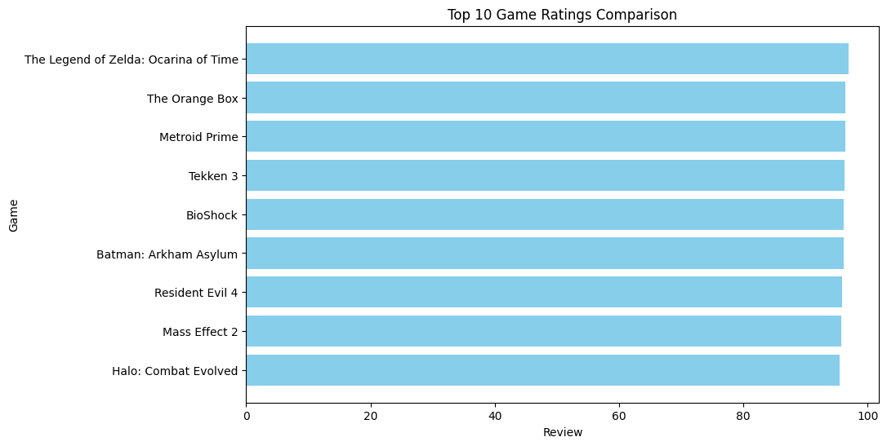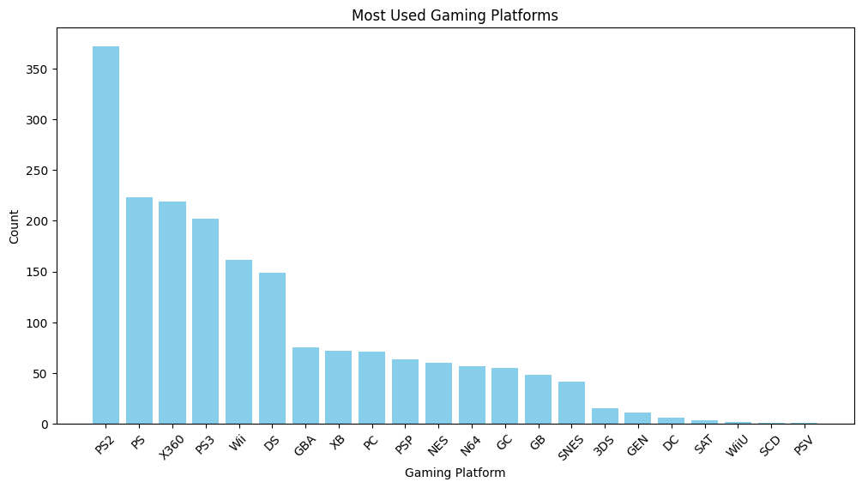

1. Finally I had an overall insight of the game dataset and it is found that ‘wii sports’ game has the highest sales record than others. And by the analysis I found that North America has more gaming sales and Ps2 is the most played gaming platform and Electronic Arts is the highest game publishers.