Request for Services (RFS)

Project: | VoIP Gateway Design Evaluation
Creation Date: | 2015-11-18
Last Revision Date: | 2016-11-13
Version: | 1.2
Status: | Proprietary and Confidential

Table of Contents

1 Introduction and Background 3
1.1 Purpose 3
1.2 Administrative 5
1.2.1 TECHNICAL CONTACT 5
1.2.2 CONTRACTUAL CONTACT 5
1.3 DUE DATES 5
1.4 SCHEDULE OF EVENTS 6
1.5 Reference Documents 6
1.6 Scope 6
2 Guidelines for Report Preparation 7
2.1 REPORT SUBMISSION 7
3 DETAILED PATTON PRODUCT REQUIREMENTS 8
3.1 SCHEDULE 8
3.2 BUDGET 8
3.3 PERFORMANCE (FEATURES) 8
4 EVALUATION FACTORS 10
4.1 CRITERIA 10
5 SCOPE OF WORK 11
5.1 EVALUTION 11
5.2 DELIVERABLES 11
6 Acronyms and Definitions 12

Introduction and Background

Purpose
Patton is all about connections. It is our joy and mission to connect real-world customer challenges with high-quality, right-priced solutions—complemented by unrivaled customer service and technical support. Incorporated in 1984, Patton has built everything from micro-sized widgets that connect "this-with-that," to carrier-grade Telecom gear that connects subscribers to service providers. Patton's specialty is interconnecting legacy TDM and serial systems with new-generation IP-based voice, data, and multimedia technologies.
Headquartered in Gaithersburg, Maryland, USA, Patton equipment—including VoIP, Ethernet extension, and high availability router technologies—is up-and-running in carrier, enterprise and industrial networks worldwide. Patton works in connection with a growing network of technology, business, and sales-channel partners. To connect with local-market requirements, Patton operates training and support centers in Switzerland, Hungary, Lebanon, India, Vietnam, and the USA. | Patton... Let's Connect!

Patton requires hardware development services in support of a new product development. Specifically, the company requires embedded system design evaluation for the proposed e911 IP-PBX VoIP Gateway. Implementation of pre-production prototypes is a desirable follow-on contract. The scope of the work required includes evaluation, and testing of the proposed embedded system platforms.

In particular, Patton wants a result better than the competitive product pictured here, making reuse of the product shown in the next picture:

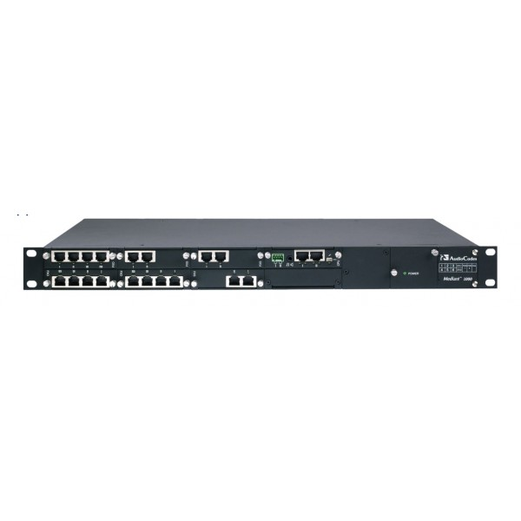

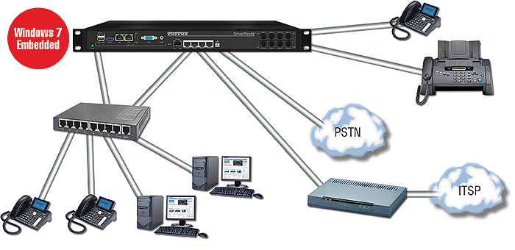

Administrative

TECHNICAL CONTACT

Any questions concerning technical specifications or Statement of Work (SOW) requirements must be directed to:

Name | Arundhathi Swami
Address | 1111 Engineering Drive, Boulder CO, 80309
Phone | NA
FAX | NA (are you kidding?)
Email | Arundhathi.swami@colorado.edu

Name | Shalin Shah
Address | 1111 Engineering Drive, Boulder CO, 80309
Phone | TBD
FAX | NA
Email | Shalin.shah@colorado.edu

CONTRACTUAL CONTACT

Any questions regarding contractual terms and working conditions or report format must be directed to:

Name | Tim Scherr
Address | 1B67, 1111 Engineering Drive, Boulder CO, 80309
Phone | 3037357633
FAX | NA
Email | Timothy.scherr@Colorado.edu

DUE DATES
All Reports are due by 11:59 pm MST on 2017/12/13. Any Report received at the designated location after the required time and date specified for receipt shall be considered late and receive a 10% per day penalty. Any late reports will not be evaluated for the Top Prize.

SCHEDULE OF EVENTS

Event | Date
1. RFS Distribution to Vendors | 2017/11/13
2. Platform Evaluation begins | 2017/11/13
3. Questions from Vendors about scope or approach due | 2017/11/17
4. Approximate Completion of Module 1 | 2017/11/17
5. Approximate Completion of Module 2 | 2017/11/29
6. Approximate Completion of Module 3 | 2017/12/04
7. Approximate Completion of Module 4 | 2017/12/10
8. Report and Deliverables Due Date | 2017/12/13
9. Awarding of Prizes | 2017/12/15

Reference Documents
- Project 3 Guide, which describes the 4 Test Modules to be completed.
- TI AM3358 Datasheet.
- TI AM3358 Reference Manual.
- BeagleBone Black Quick-Start Guide (external link)
- BeagleBone Black System Reference Manual (external link)
- BBB_WinCE_Platform Support.docx
- Windows Embedded Compact 7 Evaluation Edition.docx
- Others, yet to be determined.

Scope
The scope of this document concerns the requirements for the Patton e911 IP-PBX VoIP Gateway product and work to evaluate a potential MPU to meet those requirements. It describes the product function, criteria for evaluating the performance of the product, and performance requirements to guide the evaluation work. It does not describe how the design is to be done, only what the outcome should be. The work required is limited to evaluation of potential solutions to the embedded system implementation for the product.

Guidelines for Report Preparation

REPORT SUBMISSION
Award of the Top Prize resulting from this RFS will be based upon the most responsive Vendor whose evaluation results will be the most advantageous to Patton in terms of cost, functionality, and other factors as specified elsewhere in this RFS.

Vendor's Report shall be submitted in several parts as set forth below. The Vendor will confine its submission to those matters sufficient to define its Report and to provide an adequate basis for Patton’s evaluation of the Vendor’s Report. In no case should the report exceed 5 pages long.

Vendor’s Report(s) in response to this RFS must include a system block diagram and links to code, images and diagrams. We recommend storage of these items in a GIT repository. The submitted Reports are suggested to include each of the following sections:

- Executive Summary
- Problem Statement and Objectives
- Approach and Methodology for Evaluation
- Module Test Results
- List of Project Deliverables
- Recommendations
- Appendix: References
- Appendix: Project Team Staffing

The detailed requirements for each of the above-mentioned sections are outlined below.

DETAILED PATTON PRODUCT REQUIREMENTS

SCHEDULE
This product must be developed within the next 18 months, ready for market. It is an evolution of existing products.

BUDGET
Budget for the embedded system is not to exceed $50 in production. This includes the PCB and connectors. Cost for the MPU should not be greater than $15.

PERFORMANCE (FEATURES)

Capacity**
• 64 calls with Transcoding
• 128 calls with RTP Relay
• 20 cps
Gateway Capacity
Up to 120 (PRI), 16 (BRI), 8
(FXS) simultaneous VoIP or T.38
fax calls (depending on the
model).
BRI Voice Connectivity
• 2/4/8 BRI So ports, RJ-45
• Built-in line power on each
port (total 4W)
• DSS1, Q.921, Q.931. NTT-64
FXS/FXO Voice
Connectivity
• Up to 4 FXS and FXO ports
• 2-wire Loopstart on RJ-
11/12
• Caller-ID FSK and
ITUV.23/Bell 202 generation
• FSK & stuttering dial tone
MWI
PRI Voice Connectivity
• 1 or 4 T1/E1 PRI port(s)
(NT/TE)
• Signaling support (ISDN
DSS-1, NI-2, Q.SIG, CAS
Robbed bit loop and ground
start, E&M, immediate, wink,
double wink)
• ISDN speech, audio & data
(Fax Gr 4, UDI 64, RDI64)
• CAS protocols: RBS (Loop
start, ground start, E&M
wink, intermediate, doublewink)
and R2/MFC-R2
(Q.400–Q.490 and
Configurable country profiles)
LAN/WAN Connectivity
• 2 x 10/100/1000 TX Ethernet
ports or 4 x 10/100Base-T
Ethernet ports (depending
on the model)
• Auto-MDI-X • DHCP Client
• PPPoE Client (multi-session)
Voice Processing
• Codec G.711 a-law/mu-law,
G.723, G.729ab, G.726,
G727, T.38 fax relay (9.6 k,
14.4 k)
• G.711 transparent fax and
bypass
Call Routing and Services
• Regular expression call routing
and manipulation
• Number blocking
• Short-dialing
• Digit collection, distribution
and hunt groups
IP Quality of Service
• Voice priority
• Traffic management
• IEEE 802.1p, TOS, DiffServ
labeling
• IEEE 802.1Q, VLAN tag
insertion/deletion 4,096
Management
• Web/HTTP, CLI with local
console & remote Telnet
access
• TFTP configuration &
firmware loading
• Built-in diagnostic tools
(trace, debug, call generator)
Processor?
Memory
• DDR2 RAM 1GB
• 250 GB HDD
Ethernet
2 10/100/1000 Ethernet Ports
External Power Supply
12 VDC, 8.5 A (102 W max)
Operating Environment
• Operating Temperature: 32
to 104° F (0 to 40°C)
• Operating Humidity: up to
90%, non-condensing
Dimensions
• 19W x 1.7H x 12D in.
(48.3W x 4.4H x 30.5L cm)
• Rack mountable chassis
Compliance
• EMC: EN55022 and EN5502
• Safety: EN 60950
• CE
• FCC Part 15 Class A; Part

Inputs:
- 1 switch
- 1 T1/E1 PRI Port (RJ45)
- 4 10/100 Ethernet Ports (RJ45)
- 2 USB 2.0

Outputs
- 1 LED
- VGA display
- HDMI
- 8 BRI ports for up to 4 FXS and 4 FXO lines
- Audio out
- 2 10/100 Ethernet Diagnostic Ports (RJ45)

Processing Requirement
Estimated 500 DMIPs, 1000 MMACs

Power: 12VDC input.

EVALUATION FACTORS

CRITERIA
Any award to be made pursuant to this RFS will be based upon the proposal with appropriate consideration given to technical, spelling, grammar, and management requirements. Evaluation of projects will be based upon the Vendor’s responsiveness to the RFS. The following elements will be the primary considerations in evaluating all submitted Reports and in the selection of a Vendor or Vendors for Top Prizes:

30% Technical Report
10% Executive Summary
10% Recommendations
10% Peer Review
10% Deliverables for each Project Module (4 total possible)

SCOPE OF WORK

EVALUTION
At a minimum, the work to be performed includes:
- Evaluate the hardware and software capabilities of the TI Sitara AM3358 MPU by using the BeagleBone Black platform to perform a series of tests and also by design calculations.
- Draw a block diagram showing the inputs, processor, and outputs for this device.
- Evaluate software performance by completion of the 4 assigned modules. See the Project 3 Guide for details. In particular, Patton wants a comparison of the WinCE 7, WinCE2013, Debian Embedded Linux and Angstrom Embedded Linux for this purpose. Compatibility with the Asterisk IP-PBX stack is desired. If after the software evaluation, a better processor choice is available, please recommend it.
- Evaluate hardware suitability by suggesting possible I/O interfaces including, 1 T1/E1 PRI Port, 6 10/100 Ethernet Ports, 2 USB 2.0, VGA, HDMI, 8 BRI telephone ports, Audio out, and LED drivers and calculating required I/O current drive and voltage levels for the processor I/O.
- Produce a Technical Report showing results of the evaluation.
- Provide recommendations for circuit design and MPU selection.

DELIVERABLES
At the conclusion of the project, PATTON requires written documentation of the approach, findings, and recommendations associated with this project to be delivered to the contracting agent through D2L. An informal presentation of the findings and recommendations to senior management may also be required as part of a peer evaluation. The documentation should consist of the following:

1 DETAILED TECHNICAL REPORT
A document developed for the use of PATTON’s technical staff which discusses: the evaluation methodology employed, detailed technical findings, and recommendations as indicated in section 2 of this document.

2 EXECUTIVE SUMMARY REPORT
A document developed to summarize the scope, approach, findings and recommendations, in a manner suitable for senior management (3 paragraphs or less).

3 SOFTWARE DESIGN FILES AND DOCUMENTATION
Deliverables should include
- All drawings, images, and design documents in Word or PDF electronic
- Source code in zip format
- Test Data and Screenshots

Acronyms and Definitions

Item | Description
ATP | Acceptance Test Plan
ADC | Analog to Digital Converter
DAC | Digital to Analog Converter
LED | Light Emitting Diode
PWM | Pulse Width Modulation
RFS | Request For Services

