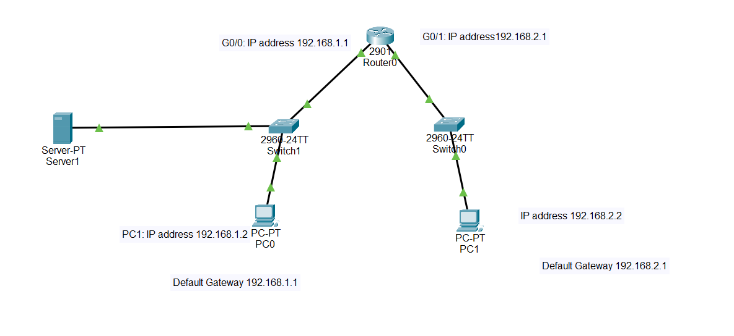

Exp: 2: Execute the following networking commands like **ipconfig, tracert, telnet, ping, nslookup and netstat** in the command prompt with simple topology.

step-by-step guide to opening Cisco Packet Tracer and executing the commands in a simple topology:

**Step 1: Launch Cisco Packet Tracer**:

* Double-click the Cisco Packet Tracer icon on your desktop or find it in your applications list to open the program.

**Step 2: Create a Simple Network Topology**

1. **Add Devices**:
   * **Routers and Switches**: Drag and drop a router and a switch from the device list onto the workspace.
   * **PCs**: Drag and drop two PCs onto the workspace.
2. **Connect Devices**:
   * Use the **Connection** tool to connect the devices:
     + Connect one PC to the switch using a copper straight-through cable.
     + Connect the switch to the router using another copper straight-through cable.
     + Connect the second PC to the switch using a copper straight-through cable.

**Step 3: Configure Devices**

1. **Configure the Router**:
   * Click on the router.
   * Go to the **Config** tab.
   * Assign IP addresses to the router interfaces.
   * Example:
     + Interface G0/0: IP address 192.168.1.1, Subnet Mask 255.255.255.0
     + Interface G0/1: IP address 192.168.2.1, Subnet Mask 255.255.255.0
2. **Configure the PCs**:
   * Click on each PC.
   * Go to the **Desktop** tab and then **IP Configuration**.
   * Assign IP addresses to each PC.
   * Example:
     + PC0: IP address 192.168.1.2, Subnet Mask 255.255.255.0, Default Gateway 192.168.1.1
     + PC1: IP address 192.168.2.2, Subnet Mask 255.255.255.0, Default Gateway 192.168.2.1

**Step 4: Execute Networking Commands**

1. **Open Command Prompt on a PC0**:
   * Click on a PC0.
   * Go to the **Desktop** tab and open the **Command Prompt**.
   1. **ipconfig**:

This command displays all current TCP/IP network configuration values and refreshes DHCP and DNS settings.

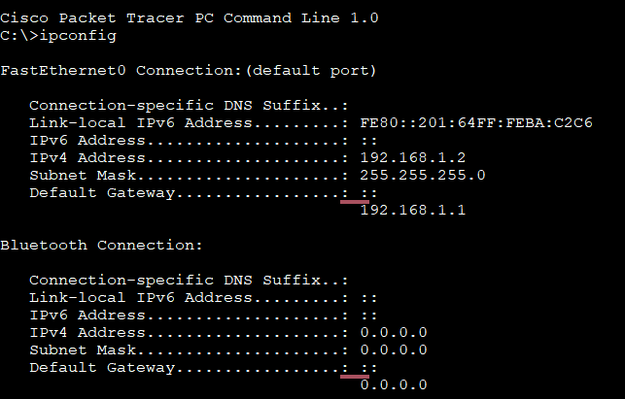

* 1. **tracert**:

This command traces the path taken to a destination by sending ICMP Echo Request messages.

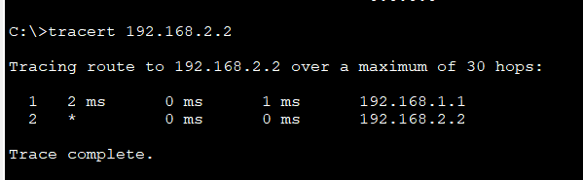

* 1. **telnet**:

This command is used for interactive communication with another host using the Telnet protocol.

telnet <destination IP> <port>

#### Configure the Router

1. **Assign IP Address**:
   * Click on the router.
   * Go to the **Config** tab.
   * Select the interface connected to the switch (e.g., G0/0).
   * Assign IP address: 192.168.1.1, Subnet Mask: 255.255.255.0

Router>enable

Router>configure terminal

Router(config-if)#line vty 0 4

Router(config-line)#password cisco

Router(config-line)#login

Router(config-line)#exit

Router(config)#end

Router#

%SYS-5-CONFIG_I: Configured from console by console

Router#write memory

Building configuration...

[OK]

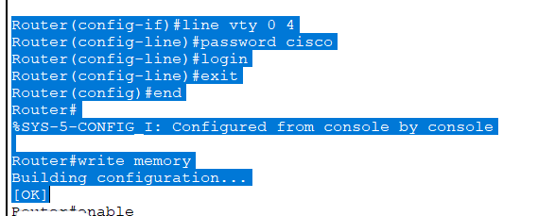

#### Telnet from PC to Router

1. **Open Command Prompt**:
   * On the PC0, go to the **Desktop** tab and open the **Command Prompt**.
2. **Execute Telnet Command**:

**telnet <destination IP> <port>**

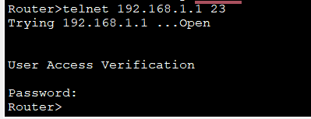

• **Telnet Security**: Telnet is an unencrypted protocol and is not secure. For real-world applications, consider using SSH for secure remote connections.

• **Enabling Telnet on a Real Router**: If using real equipment, make sure Telnet is enabled and the device is configured to accept Telnet connections.

* 1. Router configuration and Brief Ip Interface

This command is a scripting utility that allows you to display or modify the network configuration of a computer.

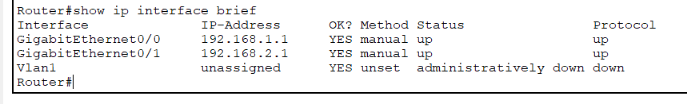

* 1. **Ping 192.168.2.2**

**ICMP Echo**

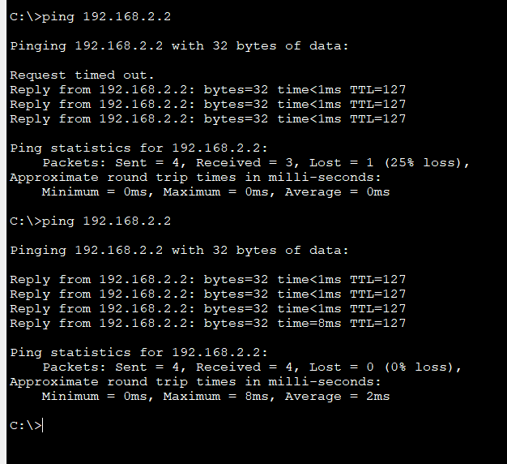

* 1. **nslookup**

**nslookup** [**www.google.com**](http://www.google.com)

• This command queries the DNS to obtain domain name or IP address mapping.

To use the nslookup command to resolve a domain name to an IP address in Cisco Packet Tracer, you'll need to ensure that the DNS server is properly configured in your network topology.

1. Add one server (to act as a DNS server).
2. Connect both PCs and the server to the switch using copper straight-through cables.

#### Configure the DNS Server

1. **Assign IP Address**:
   * Click on the server.
   * Go to the **Config** tab and select the **FastEthernet0** interface.
   * Assign IP address: 192.168.1.3, Subnet Mask: 255.255.255.0, Default Gateway: 192.168.1.1.

**Configure DNS Service**:

* Go to the **Services** tab on the server.
* Select **DNS** and turn the service **On**.
* Add an entry for www.google.com with an IP address (e.g., 8.8.8.8).

#### Use the nslookup Command

1. **Open Command Prompt on PC0**:
   * Go to the **Desktop** tab on PC0.
   * Open the **Command Prompt**.
2. **Execute the nslookup Command**:

**nslookup www.google.com**

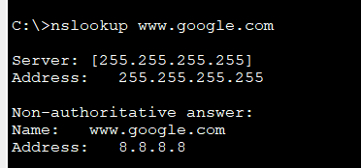

This indicates that the PC successfully queried the DNS server and resolved the domain name www.google.com to the IP address 8.8.8.8.

• **DNS Server Configuration**: Ensure that the DNS server is correctly configured and running.

• **DNS Entries**: The DNS entry for www.google.com should be added to the DNS server with an IP address.

• **Network Configuration**: Ensure that all devices are correctly connected and configured with appropriate IP addresses, subnet masks, and default gateways.



* 1. Netstat

This command displays network connections for the Transmission Control Protocol (TCP), routing tables, and a number of network interface and network protocol statistics.

The netstat command is used to display network connections, routing tables, interface statistics, masquerade connections, and multicast memberships.