**3. Python Program to count even and odd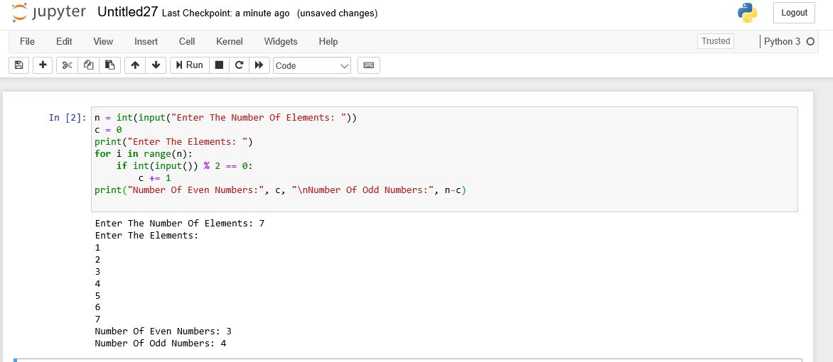 numbers.**

**4. Python program to reverse a string using recursion**

