1. Create an index which will be used by this query and provide proof (from explain() or Compass UI) that the index is indeed used by the winning plan: db.restaurants.find({ name: "Glorious Food" })



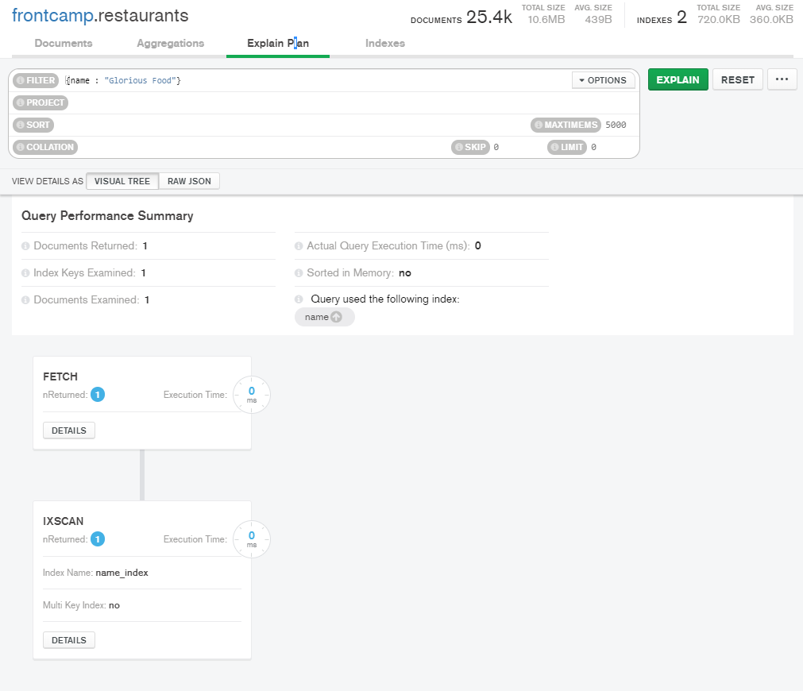

1. Drop index from task 1

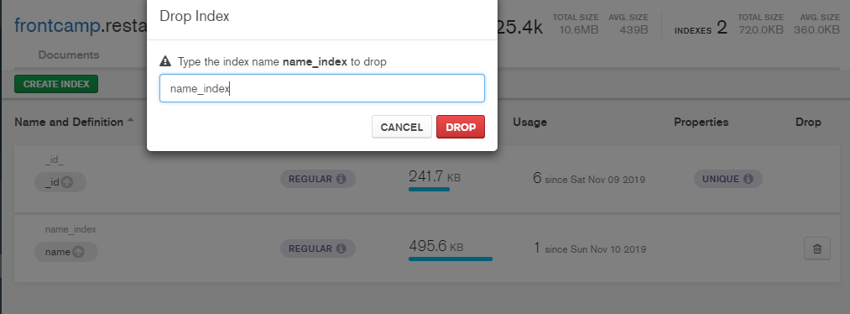

1. Create an index to make this query covered and provide proof (from explain() or Compass UI) that it is indeed covered: db.restaurants.find({ restaurant_id: "41098650" }, { _id: 0, borough: 1 })



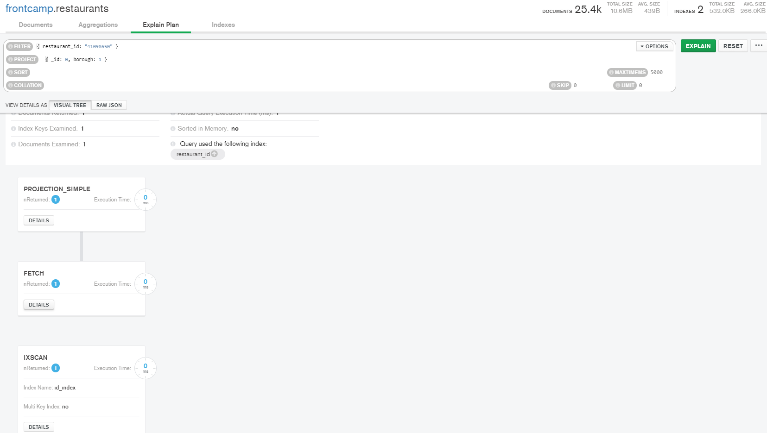

1. Create a partial index on cuisine field which will be used only when filtering on borough equal to “Staten Island”: db.restaurants.find({ borough: "Staten Island", cuisine: "American" }) – uses index db.restaurants.find({ borough: "Staten Island", name: "Bagel Land" }) – does not use index db.restaurants.find({ borough: "Queens", cuisine: "Pizza" }) – does not use index

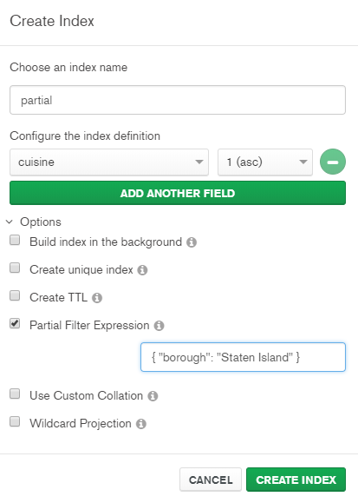

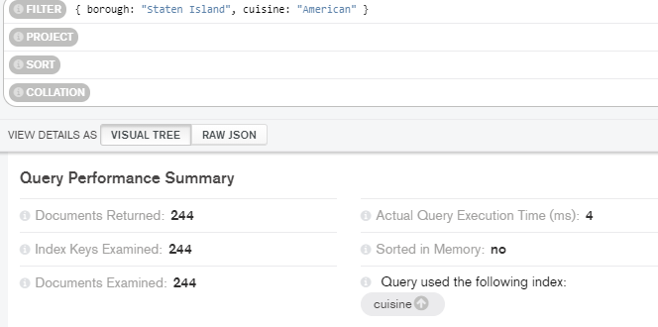

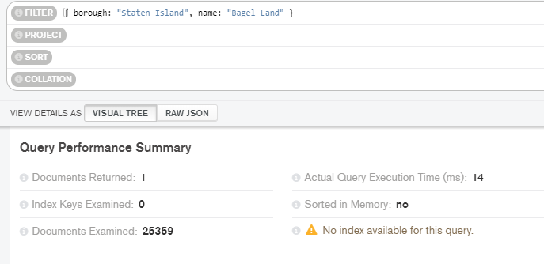

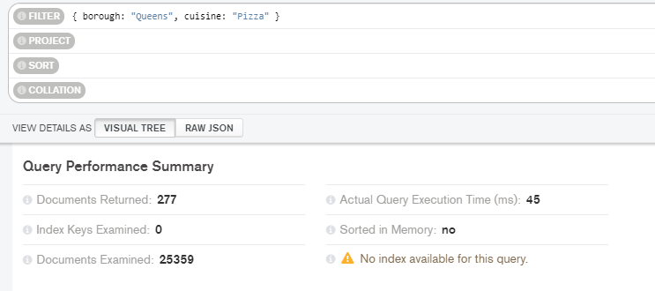

1. Create an index to make query from task 3.4 covered and provide proof (from explain() or Compass UI) that it is indeed covered

What are the names of the restaurants which have a grade at index 8 with score less then 7? Use projection to include only names without _id.



