Ширина макета: 1280px

Цвета: 000000;

227dd3;

43a06d;

e25842;

5fc18b;

44a36f;

ffffff;

Надписи: Be sure you put your feet (OpenSans Regular) font-size: 49.39px ;

in the right place (OpenSans Bold) font-size: 49.35px ;

Enter your zip code (OpenSans Regular) font-size: 13.35px ;

This is Photoshop's version of Lorem Ipsum. (OpenSans Regular) font-size 15.35px ;

Press me (OpenSans Semibold) font-size 25.65px ;

Documents (OpenSans Semibold) font-size 27.35px ;

This is Photoshop's version of Lorem Ipsum. Proin gravida nibh vel velit auctor aliquet. Aenean sollicitudin (OpenSans Regular) font-size 14px ;

Photos (OpenSans Semibold) font-size 27.35px ;

This is Photoshop's version of Lorem Ipsum. Proin gravida nibh vel velit auctor aliquet. Aenean sollicitudin (OpenSans) font-size 14px ;

This is a Heading (OpenSans Semibold) font-size 39.35px ;

This is Photoshop's version of Lorem Ipsum. Proin gravida nibh vel velit auctor aliquet. Aenean sollicitudin, lorem quis bibendum auctor, nisi elit consequat ipsum, nec sagittis sem nibh id elit. Duis sed odio sit amet nibh vulputate cursus a sit amet mauris. (OpenSans Regular) font-size 14px ;

Morbi accumsan ipsum velit. Nam nec tellus a odio tincidunt auctor a ornare odio. Sed non mauris vitae erat consequat auctor eu in elit. Class aptent taciti sociosqu ad litora torquent per conubia nostra, per inceptos himenaeos. Mauris in erat justo. Nullam ac urna eu felis dapibus condimentum sit amet a augue. Sed non neque elit. Sed ut imperdiet nisi. Proin condimentum fermentum nunc. Etiam pharetra, erat sed fermentum feugiat, velit mauris egestas quam, ut aliquam massa nisl quis neque. Suspendisse in orci enim. (OpenSans Regular) font-size 14px ;

This is a Heading (OpenSans Semibold) font-size 39.35px ;

Morbi accumsan ipsum velit. Nam nec tellus a odio tincidunt auctor a ornare odio. Sed non mauris vitae erat consequat auctor eu in elit. Class aptent taciti sociosqu ad litora torquent per conubia nostra, per inceptos himenaeos. Mauris in erat justo. Nullam ac urna eu felis dapibus condimentum sit amet a augue. Sed non neque elit. Sed ut imperdiet nisi. Proin condimentum fermentum nunc. Etiam pharetra, erat sed fermentum feugiat, velit mauris egestas quam, ut aliquam massa nisl quis neque. Suspendisse in orci enim. (OpenSans Regular) font-size 14px ;

Download (OpenSans Semibold) font-size 27.35px ;

Name (OpenSans Regular) font-size 14px ;

email address (OpenSans Regular) font-size 14px ;

Message (OpenSans Regular) font-size 14px ;

© Copyright 2013 Css Author, All Rights Reserved. (OpenSans Regular) font-size 14px ;

Шрифты: OpenSans Regular, OpenSans Semibold, font-size 27.35px.

Картинки (png, jpg, svg не выводиться, просто значек Edge)

1)Ширина 1280px, высота 800px.

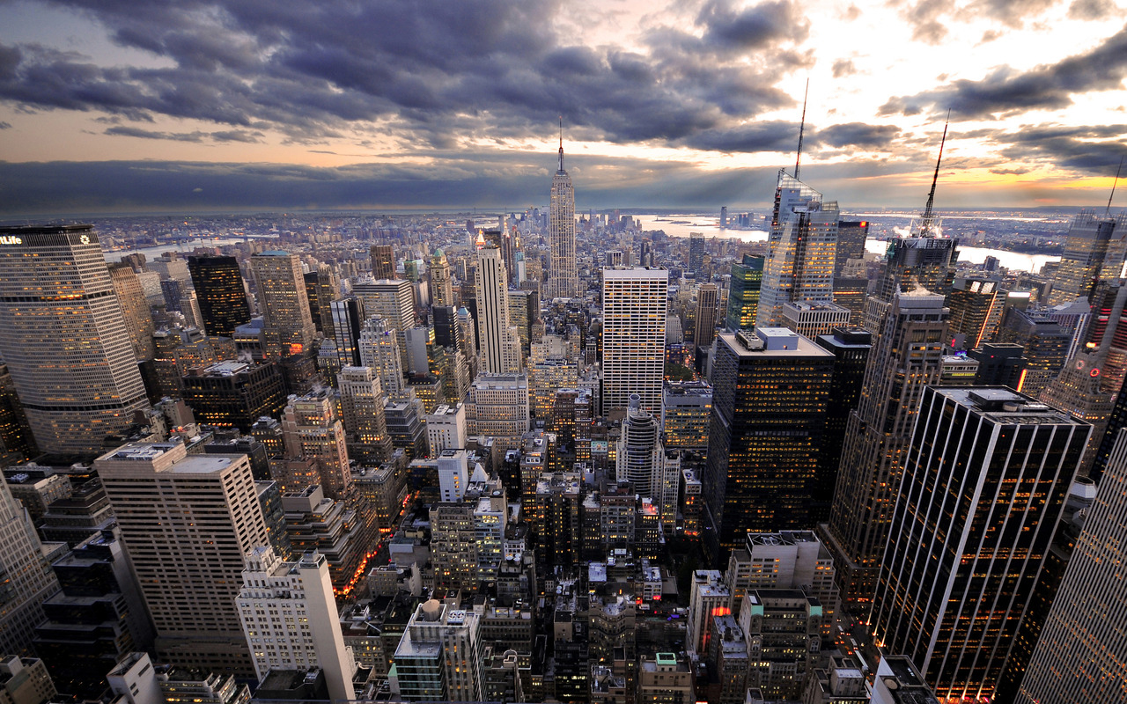

2)Градиент, ширина 1280px, высота 800px.



3)Ширина 335px, высота 87px.

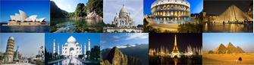

4)Ширина 1280px, высота 635px.

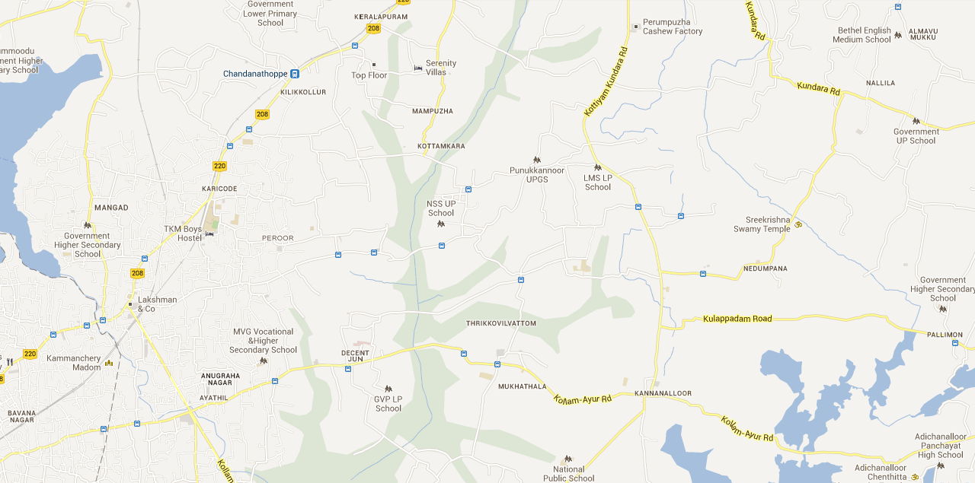

Выполнили: Андрей Клименко, Виталий Осадец, Ольга Неменша.