Using the “Keep with next” option to bind paragraphs together in Microsoft Word

Introduction
Documents are more visual and readable when relevant information is kept together on the same page. The “Keep with next” option allows users to organize the text so that some elements are always displayed together, without page breaks occurring between them.
For example, this feature may be used to ensure a topic heading and the first paragraph of the corresponding text are not separated by a page break. Similarly, it can be used to ensure that an entire numbered (or bulleted) list of items is displayed on the same page.
This article describes how to use the “Keep with next” option in Microsoft Word to bind together paragraphs located in various areas of the text, and provides several common use cases.

Keeping paragraphs together on page
The basic function of the “Keep with next” option is to connect a selected text paragraph to the next paragraph, prohibiting page breaks between them. This section describes how to access the “Keep with next” option in the Paragraph dialog box, and how to use “Keep with next” to bind together text located in text headings, text body, tables, bulleted lists, and images.

Opening the Paragraph dialog box
The “Keep with next” option is accessed in the Paragraph dialog box, which contains settings applied to the current paragraph. This dialog box can be opened from the Home tab, from the Layout tab or from the context menu that opens on right-click.
To open the Paragraph dialog box from the Home tab or from the Layout tab:
- Select the Home (or Layout) tab.
- In the lower right corner of the Paragraph group, click the Paragraph dialog box launcher icon, as shown below:
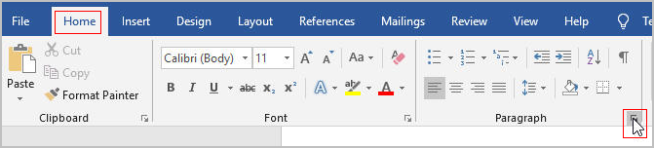
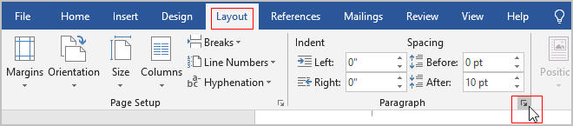
- When the Paragraph dialog box opens, make sure that the Lines and Page Breaks tab is selected. The “Keep with next” option is located in the Pagination block:
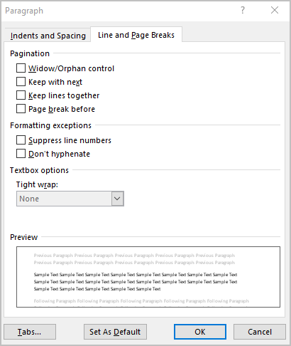
Alternatively, the Paragraph dialog box can be opened from the context menu. To open the Paragraph dialog box from the context menu, perform the following steps:
- Place the cursor over any part of the text located in the desired paragraph.
- Right-click and select Paragraph. The Paragraph dialog box will open.
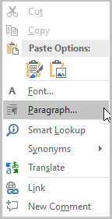

Using the “Keep with next” option to bind paragraphs
This section explains how to use “Keep with next” to bind paragraphs together, when the they are located in the following areas of the text:
- Keeping headings and related text paragraphs together
- Keeping paragraphs together in the main text body
- Keeping numbered or bulleted lists on the same page
- Keeping text paragraphs in table cells on the same page
- Keeping together images and caption text

Keeping headings and related text paragraphs together
Documents are more readable when a heading (or a subheading) and the first paragraph of the related text are located on the same page. To prevent page breaks between the heading and the first paragraph that follows it, perform the following steps:
- Right-click the heading, and select Paragraph. (Alternatively, any method of opening the Paragraph dialog box described in section 2.1 can be used).
- Select the Line and Page breaks tab.
- Select the “Keep with next” check box as shown in the picture below.
- Click OK.
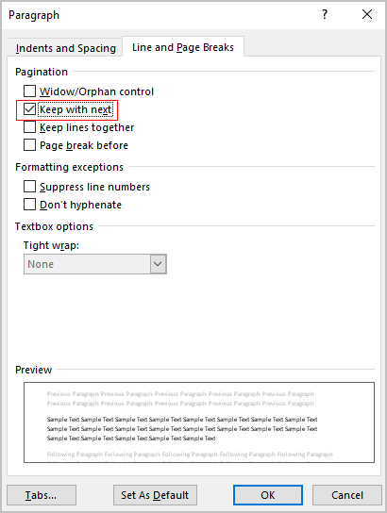
The heading followed by the first paragraph of the related text will now always be on the same page.

Keeping paragraphs together in the main text body
To keep contextually-related information together, users may need to keep adjacent text paragraphs on the same page, prohibiting page breaks between them. To keep two paragraphs in the text body on the same page:
- Right-click the leading paragraph, and select Paragraph. (Alternatively, users may utilize any method of opening the Paragraph dialog box described in section 2.1)
- Select the Line and Page breaks tab.
- Select the “Keep with next” check box.
- Click OK.
The leading paragraph and the first line of the next paragraph will now always be located on the same page.
Note: Selecting the “Keep with next” check box ensures that the last line of the leading paragraph and the first line of the next paragraph are displayed on the same page. However, this does not prohibit page breaks from occurring elsewhere within the first or the second paragraph. To keep both entire paragraphs as whole blocks of text on the same page, the user should also check the “Keep lines together” check box in the Paragraph dialog box for the leading paragraph, and likewise, open the Paragraph dialog box, and select “Keep lines together” for the following paragraph.

Keeping numbered or bulleted lists on the same page
Users may wish to display a numbered (or bulleted) list of items on the same page, without a page break between the list items. Since Microsoft Word treats each item in the list as a paragraph, users can apply the “Keep with next” option to the list items, enabling a particular group of list items or the entire list to be displayed on the same page.
To keep a numbered (or bulleted) list of items on the same page:
- Select the list (or the group of items in the list), as shown on the picture below and right-click to open the Paragraph dialog box (Alternatively, users may utilize any method of opening the Paragraph dialog box described in section 2.1)
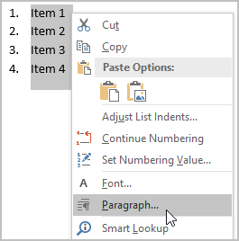
- Select the Line and Page breaks tab.
- Select the “Keep with next” check box.
- Click OK.
The selected list of items will now be always displayed on the same page without page breaks between them.

Keeping text paragraphs in table cells on the same page
Sometimes, users create large tables with cells that contain long blocks of text, consisting of several paragraphs. Such paragraphs may be displayed on different pages when a page break occur between them. This splits text in the table cell, making it less readable. To prevent page breaks from occurring in between two paragraphs in the cell of a table:
- In the table cell, click the leading paragraph.
- To open the Paragraph dialog box, click the Paragraph dialog box launcher icon in the lower right corner of the Home tab or in the Layout tab (see illustration in section 2.1).
- Select the Line and Page breaks tab.
- Select the “Keep with next” check box.
- Click OK.
The current paragraph and the first line of the next paragraph will now always be located on the same page.
Note: To keep both paragraphs in the table cell as whole blocks of text on the same page, users should also check the “Keep lines together” check box in the Paragraph dialog box for the leading paragraph, and likewise, open the Paragraph dialog box, and select “Keep lines together” for the following paragraph.

Keeping together images and caption text
When adding images to the document, a user often provides a caption containing explanatory text. The caption is a paragraph that follows the image, as shown in the example below:
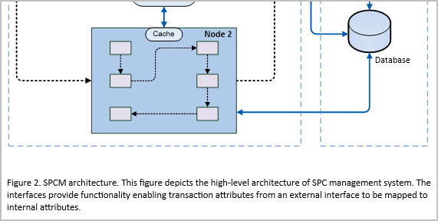
In this case, keeping the image on the same page with the following caption paragraph ensures proper connection between the image and the related text.
To prevent page breaks between the image and the caption paragraph that follows:
- Click the image to select it.
- To open the Paragraph dialog box, click the Paragraph dialog box launcher icon in the lower right corner of the Home tab or in the Layout tab (see illustration in section 2.1).
- In the Paragraph dialog box, select the Line and Page breaks tab.
- Select the “Keep with next” check box.
- Click OK.
The image and the first line of the related paragraph that follows will always be kept on the same page.

Conclusion
Keeping related information together is a common formatting task. The “Keep with next” option in Microsoft Word enables users to keep paragraphs, containing related information, on the same page (without being separated by page breaks). The “Keep with next” option can be applied to paragraphs located in various areas of the document, such as headings, text body, lists, tables and so on. By using the “Keep with next” option, users can make sure that the formatted text elements and blocks are visual, readable, and compact.
Author’s note:
If I did not need to comply with the ToR for this article, I would use second person narration when referring to a task purpose. For example, instead of using the word “users”, I would use “you”: “You may wish to display the numbered (or bulleted) list of items on the same page”.

