
PROJECT SPY

1. Create the project in the workspace.
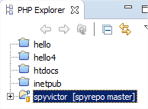

2. Track the project with Git. Right bottom -> Team -> Share Project.
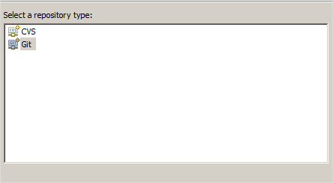

3. Creat a new repo in git folder.

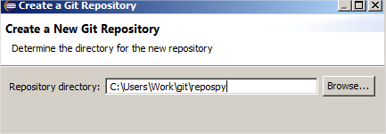

4. Create and start typing a Html file. This file will have five links to five diferent pages.

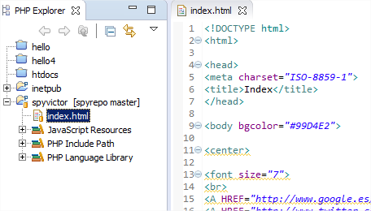

4.1. We need a remote repo in GitHub. If we don't have we need to create.
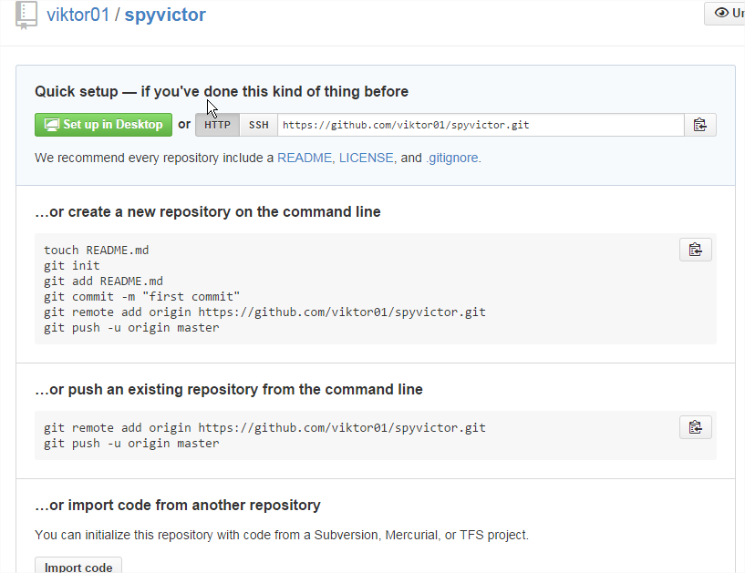

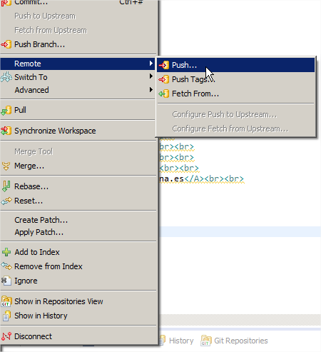
5. Then, do commit and push to the remote repo.

5.1. You have to configure the settings to push the repo and finish.
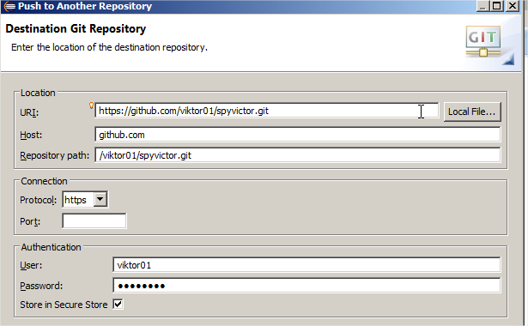

5.2. We can see our project in Github:

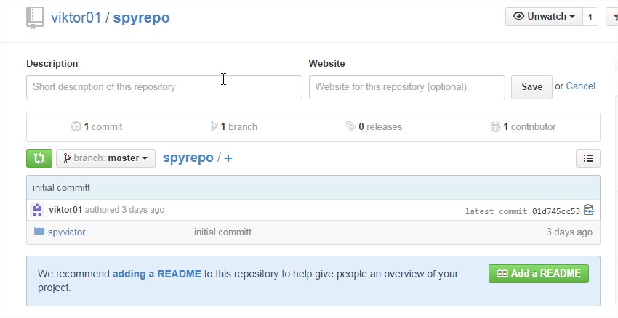

6. So, now we have to pull the project of our partner to own pc.
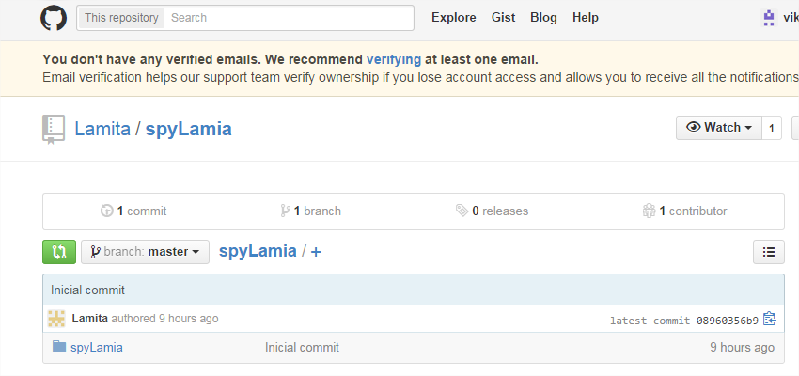

6.1. Click in ''FORK'' to clone the project.

6.2. Now open Eclipse, ''File -> Import...'', Choose ''Projects from Git:
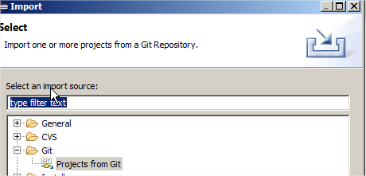
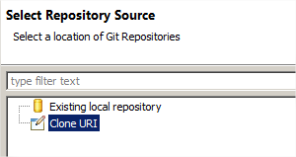
6.3. Click in ''Clone URL'' , configure it and click in finish.

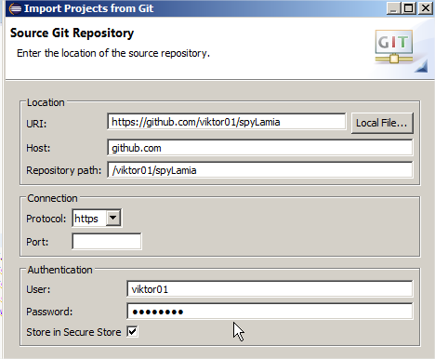
6.4. Now i have the project of my partner Lamia in my pc!
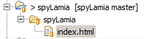

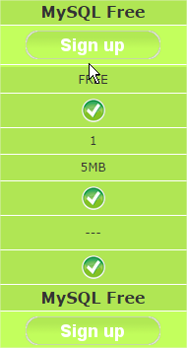
7. We gonna create the DB. In freesqldatabase.com.

7.1 Go to ''Control panel'' and click in ''Start New database''
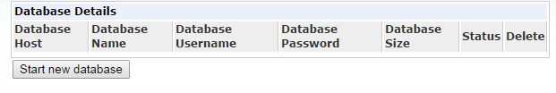

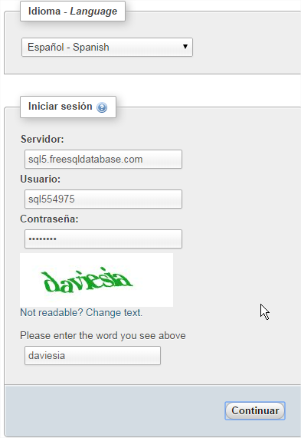
7.2. Connecting to DB.

7.3. Create de table:

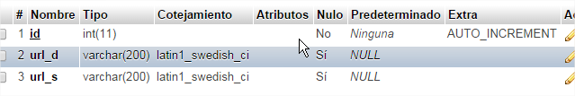

8. Type php code:

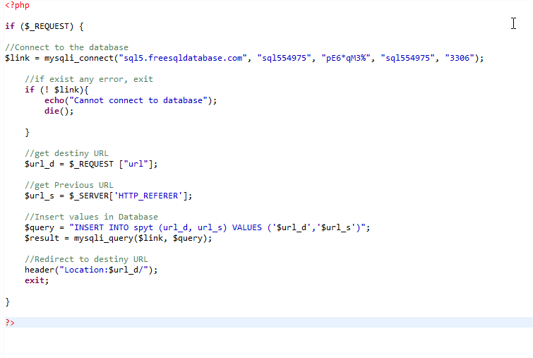
9. Now when we click in any link of our web, the html file do a redirection to php file, and php file send the information to the database:

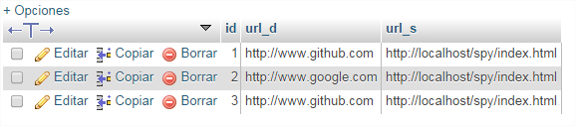
9.1 My project in hostinger:

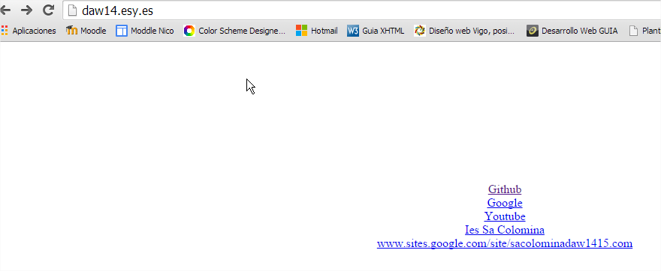

10. For finish, we go to do a pull request to lamia.

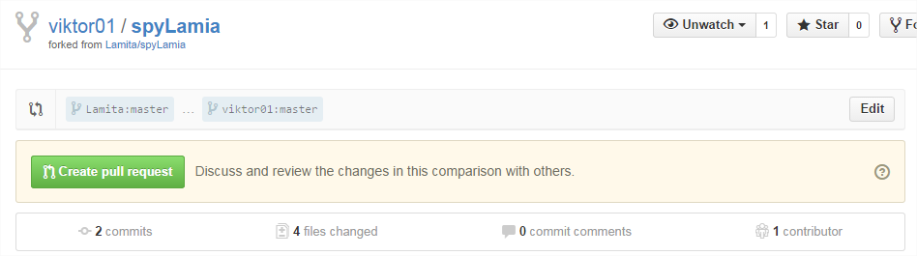

Pull request accepted!
