🍰 Sweet Treat Shop – Power Platform Project

1. **Project Overview**

This project is a simulation of a small bakery business called *Sweet Treat Shop*. It uses Power Platform tools (Power Apps, Power Automate, Power BI, SharePoint) to manage product orders, track ingredient inventory, send automated alerts, and visualize business performance.  
  
**2. Used Tools**

|  |  |  |  |  |  |  |  |
| --- | --- | --- | --- | --- | --- | --- | --- |
| |  |  |  | | --- | --- | --- | | SharePoint | |  | |  | |  | |  | | Backend for storing orders and inventory |
| Power Apps | Frontend app for placing orders |
| Power Automate | Alerts for low ingredient stock |
| Power BI | Visualizations of sales, products, and performance insights |

3. **SharePoint Lists**

**Home  
Obrázok, na ktorom je text, snímka obrazovky, jedlo

Obsah vygenerovaný pomocou AI môže byť nesprávny.**

Coundown to new flavour, banner, lists..

a) Orders list  
Obrázok, na ktorom je text, snímka obrazovky, jedálny lístok, dokument

Obsah vygenerovaný pomocou AI môže byť nesprávny.

Obrázok, na ktorom je text, snímka obrazovky, ovocie, jedlo

Obsah vygenerovaný pomocou AI môže byť nesprávny.b) Products

c) Inventory

Obrázok, na ktorom je text, snímka obrazovky, číslo, písmo

Obsah vygenerovaný pomocou AI môže byť nesprávny.

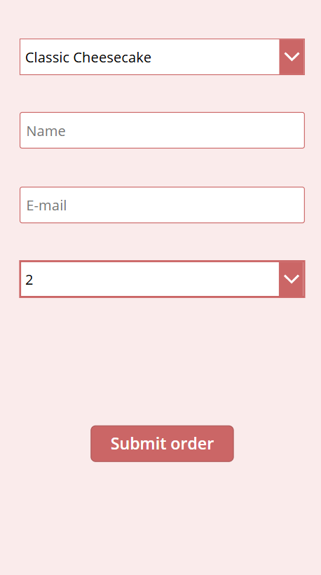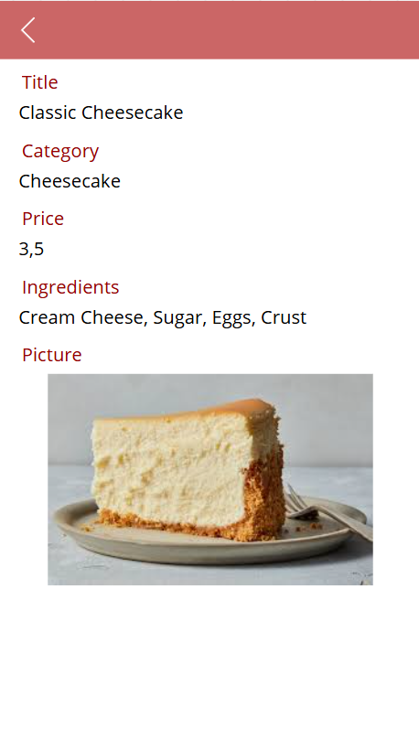Obrázok, na ktorom je text, snímka obrazovky, jedálny lístok, jedlo

Obsah vygenerovaný pomocou AI môže byť nesprávny.Obrázok, na ktorom je text, dezert, jedlo, sladkosť

Obsah vygenerovaný pomocou AI môže byť nesprávny.4. **Power Apps**

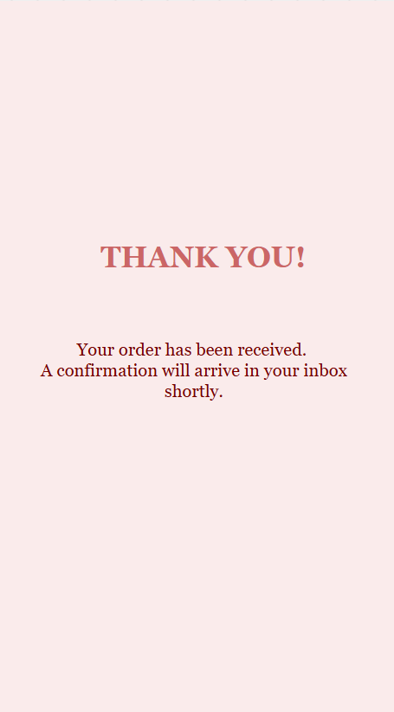

Simple costumer facing app, to see products, price, ingredients. Customer from the dropdown will choose product, put in the name, email for order confirmation and quantity. When submitting order, the order is added to the Orders_list in SharePoint, Power Automate will send order confirmation and costumer will be navigated to the Thank you screen.

5. **Power Automate-order confirmation & low stock alert**

**Low stock alert-**when the stock is lower than minimum stock, automatically an email is send to me to notify me about restocking.

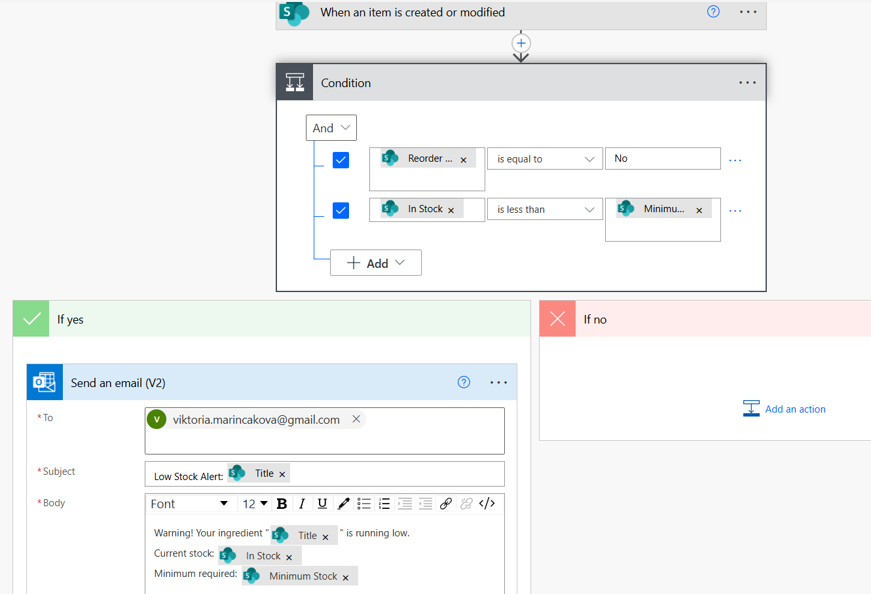

**Obrázok, na ktorom je text, snímka obrazovky, písmo, algebra

Obsah vygenerovaný pomocou AI môže byť nesprávny.**

**Order Confirmation** – when an order is placed, the mail is automatically send to the person who put an order(now there is everywhere my e-mail, was used for testing)

Obrázok, na ktorom je text, snímka obrazovky, písmo

Obsah vygenerovaný pomocou AI môže byť nesprávny.

**6.** **Power BI Dashboard**

The **Sweet Treat Shop Sales & Orders Dashboard** was created using Power BI to visualize key performance indicators(KPI) for a fictional bakery business. The dashboard tracks and analyzes data from orders stored in SharePoint, offering insights into **total orders**, **customer count**, **average order size**, and **total revenue**.

Obrázok, na ktorom je text, ružová, snímka obrazovky, písmo

Obsah vygenerovaný pomocou AI môže byť nesprávny.

The main visualizations include:

* A **monthly sales trend chart** showing how product sales evolved from January to July 2025.
* A **bar chart of top products by quantity sold**, helping identify the most popular treats.
* A **profit comparison chart by product**, showing which items generate the most revenue.
* Interactive slicers to **filter data by product**.

The main visualizations include:

* A **monthly sales trend chart** showing how product sales evolved from January to July 2025.
* A **bar chart of top products by quantity sold**, helping identify the most popular treats.
* A **profit comparison chart by product**, showing which items generate the most revenue.
* Interactive slicers to **filter data by product**.

The Best product is-Lemon Tart  
Obrázok, na ktorom je text, ružová, snímka obrazovky, dizajn

Obsah vygenerovaný pomocou AI môže byť nesprávny.

**7.** **Conclusion & Reflection**

This project demonstrates how Microsoft Power Platform tools—**Power Apps**, **SharePoint**, **Power Automate**, and **Power BI**—can be integrated to create a complete business solution for managing and analyzing sales data.

Through the fictional **Sweet Treat Shop**, I designed a Power Apps application to collect customer orders, stored them in SharePoint lists, and used Power Automate to trigger email notifications for low inventory alerts and order confirmation. Finally, I built a Power BI dashboard to visualize key metrics such as **total revenue, top-selling products and order trends.**

This hands-on project strengthened my skills in low-code development, data analysis, and process automation—key areas in digital business transformation. It also reflects how powerful and accessible these tools are for small businesses to make informed decisions based on real-time data.

Working on this project allowed me to explore and understand the **full potential of the Microsoft Power Platform**. Before starting, I had limited experience—mostly with Power BI—but through this hands-on approach, I learned how to **design apps in Power Apps**, **automate workflows in Power Automate**, and **store and manage data in SharePoint**.

Overall, this project was a valuable learning experience that helped me develop both technical and analytical skills. It gave me confidence in building complete digital solutions and confirmed my interest in continuing to learn more about data analytics, automation, and app development.