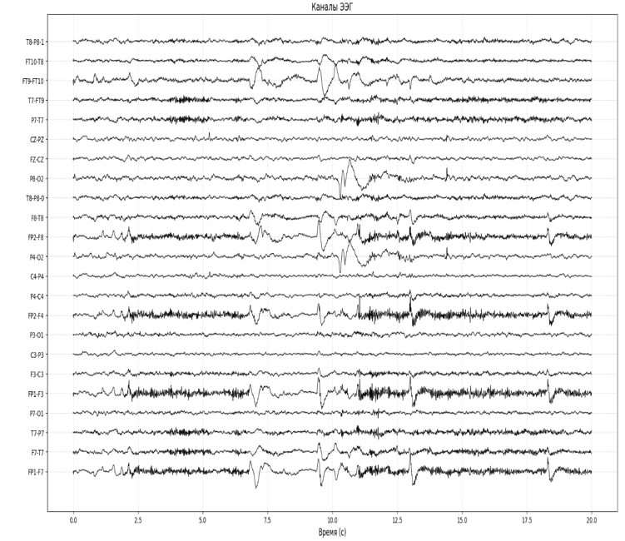
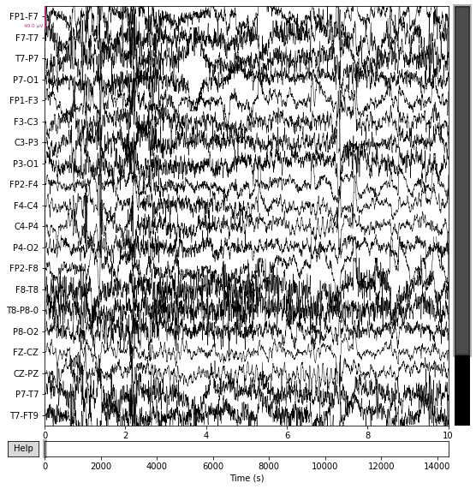
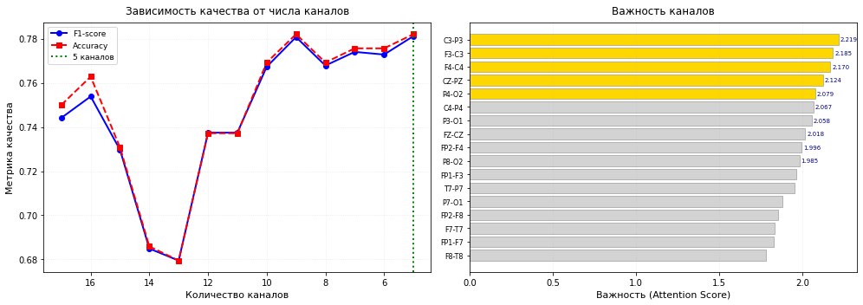



Итерация | Количество каналов | Удалённый канал | Accuracy | F1-score
0 | 17 | - | 0.750 | 0.744
1 | 16 | F8-T8 | 0.763 | 0.754
2 | 15 | FP1-F7 | 0.731 | 0.730
3 | 14 | F7-T7 | 0.686 | 0.685
4 | 13 | FP2-F8 | 0.679 | 0.679
5 | 12 | P7-O1 | 0.737 | 0.737
6 | 11 | T7-P7 | 0.737 | 0.737
7 | 10 | FP1-F3 | 0.769 | 0.767
8 | 9 | P8-O2 | 0.782 | 0.781
9 | 8 | FP2-F4 | 0.769 | 0.768
10 | 7 | FZ-CZ | 0.776 | 0.774
11 | 6 | P3-O1 | 0.776 | 0.773
12 | 5 | C4-P4 | 0.782 | 0.781

