**First project idea – Movie analysis**

**Data sources:**

1. **Main data source - IMDB Database (we can select the size of the database)**

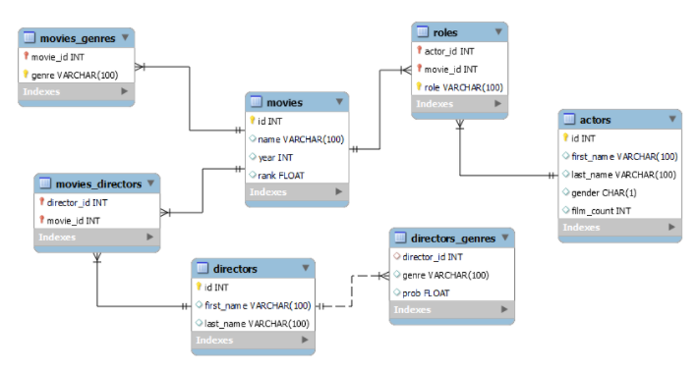

1. **API - TMDb API (join on movie name)**

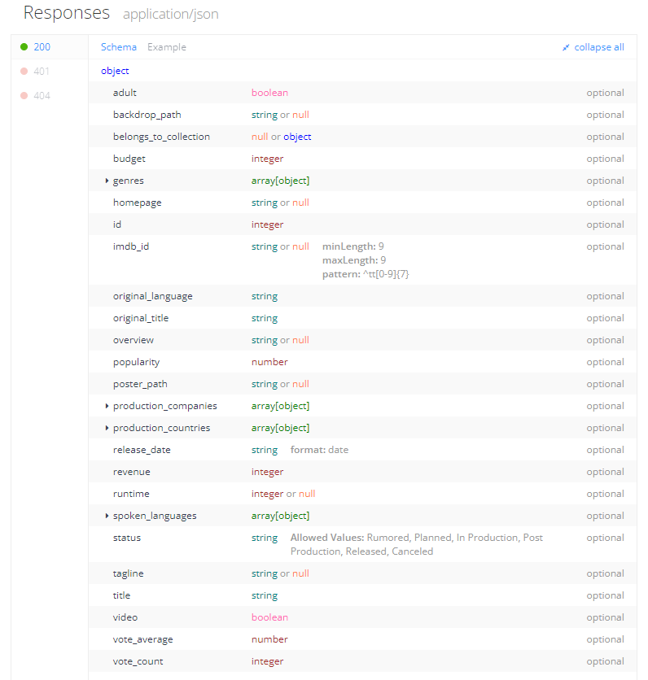

**Analytical questions:**

* Q1 Who are the most important for movie popularity: directors, actors, production companies or writers?
* Q2 How much budget affects popularity? How does budget compare to the revenues?
* Q3 Clustering movies, does it match genres?
* Q4 Review Sentiment of movie descriptions or reviews.

**Second project idea – Boardgames analysis**

**Data sources:**

1. **Main data source – Tidytuesday (10,532 games)**

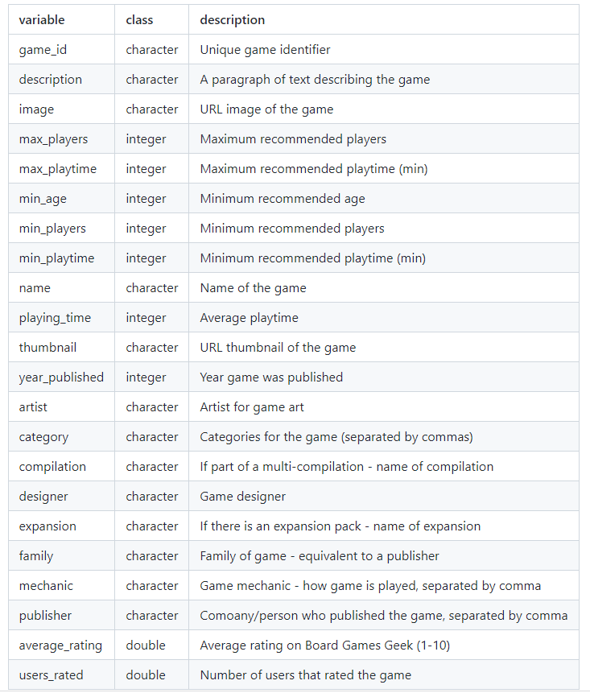

1. **API - boardgameatlas.com**

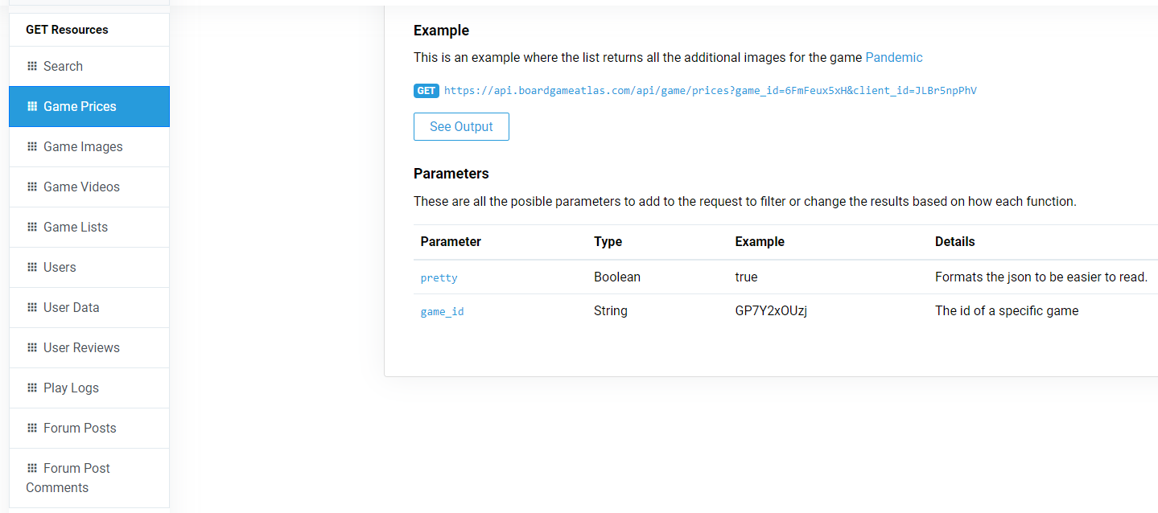

**Analytical questions**

* Q1 What drives rating the most: playtime, category, publisher, age?
* Q2 What drives price the most: playtime, category, publisher, age, number of players?
* Q3 Clustering games, does it match genres?
* Q4 Review Sentiment of game descriptions.