School of Informatics & Cybersecurity - Assessment Submission Coversheet

Student Information
Student Number: | ******
Student Name: | Viktoriia Bielhrad

Module Information
Module Title: | IT Maths & Data Visualisation
Module Code: | COMP H2038

Assessment Information
Assessment Title: | Data Exploration & Data Visualisation

Declaration
☐ I confirm that I have read and understood the University’s Academic Integrity Policy.
https://www.tudublin.ie/explore/about-the-university/academic-affairs/academic-quality-assurance-and-enhancement/academic-integrity/
☐ I have completed the TU Dublin AI Driving License theory test.
https://www.tudublin.ie/explore/about-the-university/academic-affairs/lta/lta-resources/artificial-intelligence-driving-license/
☐ I declare that this assessment submission is my own work.
☐ I confirm that I have read and understood the AI traffic light system used as part of this assessment brief and I have adhered to the level of AI usage allowed for this assessment.

Student signature:
Date: | 13/11/2025

Project Report
Data Exploration & Visualisation Project – Palmer Penguins dataset

Title page
Palmer Penguins dataset
Viktoriia Bielhrad
COMP H2038: IT Maths & Data Visualisation
13/11/2025

Key questions to answer through your analysis:
- How do bill length and bill depth vary among penguin species?
- Which species has the longest flippers or heaviest body mass?
- Are there visible differences between male and female penguins?
- How does island location relate to species distribution?
- Are there other interesting patterns or relationships in the data?

Abstract: (100-150 words)
Brief summary of the dataset, key methods, and findings.

The Palmer Penguins dataset includes measurements of certain penguin species that live on the Palmer Archipelago, Antarctica. Key methods that can be used to examine the structure and quality of this dataset include: summary, names, sum, hist, boxplot etc.
Using different methods, we can see the differences between the three penguin species, assess the quality of the data, and visualize the relationships between variables, which will make data analysis faster and easier.

1 Introduction What does this dataset represent and why is it interesting to explore? Briefly describe the Palmer Penguins dataset and its purpose. Outline what you aim to explore (e.g. differences between species, body size relationships etc.). Mention the tool(s) used (R and any relevant libraries). Outline the structure of your report.
This dataset contains information about 344 penguins in the Palmer Archipelago, Antarctica (Biscoe, Dream or Torgersen). There are three species of penguins, and the interesting thing is that each species is unique and has its own certain differences. With this dataset, I am going to investigate these differences between these species based on the following parameters: culmen length/depth, body mass, flipper length, sex.
In order to connect my Google Drive to Collab, I change the runtime to Python 3. And for the rest of the code, I use the R library.

Structure of this report:
- Introduction
- Data Importing and Description
- Data Characteristics
- Data Quality and Data Cleaning
- Exploratory Data Analysis
  - Univariate
  - Bivariate
- Conclusions
- References
- Appendices

2 Data Importing and Description How is the dataset organised? What types of data are included?
Load the dataset into R. Identify the number of rows, columns and variable names. Describe the variable data types (categorical or numerical).

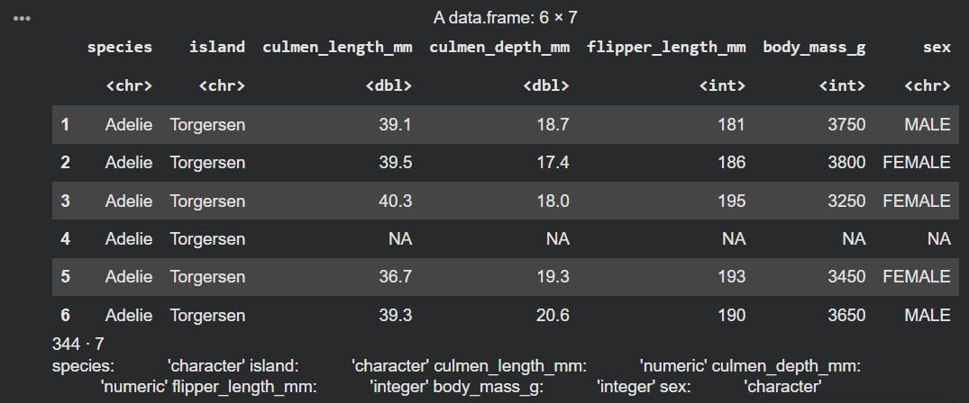

The dataset has the form of a 344x7 table. 344 is the total number of penguins in this dataset and the total number of rows. 7 is the number of variables (columns).

This image shows only the first 6 rows of information because the head() function was used. Here we can see the structure and content of this dataset. Data frame: 6x7 means that we have the first 6 rows and 7 variables of the dataset. Here are the names of the variables, their data type (char, int, double). The first six rows show the culmen length, culmen depth, flipper length, body mass and sex of the Adelie penguin that inhabits Torgersen Island.

Variables and their data types
Сategorical | Numerical
Species (Character) | culmen_length_mm (Double)
Island (Character) | culmen_depth_mm (Double)
Sex (Character) | flipper_length_mm (Integer)
 | body_mass_g (Integer)

3 Data Characteristics What do the summary statistics and initial plots tell us about the data?
Summarize the main variables using summary statistics and use simple plots to show key patterns. Note your initial observations and discuss why summary statistics and visualisations are important.
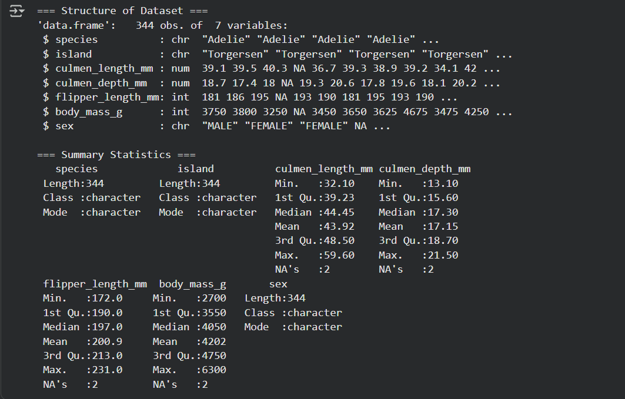
The summary statistics show that penguin species, island, and sex (i.e. categorical datа)have a length of 344, meaning 344 values.
Regarding the numeric values, the summary shows the minimum and maximum values, 1st and 3rd quartiles, median, and mean for each numeric variable. We can also notice a row called NA’s. It shows the missing values, in this case for all numeric columns this value is 2.

We can see that in the culmen length the mean (43.92) is less than the median (44.45) which means that the data is slightly skewed to the left (negative skew).
In the culmen depth the median and mean are approximately the same which indicates a normal distribution.
In the flipper length the median (197.0) is less than the mean (200.9) which means that the data is skewed to the right (positive skew).
If we talk about the body mass of penguinns then the median (4050) is less than the mean (4202) which also means a right (positive) skew.

4 Data Quality and Data Cleaning Are there missing values, duplicates or outliers in the dataset? How can you address these and why?
Outline your findings on data quality covering missing values, duplicates and outliers (including relevant visualisations). Briefly discuss these data quality concepts and why it is important to address them.

1.

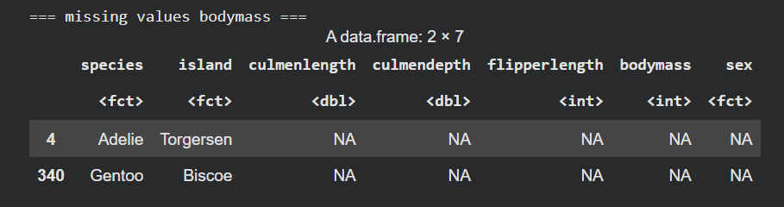
2.

After running the code that should search for missing values, the following results appeared, as shown in the first screenshot:
- species: 0
- islands: 0
- culmen length: 2
- culmen depth: 2
- flipper length: 2
- body mass: 2
- sex: 10 missing values.
In the second screenshot of the table where we can see that for example the places where the body weight values ​​are missing are marked as NA.

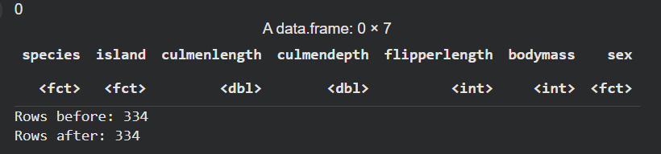
Here we can see that the number of duplicates is 0, so the number of Rows Before is equal to the number of Rows After.

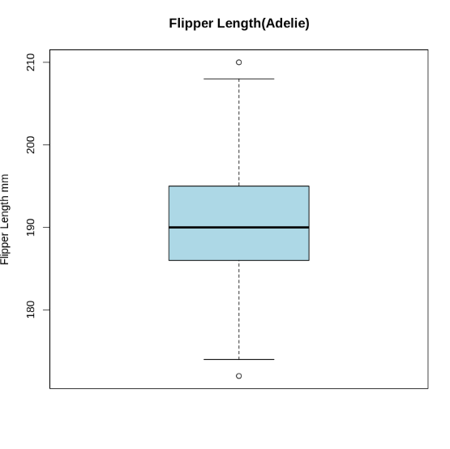
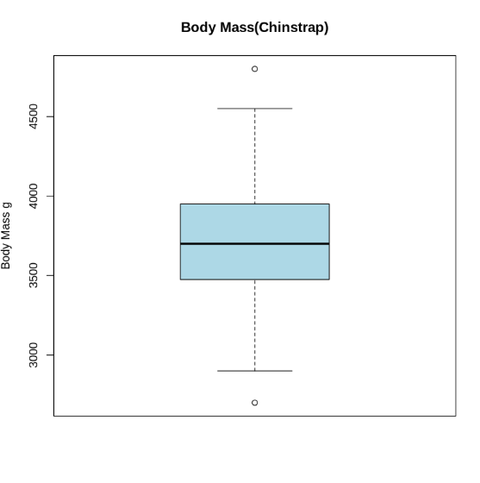
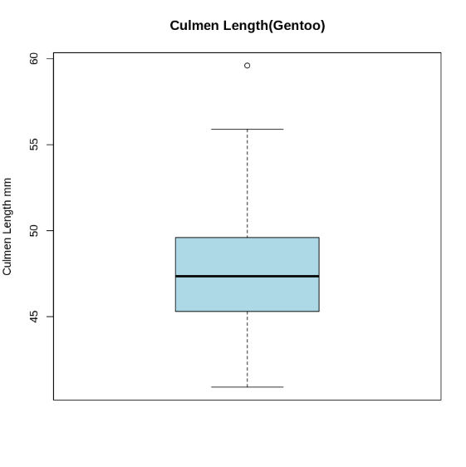
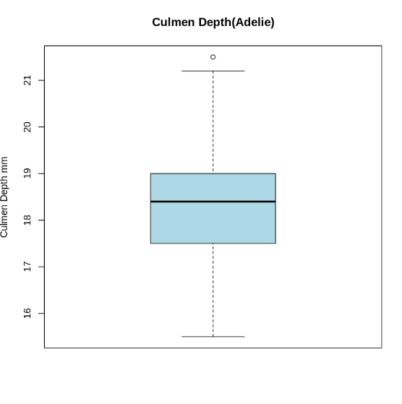
Figure 1 - Boxplots showing outliers
Outliers are values ​​that are not in the expected range. Boxplots(Figure 1) are very useful for identifying outliers because they are clearly shown as small circles.
So the outliers were in the Adelie species (flipper length and culmen depth), the Chinstrap species (body mass), and the Gentoo species (culmen length).

It is very important to find outliers, duplicates and missing values ​​to fix them. This way we improve the quality and reliability of the data. Data quality is key for accurate data analysis and making decisions or conclusions about the data.

5 Exploratory Data Analysis (Univariate and Bivariate) What relationships can be seen between variables (e.g. body mass and flipper length)? Which plot types best represent these relationships and why?
Report the findings from your univariate and bivariate analysis. Include the most significant/insightful outputs and visualisations. Comment briefly on why these plots were chosen for the data types under study. Integrate statistical values to support the findings. Outline how you have used colour & annotation (where relevant) to aid the presentation and interpretation of your visualisation.

Univariate Data Analysis

Since my goal is to compare the differences between species, next we will look at the graphs on which we will see this.
Let's start with the numerical values.

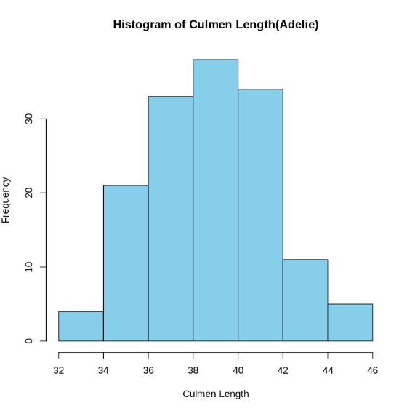
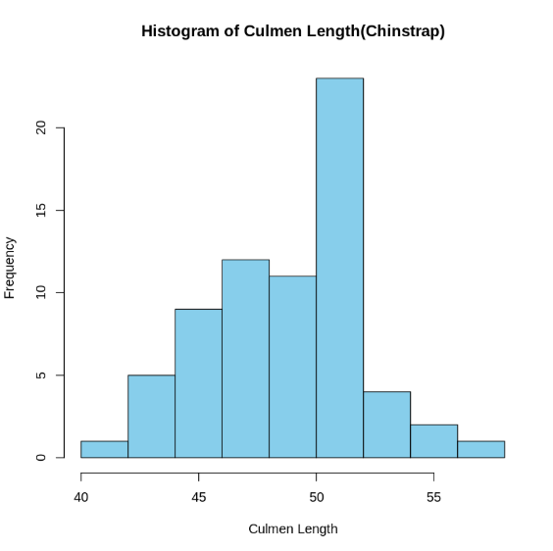
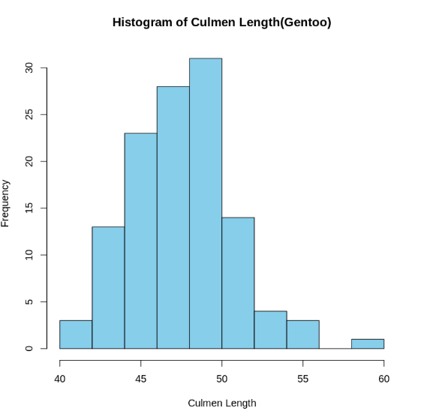
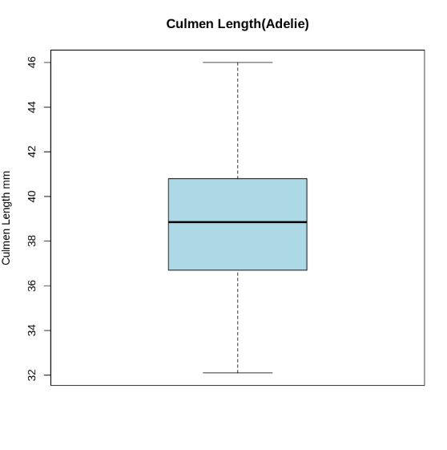
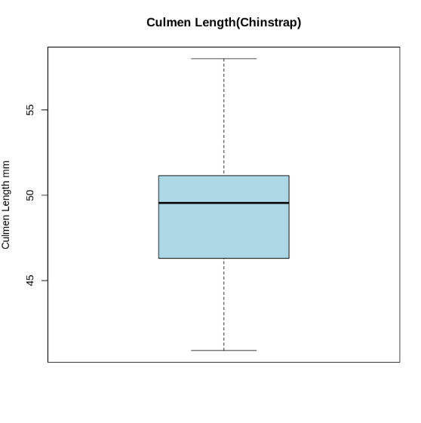
Figure 2 - Histogram and box plots of Culmen Length for 3 species of penguins

Histograms show how often penguins of a certain species with certain measurements (culmen length, body weight, etc.) occur.

In Figure 2 we can see that the length of the culmen of the Adelie species is about 38-40 mm, which is most common. As for the Chinstrap species, it is 50-52 mm,
and Gentoo 48-50 mm.
In conclusion, the greatest length of the culmen is found precisely in the Chinstrap species.

The boxplot allows us to see the range of values ​​for the culmen length, as well as the median and the first and third quartiles.

We can see that the ranges of values ​​for these three species of penguins are:
-Adelie: 32-46 mm
-Chinstrap: 40-60 mm
-Gentoo: 40-56 mm

While the median for the Adelie and Gentoo species is approximately in the middle, indicating a symmetrical distribution of the data, for the Chinstrap species it is closer to the top. This means that the distribution here is negatively skewed.

Also in the Gentoo species boxplot we can see small circle that is outlier, indicating the presence of value ​different from the majority. The range of values ​​in this species is the smallest, as indicated by the size of the whiskers, and the quartile limits are also the smallest among all species. So this species does not have much variation in culmen size.

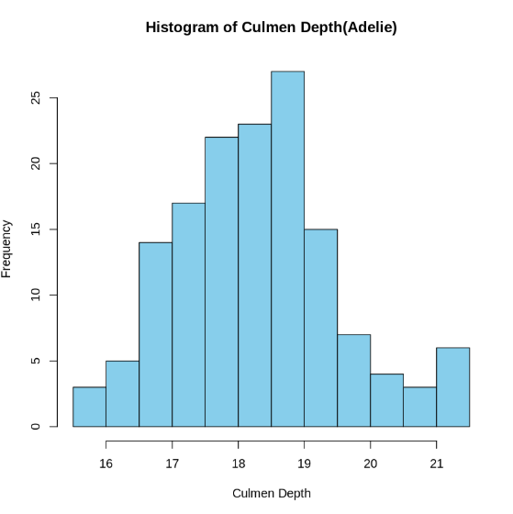
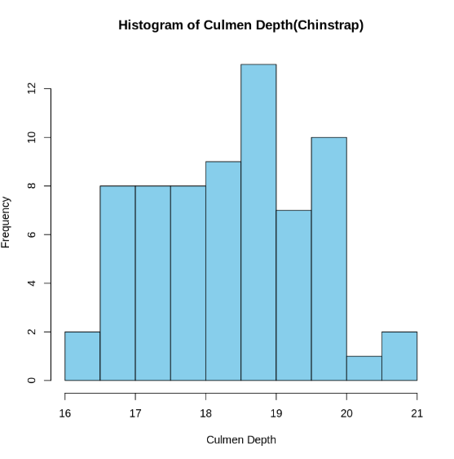
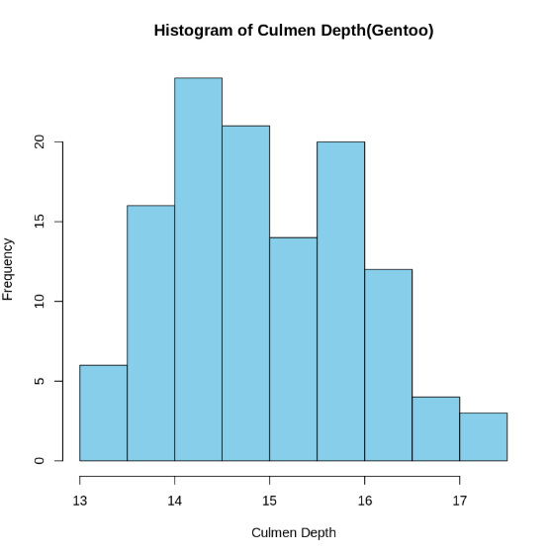
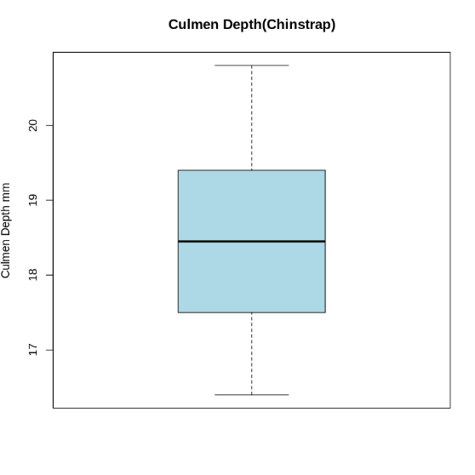
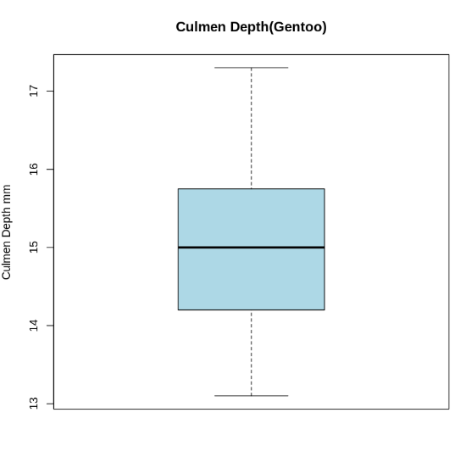
Figure 3 - Histogram and box plots of Culmen Depth for 3 species of penguins
Now let's look at the frequency of the culmen depth (Figure 3).
In individuals of the Adélie species, the most common culmen depth is around 18.5 - 19 mm.
In Chinstraps, these numbers are the same.
The smallest culmen depth is found in Gentoo penguins - 14 -14.5 mm.

The range of values ​​shown in the boxplots is approximately as follows:
-Adélie: 15.5 - 21 mm
-Chinstrap: 16.5 - 21 mm
-Gentoo: 13 - 17 mm

While in Chinstrap and Gentoo species the median is in the middle, indicating a normal distribution and the range of values ​​and quartile limits are the largest among other species, in the Adélie species it is slightly closer to the upper limit, which may indicate a slight negative skewness.

Apparently the Chinstrap species has the largest culmen (length x depth). The histogram of the culmen depth of the Chinstrap species visually has a flatter peak and light tails.

In the Adelie species they are mostly shorter in length and deeper, while in the Gentoo species it is the opposite.

There is one outlier in Culmen Depth (Adelie) boxplot as well.

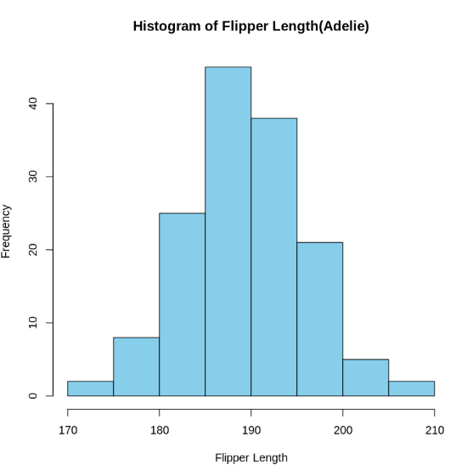
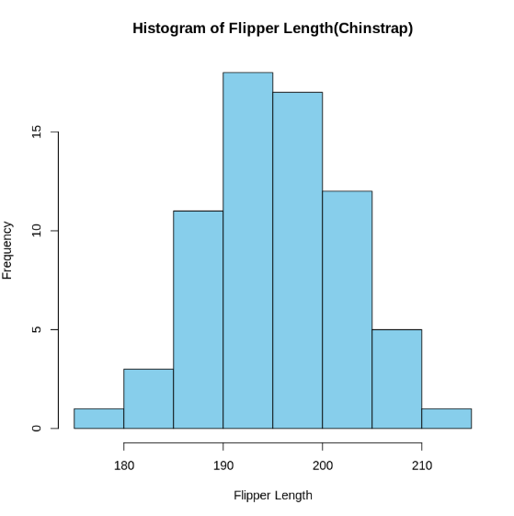
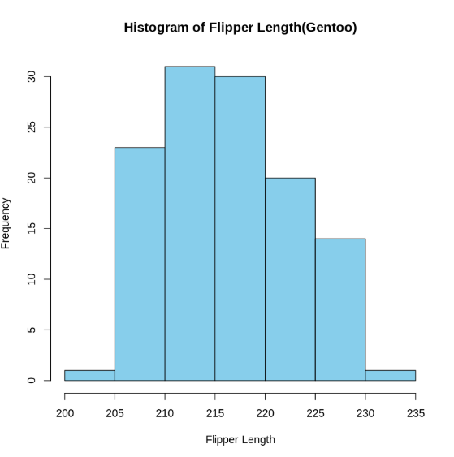
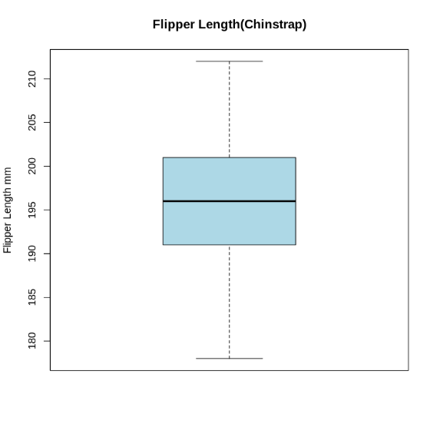
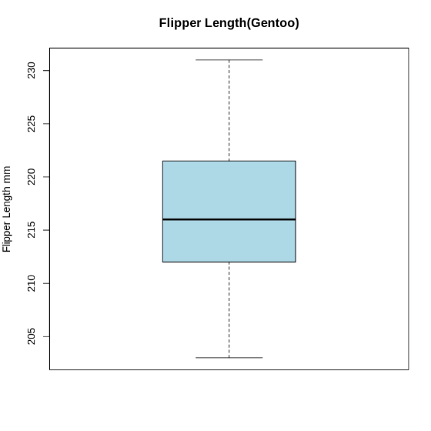
Figure 4 - Histogram and box plots of Flipper Length for 3 species of penguins
The largest flipper length (Figure 4) is observed in the Gentoo species and is 210 - 215 mm in more than 30 individuals of this species, which is the highest frequency.
in the Chinstrap species it is 190 - 195 mm, and in the Adelie 185 - 190 mm(the smallest).

Although the Adelie and Chinstrap boxplots show a normal distribution, a slight positive skew is noticeable in the Gentoo.
Also in the Adelie species boxplot we can see two outliers.

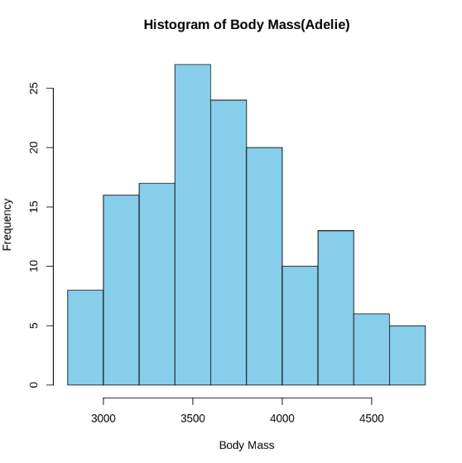
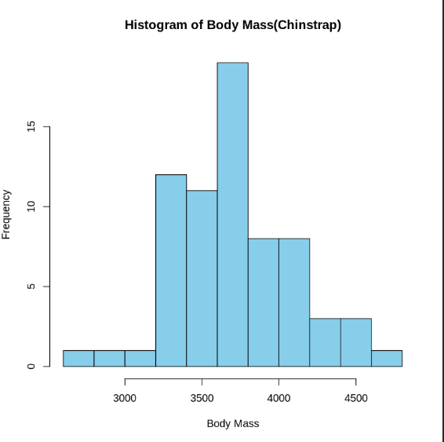
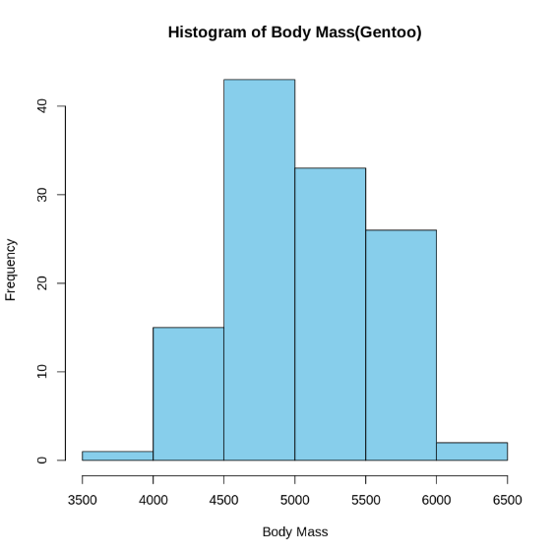
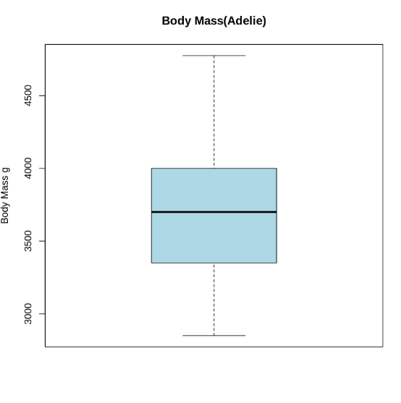
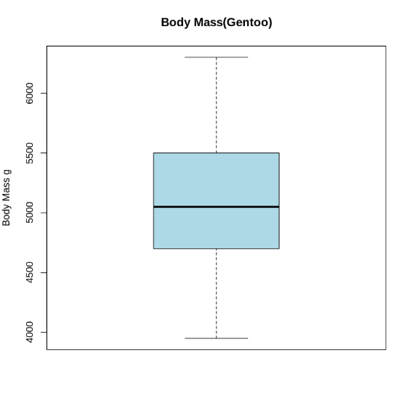
Figure 5 - Histogram and box plots of Body Mass for 3 species of penguins
The next value is the body mass of the penguin, measured in grams (Figure 5).

The body mass of the Adelie species, according to the histogram, is most often 3400 - 3600 g. In Chinstraps, this value is 3600 - 3800 g, and in Gentoos 4500 - 5000 g, which is the largest mass found in more than 40 penguins.

Regarding the boxplots, although Chinstraps have a noticeable normal distribution, there are outliers.
The Adelie species has a slight negative skew, and the Gentoo species has a slight positive skew.

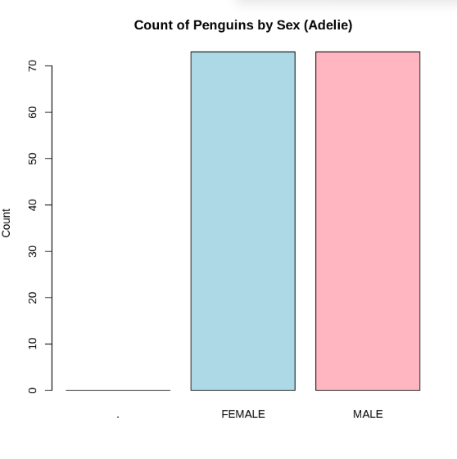
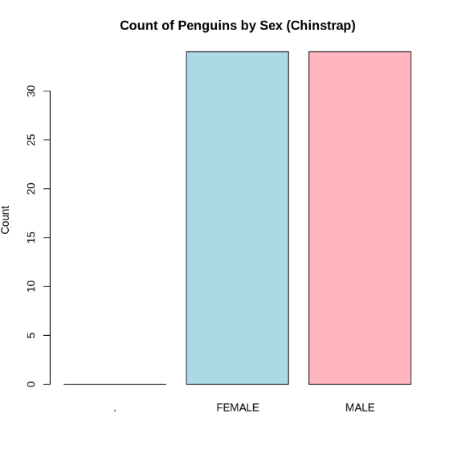
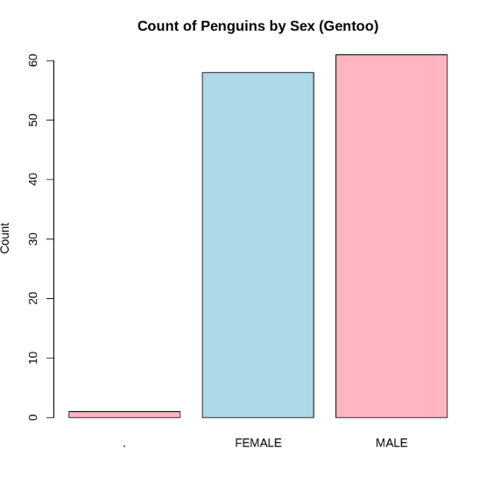
Barcharts (Figure 6) can be used to examine the ratio of the number of female and male individuals among penguins of different species.
Figure 6 - Barchart ratio of female to male penguins

The Adelie and Chinstrap species have the same ratio. The Adelie has over 70 males and females, while the Chinstrap has over 30.
The ratio of male to female individuals of the Gentoo species stands out from other species because it has fewer than 60 females and over 60 males.

We can also notice the presence of a bar that shows the number of outliers. In the Gentoo species, there is one outlier.
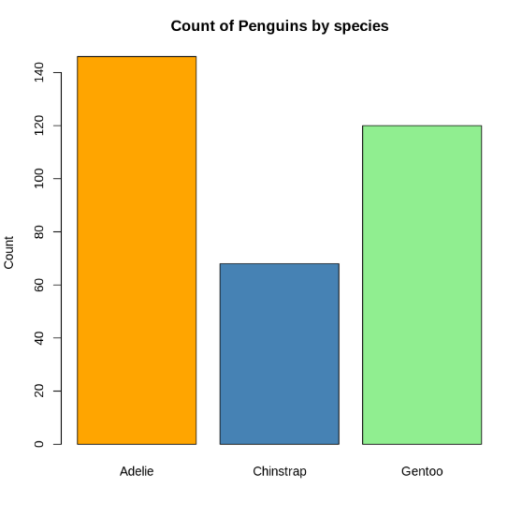

There is also a bar chart that shows the number of penguins of each species (Figure 7).
We can notice that the number of individuals of the Adelie species is the largest - over 140, while the Gentoo has up to 120 individuals, and the Chinstrap has the smallest number - up to about 65 individuals.

Figure 7 - Barchart of penguin numbers by species

Kurtosis
The following screenshot shows the kurtosis of the numerical values.
-culmen length = 2.1;
-culmen depth = 2.1;
-flipper length = 2;
-body mass = 2.25;
All of these values ​​are less than 3, which means light tails and a flatter peak.
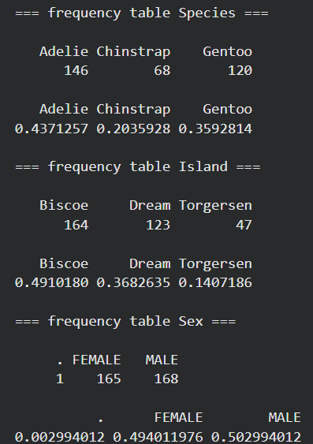
This is a table of the frequency of species, the number of penguins on the three islands, and the frequency of males and females.

From here we can see that the largest number of penguins is the Adelie (146) and the smallest is the Chinstrap (68).
It also shows how many penguins inhabit each island. The largest number of penguins is found on Biscoe Island (164) and the smallest is Torgersen (47).
The total number of males is 165 and females - 168, which is a larger value.
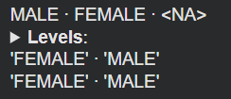
# notice in the previous output that there is an error for variable sex '.' recorded

Bivariate Data Analysis

The following graph (Figure 8) shows the relationship between the numerical values ​​of the three categories of penguins:
- red color – Adelie species
- green color – Chinstrap species
- blue color – Gentoo species
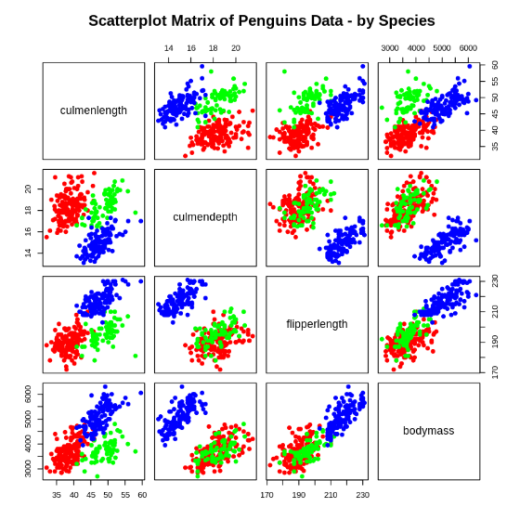
Figure 8 - Skatterplot Matrix of Penguins Data by 3 species
There are two interesting points here:
1) in such ratios as [culmen depth/flipper length] and [body mass/culmen depth] the blue dots denoting the Gentoo species form a separate group from the others, since their culmen depth is smaller compared to the others and their body mass is larger.
2) a correlation is visible in the ratio of flipper length and body mass of all three species.

Based on my initial observations, I can clearly see why summary statistics and visualizations are important. They make the process of analysis, understanding data, identifying outliers, and helping to quickly see major patterns and certain unusual results. It is easier to compare data, see relationships between them.
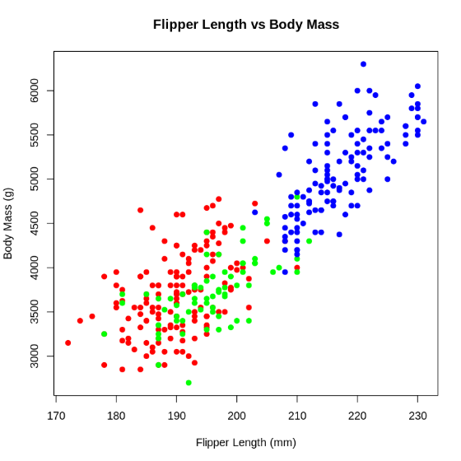
Figure 9 - Scatterplot Flipper Length vs Body Mass

One of the interesting outputs from the scatterplot is the ratio of body mass to flipper length between the three penguin species (Figure 9).
We can see that gentoo penguins will generally be larger than penguins of other species because their flipper length and mass are greater.
We can also see a high positive correlation here.

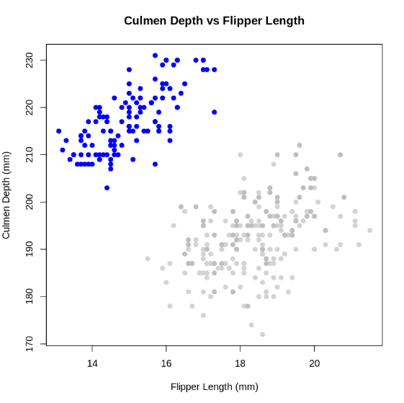
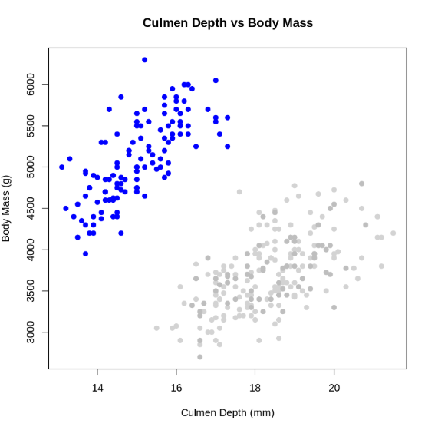
Figure 10 - Scatterplot showing Gentoo species difference
Here I would like to draw attention to how the Gentoo species (Figure 10) again differs from the rest in that its values ​​are greater in these two ratios. For this, I marked the species with the following colours:
- Gentoo - blue
- Adelie - light gray
- Chinstrap - gray.
I did this to emphasize the Gentoo species. In this way, all attention will be focused on this species, because this colour is brighter and makes it stand out.

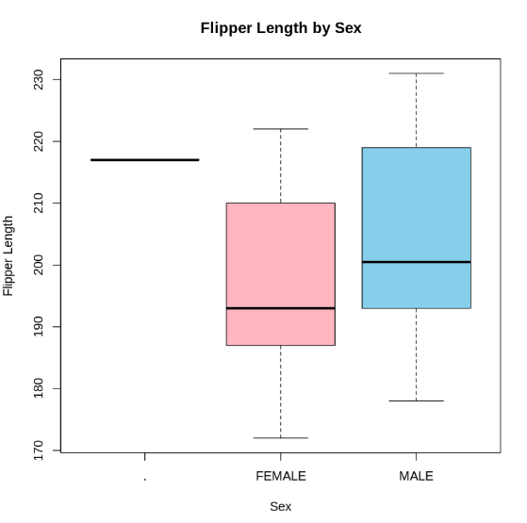
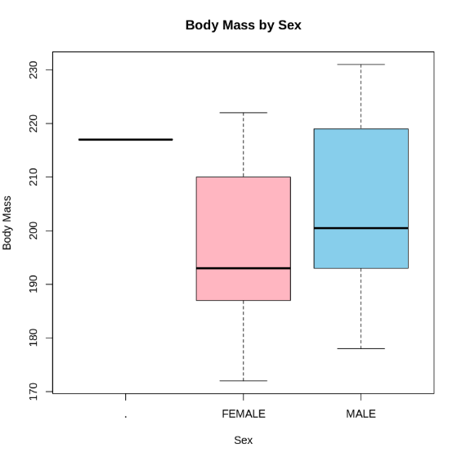
Figure 11 - Boxplots showing difference between sexes

Judging from these boxplots of sex-to-flipper length/body mass ratios, males have higher values. However, one similarity is the placement of the median, which indicates a noticeable positive skew.
There is a dotted line in front of the boxes indicating the presence of outliers.

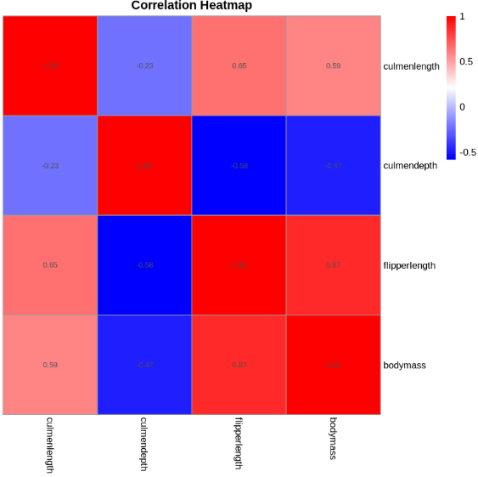
Figure 12 - Correlation Heatmap
This graph (Figure 12) shows the correlation coefficient between numerical values.

Darker blue colour = stronger negative correlation,
darker red colour = stronger positive correlation.
Closer to white -> lower correlation, and white -> there is no correlation.

A strong positive correlation is observed in the ratios:
- culmen length/depth
- flipper length and flipper length
- body mass and body mass
- culmen depth and culmen depth.

A strong negative correlation is observed in:
- culmen depth and flipper length
- culmen depth and body mass.

A low positive correlation is between the values ​​of body mass and culmen length.
A low negative correlation is between length/depth of the culmen.

6 Conclusions What are your key takeaways about the Palmer Penguins dataset and the EDA process?
Bring together the main findings from your EDA work. Explain what patterns or relationships were discovered. Reflect on what you have learned about data exploration and visualization.

Guiding questions for this section.
- What are the main insights from exploring the Palmer Penguins dataset (address the 5 questions outlined at the start of this report template)?
- Which variables appear most closely related, and how did you determine this?
- What is the data quality (if any) issues for this data set.
- How did your choice of visualisation help communicate findings clearly?

Among the Chinstrap species, individuals with the largest culmen (length x depth) are often found.
In the Adelie species, the culmen are mostly of the shortest length and average depth, and the Gentoo has an average length and the smallest culmen depth.
The longest flipper length is observed in the Gentoo species (210 - 215 mm).
For all four numerical indicators, the range of values ​​for males has larger values ​​for the variables than for females, indicating that male penguins may be larger or the same size as females.
The number of penguins may vary depending on the island. The largest number of penguins is found on Biscoe Island (164) and the smallest is Torgersen (47).
Interesting patterns are the similarity of the Adelie and Chinstrap species in that they have equal numbers of males and females. The Gentoo species also stands out for its culmen depth/flipper length and culmen length/body mass ratios. The numerical points form a cluster that lies separately from the others on the scatterplot. Gentoos have the largest body mass and the smallest culmen depth.
The flipper length to body mass ratios of the three penguin species show the most closely related results. There is an apparent high positive correlation.
Data quality issues in this dataset were related to missing values ​​and the presence of outliers.
I used histograms to compare frequencies, boxplots were a great way to visually see the distribution of data and outliers, bar charts are great for representing categorical variables, and scatterplots help to easily explore relationships and correlations between variables.

7 References
- Phillips, N. D. (2024, November 11). 11.4 Histogram: hist() | YaRrr! The Pirate’s Guide to R. https://bookdown.org/ndphillips/YaRrr/histogramhist.html?utm_source=chatgpt.com
- GeeksforGeeks. (2025, July 23). What is Data Cleaning? GeeksforGeeks. https://www.geeksforgeeks.org/data-analysis/what-is-data-cleaning/
- Rose, Q. (2025, June 12). Importance of data visualization in statistical analysis. StatAnalytica. https://statanalytica.com/blog/data-visualization-in-statistical-analysis/

8 Appendices
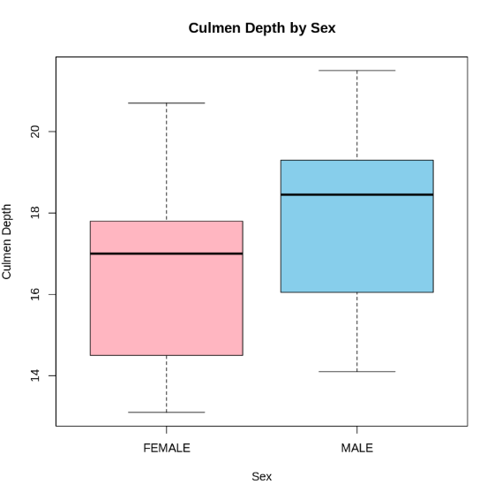
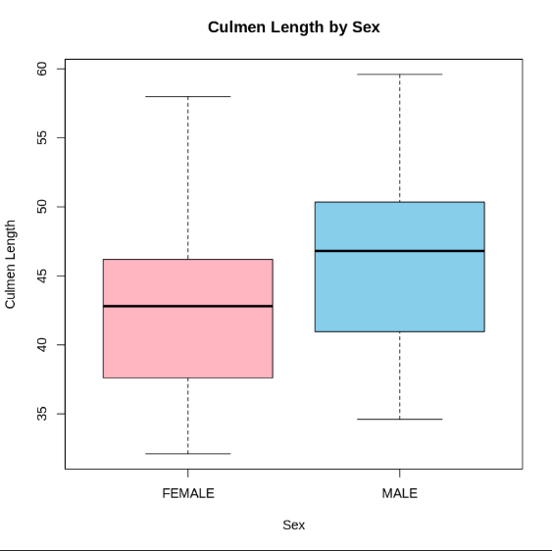
Figure 13 - Boxplots showing difference between sexes
A few more comparisons of the parameters of female and male penguins. Males can often have larger culmens (length x depth). There is also a negative skew in all cases.

