# - comment in R
data() is a function in R that loads built-in datasets. The data is loaded into your R session as a data frame
A data frame is a data structure that is used to store tabular data. It has rows (observations) and columns (variables). Each column can contain different types of data (numeric, character, factor, etc.). All columns must have the same number of rows.
iris is one of R's built-in datasets. It contains 150 observations of iris flowers across 3 species (setosa, versicolor, virginica).
head() is a function in R that shows the first 6 rows of a dataset (by default).
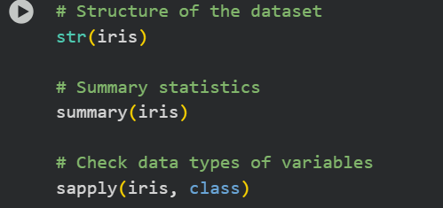
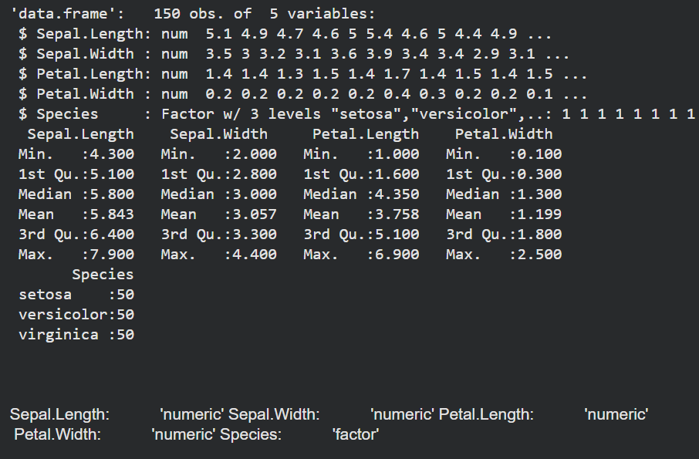
str() stands for structure. It shows a compact overview of the dataset:What type of object it is (e.g., data frame).How many rows(5) and columns(150).The data type of each column (numeric, factor, character, etc.).A preview of the first few values in each column.
summary() gives descriptive statistics for each column: For numeric variables: minimum, 1st quartile, median, mean, 3rd quartile, maximum. For categorical variables (factors): counts of each category.
sapply() applies a function to each column of the dataset.Here, it applies class to each column. class returns the data type of that column.
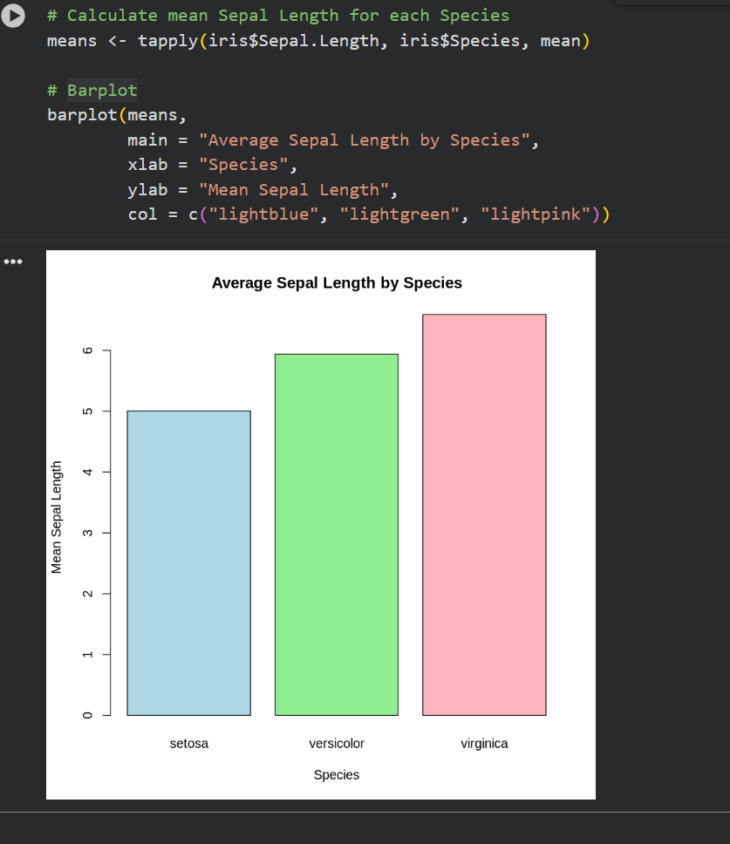

In this step we are going to take the Sepal Length values, split them by species, and calculate the mean of each group.
The tapply() function applies a function (we are using mean) to subsets of a vector, grouped by a factor.
First argument: iris$Sepal.Length → the numeric values we want to analyze.
Second argument: iris$Species → the grouping factor (3 species: setosa, versicolor, virginica).
Third argument: mean → the function to apply to each group.
The results is stored in means
barplot() creates a bar chart for means (average sepal length for each species).
main sets the title of the plot. xlab → label for the x-axis (“Species”). ylab → label for the y-axis (“Mean Sepal Length”). The col argument sets the fill color of the bars.
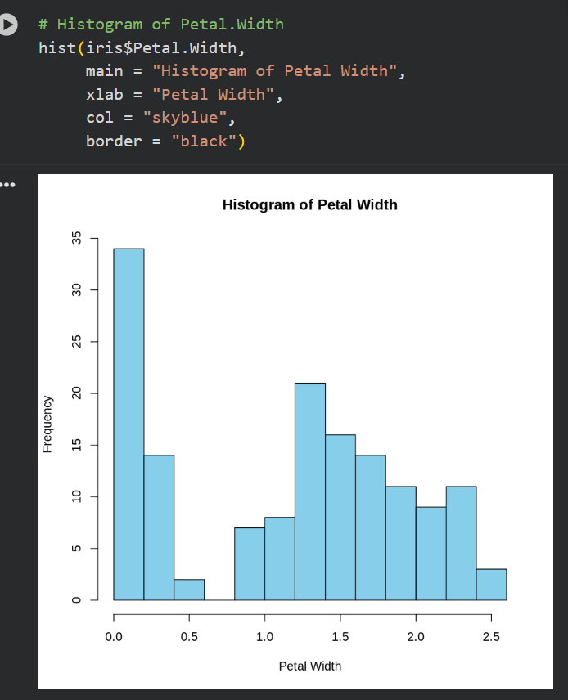
hist() creates a histogram used to show the distribution of a numeric variable.
We are creating a histogram for the Petal.Width column. main, xlab → add title and axis label. col, border → control the colors of the bars.
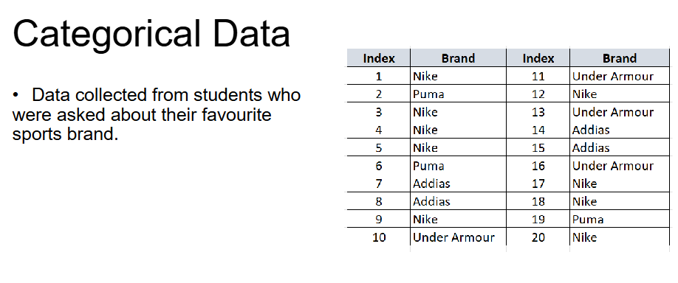
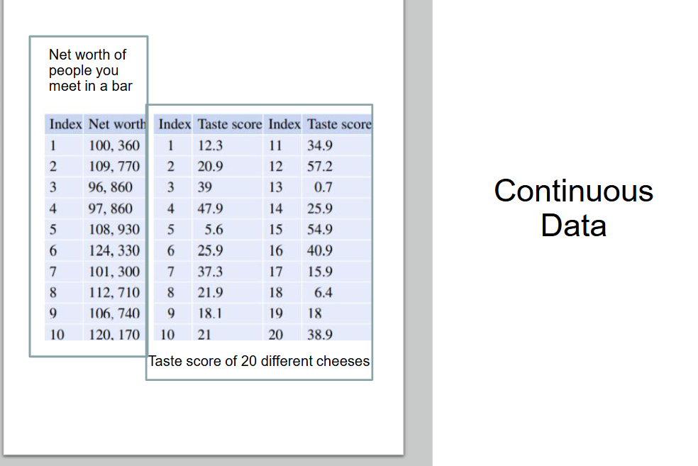
N – used to denote the size (number of rows/instances/tuples/observations) in a dataset
Time Series Plots and Scatter Plots
- The order of the data is important
- The data occur in pairs and the relationship between the values
in each pair is of interest
Sequential Data: Time Series Data - graph usually has time
(months or years) on the horizontal axis and the values of interest
on the vertical axis.

The graph below shows company sales data for 20 year period 1984 - 2004.
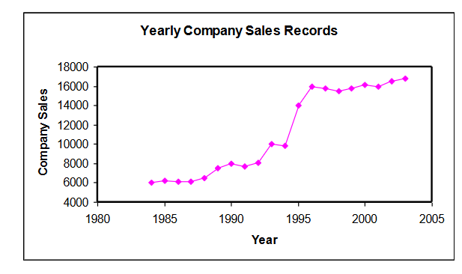
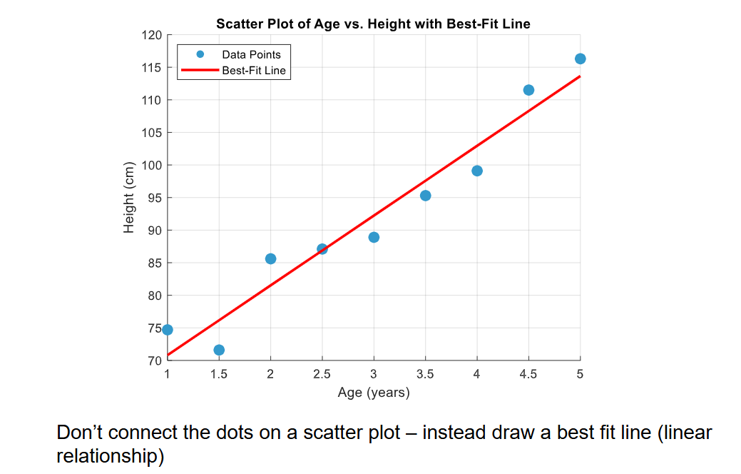
Correlation types
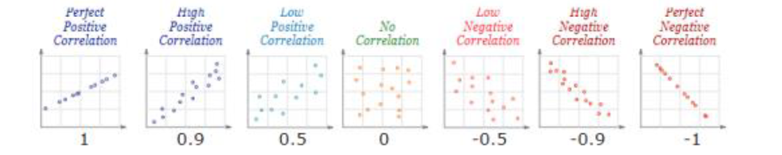
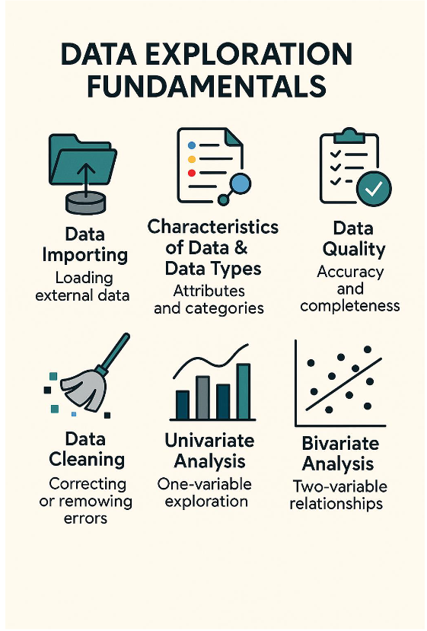
Properties of a data set
• Data types – is the data numerical or text / alphanumeric?
• Dimensionality - number of attributes that are in database (no. of columns)
• Instances – number of rows in the dataset
– EDA enough rows to see stable patterns or distributions per feature
(hundreds at least).
• Resolution – any column can be calculated at different resolutions e.g. height
could be recorded in centimeters or meters
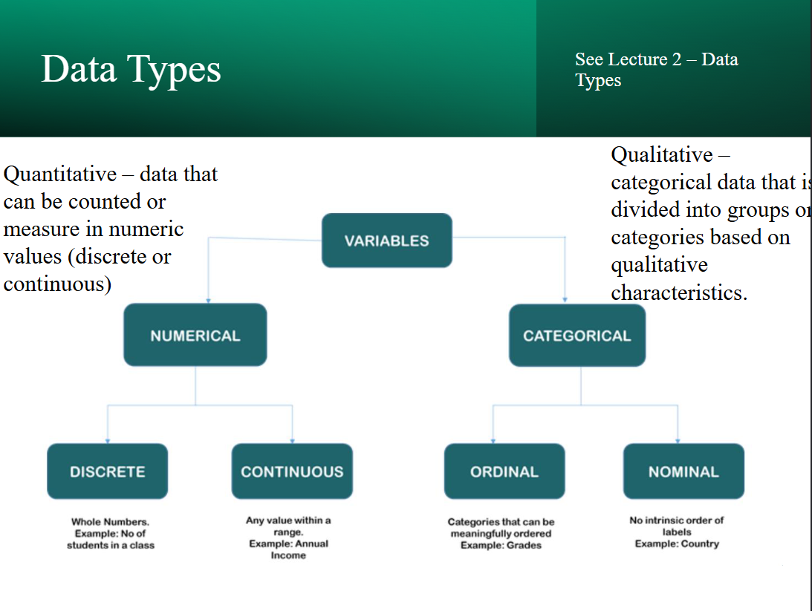
Interval
– Has an order but also carries the information about the distance between
values on the scale e.g. temperature (Celsius or Fahrenheit) calendar dates
Ratio
– As for interval but you can express meaningful ratios based on the
numbers in the scale e.g. length, time counts
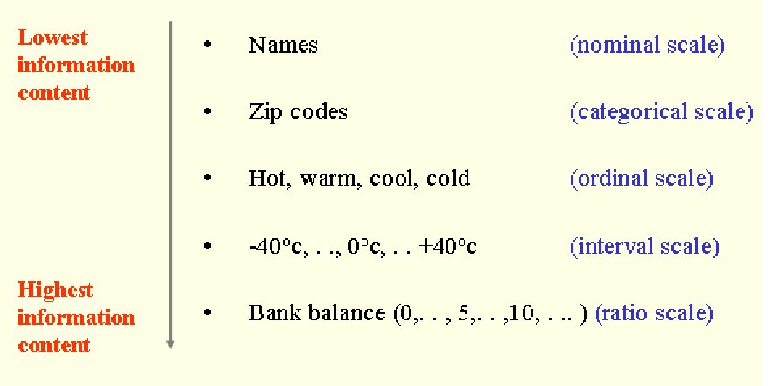
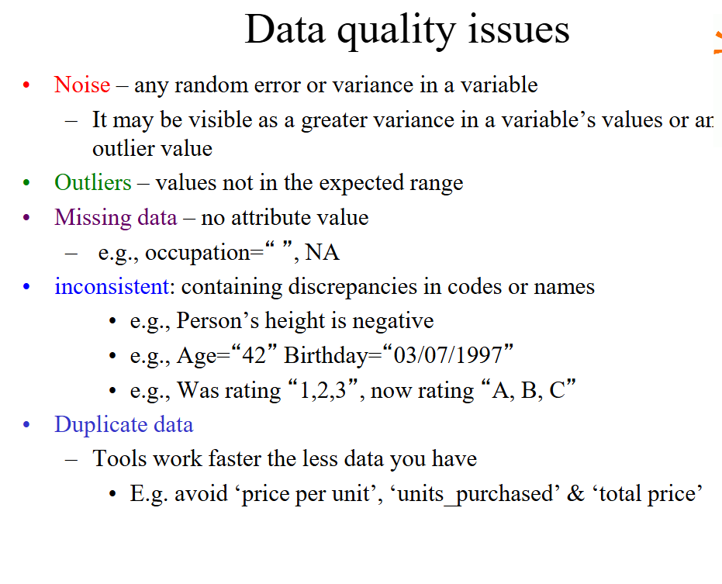
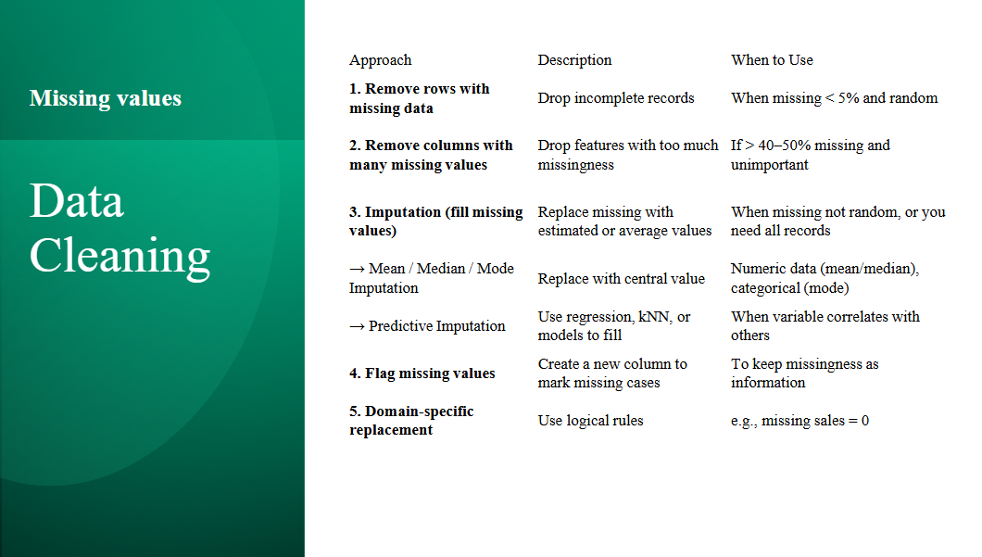

UNIVARIATE ANALYSIS
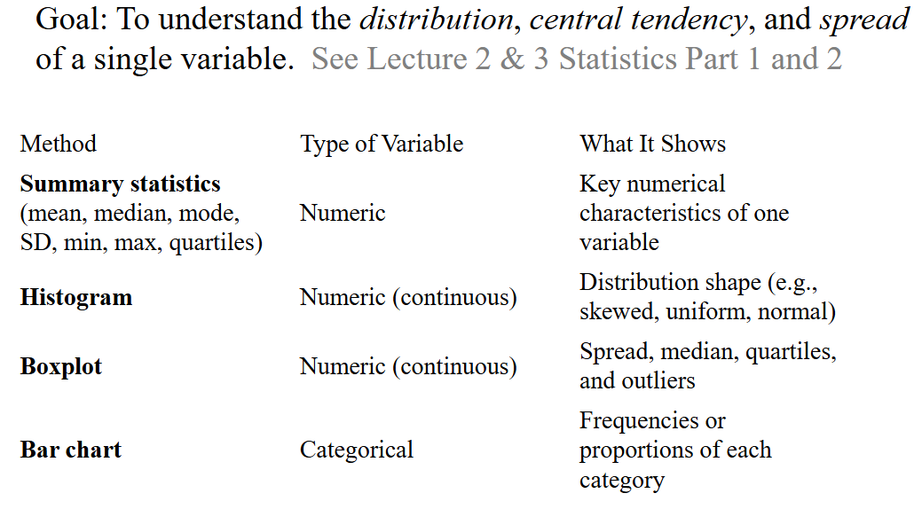
📊 Central Tendency
This describes where the center of the data lies — essentially, the "typical" value.
- Mean: The average of all values.
- Median: The middle value when data is ordered.
- Mode: The most frequently occurring value.
These measures help summarize the dataset with a single representative value.
📈 Spread (or Dispersion)
This tells you how much the data varies or is dispersed around the central value.
- Range: Difference between the maximum and minimum values.
- Interquartile Range (IQR): Spread of the middle 50% of values.
- Variance and Standard Deviation: Measures of how far values typically deviate from the mean.
Understanding spread helps you assess consistency, variability, and potential outliers in the data.

• Summary statistics are usually calculated by
analysis tool / program when the data is read in,
including:
• Numeric data: :
– Mean – average value (sensitive to outliers)
– Standard deviation– how far from the mean,
on average, values lie
– Median – middle value (resistant to outliers)
– 1st and 3rd quartile values – 25th and 75th
percentiles
– Range: min value and max value (allows
you to identify if outliers are distorting the
mean and standard deviation).
• Nominal data:
– Mode: most frequently occurring term
– Value frequencies – the percentage of time
that value occurs in the dataset.
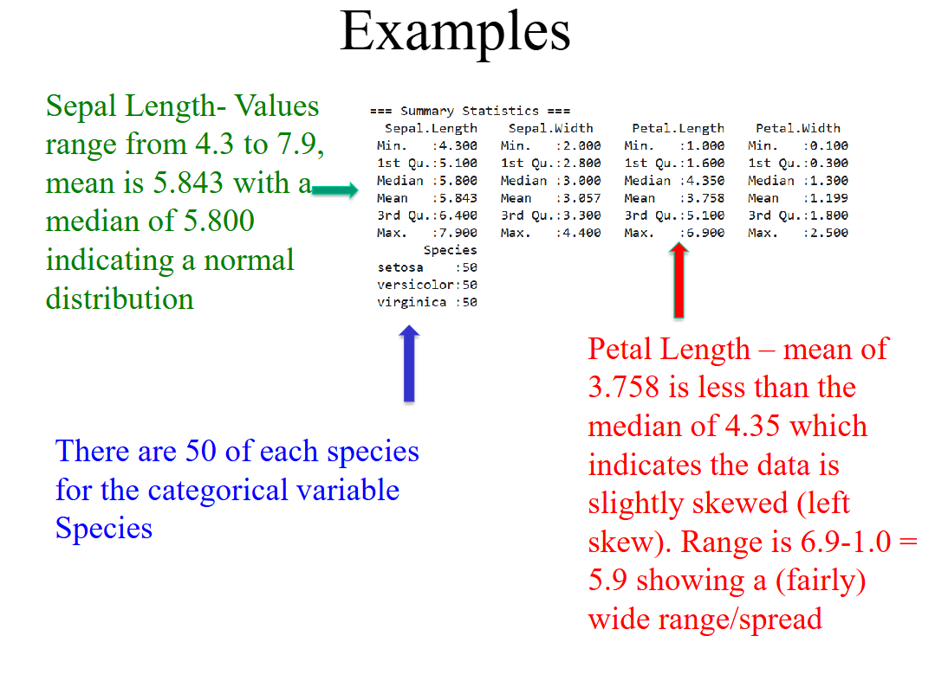if the mean is higher than the median, the data is typically right-skewed — also known as positively skewed.
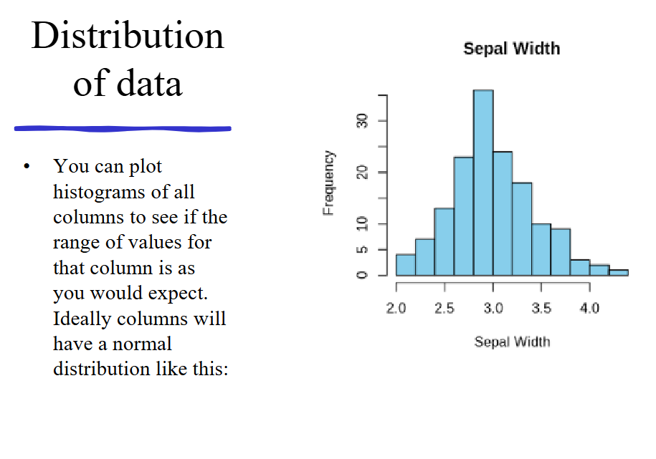
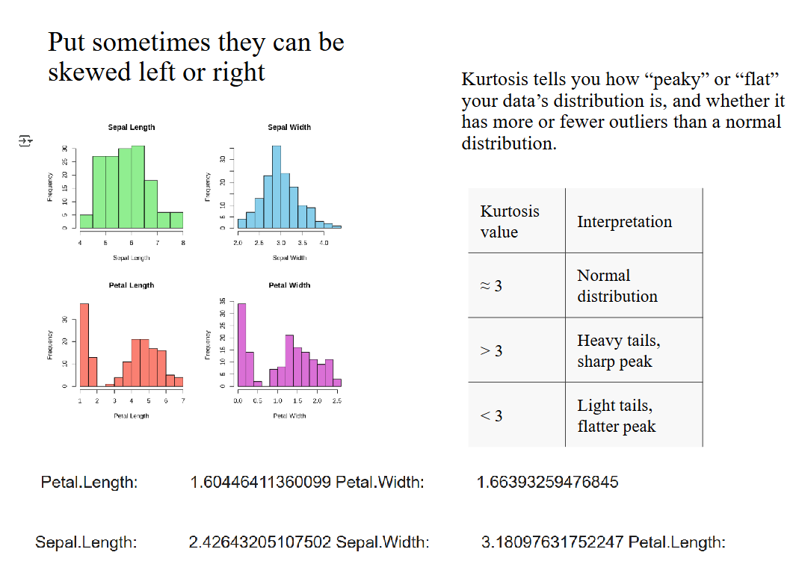
BIVARIATE ANALYSIS
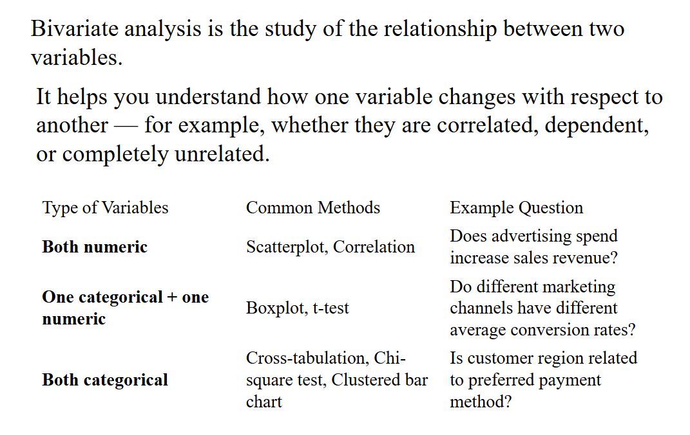
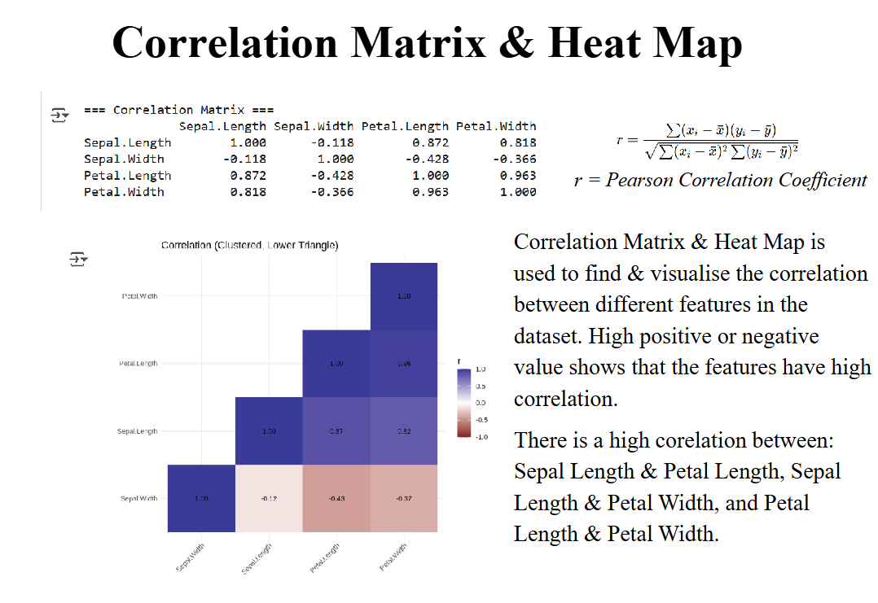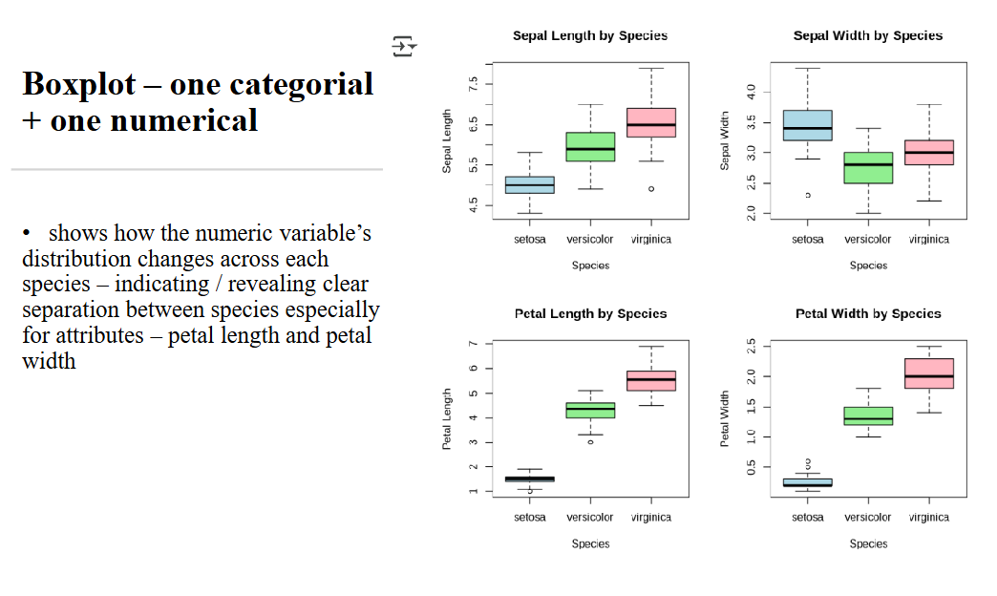• A t-test compares the means of a
numeric variable between two
groups (categorical variable) to see
if it is statistically significant i.e.
p< 0.05 is statistically significant
p <0.001 highly statistically significant
• Iris dataset – comparing Sepal
Length between two species e.g.
setosa and versicolor we get a p-
value < 2.2e-16
• The average Sepal Length of setosa
(5.006 cm) is significantly shorter
than that of versicolor (5.936 cm).
The difference (about 0.93 cm) is
highly statistically significant (p <
2.2e−16).
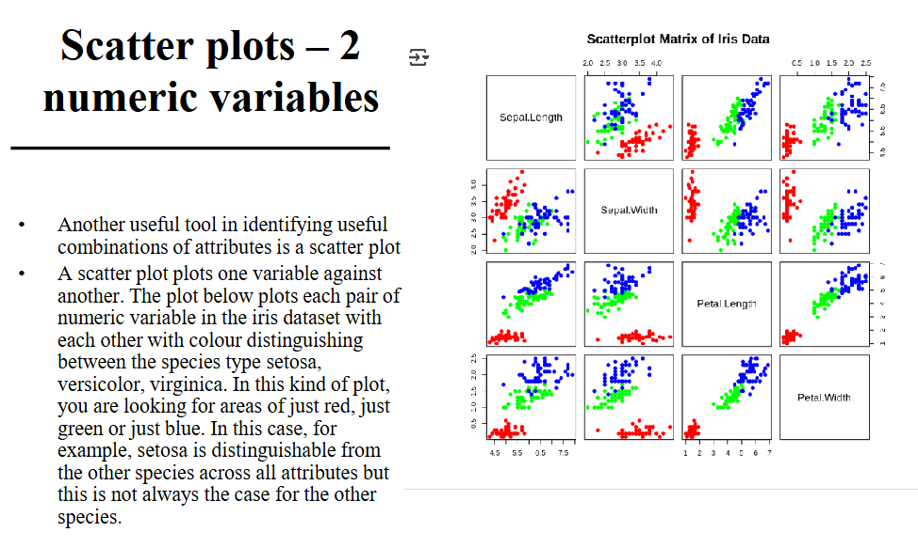
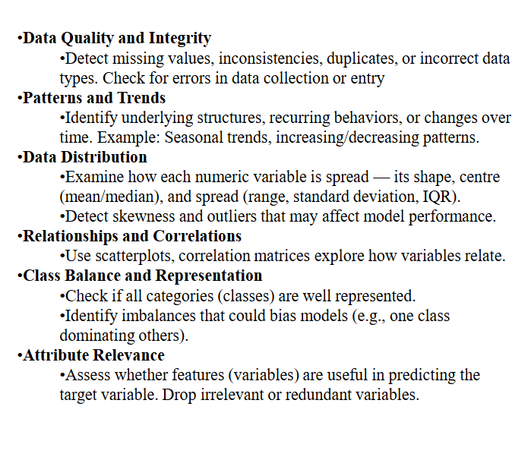
What is Data Visualisation?
- The graphical representation of information and data to
reveal patterns, trends and insights.
