ES Next

**DEADLINE:** 05/02/2022

## FOLDER STRUCTURE

|  |  |
| --- | --- |
| FL18_HW6/ *  ├─ task  ├─ homework/ *  ├─ js/ *  ├─ tasks.js *  ├─ .eslintrc.js *  ├─ index.html * | *  - required |

## TASK

**Note:** Under the new operators we consider all operators from ECMA Script 6 and higher.

1. Create a function which returns max **even** element in array from array of strings
   * Use Math.max(), reduce and other new operators.

1. Write a code which swap variables values without a temporary variable
   * Please, use destructuring assignment.

1. Create a function which simply return value when there is some defined value passed and empty text string ‘-‘ when it is not defined .

* Check ES2020 operators, one of them can help here.

1. Create a function which return objects from array of arrays.

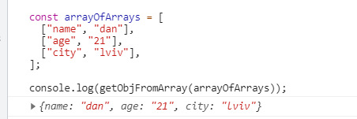

1. Create function to enhance element with unique id. Here is how function should be invoked:
   * Use Symbol() as a unique identifier

https://lh3.googleusercontent.com/KzMhB1HInPbLzPVKVwJDs5y2iHfRlYnk8ZVV1mAvNchoC55M4VouA-H7_-Z59sJx3MnMOG21Btt6V3n4T2STmHB1inCSbO73-g3CZmEO9vQKUgLuFTKqUHLDBMk_Mg5K_nWeYnCx

* + As a result, returned object should have extra property - unique identifier. Returned object should be copy of the passed parameter. Original object should not contain this id.

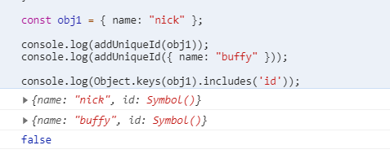

1. Write a function which regroups object properties
   * Destruct old object and construct new

1. Create a function which finds unique elements in array
   * Use one of the new data types

1. Create a function which masks phone number, leaves only last 4 digits
   * Use padStart

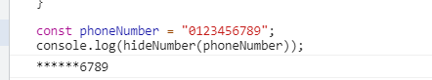

1. Create function which has all parameters always required. If they are not - throw error.
   * Use default parameters feature and assign a function to it

1. Use generator function to create an iterable sequence of values:

**RESTRICTIONS**

* Adding **task/** folder is forbidden. Do not push it to repository. (Only **homework/** folder should be pushed)
* Do not use any external libraries

## BEFORE SUBMIT

* Code should be clean, without comments, readable, and tested
* Make sure your GitLab folder structure meets folder structure from this document (without **task** folder)
* Use linter :

- In order to use npm package manager you should install nodejs (https://nodejs.org/ )

- Install eslint to check your code (npm install -g eslint)

- open a terminal (or cmd)

- run eslint (i.e. eslint ./js/task1.js)

Code should be without ‘errors’

## SUBMIT

* The **FL18_HW6** folder without **task** folder should be uploaded to GitLab repository “**FL-18**” into **main** branch.