# Trello Authorization

In order to **use** the **Trello API**, we need to have an **API Key** and **Token** and use them in the variables. Trello API **doesn't use passwords**. In order to have API Key and Token we need to **create Trello Power-Up**. At its core a Power-Up is **just a configuration**. So just follow the next steps to generate all the attributes needed or you can read [Trello documentation](https://developer.atlassian.com/cloud/trello/guides/rest-api/api-introduction/).

Go to <https://trello.com/power-ups/admin>

Agree to the [Trello Developer Terms](https://developer.atlassian.com/platform/marketplace/atlassian-developer-terms/)

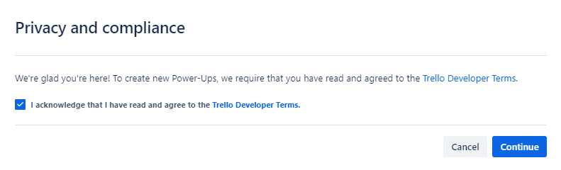

Create a New Power-Up

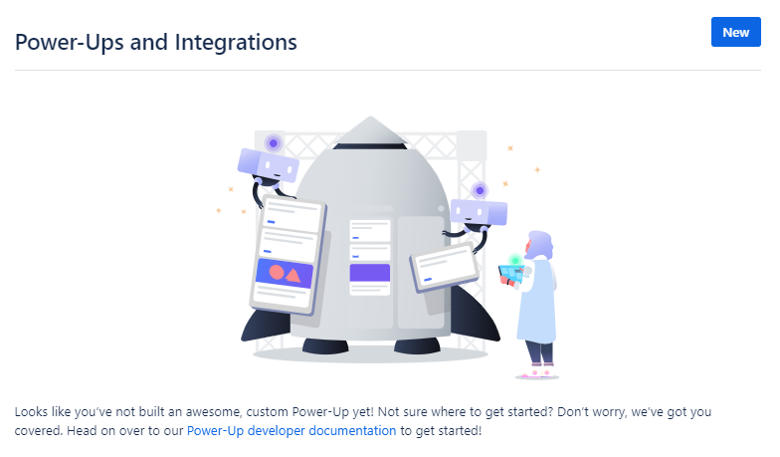

**Fill in some data**. **Leave the red one as it is**. We **named our Power-Up "Postman"**, but feel free to   
choose otherwise.

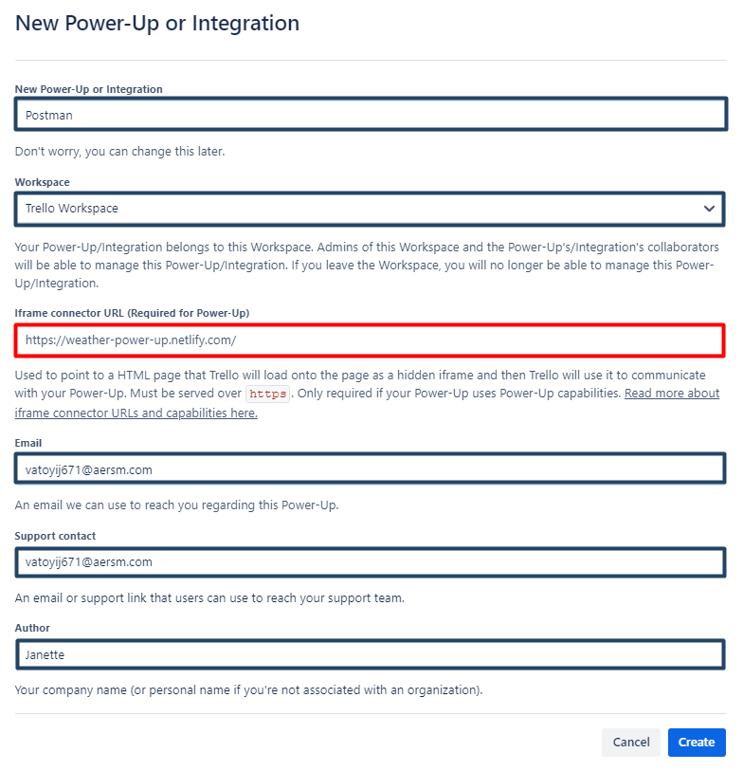

Click on **"Generate a new API Key button"**

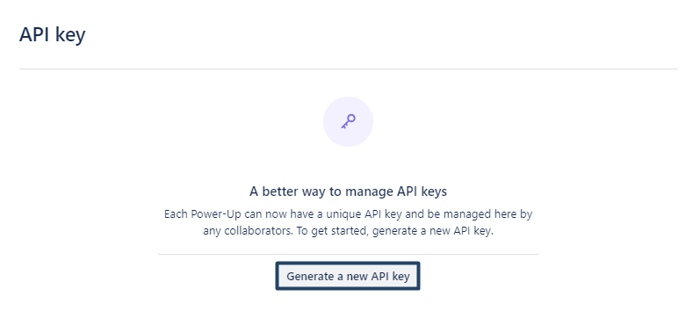

And then **"Generate API key"**

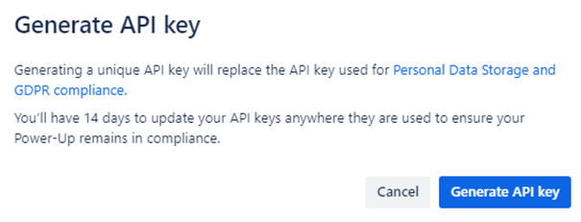

We need the **API key**. **Forget the other options**. **Copy and paste your API Key somewhere safe**, because we will need it in order to make requests and click on **Token**.

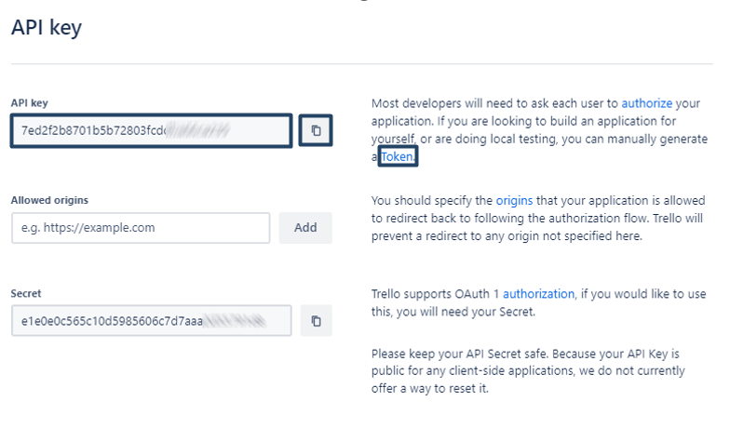

On the page that will **open in a new tab**, you have to **give permission** to **your Power-Up** (in our case, we named our Power-Up "Postman", remember?) to **use your Trello Account**.

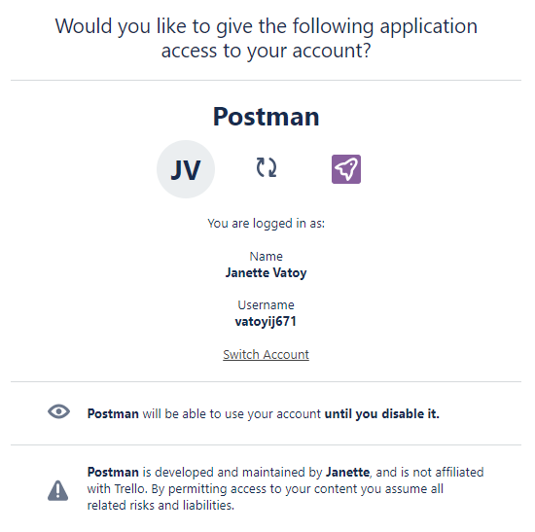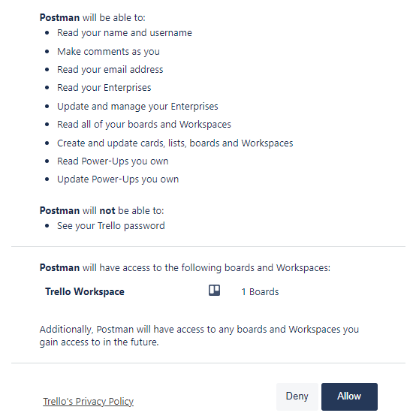

And it will **generate your Token**. **Copy and paste this Token somewhere safe**, because you will need it in your Postman requests.

