Created Playwright with Java code using vibe coding for AI Browser extension
PRompt given for ASK

Context : Act as a software automation test lead having experience in Playwright with Java and wants to modify the existing AI browser extension code to append Playwright with Java

Instruction :
[MANDATORY]: Analyse the impacted files of existing Selenium with Java code properly
[MANDATORY]: Also analyse the impacted files for modifing the code for playwright with Java

Persona : Act as a test automation lead and review the impacted files shared. Finally share me the impacted files for Selenium with Java code and files that will be imacted for appending playwright with Java arhitecture

Prompt Given for Agent
Act as a test automation architect and implement these changes step and step carefully without affecting the existing functionality or code. STRICTLY Lets go Step by Step And show me the changes that will be implemented in the files and proceed further only upon my approval

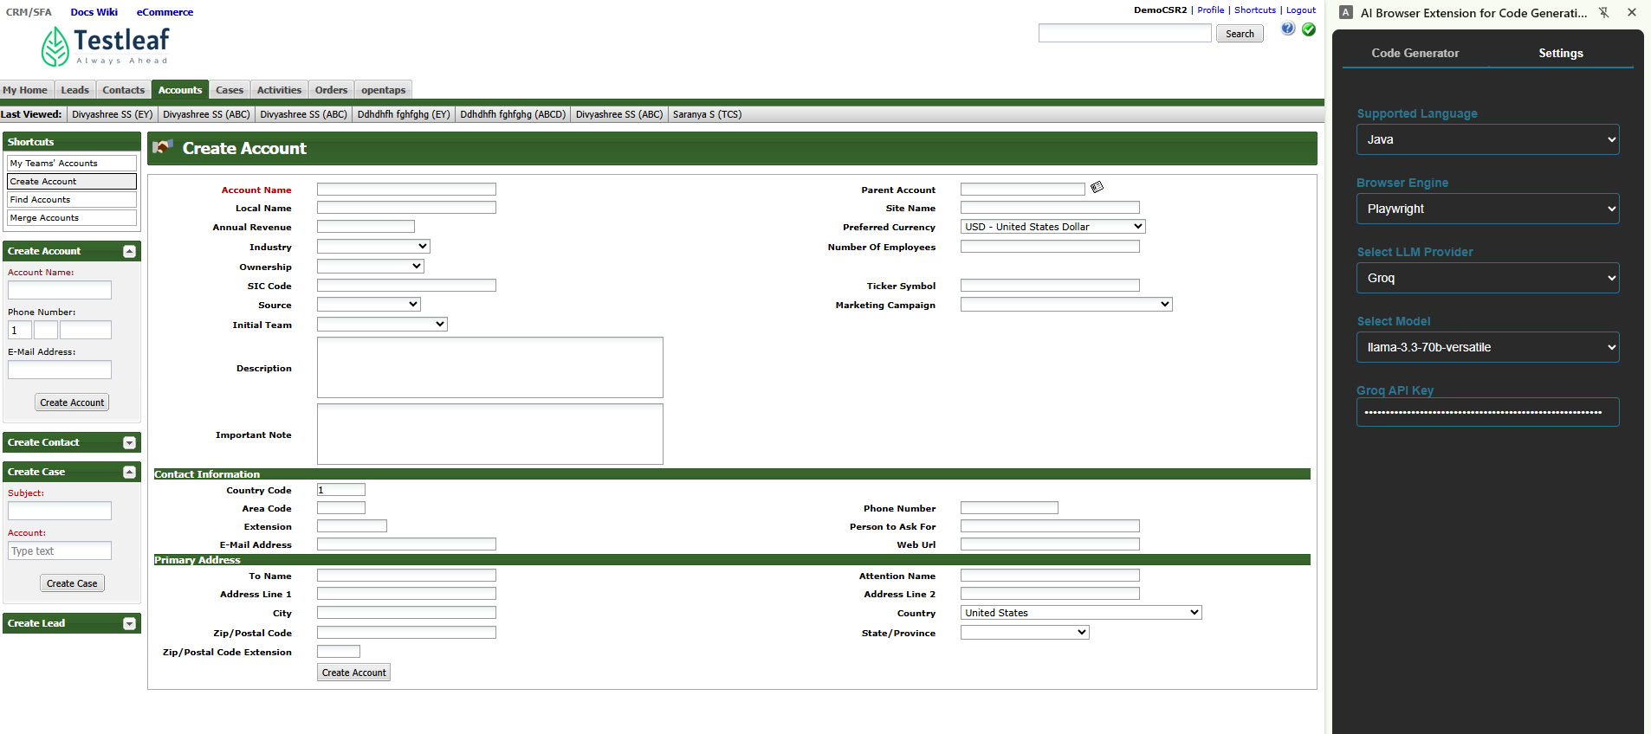
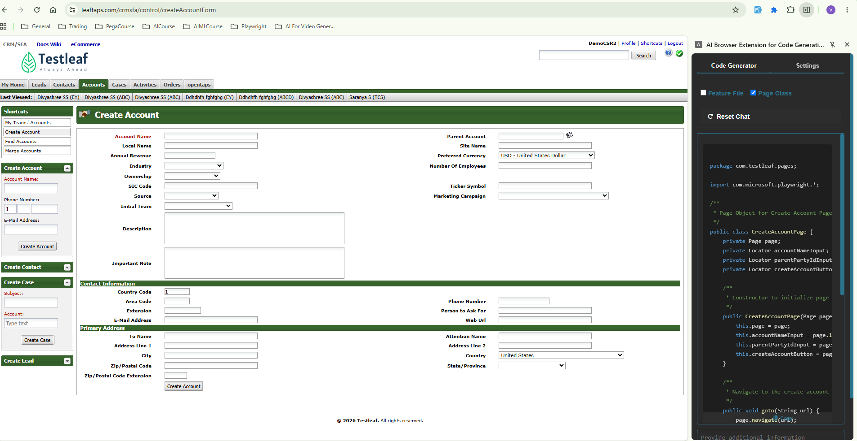

There was an issue. If I select only feature file checkbox, then also code was getting generated. Again with Vibe coding, I was able to fix the issue
Issue
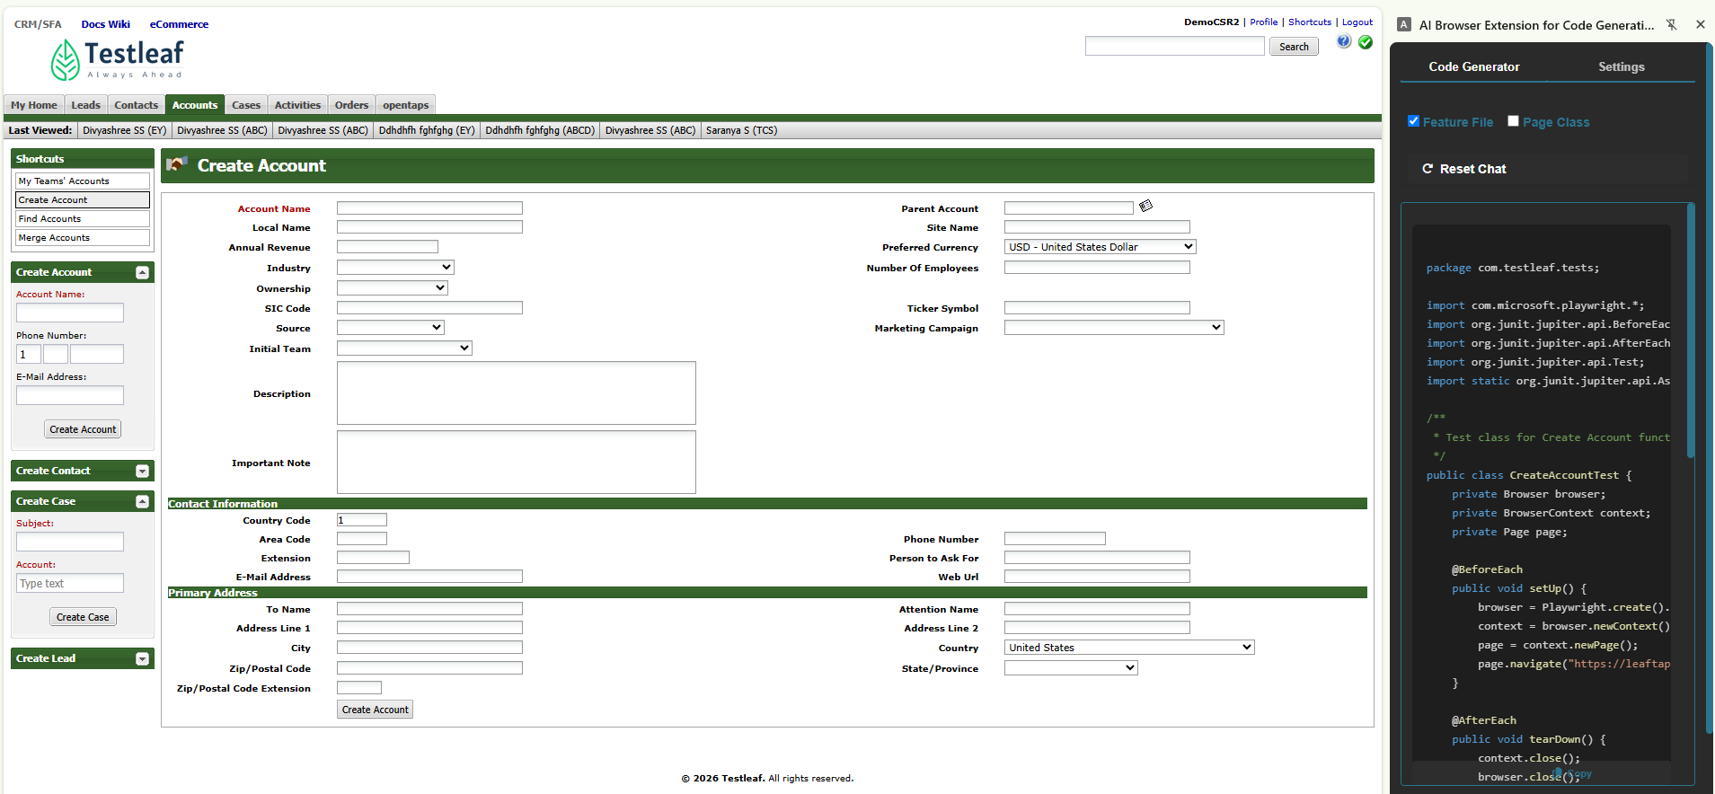

Issue Fixed
