OpenGammaKit
Assembly Guide v0.1.3

Exploded Assembly View
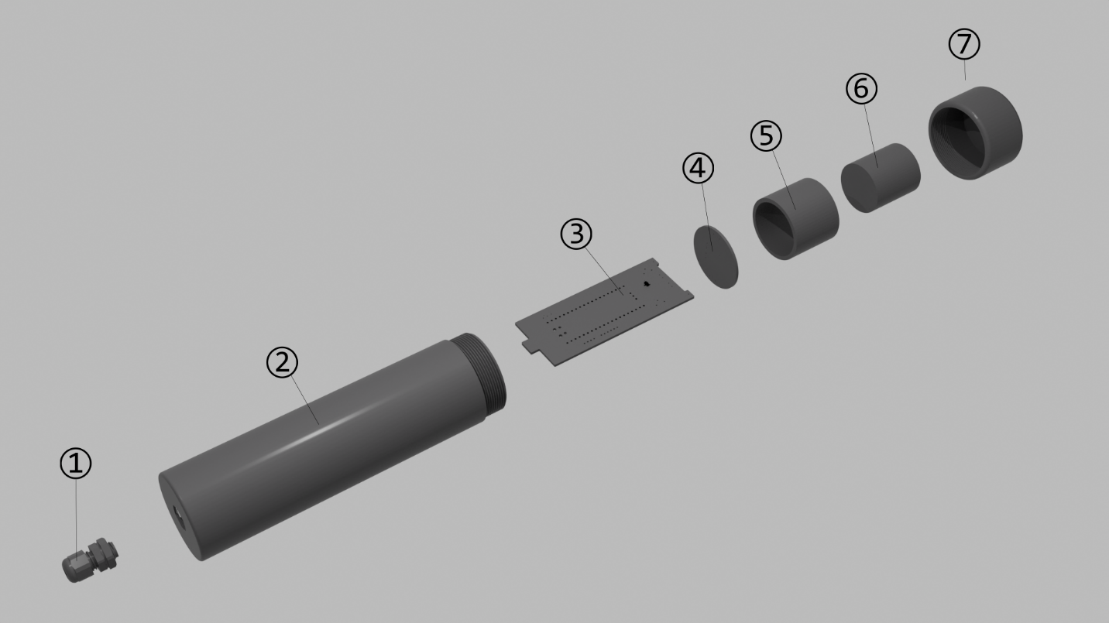
Parts List
- Cable gland
- Enclosure tube
- Main board
- SiPM board
- Spacer ring
- Scintillation crystal NaI(Tl)
- End cap

Assembly Sequence
- Print the enclosure enclosure tube (2), inner support ring (6), end cap (7). Use 3d printing settings from Appendix A.
- Insert the USB cable (3.5 mm diameter) through the cable gland (1).
- Solder the USB Micro connector to the cable, adding a 4.7 – 5.1 kΩ resistor between the CC (Configuration Channel) and GND pins (see Appendix B).
- Feed the cable with the connector through the enclosure tube (2).
- Secure the cable gland (1) inside the enclosure to hold the cable firmly in place.
- Solder the SiPM board (4) to the main board (3) and connect it to the USB Micro connector.
- Insert the main board (3) into the internal guide slots of the enclosure tube (2), pulling the cable through the cable gland.
  - The SiPM board should rest precisely on the inner support ring (6) inside the enclosure.
  - The SiPM sensor must face outward from the enclosure.
- Tighten the cable gland on the outside of the enclosure.
- Apply a small drop of silicone oil to the surface of the SiPM to ensure good optical coupling.
- Insert the spacer ring (5) into the upper part of the enclosure.
- Place the NaI(Tl) scintillation crystal (6) inside the spacer ring.
- Screw the end cap (7) onto the top of the enclosure with light tension—tight enough to secure the crystal without applying excessive force.
- (Optional – Light Shielding):
If the enclosure is made of optically transparent plastic, the SiPM must be protected from external light exposure.
  - Slide a black heat-shrink tube (50 mm diameter) over the assembled enclosure.
  - Gently heat the shrink tubing to fit snugly, taking care not to overheat or deform the plastic enclosure.

Notes
- Ensure that all solder joints are clean and free of flux residues.
- Avoid touching the surface of the SiPM or the crystal directly—use gloves or optical tissue if necessary.
- Verify correct alignment before sealing the enclosure.

Appendix A
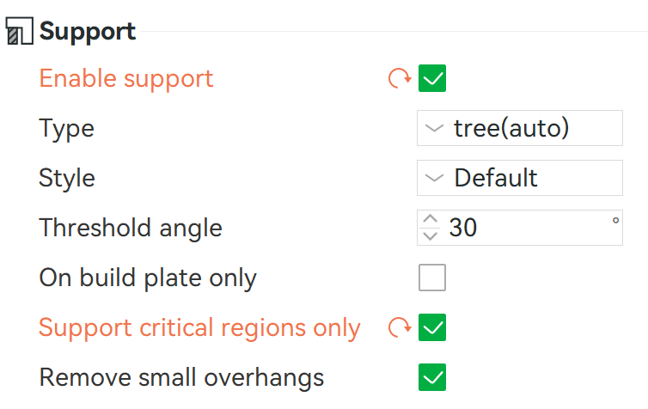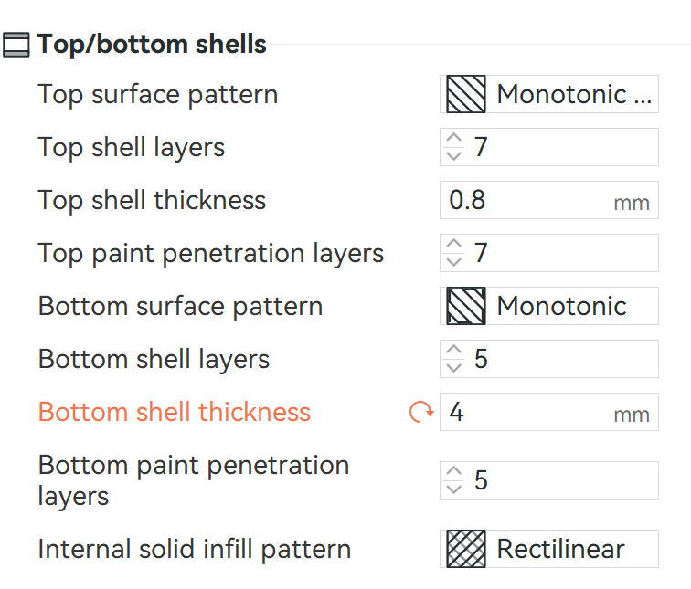
3D printing settings

Appendix B
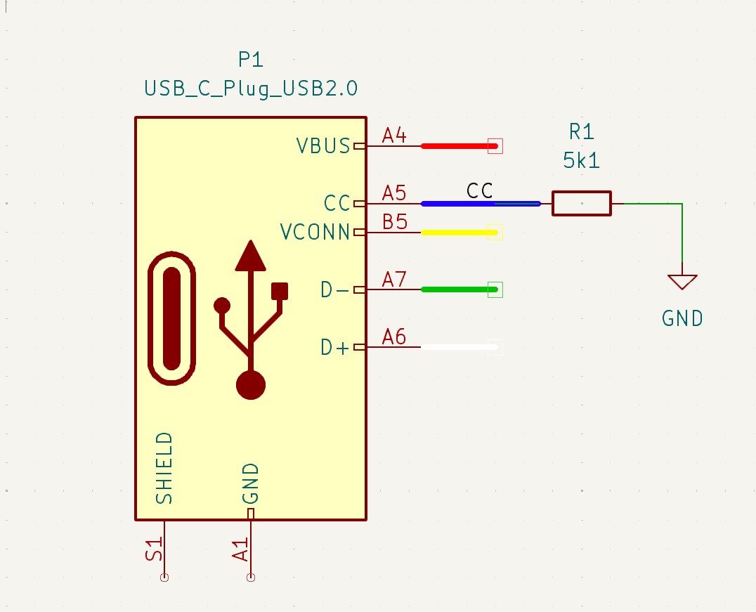
USB Type-C Cable schema

