Project Proposal
On

Hospital Management System

Guided By: Mr. Anuj Kumar
Created By: Silki , Vikul
AFid: AF04991241 and AF04991727

Batch Code: ANP-D2405
Course Code: ITPR

Table Of Contents
Index

- Title of the Project…………………………….
- Introduction……………………………………
- Objective
- Project Category
- Analysis
○ Modules and Description
○ Database Design
○ ER Diagram
○ Data Flow Diagram
- Complete Structure
○ Process Logical Diagram
- Platform Used
○ Hardware Requirement
○ Software Requirement
- Future Scope
- Bibliography

INTRODUCTION

The Hospital Management System (HMS) is a digital solu on designed to manage all hospital ac vi es efficiently. It helps in handling pa ent records, doctor informa on, appointment scheduling, staff details, medicines, and billing in a smooth and organized way.
By replacing manual work with an automated system, it reduces errors, saves me, improves accuracy, and ensures be er pa ent care.
This system provides a centralized pla orm where all hospital data can be accessed quickly and securely, making hospital opera ons faster and more efficient.

This system is specifically designed to enhance hospital produc vity, improve data accuracy, and support healthcare staff in delivering be er pa ent services.

OBJECTIVE

The primary objec ves of the Hospital Management System are:

- To digitalize pa ent registra on and medical records
- To automate doctor scheduling and appointment handling
- To maintain accurate billing and payment records
- To reduce manual workload and minimize human errors
- To provide secure and role-based access to hospital staff
- To enable fast and reliable data retrieval whenever required

PROJECT CATEGORY
💻 ⚙ Language: Java
🗄 Database: MySQL
🔗 Connec vity: JDBC
🛠 IDEs: Eclipse
📦 Tools: MySQL Server

ANALYSIS

a) Modules and Descrip on

1. Pa ent Management Module
- Add new pa ent
- View all pa ents
- Search pa ent by ID

2. Doctor Management Module
- View all doctors
- Search doctor by ID

3. Appointment Management Module
- Book appointment
- Check pa ent exists
- Check doctor availability
- View all appointments
4. Medicines Management Module
- Add medicine
- Update stock
- View all medicines

5. Billing Module
- Create pa ent bill
- Calculate total amount
- Manage payment status

6. User/ Admin Module
- Secure login system for administrator
- Admin can add/remove users
- Role-based access

7. Staff Module • Add staff
• View staff

b) Database Design
Main tables used:
PATIENTS Table Design:
Fields | Datatype | Proper es
pa ent_id | int | Primary key, not null, auto_increment
name | varchar(100) | not null
age | Int | not null
gender | Varchar(10) | not null

DOCTORS Table Design:
Fields | Datatype | Proper es
doctor_id | int | Primary key, not null, auto_increment
name | varchar(100) | not null
specializa on | varchar(100) | not null

APPOINTMENT Table Design:
Fields | Datatype | Proper es
appointment_id | int
pa ent_id | int | Foreign key, not null
doctor_id | int | Foreign key, not null
appointment_date | date | not null

MEDICINE Table Design:
Fields | Datatype | Proper es
medicine_id | int | Primary key, not null, auto_increment
name | varchar(100) | not null
quan ty | int | not null
price | decimal(10,2) | not null

BILL Table Design:
Fields | Datatype | Proper es
bill_id | int | Primary key, not null, auto_increment
pa ent_id | int | Foreign key, not null
doctor_fee | decimal(10,2) | not null
room_charges | decimal(10,2) | Default 0
medicine_charges | decimal(10,2) | Default 0
other_charges | decimal(10,2) | Default 0
total_amount | decimal(10,2) | not null
payment_status | varchar(20) | not null
bill_date | date | not null

STAFF Table Design:
Fields | Datatype | Proper es
staff_id | int
name | varchar(100) | not null
role | varchar(50) | not null
phone | varchar(15) | not null
salary | decimal(10,2) | not null

USER/ADMIN Table Design:
Fields | Datatype | Proper es
user_id | int | Primary key, not null
username | varchar(50) | Unique not null
password | varchar(100) | not null
role | varchar(30) | Default ‘admin’

The design follows normaliza on rules to avoid redundancy and ensure data integrity.

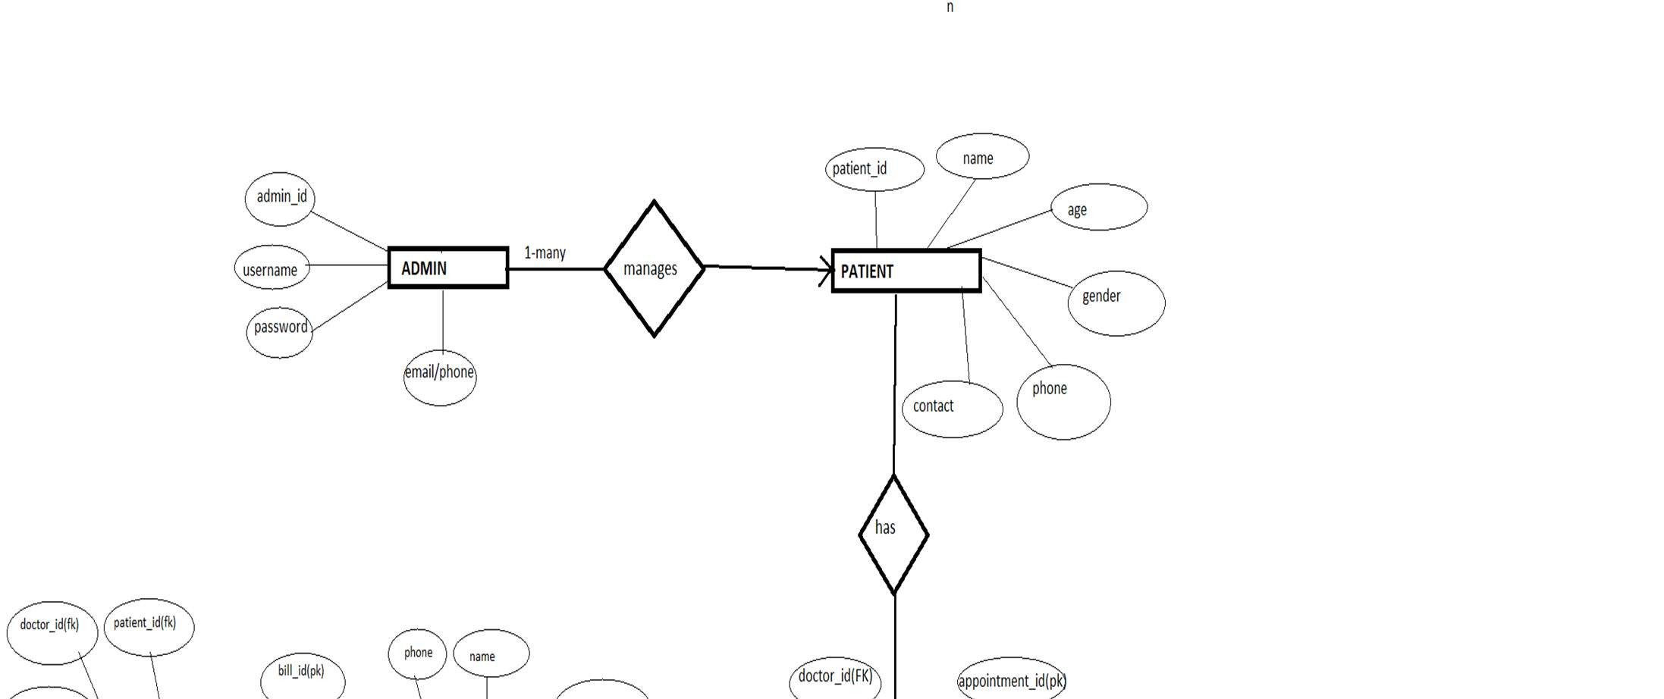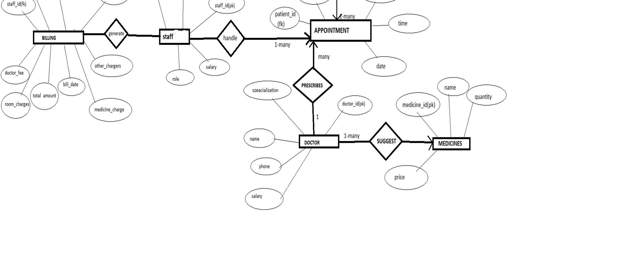
ER DIAGRAM

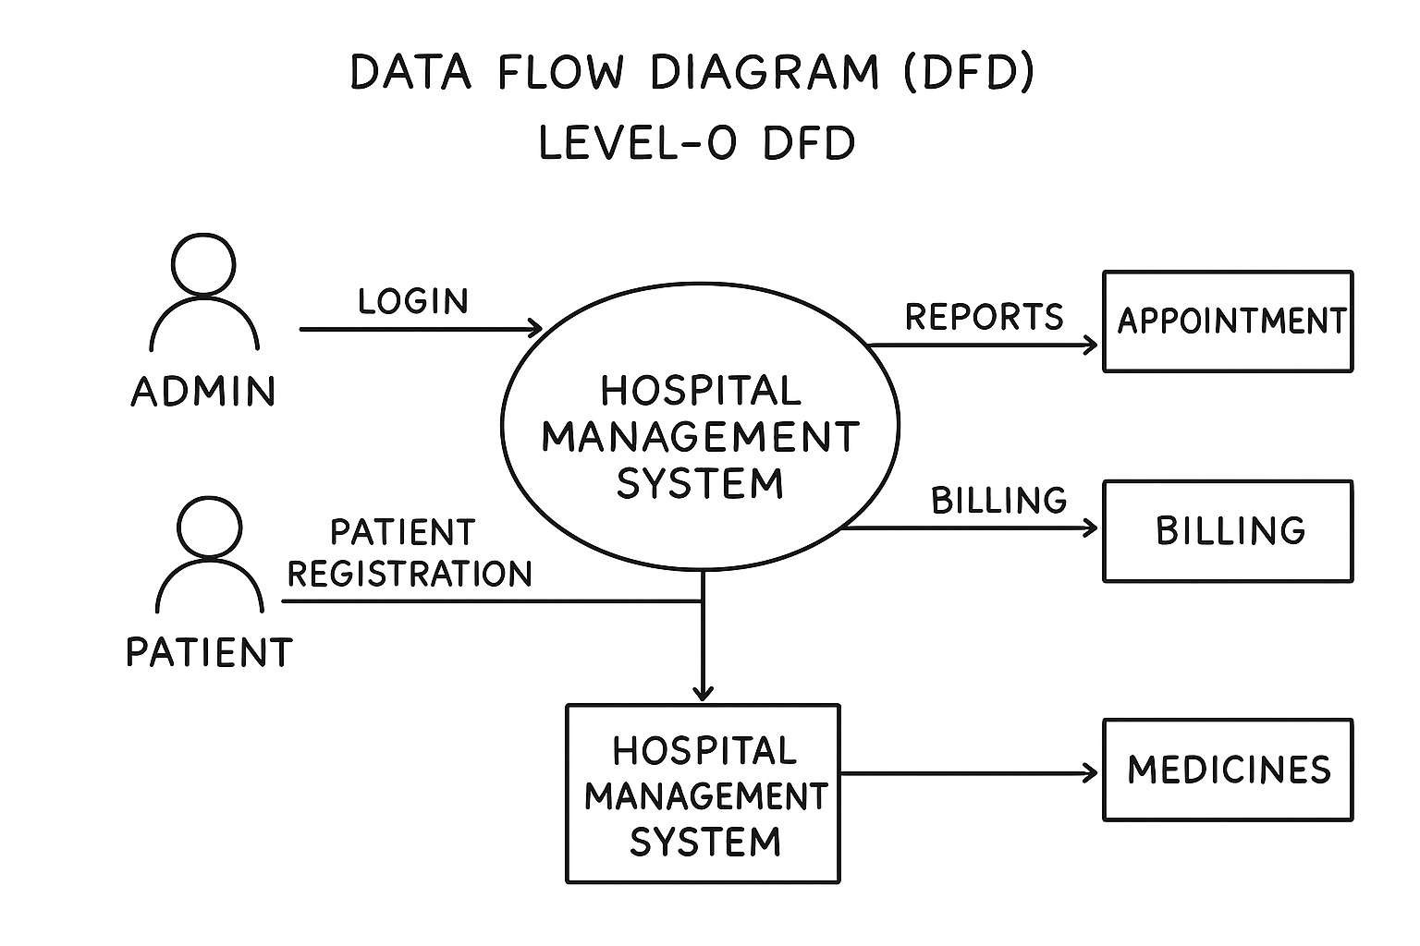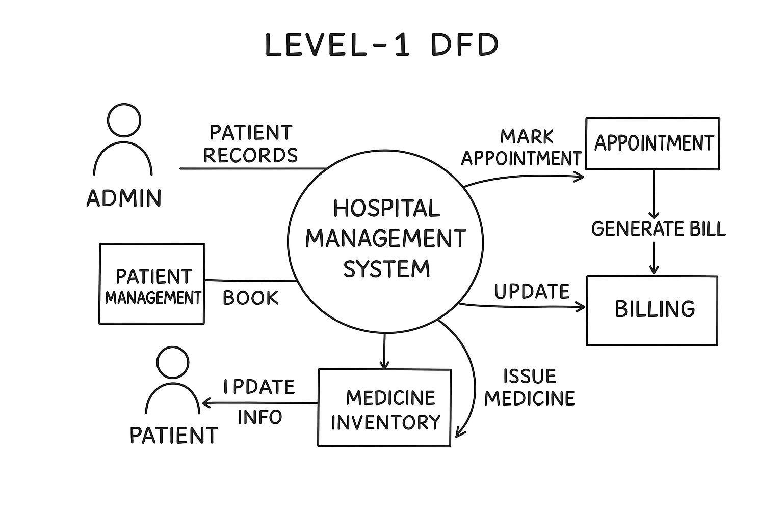

DATA FLOW DIAGRAM (DFD)

COMPLETE STRUCTURE
• Process Logic Diagram

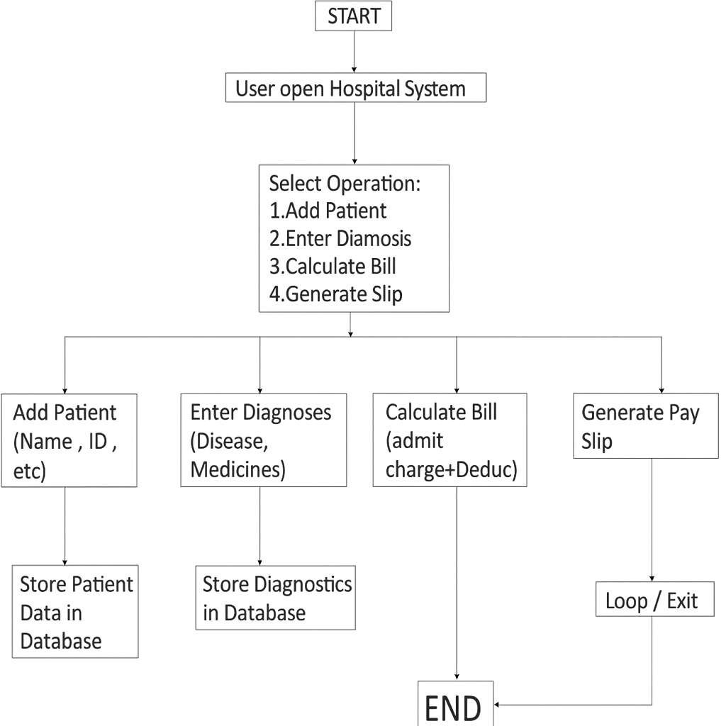

Platform Used

- Hardware Requirements
  - Processor: Intel i3 or higher
  - RAM: Minimum 4GB
  - Hard Disk: 500MB free space
  - Operating System: Windows/Linux/Mac

- Software Requirements
  - JDK 8 or above
  - MySQL Server
  - MySQL Workbench / phpMyAdmin
  - IDE: Eclipse / IntelliJ IDEA / NetBeans
  - JDBC Driver
  - OS: Windows 10/11

FUTURE SCOPE

- Automated Billing with UPI/Online Payments

- Advanced Data Analy cs & Repor ng

- Cloud Hos ng for Remote Access

- Mobile app integra on

- Mul -Hospital Integra on

- Automated Medicine Inventory System

- Advanced Data Analy cs & Repor ng

BIBLIOGRAPHY

- Oracle Java Documenta on

- MySQL Official Documenta on

- JDBC API Guide

- Reference books on DBMS and Java Programming

- Online educa onal resources (GeeksforGeeks, TutorialsPoint, JavaTPoint)

