Introduction/Business problem:
I am an ardent movie lover and so are more than half the population of this world. In this project I am going to help people who are planning to make movies and also the ones planning to build theatres in USA. So my report will be able to help:
- People who wish to make short movies in USA can have an insight about which genre is the most popular.
- People who wish to build a theatre will be able oversee which town has the largest number of theatres and hence where to build them
- Also my fellow beginner data scientists

So these are the main problems I will be trying to address in my project

Data preparation
I have taken data mainly from Wikipedia from the pages
1)List of highest grossing movies
2)List of highest grossing movies in the super hero, horror, comedy, science fiction and animation genres
3)Lastly I have also used the Foursquare API to get data.
Methodology
The cinema of the United States has had a large effect on the film industry in general since the early 20th century. The dominant style of American cinema is the classical Hollywood cinema, which developed from 1913 to 1969 and characterizes most films made there to this day. While Frenchmen Auguste and Louis Lumière are generally credited with the birth of modern cinema,^{[6]} American cinema soon came to be a dominant force in the emerging industry. It produces the largest number of films of any single-language national cinema, with more than 700 English-language films released on average every year. While the national cinemas of the United Kingdom (299), Canada (206), Australia, and New Zealand also produce films in the same language, they are not considered part of the Hollywood system. Hollywood has also been considered a transnational cinema.^{[8]} Hollywood produced multiple language versions of some titles, often in Spanish or French. Contemporary Hollywood off-shores production to Canada, Australia, and New Zealand.
Hollywood is considered the oldest film industry where earliest film studios and production companies emerged, it is also the birthplace of various genres of cinema—among them comedy, drama, action, the musical, romance, horror, science fiction, and the war epic—having set an example for other national film industries.

So I started by first scraping out the data from Wikipedia of the highest grossing movies in the world just as an introduction the data was as follows:
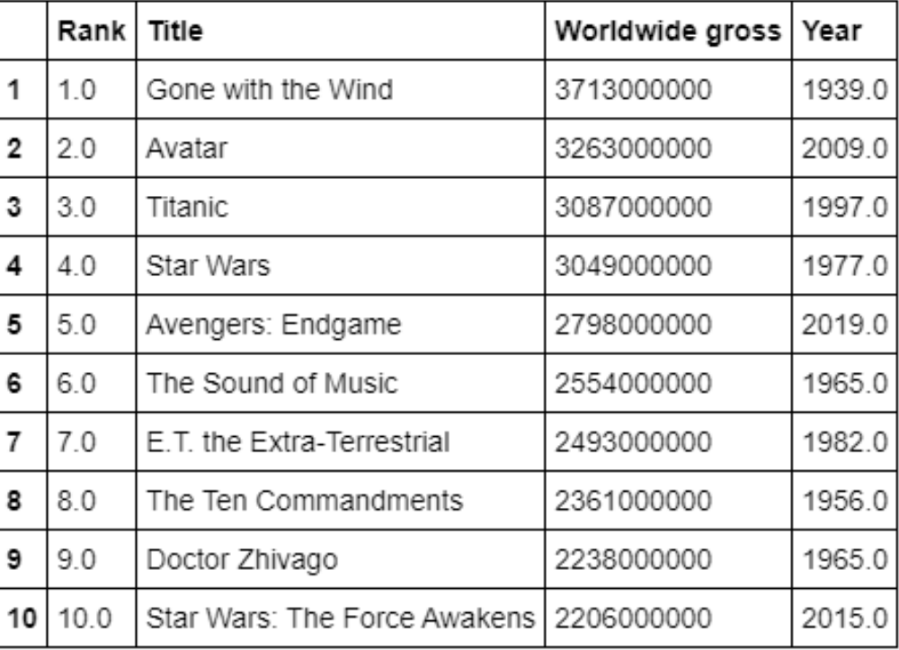

Then I scraped data for three different genres and plotted bar graphs to find out which year was most favourable for the different genres:
The associating graphs are shown below:
For action genre:
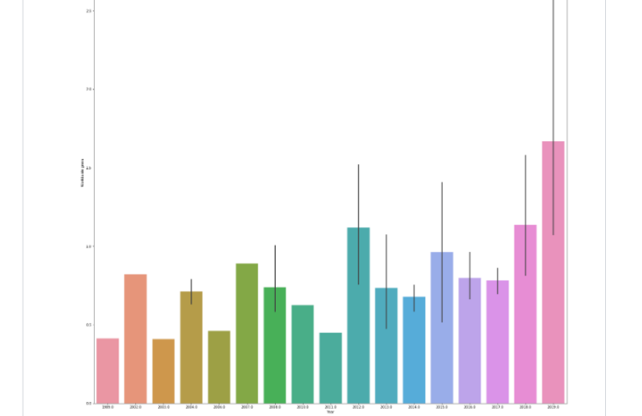

The graph shows that 2019 was the most popular year for action movies. The highest grossing movie was Avengers:Endgame
Now moving on to the science-fiction genre:
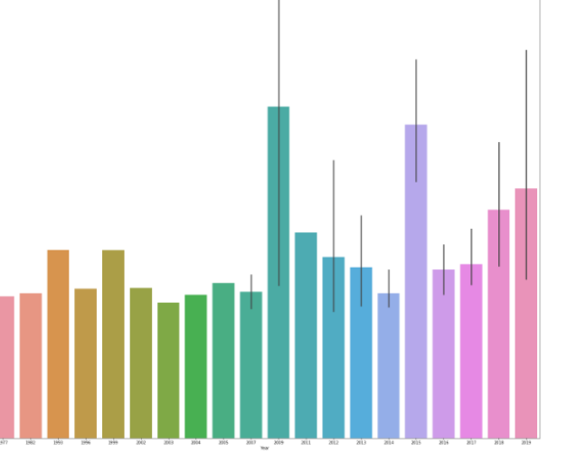
2009 was the most popular for this genre and few of the highest grossing movies in this genre were Avatar, Transformers : Revenge of the fallen etc.
Moving to the horror genre:
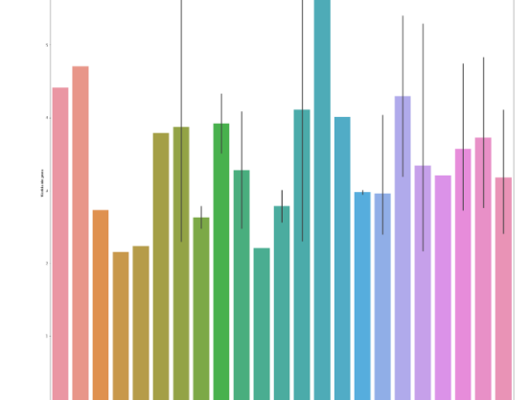
2007 was popular for horror.
Now going to the comedy and animation genres:

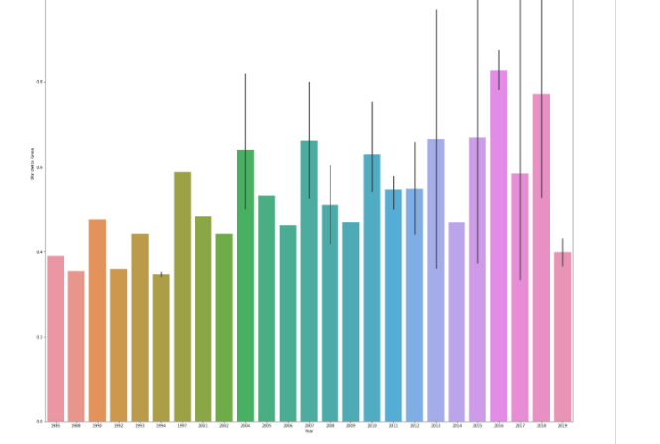
Comedy
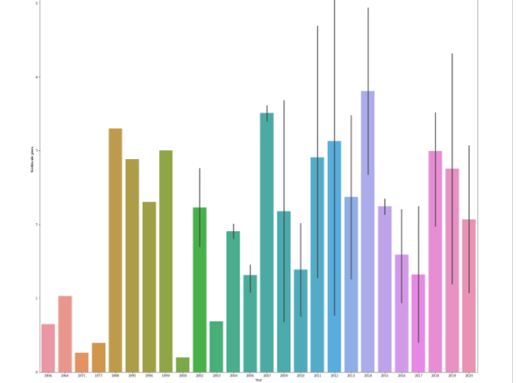
Horror
For comedy it was 2016 and for animation it was 2014.So now we have the data about all genres. Now we compare all these genres by creating a new data frame by combining the information about all these genres and we finally get a bar graph comparing the popularity of all these genres
A brief definition of all these genres before moving on to the result:
Comedy is a literary genre and a type of dramatic work that is amusing and satirical in its tone, mostly having a cheerful ending
Action film is a film genre in which the protagonist or protagonists are thrust into a series of events that typically include violence, extended fighting, physical feats, and frantic chases.
Science fiction (sometimes called sci-fi or just SF) is a genre of speculative fiction that typically deals with imaginative and futuristic concepts such as advanced science and technology, space exploration, time travel, parallel universes, and extraterrestrial life.
horror (pronounced hawr-er) is a genre of fiction whose purpose is to create feelings of fear, dread, repulsion, and terror in the audience—in other words, it develops an atmosphere of horror.
Animations are not a strictly-defined genre category, but rather a film technique, although they often contain genre-like elements.
Now moving on to our result
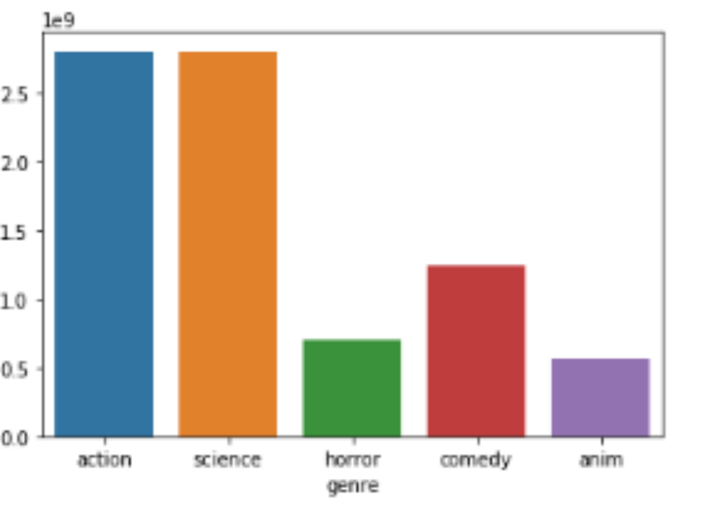
Alas!!!!! Action and science fiction are the most popular among movie-lovers in the U.S
Now moving on to the next aim of the project which is to find out which popular city in the US has the most number of theatres and hence which city is most popular for movies.
So first I used Wikipedia to find out the most populated cities in the world picked the top 20 and used the Foursquare app to find out the number of theatres in these cities.So first listing out the table of movie theatres in the top 20 cities:
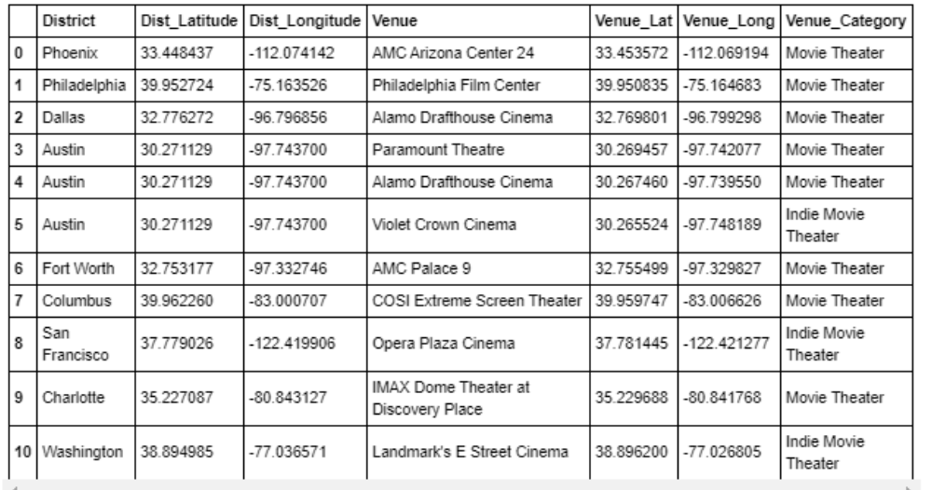
Now using the folium map plotting the number of theaters in the different cities and also plotting a bar graph to know the numbers. Here you go!!!
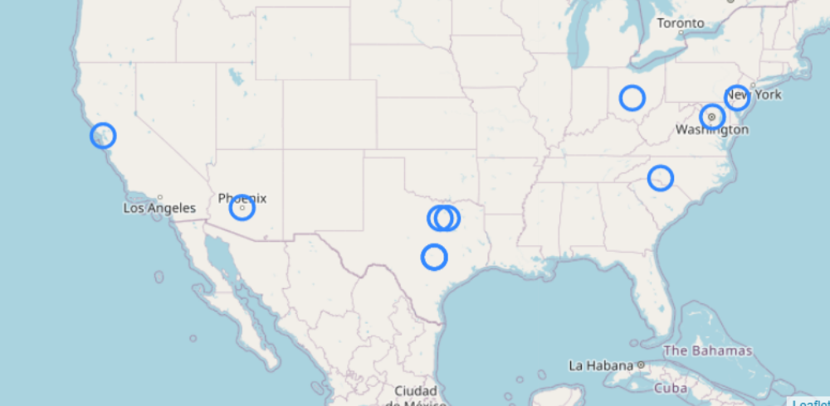
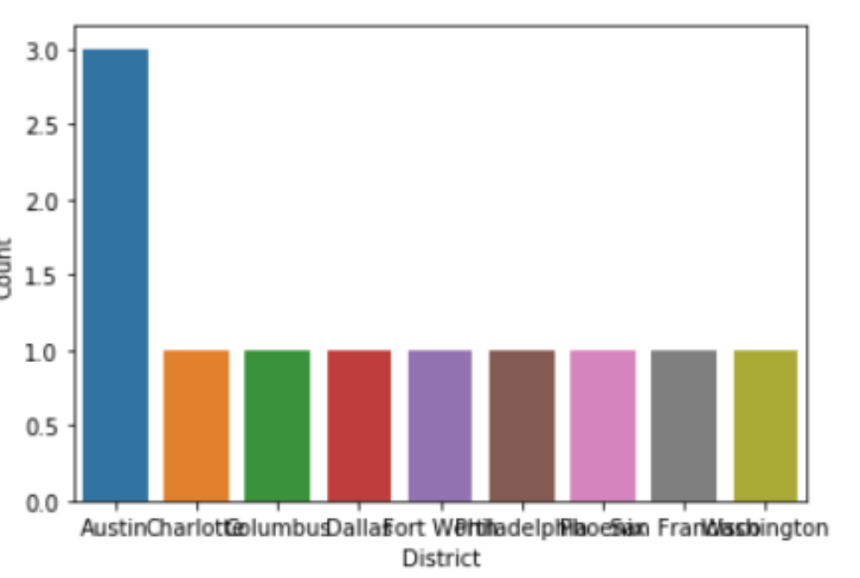

So Austin is the city with the most number of theatres

RESULT
So the result shows that action and science fiction movies are very popular among the American population and Austin is the city with the most number of theatres.

DISCUSSION
You can further check the age groups we have to target while going to make a short movie…and also movie locations which interest the people who watch movies, and further on this discussion
CONCLUSION
So towards the end I leave it up to you guys to work more on the conclusions that I have reached. Many thanks to IBM for providing me such a wonderful opportunity to experience the world of a data scientist. Cheers!!!

