Test Execution Report

This Test Execution Report includes status and screenshots of all the Test Steps of Test Cases which were included in scope. Following is the status,

|  |  |
| --- | --- |
| Total Test Cases Executed | 100 |
| Total Test Cases Passed | 95 |
| Total Test Cases Passed | 5 |

## Test Case : To verify that home page is loaded successfully STATUS : PASS

#### Test Step : Verify that url is accessed

Test Status = PASS

Expected Output = Home page should be accessible

Actual Output = URL accessed as expected

Test Type = get_url

SCREENSHOT

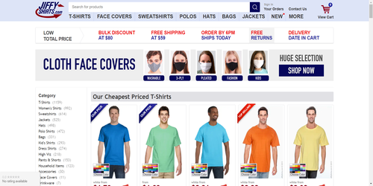

#### Test Step : Verify that Product Category Category is Visible

Test Status = PASS

Expected Output = Label should be Category

Reference String (Value to be checked on UI) = Category

Actual Output = Element found with label text as Category

Test Type = search_element

SCREENSHOT

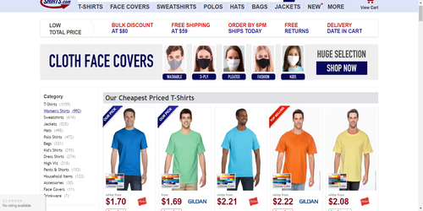

#### Test Step : Verify that Product Category Cut is Visible

Test Status = PASS

Expected Output = Label should be Cut

Reference String (Value to be checked on UI) = Cut

Actual Output = Element found with label text as Cut

Test Type = search_element

SCREENSHOT

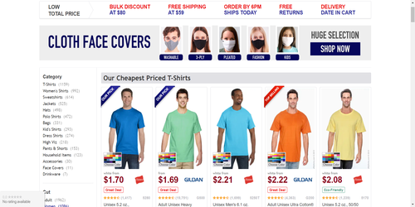

#### Test Step : Verify that Product Category Blend is Visible

Test Status = PASS

Expected Output = Label should be Blend

Reference String (Value to be checked on UI) = Blend

Actual Output = Element found with label text as Blend

Test Type = search_element

SCREENSHOT

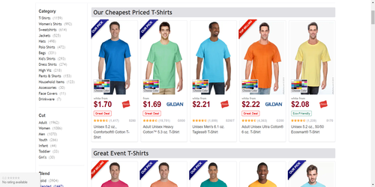

#### Test Step : Verify that Product Category Color Group is Visible

Test Status = PASS

Expected Output = Label should be Color Group

Reference String (Value to be checked on UI) = Color Group

Actual Output = Element found with label text as Color Group

Test Type = search_element

SCREENSHOT

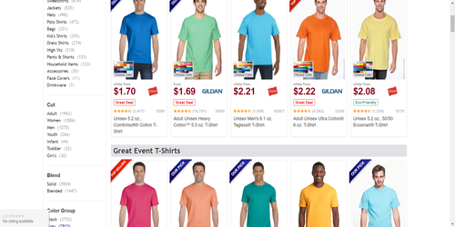

#### Test Step : Verify that Product Category Collar is Visible

Test Status = PASS

Expected Output = Label should be Collar

Reference String (Value to be checked on UI) = Collar

Actual Output = Element found with label text as Collar

Test Type = search_element

SCREENSHOT

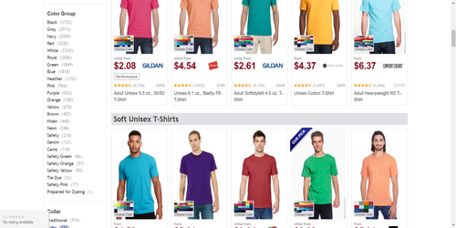

#### Test Step : Verify that Product Category Fabric is Visible

Test Status = PASS

Expected Output = Label should be Fabric

Reference String (Value to be checked on UI) = Fabric

Actual Output = Element found with label text as Fabric

Test Type = search_element

SCREENSHOT

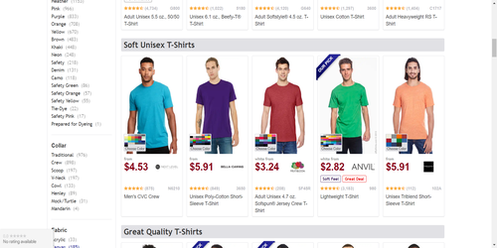

#### Test Step : Verify that Product Category Thickness is Visible

Test Status = PASS

Expected Output = Label should be Thickness

Reference String (Value to be checked on UI) = Thickness

Actual Output = Element found with label text as Thickness

Test Type = search_element

SCREENSHOT

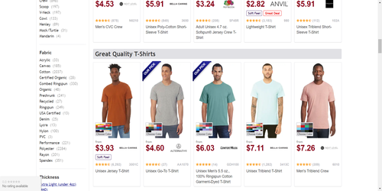

#### Test Step : Verify that Product Category Size is Visible

Test Status = PASS

Expected Output = Label should be Size

Reference String (Value to be checked on UI) = Size

Actual Output = Element found with label text as Size

Test Type = search_element

SCREENSHOT

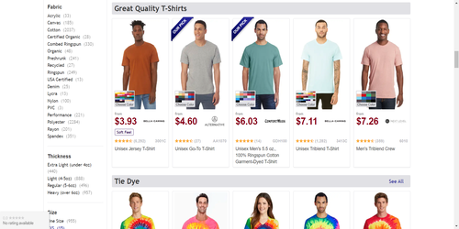

#### Test Step : Verify that Product Category Tag is Visible

Test Status = PASS

Expected Output = Label should be Tag

Reference String (Value to be checked on UI) = Tag

Actual Output = Element found with label text as Tag

Test Type = search_element

SCREENSHOT

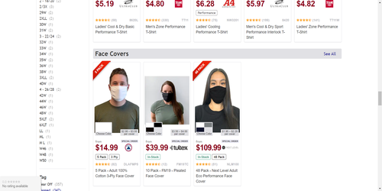

#### Test Step : Verify that Product Category Brand is Visible

Test Status = PASS

Expected Output = Label should be Brand

Reference String (Value to be checked on UI) = Brand

Actual Output = Element found with label text as Brand

Test Type = search_element

SCREENSHOT

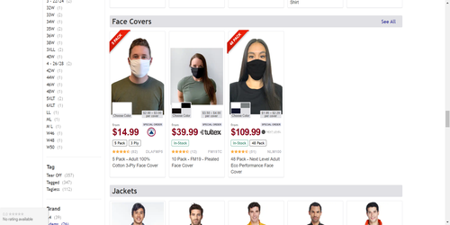

#### Test Step : Verify that Product Category Brand Logo is Visible

Test Status = PASS

Expected Output = Label should be Brand Logo

Reference String (Value to be checked on UI) = Brand Logo

Actual Output = Element found with label text as Brand Logo

Test Type = search_element

SCREENSHOT

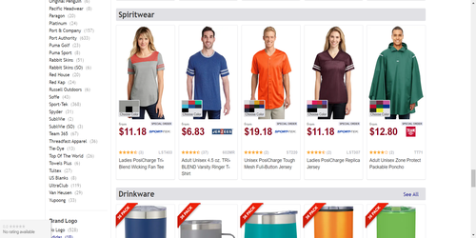

#### Test Step : Verify that Product Category Material is Visible

Test Status = PASS

Expected Output = Label should be Material

Reference String (Value to be checked on UI) = Material

Actual Output = Element found with label text as Material

Test Type = search_element

SCREENSHOT

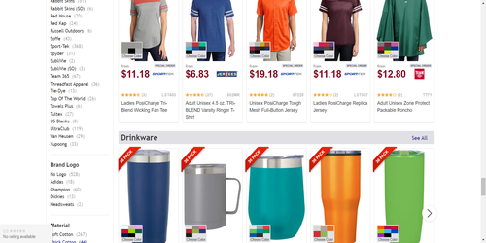

#### Test Step : Verify that Product Category Treatment is Visible

Test Status = PASS

Expected Output = Label should be Treatment

Reference String (Value to be checked on UI) = Treatment

Actual Output = Element found with label text as Treatment

Test Type = search_element

SCREENSHOT

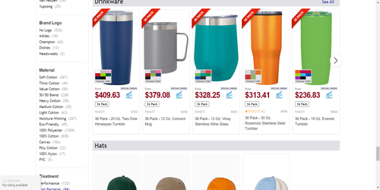

#### Test Step : Verify that Product Category Fulfillment Group is Visible

Test Status = PASS

Expected Output = Label should be Fulfillment Group

Reference String (Value to be checked on UI) = Fulfillment Group

Actual Output = Element found with label text as Fulfillment Group

Test Type = search_element

SCREENSHOT

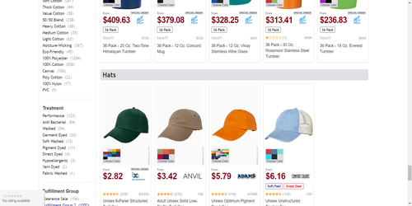

#### Test Step : Verify that Product Category Special is Visible

Test Status = PASS

Expected Output = Label should be Special

Reference String (Value to be checked on UI) = Special

Actual Output = Element found with label text as Special

Test Type = search_element

SCREENSHOT

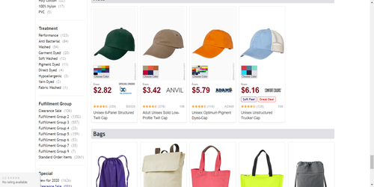

#### Test Step : Verify that url is re-accessed for next Test

Test Status = PASS

Expected Output = Home page should be re-accessible

Actual Output = URL accessed as expected

Test Type = get_url

SCREENSHOT

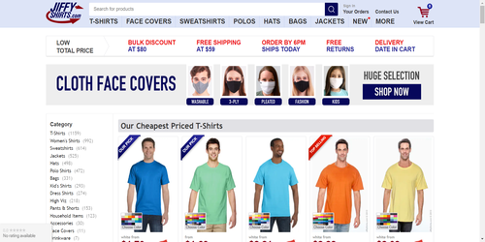

## Test Case : To verify that home page is loaded successfully STATUS : FAIL

#### Test Step : Verify that url is accessed

Test Status = PASS

Expected Output = Home page should be accessible

Actual Output = URL accessed as expected

Test Type = get_url

SCREENSHOT



#### Test Step : Verify that Product Category Category is Visible

Test Status = PASS

Expected Output = Label should be Category

Reference String (Value to be checked on UI) = Category

Actual Output = Element found with label text as Category

Test Type = search_element

SCREENSHOT



#### Test Step : Verify that Product Category Cut is Visible

Test Status = PASS

Expected Output = Label should be Cut

Reference String (Value to be checked on UI) = Cut

Actual Output = Element found with label text as Cut

Test Type = search_element

SCREENSHOT



#### Test Step : Verify that Product Category Blend is Visible

Test Status = PASS

Expected Output = Label should be Blend

Reference String (Value to be checked on UI) = Blend

Actual Output = Element found with label text as Blend

Test Type = search_element

SCREENSHOT



#### Test Step : Verify that Product Category Color Group is Visible

Test Status = PASS

Expected Output = Label should be Color Group

Reference String (Value to be checked on UI) = Color Group

Actual Output = Element found with label text as Color Group

Test Type = search_element

SCREENSHOT



#### Test Step : Verify that Product Category Collar is Visible

Test Status = PASS

Expected Output = Label should be Collar

Reference String (Value to be checked on UI) = Collar

Actual Output = Element found with label text as Collar

Test Type = search_element

SCREENSHOT



#### Test Step : Verify that Product Category Fabric is Visible

Test Status = PASS

Expected Output = Label should be Fabric

Reference String (Value to be checked on UI) = Fabric

Actual Output = Element found with label text as Fabric

Test Type = search_element

SCREENSHOT



#### Test Step : Verify that Product Category Thickness is Visible

Test Status = PASS

Expected Output = Label should be Thickness

Reference String (Value to be checked on UI) = Thickness

Actual Output = Element found with label text as Thickness

Test Type = search_element

SCREENSHOT



#### Test Step : Verify that Product Category Size is Visible

Test Status = PASS

Expected Output = Label should be Size

Reference String (Value to be checked on UI) = Size

Actual Output = Element found with label text as Size

Test Type = search_element

SCREENSHOT



#### Test Step : Verify that Product Category Tag is Visible

Test Status = FAIL

Expected Output = Label should be Tag

Reference String (Value to be checked on UI) = Vikram

Actual Output = Element found with label text as Tag

Test Type = search_element

SCREENSHOT



#### Test Step : Verify that Product Category Brand is Visible

Test Status = PASS

Expected Output = Label should be Brand

Reference String (Value to be checked on UI) = Brand

Actual Output = Element found with label text as Brand

Test Type = search_element

SCREENSHOT



#### Test Step : Verify that Product Category Brand Logo is Visible

Test Status = PASS

Expected Output = Label should be Brand Logo

Reference String (Value to be checked on UI) = Brand Logo

Actual Output = Element found with label text as Brand Logo

Test Type = search_element

SCREENSHOT



#### Test Step : Verify that Product Category Material is Visible

Test Status = PASS

Expected Output = Label should be Material

Reference String (Value to be checked on UI) = Material

Actual Output = Element found with label text as Material

Test Type = search_element

SCREENSHOT



#### Test Step : Verify that Product Category Treatment is Visible

Test Status = PASS

Expected Output = Label should be Treatment

Reference String (Value to be checked on UI) = Treatment

Actual Output = Element found with label text as Treatment

Test Type = search_element

SCREENSHOT



#### Test Step : Verify that Product Category Fulfillment Group is Visible

Test Status = PASS

Expected Output = Label should be Fulfillment Group

Reference String (Value to be checked on UI) = Fulfillment Group

Actual Output = Element found with label text as Fulfillment Group

Test Type = search_element

SCREENSHOT



#### Test Step : Verify that Product Category Special is Visible

Test Status = PASS

Expected Output = Label should be Special

Reference String (Value to be checked on UI) = Special

Actual Output = Element found with label text as Special

Test Type = search_element

SCREENSHOT



#### Test Step : Verify that url is re-accessed for next Test

Test Status = PASS

Expected Output = Home page should be re-accessible

Actual Output = URL accessed as expected

Test Type = get_url

SCREENSHOT



## Test Case : To verify that Demo site is accessed STATUS : PASS

#### Test Step : Verify that user is able to access url

Test Status = PASS

Expected Output = Webpage Is accessed

Actual Output = URL accessed as expected

Test Type = get_url

SCREENSHOT

