DALFI Tenant Onboarding

2021

DALFI Purpose
A general-purpose Data Access Utility to query & extract GRID data which provides ability for consumers to pull data out of GRID for their own application specific needs
Getting data into GRID – there is essentially one way: SOR Events + PROOF + GDF​
GRID data platform has a well-defined pattern for getting data in: ​
- SORs publish close events​
- PROOF synchronizes events into a synthetic close then loads to the RDZ​
- GRID Data Framework materializes dataframes from raw data in RDZ​

Tenant Onboarding
Guiding principle to onboard tenants to DALFI .
Tenant Responsibilities​
  - Tenant should expose rest end point for PROOF invocation to inform data readiness
  - Tenant need to get certificate and install .pfx certificate in local machine to call DALFI API ​securely using certificate-based authentication
  - Tenant will get the response from DALFI API in the form of stream by default .If they receive out of Memory exception or if tenant want to override default streaming option to file ,then can run/rerun with Delivery option of File
  - Tenant should provide status (success/failure – with failure message) to PROOF​ using proof end point
  - Tenants should provide the query requirements and work with Dalfi team to configure the query

PROOF Responsibilities
- PROOF orchestration will invoke Tenant Rest end point to inform data readiness and will maintain the status of the operation in PROOF. ​
- Proof will give back endpoint where tenant can update the status back
- PROOF will provide option to rerun from Proof UI in case of failure response or if there is an underlying base data frame change
- PROOF Features: Comprehensive PROOF monitoring UI, Rerun, Hold and app insight log​

DALFI Responsibilities
- Tenant certificate installation in Dalfi and authentication based on tenant certificate
- Provide end point for tenant to call to query & extract GRID data
- Repository for Query definition
- Deliver data in the form of stream and file
DALFI High Level Architecture
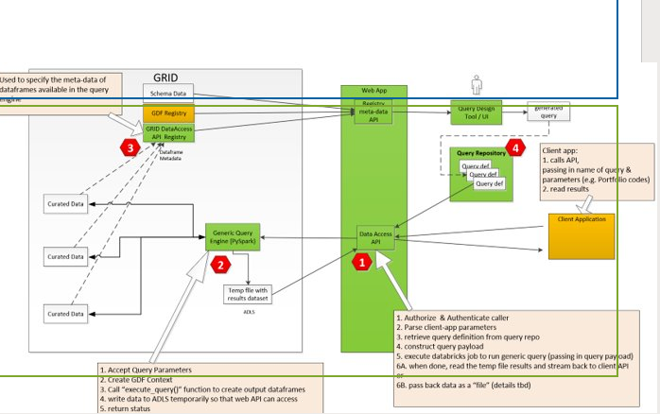

PROOF-TENANT- DALFI Low Level Design

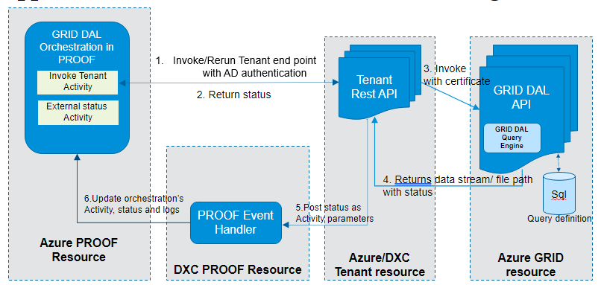

Authentication Requirements
Certificate authentication
The certificate installation steps below in blue to be performed by engineering team are one-time
process and needs to be updated only when the existing certificate is expired ​

At tenant side:​
- Firewall request to access Azure in case of DXC tenant​
- Get the certificates from Engineering team ( both .pfx and .cer file ) ​
- Install the .pfx file ( private key )in tenant DXC box ​
- Share the .cer file (public key ) with Cloud Ops & GRID DAL API team ​
- To call GRID DAL API securely with certificate ,pass the certificate in header for tenant ( base 64 encoded format) -> GRID API call using HTTP Client ​
- Verify the connectivity after certificate installation

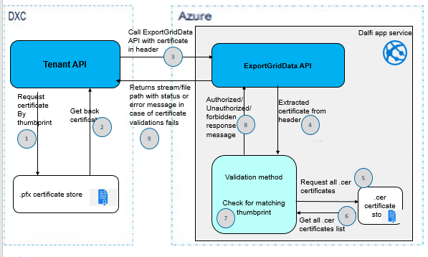

PROOF-TENANT- DALFI FLOW

Proof to Tenant API

Proof will call tenant API endpoint to inform the data availability
// tenant API endpoint is required all env
DEV
INT
QA
PROD

Proof service id needs to be added in tenants service AD groups or should be given access to the REST endpoints. Proof service Id as below

Dev | INT | QA | PROD
AT1227601 | AI1227601 | AQ1227601 | AP1227601

//Tenants service AD details should be provided for DEV, INT, QA and PROD environment.
DEV
INT
QA
PROD

Sample payload structure from Proof to tenant API:
{​
{Name: “AsOfDate”,Value:”2021-20-01”},​
{Name: “Region”, Value: “glob”},​
{Name: “Period”, Value:” d”},​
{Name: “PayloadTag”,Value:”query_mis_coml_posi“},​
{Name: “EaiCode” ,Value:”13066”},​
{Name: “ActivityInstanceId”,Value:”101”},​
{Name: ”OrchestrationInstanceId”,Value:”2001”}​
}
Tenant to Dalfi API

DALFI endpoints
FW/ proxy needs to be requested to below endpoint
DEV | https://dev-grid-dal-api.iazedsase0002.appserviceenvironment.net
INT | https://int-grid-dal-api.iazetsase0001.appserviceenvironment.net
QA
PROD

DALFI Endpoint for Data Retrieval in all environments:
Certificate should be passed in header for calling below API
DEV | https://dev-grid-dal-api.iazedsase0002.appserviceenvironment.net/v1/Dalfi/ExportGridData
INT | https://int-grid-dal-api.iazetsase0001.appserviceenvironment.net/v1/Dalfi/ExportGridData
QA
PROD

Tenant to Dalfi endpoint Sample payload structure:
{​
"query": "asset_master_party_relations", ​
"as_of_date":"20200817",​
"region":"glob",​
"period":"d",​
“deliveryoption":"file",​ --Optional
"eaicode":"9683", ​
"orchestrationInstanceId": "2001",​
"activityisntanceid":"101",​
"parameters" : { “parameter”:"PORTFOLIOS" ,”value”: “['ADL', '0BU’]”} ​
}

Tenant to access DALFI NAS path

Tenants service id needs to be added in DALFI service AD group with read access and the service ID details should be provided for DEV, INT, QA and PROD environment

DEV | APP_13066_Tenants_SVC_DEV_RD
INT | APP_13066_Tenants_SVC_INT_RD
QA | APP_13066_Tenants_SVC_QA_RD
PROD | APP_13066_Tenants_SVC_PROD_RD

Data Retrieval – how To
- All Queries will provide Streaming output by default in JSON format

- If File output is requested, the output file will be generated in JSON format

\\DEV.ndcnas.metlife.com\DEV\13066\Outgoing\DDZ\ <<MIS EAI Code>>\<<queryName>>\<<asofdate YYYY-MM-DD>>

Sample output file location:
\\DEV.ndcnas.metlife.com\DEV\13066\Outgoing\DDZ\12096\coml_all_amort_schedule\2020-08-17

- Output file name format
<<QueryName>>_<<QueryInstanceID>>_<<ASOFDATE YYYYMMDD>>_<<MIS EAI Code>>__<<Frequency>>_<<Rundate>>_<<RUNTIME>>.json
Sample file name: coml_all_amort_schedule_00001_20200817_12096_d_20210330_094751.json

Sample Query Definition

{
"name" : "loan_price",
"description" : "",
"parameters" : [
],
"sources": [
"coml_lprc_df.Price as coml_lprc_price",
"coml_asmt_df as asmt"
],

"filters": [

],

"joins": [
{ "join" : "coml_lprc_price.MetLifeAssetID == asmt.MetLifeAssetID", "how":"inner"}
],

"outputs" : [
{
"filename": "lprc.json",
"folder" : "/mnt/data/Training/prototype/export",
"format" : "json",
"fields": [
{ "target":"MeLifeAssetID", "field":"asmt.MetLifeAssetID"},
{ "target":"EffectiveDate", "field":"coml_lprc_price.PriceDate"},
{ "target":"BRSPrice", "field":"coml_lprc_price.LoanPrice", "format":"Decimal(18,2)"},
{ "target":"CurrentLoanToValueRatio", "field":"asmt.LoanToValueRatio", "format":"Decimal(18,2)"}
]
}
]
}

Sample format of file
{
"Header": {
"QueryName": "COMLLoanCashFlow",
"EAICode": "13066",
"RecordCount": "85297",
"AsOfDate": "20210202",
"QueryInstanceID": "164"
},
"Items": [
{
"MetLifeAssetID": "LN_0000702821",
"LoanCategory": "COM",
"CurrencyCode": "USD",
"CurrencyType": "LOCAL",
"InstallmentDate": "2016-07-01",
"BeginPrincipalBalance": 47000000.00,
"EndPrincipalBalance": 47000000.00,
"StatusCode": "P"
}

PFB table for request json payload for each query
Query Name | Tenant Request Json | EAI code
COMLLoanCommitmentsFull | {  "query": "COMLLoanCommitmentsFull",  "as_of_date": "20210202",  "region": "glob",  "eaicode": "13066",  "period": "d",  "orchestrationInstanceId": "2001",  "activityisntanceid":"101",  "parameters": []  } | 1477
COMLLoanPrice | {  "query": "COMLLoanPrice",  "as_of_date": "20210202",  "region": "glob",  "eaicode": "13066",  "period": "d",  "orchestrationInstanceId": "2001",  "activityisntanceid":"101",  "parameters": []  } | 1477
COMLLoanHoldings | {  "query": "COMLLoanHoldings",  "as_of_date": "20210202",  "region": "glob",  "eaicode": "13066",  "period": "d",  "orchestrationInstanceId": "2001",  "activityisntanceid":"101",  "parameters": []  } | 1477
COMLLoanHoldingsClient | {  "query": "COMLLoanHoldingsClient",  "as_of_date": "20210202",  "region": "glob",  "eaicode": "13066",  "period": "d",  "orchestrationInstanceId": "2001",  "activityisntanceid":"101",  "parameters": [  { "parameter": "PARTYID", "value": [ "M00TLH", "M00TLL","M000D9", "M00TL7","M00TLB", "M00TLJ" ] },  { "parameter": "REIMANAGEDIND", "value": ["Y"] },  { "parameter": "LOANSTATUS", "value": ["ACTIVE"] } ]  } | 12281
COMLLoanSchedule | {  "query": "COMLLoanSchedule",  "as_of_date": "20210202",  "region": "glob",  "eaicode": "13066",  "period": "d",  "orchestrationInstanceId": "2001",  "activityisntanceid":"101",  "parameters": []  } | 1477
COMLLoanCashFlow | {  "query": "COMLLoanCashFlow",  "as_of_date": "20210202",  "region": "glob",  "eaicode": "13066",  "period": "d",  "orchestrationInstanceId": "2001",  "activityisntanceid":"101",  "parameters": []  } | 1477

How to request access to query
For tenant to add their application to an existing query, review query requirements with Dalfi team and if it suits their requirement , they can provide EAI code which can be added in DALFI Query application permission table to provide access
For tenant to request new query, provide query requirements to Dalfi team , and Dalfi team to configure new query and provide access

DALFI ERROR CODES
Below Dalfi validation error which will be send back to Proof and the action items for the same

Error Code | Message | Description | Tenant Action
400 | Bad Request | Check input query formats, verify is all mandatory fields are available or not
401 | Unauthorized | Certificate provided is not valid in DAFLI Context | Please try with a valid certificate
403 | Forbidden | No Certificate is provided in the header | Please provide a certificate in the header
404 | Not Found | Query requested is not found in DALF DB | Please confirm if the query is part of DALFI
405 | Query not ready for retrieval. No Data in Databricks. | Query is not ready for retrieval, Requested query data not available in GRID | Wait for the query data availability
406 | Bad Request (Parameter validation error) | Input parameters failed against query definition validation | Check the parameters count, data type etc.
407 | User lacks authorization to perform this request | Requested query is not authorized for this EAI Code | Request to get the query permission for your EAI Code
501 | Stream limit Exceeded | Stream limit exceeded, cannot stream more than 100 MB, Request for streaming cannot proceed | Please try the query with delivery option as file.
502 | Out Of Memory | There is not enough memory to continue the execution of a program | If the delivery option is stream try with delivery option as file, else contact DALFI Team.
Proof to provide Error code for out of memory scenario in case of streaming

Rerun Scenario
PROOF will provide option to rerun from Proof UI in case of failure response or if there is an underlying base data frame change .
Rerun flow for Tenants for failure
If they receive any exception, then orchestration failure notification can be sent to tenant product team and PROOF AM team members. PROOF AM team will work with tenant to rerun
Rerun flow for Tenants for in case one of the base Df is changed
In case one of the base Df is changed and delivered by upstream , then orchestration informing tenant will be on hold and notification can be sent to tenant product team and PROOF AM team members. PROOF AM team will work with tenant to rerun.

Tenant to Proof – for status response
Tenants should send back response status back to proof

Tenants service id needs to be added in Proof service AD group and the service ID details should be
provided for INT, QA and PROD environments
Tenant service Id details

Dev | INT | QA | PROD

Proof service AD group as below
DEV | APP_12276_Tenants_SVC_DEV_CH
INT | APP_12276_Tenants_SVC_INT_CH
QA | APP_12276_Tenants_SVC_QA_CH
PROD | APP_12276_Tenants_SVC_PROD_CH

PROOF Endpoints:

DEV | http://dev.proof.metlife.com/Metlife.Investments.Proof.EventHandler/v1/Events/ActivityReceiver
INT | http://int.proof.metlife.com/Metlife.Investments.Proof.EventHandler/v1/Events/ActivityReceiver
QA
PROD

Sample payload structure from Tenant to Proof

{
"orchestrationInstanceId": "41994",
"activityInstanceId": "62817",
"parameters": [
{
"name": "TenantStatus",
"value": "success"
},

{
"name": "TenantMessage",
"value": "Sucessfully exported data"
}
]
}

RACI chart

Action Items | DALFI | PROOF | Tenant | GRID | Architecture
Load data to GRID |  | R |  | A
Inform GRID Data availability |  | A | I | R
Onboard New Tenants | A | R | R | C | C
Query requirement | R | C | A | R | C
New Query configuration | A | R | C | R | C
Derived query configuration | R | C | R | A | C
PROOF orchestration configuration for tenants | C | A | C | C | I
Tenant Endpoint readiness | C | C | A | I | C
DALFI API endpoint configuration for Tenants | A | I | I | I | I
DALFI API and Tenant API integration test | R | C | A | I | I
Handling Responses from DALFI API | R | R | A | C
Providing tenant orchestration status to PROOF | R | R | A | I
Maintain DALFI Queries | A | I | R | I | I
Rerun tenant orchestrations | I | A | R | I
Plan SIT and UAT testing stages and execution | A | R | R | R | I
DALFI platform availability and issues resolution | A | C | C | C | C
Tenant platform availability and issues resolution | C | C | A | I | C

R - Responsible A- Accountable C- Consulted I – Informed

Assumptions
- Tenant to provide any additional configuration that is needed based on their setup
- Tenant is expected to define query with the help of Dalfi team (Provision access to existing query and define New query)
- Tenants participation during the test cycle
- Environment readiness

