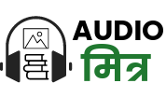

**AudioMitra**

**An Innovative Document and**   
**Content Transformation Platform**

**Problem Statement**

**“Next-Gen Multilingual AudioContent Converter Application”**

**Author: Team_11**

**[Vilal, Shriom, Madan, Hanuma]**

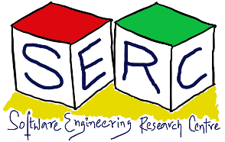**Date: 17/03/2024**

1. **Introduction:**

Audiomitra is a document and content transformation platform to provide authentic and trustworthy transformations using the computational power of artificial intelligence and cognitive power of human in the loop.

1. **Problem Statement:**

**“Next-Gen Multilingual AudioContent Converter Application”**

**Description – Audiomitra:**

Audiomitra stands as an innovative solution within the realm of language processing, aiming to streamline human endeavors through technological advancement. Functioning as a document and content transformation system, Audiomitra facilitates the transition from non-digital mediums to digital formats, such as converting paper documents into digital files. Moreover, it can convert between various digital mediums, for instance, transforming digital images into text through Optical Character Recognition (OCR), and then converting text into audio using a text-to-speech (TTS) system.

Throughout the transformation process, Audiomitra allows for the optional collaboration between human intervention and machine operation. This collaborative approach ensures the authenticity and reliability of the transformations performed. The degree of human and machine involvement is tailored to meet specific workflow requirements, with the balance dictated by the desired level of accuracy and the nature of the transformations needed.

**Target Users or Stakeholders**

The primary users of Audiomitra are individuals and organizations that require the conversion of documents and content into different formats for various purposes.

**This includes:**

* **Educational Institutions:** Schools, colleges, and universities that need to digitize textbooks, lecture notes, and other educational materials for online access.
* **Libraries and Archives:** Institutions that manage vast collections of books, manuscripts, and other historical documents, seeking to digitize and make them accessible online.
* **Publishing Houses:** Companies that produce books, magazines, and other printed materials, looking to convert their content into digital formats for distribution and preservation.
* **Content Creators and Authors:** Individuals and groups who create content in various formats, seeking to convert their work into audio for wider distribution and accessibility.

**The Problem and Need**

The challenge Audiomitra addresses is the need for efficient and accurate conversion of documents and content between digital and non-digital formats, with a particular emphasis on multilingual audio conversion.

**This includes:**

* **Digitization of Printed Documents:** Converting paper documents into digital formats for easier storage, sharing, and access.
* **Optical Character Recognition (OCR):** Extracting text from digital images or scanned documents to create editable text files.
* **Text-to-Speech (TTS) Conversion:** Transforming text content into audio formats, enabling the creation of audiobooks in various languages.

**Significance of the Problem**

**Solving this problem is significant for several reasons:**

* **Accessibility:** By converting documents into digital formats, Audiomitra enhances accessibility for individuals with visual impairments or those who prefer listening to reading.
* **Preservation:** Digital formats are more durable and easier to preserve than physical documents, reducing the risk of loss or damage.
* **Efficiency:** The platform streamlines the process of content conversion, saving time and resources for educational institutions, libraries, and publishers.
* **Globalization:** By facilitating multilingual audiobook conversion, Audiomitra supports the global dissemination of knowledge and culture, making educational and informative content accessible to a wider audience.

1. **Abstract Overview of the Proposed Solution**

**Text Extraction (OCR)**

* **Open-Source API Utilization:** Extract text content from images using the Open-Source API.
* **Flexibility**: Adaptable to other open-source OCR APIs.
* **Output:** Text files, with optional reassembly to match original document layout.

**Content Validation**

* **Text Accuracy:** Validate OCR’d content for text accuracy.
* **Human Intervention:** Optionally allow for text editing and refinement.
* **Output:** Validated text content.

**Text to Speech/Audio (TTS)**

* **Open-Source API Utilization:** Convert extracted/validated content into speech/audio.
* **Flexibility:** Adaptable to other open-source TTS APIs.
* **Output:** Audio files.

**Multiuser System**

* **Accessibility:** Accessible via a web browser, with username and password protection.
* **User Roles:** Support for various roles, including validators, authors, and voice-over artists.
* **Collaboration:** Facilitates collaboration and specialization within the platform.

1. **Technology Stack Overview for Audiomitra**

**Backend**

* **Flask (Python):** Utilized for building the backend of the Audiomitra application. Flask is a lightweight web framework that is easy to use and extend, making it ideal for developing the server-side logic of the platform.
* **Node.js:** Another backend technology option, Node.js is used for building scalable network applications. It's particularly well-suited for real-time applications and can be integrated with various databases and APIs.

**Frontend**

* **React Framework:** Employed for building the user interface of the platform. React is a popular JavaScript library for building user interfaces, especially for single-page applications. It allows for the creation of reusable UI components, enhancing development efficiency and application performance.
* **HTML/CSS:** The foundation of the frontend, ensuring the structure and styling of the Audiomitra platform.
* **Online CSS:** Bootstrap and tailwind

**Additional Technologies**

* **Open-Source API:** For OCR and text-to-speech functionalities, providing high accuracy and integration with the Audiomitra platform.
* **Microservices Architecture**: All technology services, including OCR and TTS, are deployed as microservices, offering scalability, flexibility, and ease of maintenance.
* Cloud Services: Hosting the microservices and ensuring high availability and scalability.
* **MySQL:** Used for storing structured application data and user data, providing a robust and reliable database solution.
* **MongoDB:** Employed for storing unstructured data content, offering distributed data storage that is scalable and easy to manage.
* **Apache or Nginx Web Servers:** Hosting the Audiomitra platform, ensuring stability, scalability, and security.

1. **Project Domain:**

The domain of the Audiomitra project can be best categorized under Education. This classification is based on the project's focus on transforming documents and content from non-digital to digital formats, specifically aiming to enhance the learning experiences and accessibility of educational materials.

**Reasons for Choosing Education as the Domain:**

* **Multilingual Support:** Audiomitra's capability to convert text into audio in various languages supports the global dissemination of educational content. This is particularly relevant in the context of international education, where multilingual support is crucial for reaching a broader audience.
* **Enhanced Learning Experiences:** By providing audio versions of educational content, Audiomitra can enhance learning experiences for students who may benefit from listening to content rather than reading it. This can be particularly beneficial for students with learning disabilities or those who prefer auditory learning methods.
* **Innovation in Educational Administration:** The project's ability to automatically assign metadata to documents and support batch processing of paper documents can streamline administrative tasks in educational institutions, such as the management of library collections or the digitization of archival materials.

1. **Key Functionalities**

**Core Features**

* **Preprocessing for OCR:** Preserves the structure of documents (tables, columns, forms) before OCR, ensuring accurate text extraction.
* **Image to Text Transformation:** Utilizes the Open-Source API for OCR, converting images into editable text.
* **Text Editing and Review:** Provides tools for text editing and review, ensuring the accuracy of the extracted text.
* **Audit Trails:** Optionally tracks changes made during text editing, maintaining a record of modifications.
* **Text to Audio Transformation:** Converts text into audio format using the Open-Source API, facilitating the creation of audiobooks.
* Browser based access via Internet.

**User Interaction**

* **Platform Agnostic, Cloud-Based Service:** Accessible via the internet, the system is designed to be platform-agnostic, allowing users to access it from any device with internet connectivity.
* **Browser-Based Access:** Users interact with the system through a web interface, providing a user-friendly and accessible platform for document conversion.

**Technical Highlights**

* **Open-Source API Integration:** Leverages the Open-Source API for both OCR and TTS functionalities, ensuring high-quality text-to-speech conversion.
* **Cloud Computing:** Employs cloud-based infrastructure for scalability, reliability, and cost-effectiveness.

**Architectural Tactics**

* **Microservices Architecture:** To ensure scalability and maintainability, the system is designed as a collection of loosely coupled services.
* **API Gateway:** Acts as a single-entry point for all client requests, simplifying the client-side architecture.
* **Event-Driven Architecture:** For asynchronous processing, such as document scanning and text-to-audio conversion, to improve system responsiveness.
* **Caching:** To reduce latency and improve performance, especially for frequently accessed data.
* **Security:** Implements robust security measures, including encryption and access controls, to protect user data and ensure privacy.

**Design Patterns**

* **Factory Pattern:** Used for creating objects without specifying the exact class of object that will be created, facilitating the creation of different types of documents.
* **Observer Pattern:** Employed for maintaining a list of dependents and notifying them of any state changes, useful for tracking changes in document processing.
* **Singleton Pattern:** Ensures that a class has only one instance and provides a global point of access to it, useful for managing shared resources like configuration settings.

**Architecture Diagrams**

The architecture would typically include components for document scanning, OCR processing, text editing, TTS conversion, and user interface, all interconnected through a central API gateway and possibly a message broker for asynchronous communication.

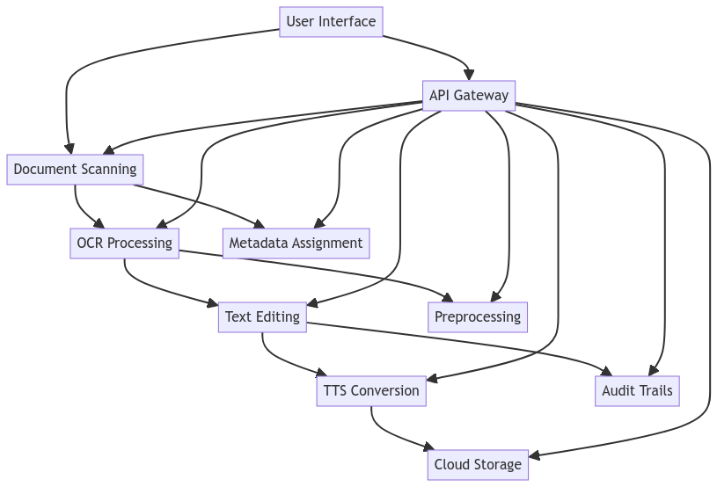

1. **Expected Time to Build a Prototype**

Project's complexity and the need to develop a working prototype of the **Audiomitra** system, a realistic timeline can be outlined as follows. This timeline assumes a team of 4 members, with each member potentially taking on multiple roles to ensure the project's success.

**Research and Planning (1 weeks)**

* **Week 1:**
  + Conduct thorough research on the problem domain, existing solutions, and the specific requirements of the **Audiomitra** system. This includes understanding the technical feasibility of **integrating** with the OpenSource API for OCR and TTS functionalities, as well as the need for metadata assignment and preprocessing.
  + Finalize the project scope, define the core features, and plan the system architecture. This phase also involves drafting a **high-level design** document that outlines the system's components, interactions, and data flow.

**Design (2 weeks)**

* **Week 1:** 
  + Design the system architecture, including the **frontend** and **backend** components, and the integration with **external APIs**. This phase also involves designing the database schema to store metadata, text content, and audio files.
  + Develop the user interface design, focusing on usability and accessibility. This includes wireframes and mockups for the web interface and any mobile app components.
* **Week 2:** 
  + Finalize the design documents and prepare for the development phase. This includes creating detailed design specifications and technical requirements for each component of the system.

**Development (4 weeks)**

* **Weeks 1:** Develop the backend services, including document scanning, OCR processing, text editing, TTS conversion, metadata assignment, preprocessing, and cloud storage. This phase also involves integrating with the Open-Source API for OCR and TTS functionalities.
* **Weeks 2:** Develop the frontend components, including the user interface for document scanning, OCR processing, text editing, TTS conversion, and user management. This phase also involves implementing the web interface and any mobile app components.
* **Weeks 3:** Implement security measures, including authentication, authorization, and encryption. This phase also involves setting up the cloud storage and database infrastructure.
* **Weeks 4:** Integrate all components and conduct initial testing to ensure that the system works as expected. This phase also involves setting up continuous integration and deployment pipelines.

**Testing (1 weeks)**

* **Week 1:** 
  + Conduct unit testing, integration testing, and user acceptance testing to ensure the system meets the project goals. This phase also involves fixing any bugs or issues identified during testing.
  + Perform load testing and stress testing to ensure the system can handle the expected user load and data volume. This phase also involves optimizing the system for performance and scalability.

**Refinement (1 weeks)**

* **Week 1:** 
  + Based on test results and feedback, make necessary adjustments to the system. This phase also involves refining the user interface and user experience based on user feedback.
  + Finalize the prototype, including documentation and user guides. This phase also involves preparing for the next phase of development, such as adding new features or integrating with other systems.

**Total Estimated Time: 9 weeks**

1. **Conclusion**

The Audiomitra project represents a significant advancement in the field of education and content transformation. By leveraging cutting-edge technologies such as OCR and TTS, Audiomitra aims to streamline the process of converting documents and content into different formats, enhancing accessibility, preservation, and efficiency. The project's focus on multilingual support and its collaborative approach to human and machine intervention ensure the authenticity and reliability of the transformations performed. The proposed solution, with its robust technology stack and well-thought-out architecture, is poised to make a substantial impact on educational institutions, libraries, publishers, and content creators, ultimately contributing to the global dissemination of knowledge and culture.