**ASSIGNMENT 4 – Heap Sort, Counting Sort**

|  |
| --- |
| Topics |
| * Heaps * HeapSort * Radix Sort |
| Readings |
| * CLRS, Chapter 6, Chapter 8 |
| Instructions | |
| 1. Select a **partner** and inform instructor who you will work with  2. Do the problems and answer the questions listed in the next section   * Keep in mind Guidelines on plagiarism.   3. Follow instructions for submitting your work.  PROBLEMS AND QUESTIONS | |
| Problems and Questions |
| Part A Tracing (10 pts) |

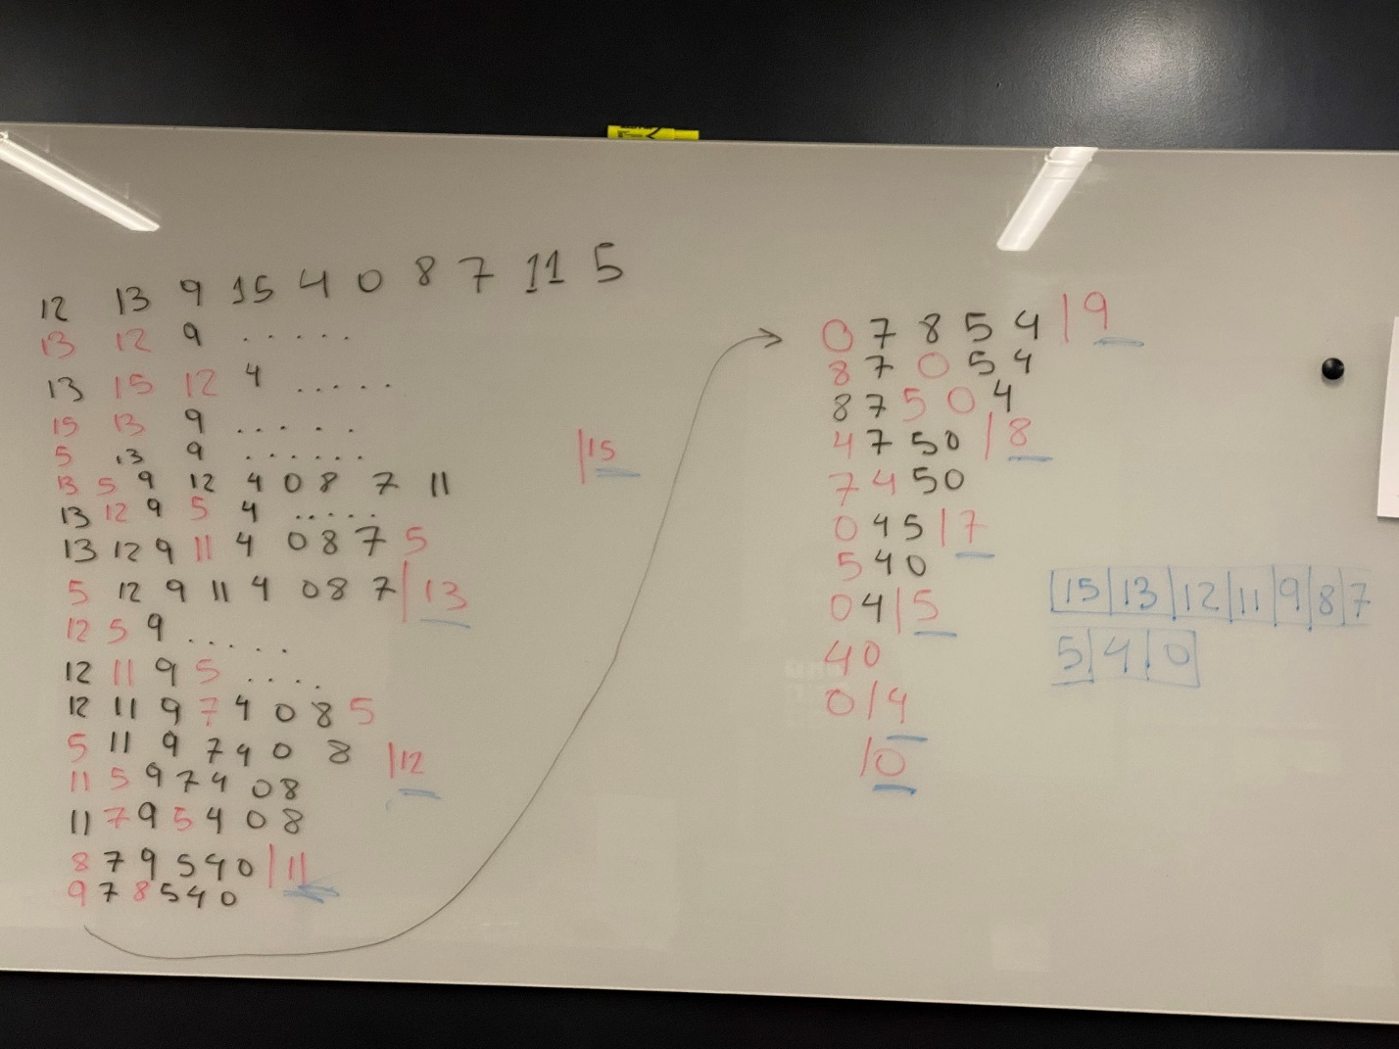Apply heapsort to sort the array {12, 13, 9, 15, 4, 0, 8, 7, 11, 5}. Show steps: heap creation and key deletions

|  |
| --- |
| Part B Heap Sort implementation ( 40 pts) |
| Implement HeapSort algorithm as a Java program with generics. For a demo, do the same as you did in Assignments 2 and 3 (extract words from the text file) |

|  |
| --- |
| Part C Tracing (10 pts) |
| Learn the definition of radix sort (e.g. Lecture 4d radixSort in the Blackboard or section 8.3 in the textbook). Then, using slide 2 (or Figure 8.3) illustrate the operation of Radix Sort on the following list of English words: COW, DOG, SEA, RUG, ROW, MOB, BOX, TAB, BAR, EAR, TAR, DIG, BIG, TEA, NOW, FOX, TAN, AIR, WAX, CAT. |

|  |
| --- |
| Part D Radix Sort implementation ( 40 pts) |
| Implement RadixSort algorithm in Java, using countingSort as basic stable sort for each position. (Hint: you may want to create a procedure  countingSort (String [] s, int k))  For a demo, use the same list as in Part C (thus verifying the result of Part C) |

|  |
| --- |
| Bonus (5 pts) |
| Implement countingSort with assumption that strings contain only capital letters: from ‘A’ to ‘Z’ (see the lecture-based exercise) |

4. **Summary questions:**

a. What concepts did you have trouble with? What still confuses you?

b. Suggestions for improving this assignment in the future?

Help instructor help you

|  |
| --- |
| Submitting your work |

1. Make sure that your name(s) are in all your files.
2. If you have more than one file for your solution, make a .zip file for your project
3. In Blackboard, attach your solution file to the submission for this assignment.

GUIDELINES ON

|  |
| --- |
| Guidelines on Plagiarism in Computer Science |

Outlined in the Syllabus