WIT COMP1000 Computer Science I

Prof. Thai

Student:

**Lab1: Install Java JDK and Eclipse**

This programming assignment will install Java JDK and Eclipse on your laptop. We will use Eclipse as our Java software development environment for the semester.

As you work through the lab be sure to answer all questions (type your answers into this document) and take all screenshots as requested (copy them into the document). For the screenshots, you can use the Snipping Tool that is built-in to Windows to capture the important parts of the lab as highlighted in the document below. Do not delete the contents of this file. When finished, you will submit this document, source code and nay associated data files to the instructor via Blackboard. DO NOT SUBMIT ZIP FILES OR INDIVIDUAL IMAGES. If you have any questions or need any clarification, see the instructor *before* the deadline.

## Java SE Development Kit 10

The Java Standard Edition (SE) Development Kit (or JDK for short) provides the ability to run programs written in Java (including applets in a browser), as well as to compile programs. In contrast, the Java Runtime Environment (JRE) can run programs, but cannot create new ones.

We will use version 10 of the Oracle JDK. Use the search term “jdk” to find Oracle’s download page. Then download and install the latest version (e.g. jdk-10.0.2_windows-x64_bin.exe) for your platform (use 64-bit, unless you have a reason not to).

Java is widely used, and thus it is common for vulnerabilities to be discovered/exploited in the JDK. *You should keep your version up-to-date to limit your exposure.*

## Eclipse IDE for Java Developers

There are several good integrated-development environments (IDEs) for Java (e.g. NetBeans, IntelliJ). In our class we will use Eclipse to develop software. Eclipse supports many languages and platforms, and is widely used in industry.

Navigate to the Eclipse Downloads page, https://www.eclipse.org/downloads/, and download the Eclipse installer (click the “Download 64 bit”). Run the Eclipse installer and select “Eclipse IDE for Java Developers” to install Eclipse on your system.

When you first run Eclipse, it will ask you to indicate a *workspace*. This is a folder that will house all your projects. You can use the folder that Eclipse suggested or choose a folder that does not currently exist, as Eclipse will directly manage its contents.

Closing the “Welcome” tab and you are now ready to use Eclipse. You should see your Eclipse IDE like the screenshot below.

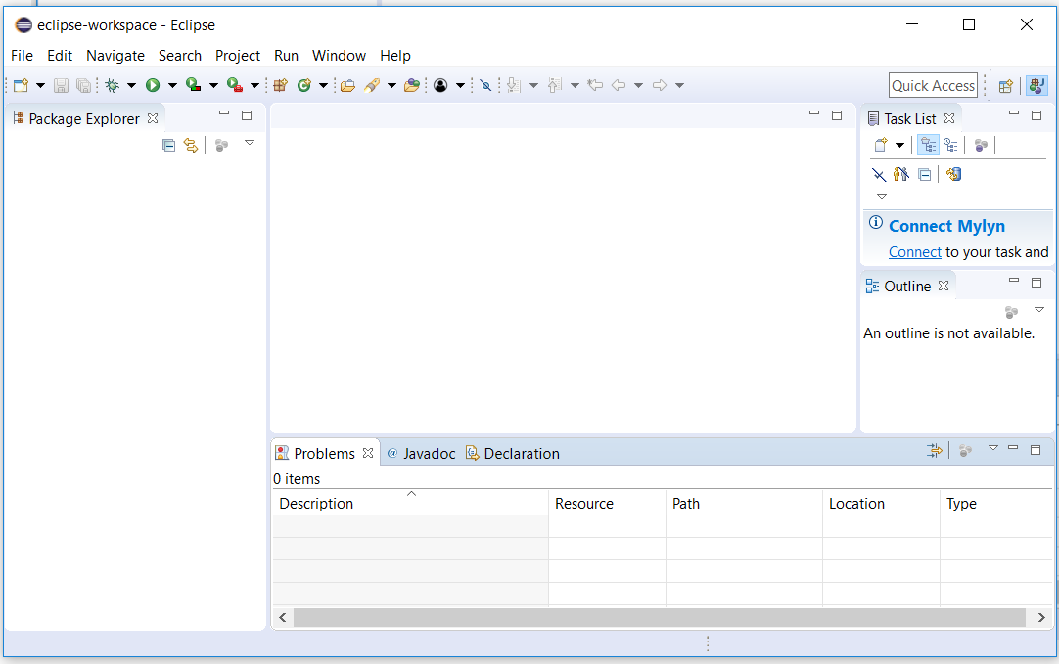

## Create Java Project

1. Start Eclipse if it is not already running.
2. In Eclipse, click on File -> New -> Java Project and enter *CS1* in the Project name field.

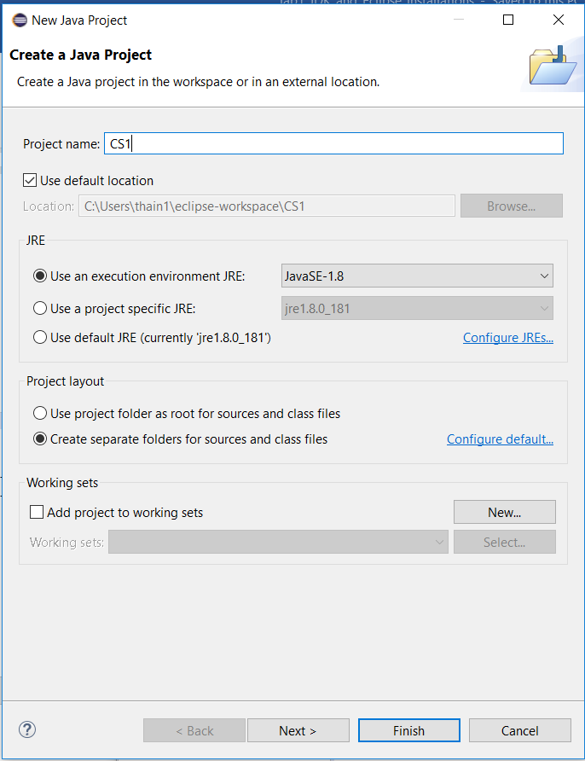

1. Click Finish to create the *CS1* project.
2. Click File -> New -> Class and enter *HelloWorld* in the name field.
3. Underneath *Which method stubs would you like to create?* Check the box *public static void main(String[] args)*. This will generate an empty entry point for your program.

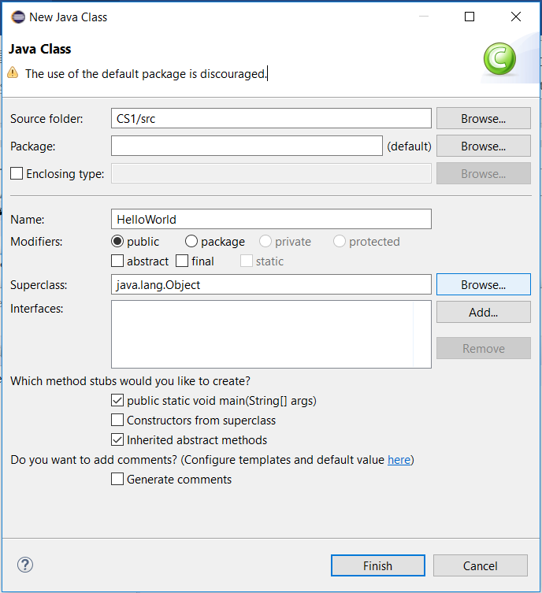

1. Click *Finish* to create an empty java class.

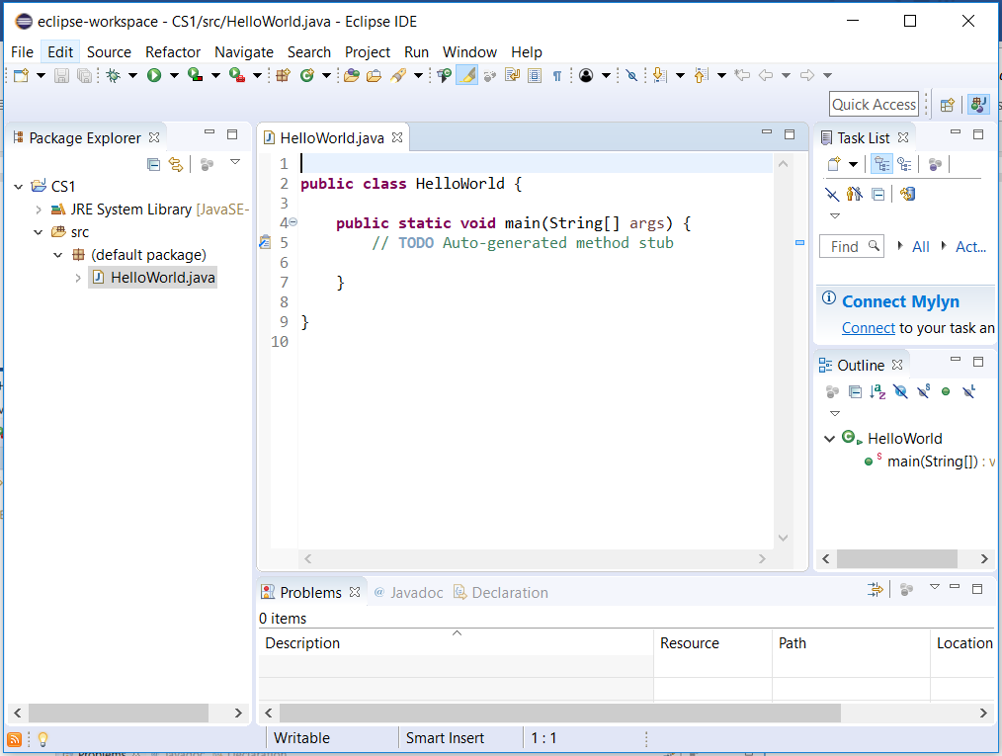

1. Replace the statement (Do not cut and paste from this document. It will have error):

// **TODO** Auto-generated method stub

With the statements:

// Write “Hello World!” to screen.

System.out.println(“Hello World!”);

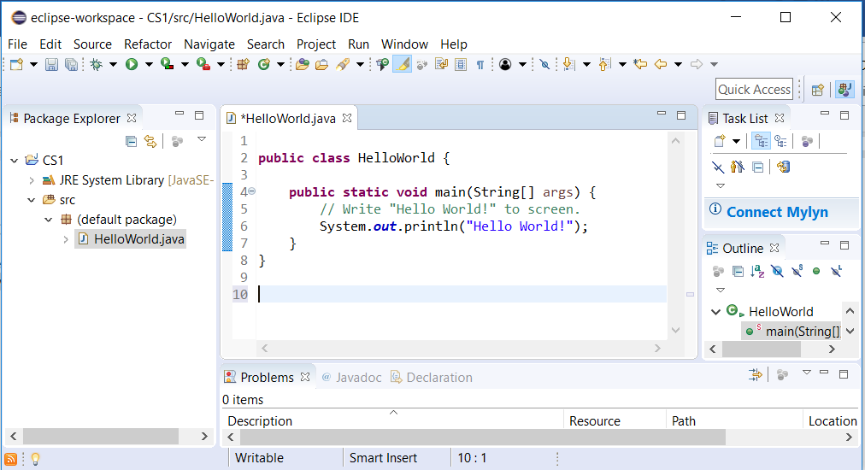

1. Click File -> Save to save your changes to disk. You can also press Ctrl + S keys to save your modifications to file instead.
2. Click Run -> Run to execute your java code.
   1. If the Save and Launch window pops up, click OK

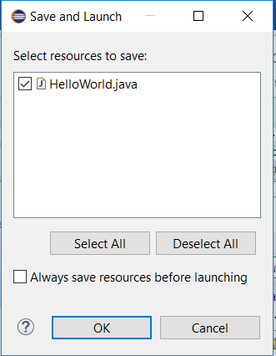

* 1. If there are no errors in your code, “Hello World!” will be displayed in Console window (in the lower part of your Eclipse window).

1. TAKE A SCREENSHOT of your Eclipse showing the “Hello World!” in the Console window and paste it here.

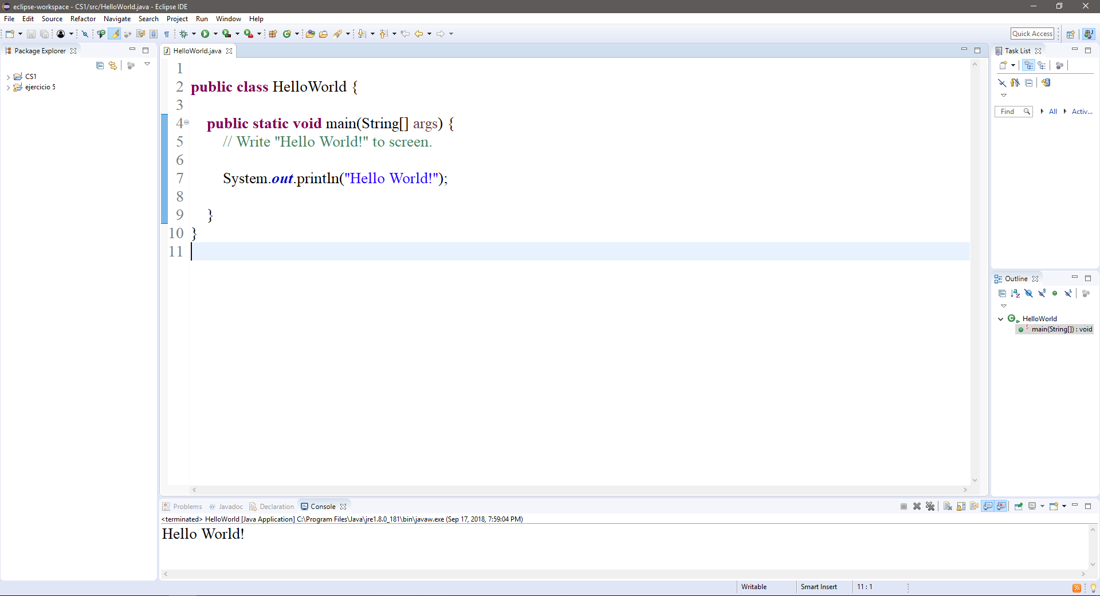

1. Click File -> Exit to close Eclipse.
2. Submit this document and the HelloWorld.java to Blackboard for grading. The HelloWorld.java should be in your workspace area, inside the CS1 folder.