WIT COMP1000 Computer Science I

Prof. Thai

Student: Carlos Daniel Jimenez

**Lab2: Notation Conversion**

The purpose of this assignment is to learn data notation conversion. In this assignment, you will convert the given data from decimal to hexadecimal, and from hexadecimal to decimal using pen and paper. You will then write a Java program to verify your results, and correct your conversion errors according.

As you work through the lab be sure to answer all questions (type your answers into this document) and take all screenshots as requested (copy them into the document). For the screenshots, you can use the Snipping Tool that is built-in to Windows to capture the important parts of the lab as highlighted in the document below. Do not delete the contents of this file. When finished, you will submit this document, source code and associated data files to the instructor via Blackboard. DO NOT SUBMIT ZIP FILES OR INDIVIDUAL IMAGES. If you have any questions or need any clarification, see the instructor *before* the deadline.

## Conversion Using Pen & Paper

1. Convert the following numbers to hex numbers (show steps):
   1. 2510
   2. 25510
2. SCAN OR TAKE PICTURES of your data conversions and paste them here. 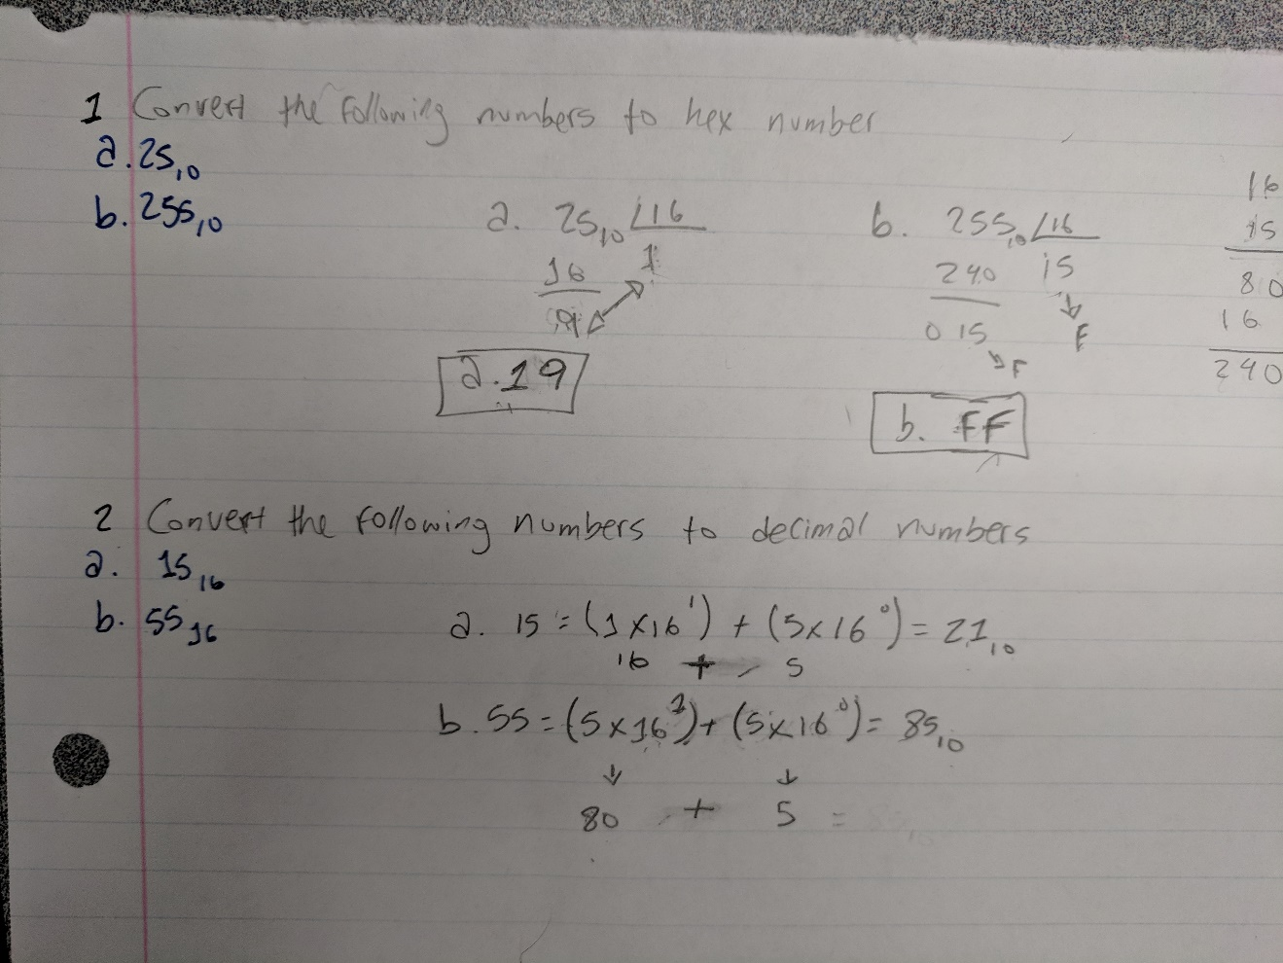
3. Convert the following numbers to decimal numbers (show steps):
   1. 1516
   2. 5516
4. SCAN OR TAKE PICTURES of your data conversions and paste them here.
5. **Writer a Java Program to verify your results**
6. As you have learned from lab1, Eclipse organizes Java code in a Java project. You have created a Java project called CS1. We are going to the CS1 project for the semester. You do not have to create another Java project; although, you can if you want to.
7. Since all Java code lives in Java classes, the first thing you need to do is to create a Java class for the lab. You are to create a Java class called Conversion.
   1. Right-click on the CS1 icon and select New -> Class
   2. In the Name field, enter Conversion (capitalized the first letter)
   3. Underneath *Which method stubs would you like to create?* Check the box *public static void main(String[] args)*. This will generate an empty entry point for your program

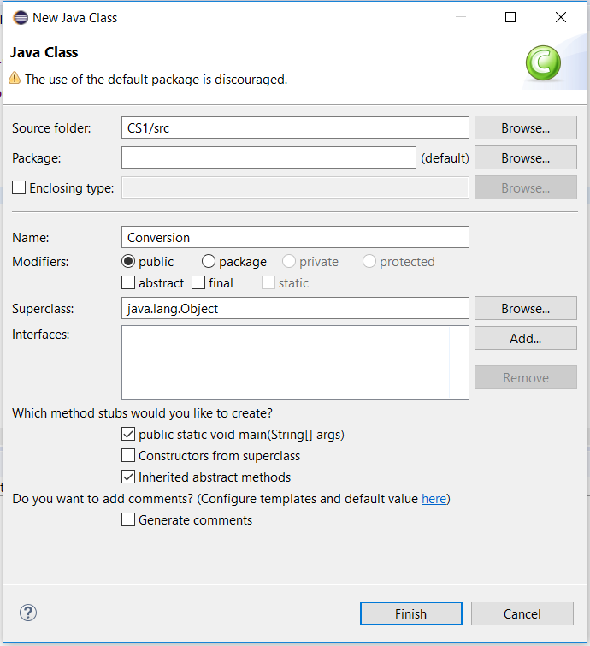

1. Write a main() method to verify your data conversion.
   1. Fix the missing code in the following listing
   2. Note: you need to remove the // and complete the missing code

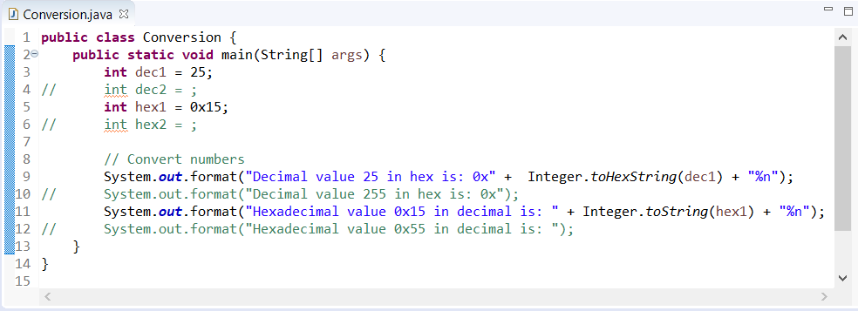

1. 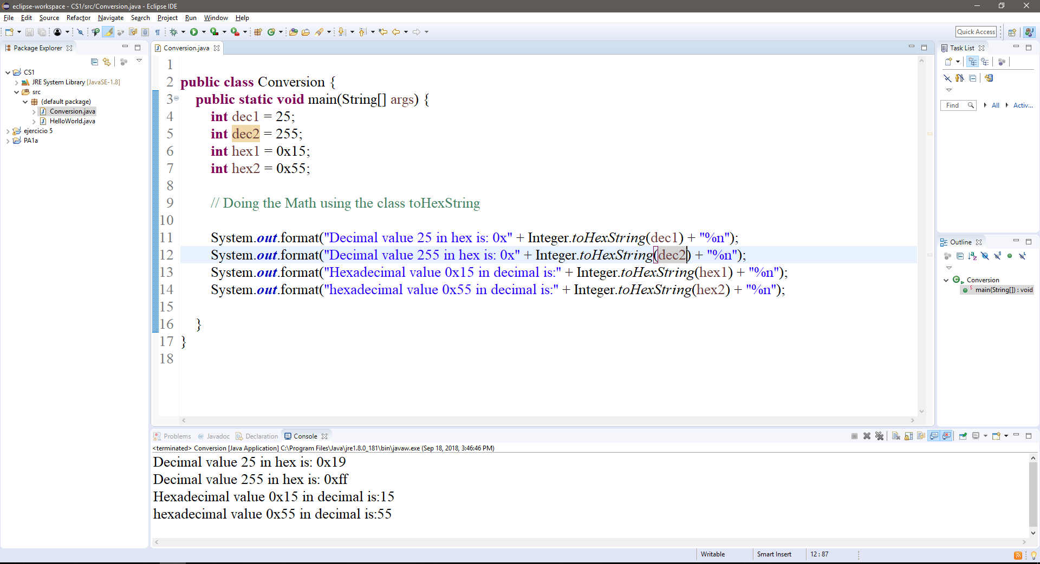TAKE A SCREENSHOT of your Conversion class and the outputs and paste them here.
2. Submit this document and the Conversion.java file to Blackboard for grading.