WIT COMP1000 Computer Science I

Prof. Thai

Student:

**Lab3: Measurement Conversion**

The purpose of this assignment is to learn how to instantiate objects and implement mathematic operations in Java.

As you work through the lab be sure to answer all questions (type your answers into this document) and take all screenshots as requested (copy them into the document). For the screenshots, you can use the Snipping Tool that is built-in to Windows to capture the important parts of the lab as highlighted in the document below. Do not delete the contents of this file. When finished, you will submit this document, source code and associated data files to the instructor via Blackboard. DO NOT SUBMIT ZIP FILES OR INDIVIDUAL IMAGES. If you have any questions or need any clarification, see the instructor *before* the deadline.

1. **Inches** (Inches.java)
2. Sometimes measurements are given in terms of yards, feet, and inches. You are to write a Java program to convert these three numbers into a total number of inches. When running, it will prompt the user to enter the number of yards, number of feet, and number of inches from the keyboard. Assume all numbers are whole (integers). Your program must calculate the total number of inches by converting each of the three inputs into inches and summing them all together. Finally, print out the total length in inches. Recall that 1 yard = 3 feet, and 1 foot = 12 inches.
3. The following represents a test case of the program in which the user inputs 1 for the number of yards, 2 for the number of feet, and 3 for the number of inches (yielding a correct output of 63 total inches).

Enter number of yards: 1

Enter number of feet: 2

Enter number of inches: 3

Total number of inches: 63

1. TAKE A SCREENSHOT of the output only and paste it here.

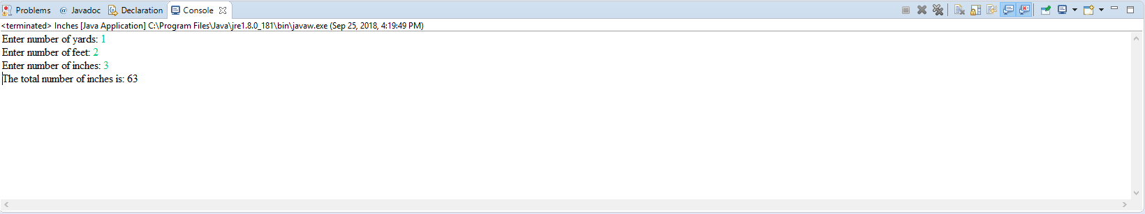

1. **YardsFeetInches** (YardsFeetInches.java)
2. Write a program to do the reverse of problem A. It prompts the user for a length in inches. You program then converts that total number of inches into yards, feet, and inches. Note that you do not convert the number of inches separately into yards, then feet, then inches. Instead the program must calculate how many yards there are in the given number of inches, then convert the remaining inches into feet, and finally have the leftover inches directly.
3. For example, if the user enters 50 for the total number of inches, your program should produce the output equals to 1 yard, 1 foot, and 2 inches. The following represents a run of the program using this sample input (again, pay very careful attention to spacing, spelling, and capitalization).

Enter number of inches: 50

Yards: 1

Feet: 1

Inches: 2

1. TAKE A SCREENSHOT of the output only and paste it here

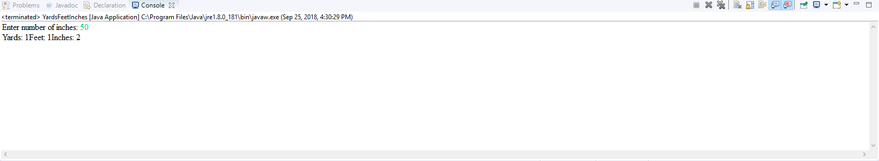

1. **Submission**

Submit this document and the .java files to Blackboard for grading.