WIT COMP1000 Computer Science I

Prof. Thai

Student:

**Lab4: Control Flow**

The purpose of this assignment is to learn writing control flow statements in Java.

As you work through the lab be sure to answer all questions (type your answers into this document) and take all screenshots as requested (copy them into the document). For the screenshots, you can use the Snipping Tool that is built-in to Windows to capture the important parts of the lab as highlighted in the document below. Do not delete the contents of this file. When finished, you will submit this document, source code and associated data files to the instructor via Blackboard. DO NOT SUBMIT ZIP FILES OR INDIVIDUAL IMAGES. If you have any questions or need any clarification, see the instructor *before* the deadline.

1. **Statistics** (Statistics.java)

Write a program to compute the sum, mean, and population standard deviation of a list of 5 numbers. First, have the user supply five numbers via the keyboard. For example: 1 2 3 4 5

Then, compute the **sum** of the numbers. In this case:

1 + 2 + 3 + 4 + 5 = 15

The **mean** is another word for the simple average:

15 / 5 = 3

To calculate the population standard deviation, it takes a few steps. First, for each inputted value, compute the difference between the mean and that number:

(1-3) = -2, (2-3) = -1, (3-3) = 0, (4-3) = 1, (5-3) = 2

Then, add up the *square* of these differences:

(-2)2 + (-1)2 + (0)2 + (1)2 + (2)2 = 4 + 1 + 0 + 1 + 4 = 10

Then divide this sum by the number of inputs:

10 / 5 = 2

And finally take the square root:

$$\sqrt{2} \sim 1.41$$

So, an example run of your program, given the above sample inputs, would look like the following:

Enter five numbers: 1 2 3 4 5

Sum: 15.00

Mean: 3.00

Population Standard Deviation: 1.41

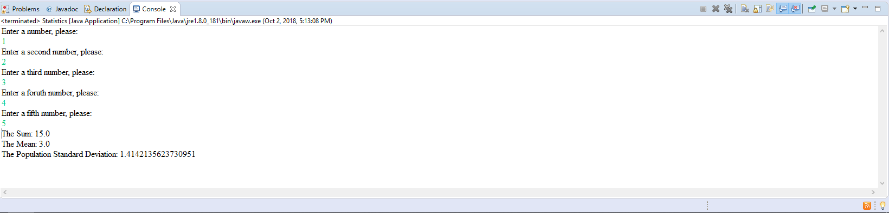TAKE A SCREENSHOT of the output console and paste it here.

1. **Heron’s Formula** (HeronFormula.java)

Get the three side lengths of a triangle from the user (which might have decimal values): a, b, c.

Check to ensure each side is greater than zero.

Check to ensure that the sides are valid for a triangle. Importantly, the sum of the lengths of any two sides must be larger than the length of the third side (you must check all three sides this way).

Calculate the semi-perimeter (*s*):



Calculate the area:



A sample test case is provided here:

Enter the length of side a: 3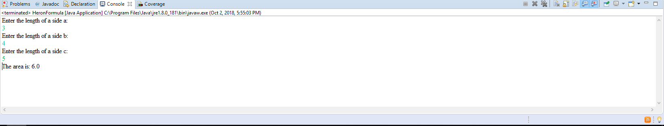

Enter the length of side b: 4

Enter the length of side c: 5

The area is 6.00

TAKE A SCREENSHOT of the output console and paste it here.

1. **Astrology** (Astrology.java)

Write an astrology program. The user will give their birthday as a month number (1 – 12) and then a day number (1 – 31). Your program will then output the person's astrological sign on one line, and then a horoscope for the user on the next. You may make up whatever horoscope you want for each different sign. Here are the sign dates:

|  |  |  |
| --- | --- | --- |
| **Sign** | **Start Date** | **End Date** |
| Aries | March 21 | April 19 |
| Taurus | April 20 | May 20 |
| Gemini | May 21 | June 21 |
| Cancer | June 22 | July 22 |
| Leo | July 23 | August 22 |
| Virgo | August 23 | September 22 |
| Libra | September 23 | October 22 |
| Scorpio | October 23 | November 21 |
| Sagittarius | November 22 | December 21 |
| Capricorn | December 22 | January 19 |
| Aquarius | January 20 | February 18 |
| Pisces | February 19 | March 20 |

A sample test case is provided here:

Enter your birth month (1-12): 9

Enter your birth day (1-31): 26

You are a Libra!

Tony Stark will buy out your business.

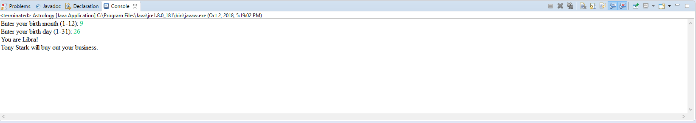TAKE A SCREENSHOT of the output console and paste it here.

Note: You are going to need to use a long set of **if** and **else if** statements. You will either need to use compound expressions (combining expressions with the “and” and “or” operators) or have nested **if** statements (**if** statements inside of **if** statements).

To get started, try to get one or two of the signs correct first, then try to make it work for the rest. You should verify that the month is between 1 and 12 and the day is between 1 and 31, but you **don't** need to check the day for specific months.