WIT COMP1000 Computer Science I

Prof. Thai

Student:

**Lab6: Operations**

1. **Operations** (Operations.java)

Write a program to calculate the result of one of three operations (minimum, L1 norm, L2 norm) on a vector of three numbers. To begin, have the user input three numbers at the keyboard (e.g. -1 2 3). Then, ask the user to type in an operation (valid operations are “min”, “l1”, or “l2”; all letters are lowercase). Assuming the user types a valid operation, your program should compute and output to the screen the result based upon the three numbers; otherwise output an error.

For “min”, the result is the minimum of the three numbers (i.e. -1). For “l1”, the result is the square of the sum of the absolute values of the three numbers (i.e. (|-1| + |2| + |3|)2 = (1 + 2 + 3)2 = 36). For “l2”, the result is the square root of the absolute value of the sum of the increasing exponential terms (i.e. $\sqrt{{|(-1)}^{1}+{(2)}^{2}+{(3)|}^{3}}=\sqrt{|1+4+27|}=\sqrt{32}=5.66$).

Test your program using the following data:

Enter three numbers: -1 2 3

Enter operation: min

min(-1.00, 2.00, 3.00) = -1.00

Enter three numbers: -1 2 3

Enter operation: l1

l1(-1.00, 2.00, 3.00) = 36.00

Enter three numbers: -1 2 3

Enter operation: l2

l2(-1.00, 2.00, 3.00) = 5.66

Enter three numbers: -1 2 3

Enter operation: l3

Invalid operation!

Enter three numbers: -1 2 3

Enter operation: MIN

Invalid operation!

Note that all values should be output with two decimal places (rounding where necessary).

TAKE A SCREENSHOT of the output console showing the above results and paste it here.

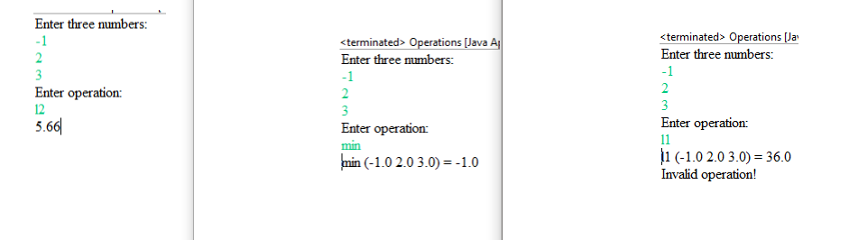

1. **Subtraction** (Subtraction.java)

Write a Java program to help first graders to practice math subtraction.

1. Your program must:
   1. randomly generate two single-digit integers, *number1* and *number2*.
      * *number1* must be greater than or equals to *number2* (i.e., *number1* ≥ *number2*)
      * If *number1* < *number2*, swap *number1* with *number2*
   2. ask the student the question: “What is *number1* - *number2*?”
   3. verify the student’s answer, and display whether the answer is correct:
      * “You are correct!”, if the answer is correct.
      * “Your answer is incorrect. *number1* - *number2* is *difference*”, if the answer is incorrect.
        + Where *difference* is the result of *number1* minus *number2*
   4. ask the student the question: “Do you want to play again?”
      * If “y” or “Y”, the program loops back to the begin.
      * If “n” or “N”, the program exits
2. The following represents two sample test cases of the program. You are required to generate the user interface (UI) as shown below.
   1. User entered correct answer (1)

What is 4 - 3? 1

You are correct.

Do you want to play again? (Y/N) Y

* 1. User entered incorrect answer (6)

What is 8 - 3? 6

Your answer is incorrect. 8 - 3 is 5

Do you want to play again? (Y/N) N

1. Run a least two test cases showing the correct and incorrect answers. TAKE A SCREENSHOT of the output console showing the above results and paste it here.

